Calls for Service
Perry Twp Crews responded to 103 incidents with 5 assists in the month of June with 298 COP (Community Oriented Policing/Patrol) entries. This includes 7 crash investigations, 7 reports generated, 62 traffic stops, 7 citations issued and 1 misdemeanor arrest. There were no mental health calls, overdoses or K-9 deployments in Perry Twp. during June.
Community Concerns
There was a community concern of speeders on Wolf Creek Pike. Deputies increased patrols in the area that resulted in numerous traffic stops where the concerned citizen reported a positive result.
Financials
June 2026 closed with the monthly expenditure of $33,752.82 leaving a balance of $406,539.06 against the contract. All financial reports were sent to Trustee Heeter and Fiscal Officer Hoover.
Goals and Objectives
No new goals and objectives to report for the month of June.
Case reports

7 reports were generated in Perry Twp. 4 of those reports needed additional follow-up by our Special Investigations Detective Section.

Notable Incidents
On June 27th, 2026 (Sat) at approximately 0323 hours, Perry Twp. Deputies responded to a single vehicle crash at Wolf Creek Pk and Diamond Mill Rd. Upon arrival, they found a 25-year-old female driver intoxicated with her vehicle heavily damaged. The female was ultimately cited for OVI and failure to control as she tested nearly double the legal limit of alcohol in her system. She was taken to the hospital for evaluation.

On June 1st, 2026 (Mon) at approximately 1736 hours, Deputies responded to a neighbor dispute on Steck Rd where a neighbor reportedly pointed a firearm at another neighbor. The suspect was charged with aggravated menacing and a firearm was confiscated by Deputies.

Forensic Services

During June, the Forensic Services Unit responded to 208 calls for evidence processing. Harrison Township generated the largest volume of activity, accounting for 121 calls. Additional calls were handled in Jefferson Township 28, Washington Township 29, Perry Township 2, and the remaining 28 calls occurred in other jurisdictions throughout the county.
First Watch technicians handled 45 calls, while Third Watch completed 54 calls. Second Watch managed the highest volume, responding to 109 calls during the month.

Traffic Services
During June, deputies from Perry Township investigated seven traffic crashes. Of these crashes, there were six property damage crashes and one minor injury crash. One person sustained a minor injury. One crash involved an impaired driver and hit and run respectively. No crashes involved a pedestrian.

Tuesday and Friday were the busiest days of the month. Failure to control was the most common causative factor, accounting for five of the crashes. Two crashes occurred on Wolf Creek Pike, and the other five occurred in varying locations throughout the township.

TRAFFIC ENFORCEMENT
 | PERRY TOWNSHIP
Traffic stops conducted | 62
Traffic-related warnings | 48
Driving under suspension | 0
Speed | 4
Adult seat belt violations | 0
Juvenile seat belt violations | 0
Other moving violations | 2
Non-Moving violations | 0
OVI (over 21) | 1
OVI (under 21) | 0
Commercial overweight violations | 0
TOTAL CITATIONS ISSUED | 7
Monthly Stats
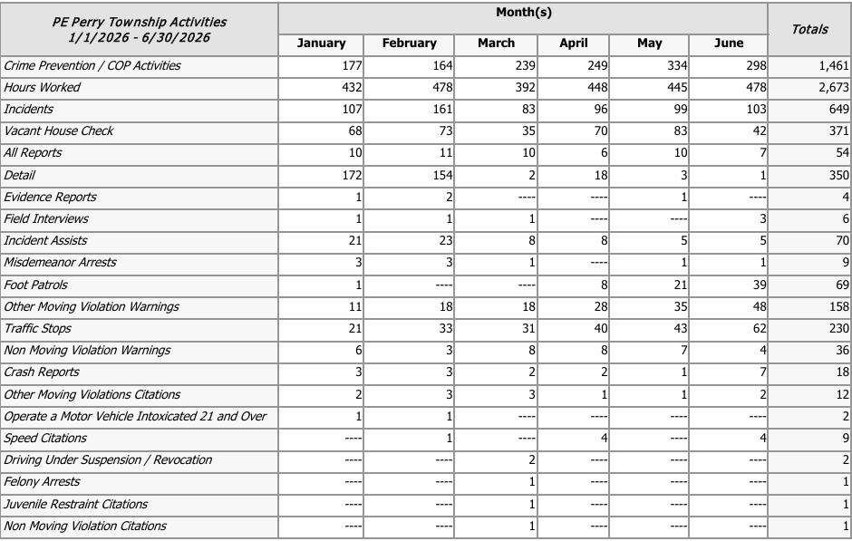

Prepared By:
Captain Walter Steele #88
Montgomery County Sheriff’s Office
District 12/Perry Township Substation
937-496-6887
Steelew@mcohiosheriff.org

