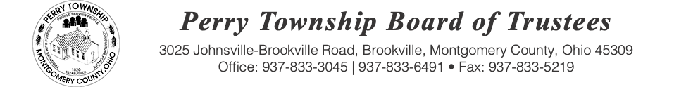

BOARD OF TRUSTEES SPECIAL MEETING AGENDA

September 22, 2025 @ 1:00 p.m.
Location: Administrative Building
3025 Johnsville Brookville Rd, Brookville, OH 45309

Welcome

Meeting called to order

Pledge of Allegiance

Fiscal Officer Roll Call:

- Executive Session pursuant to 121.22 (G)(1) to consider the employment, dismissal, discipline or compensation of a public employee

Adjourn:

