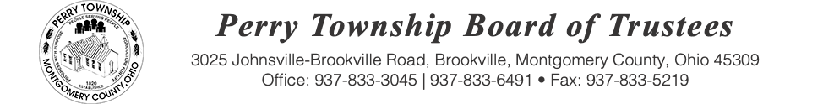

BOARD OF TRUSTEES SPECIAL MEETING AGENDA

October 2, 2025 @ 6:00 p.m.
Location: Administrative Building
3025 Johnsville Brookville Rd, Brookville, OH 45309

Welcome

Meeting called to order

Pledge of Allegiance

Fiscal Officer Roll Call:

- Amounts & Rates – Tax Year 25/26; Schedule A&B; Local Govt Fund Distribution 2026

- Spectrum/T-Mobile

- Driving Policy Compliance

- Credit Card/Spending Policy Training for all Employees

- Audit Update

- Inventory

- Records Retention Committee Status

- Comprehensive Land Use Plan Committee

- Trash Fund

- Mowing Resolution for the property located at 15011 Brookville Pyrmont Rd

- Meet the Candidate Night – October 13th @ 6:00 PM – Brookville High School Auditorium

- Police Cruiser Sale Update

- Police Department

- Executive Session pursuant to ORC 121.22 (G)(1) to consider the employment, dismissal, discipline or compensation of 2 public employees

Adjourn:

