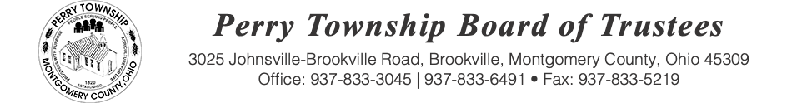

BOARD OF TRUSTEES SPECIAL MEETING AGENDA

October 16, 2025 @ 6:30 p.m.
Location: Administrative Building
3025 Johnsville Brookville Rd, Brookville, OH 45309

Welcome

Meeting called to order

Pledge of Allegiance

Fiscal Officer Roll Call:

- Terms of employment of the Police Chief

Adjourn:

