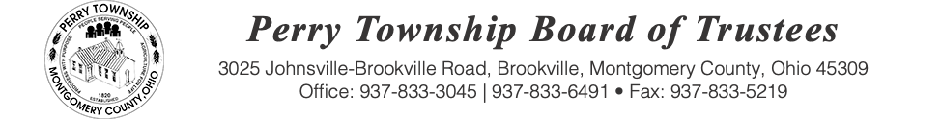
BOARD OF TRUSTEES MEETING AGENDA

December 09, 2025 @ 6:00 p.m.
Location: Administrative Building
3025 Johnsville Brookville Rd, Brookville, OH 45309

Welcome

Meeting called to order

Pledge of Allegiance

Roll Call:

Consent Agenda: Matters listed under the Consent Agenda are considered to be routine and will be enacted by one motion and one vote of consent. There will be no separate discussion of these items. If a discussion is desired, that item will be removed from the Consent Agenda and considered separately.
Fiscal Officer Report:

Roads and Cemeteries Report:

Zoning Administrator Report:

Police Department Report:

Old Business:

New Business:

Public Comments:

Adjourn:

