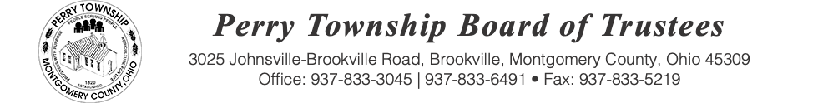

BOARD OF TRUSTEES MEETING AGENDA

November 18, 2025 @ 6:00 p.m.
Location: Administrative Building
3025 Johnsville Brookville Rd, Brookville, OH 45309

Welcome

Meeting called to order

Pledge of Allegiance

Roll Call:

Guest Speaker: County Commissioner Mary A. McDonald

Consent Agenda: Matters listed under the Consent Agenda are considered to be routine and will be enacted by one motion and one vote of consent. There will be no separate discussion of these items. If a discussion is desired, that item will be removed from the Consent Agenda and considered separately.
- Acceptance of the following minutes

  - October 14, 2025 – Regular Board of Trustees Meeting
  - October 16, 2025 – Special Meeting
  - October 30, 2025 – Special Meeting

- Acceptance of bills being paid:

  - Check numbers 39063 through 39082
  - Electronic warrant numbers 530-2025 through 601-2025

- Approval of Blanket Certificates:

  - Blanket Certificate 143-2025 through 148-2025
Fiscal Officer Report:

Roads and Cemeteries Report:

Zoning Administrator Report:

Police Department Report:

Old Business:

New Business:

Public Comments:

Adjourn:

