April 2014

The Hon Barnaby Joyce, MP

Minister for Agriculture

Parliament House

CANBERRA ACT 2600

Dear Minister

White Paper Submission

All governments must articulate for public servants what is in the national interest.

I am writing to advise you of the launch of the **Agricultural Levies Institute of Australia** (ALIA) (‘the Institute’). The Institute has been established to enable levy payers to be better informed about the implementation, use and ongoing management of levies and agriculture related customs charges. The Institute has adopted the slogan, *‘Partners with Producers’,* to signify the organisation’s dedication to the rural sector and its constituents. Over the coming weeks I will be writing to you, the Shadow Minister and other political Parties and independent Parliamentarians, to inform you of the initial work of the ALIA.

There remains significant gaps in the understanding of the development and status of levies within agriculture. A key initiative of the Institute will be to hold information sessions, seminars and conferences in rural regions to enable producers to be better informed about the role the government plays in the imposition of agricultural levies and customs charges on their agricultural products. The Institute will also assist levy payers who need assistance with completing their levy returns.

The broader issue of levies in society is even less well understood and it will be one of the Institute’s roles to better inform the public on the government’s actions in this area. The use of levies and customs charges is even less well understood and the Institute will be seeking a review of how levies are used to benefit the people who pay them.

The Institute’s initial undertaking will be to seek, from you, an interpretation of the use of the terms ‘Representative bodies’, ‘Prescribed bodies’, ‘Authorised bodies’, ‘Declared bodies’ and other like terms when referring to those industry bodies, whose responsibility it is to determine levies on behalf of their respective sectors. In particular we will be seeking to understand the authority under which these terms are used and how those bodies are taken to be representative of the participant’s/farming communities engaged in the specific agricultural commodity, especially in the area of statutory levies and their use.

Information provided to the Institute suggests that the *‘Levies Principles and Guidelines’*, are not well understood both at an administrative level, ie within the Department of Agriculture (DoAg) and at an industry level because they have little or no historical context and/or legislative imprimatur. These may be issues that need to be canvassed at regional gatherings when we are disseminating information to levy payers. At the Institute we have found that farmers are not confident with the system for establishing levies and charges. The application and reliance on the *‘Levies Principles and Guidelines’* by governments and levy payers remains

an issue of concern to levy payers and we will seek to clarify this issue with you. I would urge you to incorporate advice from officials of the Institute when considering the imposition of levies [and charges] on behalf of the agricultural sector.

The Institute will be conducting on-line surveys to gauge the views of levy payers on a number of agricultural policy issues. It is the intention and indeed a key objective [obligation] of the Institute to pass these views onto the responsible Federal, State and Territory Ministers to enable informed discussion on matters affecting farming communities. From time to time the Institute will be issuing ‘media announcements’ or statements on topics of interest to farmers. Correspondence may be published on the Institute’s website to ensure transparency.

As co-founder of the Institute, I will be doing my best to serve the farmers of Australia. I trust the Institute will have the support of your office in considering critical matters of concern to farmers, who should be the primary concern of your portfolio.

I hope the Institute’s work, to inform and work with levy payers on a range of issues affecting their farming operations, will produce good outcomes for all concerned.

I will be writing to you, in the coming weeks and months, on the issues raised here and others as they arise.

Yours sincerely



Spiro Adamopoulos

Chief Executive Officer

*‘In the Interests of Farmers’*

12 March 2014

Cc The Hon John Cobb, MP; Senator Christine Milne, the Hon Bob Katter MP, Editor - *‘The Land’*, Editor - Weekly Times; Senator Nick Xenophon, Mr Clive Palmer MP, Senator Glenn Sterle

**SUBMISSION TO THE**

**AGRICULTURAL COMPETITIVENESS**

**WHITE PAPER**

**APRIL 2014**

**from**

**AGRICULTURAL LEVIES INSTITUTE OF AUSTRALIA**

**‘Partners with Producers’**

*In the Interests of Farmers*

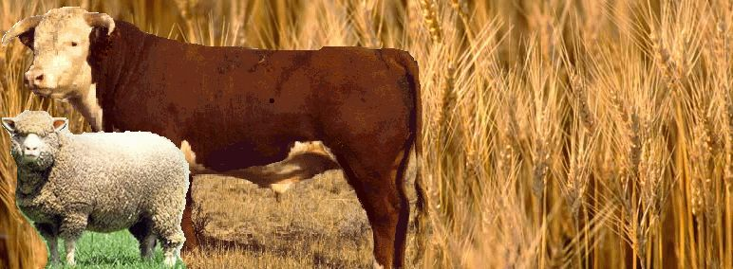

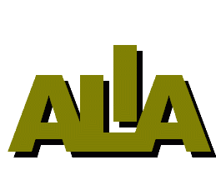

www.leviesinstitute.com.au

CONTACT INFORMATION

Spiro Adamopoulos

Chief Executive Officer

PO Box 105

JAMISON CENTRE ACT 2614

Email: [ceo@leviesinstitute.com.au](mailto:ceo@leviesinstitute.com.au)

**Introduction**

This submission is aimed at increasing the ability of Australia’s agricultural producers to do business.

The key issues for Australian agriculture is to enable a transparent and effective levies system, a transparent and effective use of farmer levies, transparency in research and development expenditure, a clear and definitive process for the imposition and collection of levies, a lawful and supported declaration of levy prescribed bodies, a clear and definitive approach to what is in the public and national interest – eg restoration of the brand Australian Quarantine, an understanding of land clearing guidelines that does not penalise farmers while considering and potentially adopting conservation initiatives used in other countries, eg the UK system of environmental measures that do not impact on the accessible farming land system of understanding how to obtain the necessary labour needed to plant and cultivate production areas (use of foreign labour).

This should be underpinned by an effective, committed and knowledgeable public service serving farmers and you. Often officials within your portfolio (Department) are not equipped with the appropriate skills to deal with agricultural issues. The Levies Institute membership has flagged this as a significant barrier to doing business.

**Levies**

, I am writing to advise you of the launch of the Agricultural Levies Institute of Australia (ALIA) (‘the Institute’). The Institute has been established to enable levy payers to be better informed about the implementation, use and ongoing management of levies and agriculture related customs charges. The Institute has adopted the slogan, ‘Partners with Producers’, to signify the organisation’s dedication to the rural sector and its constituents. Over the coming weeks I will be writing to you, the Shadow Minister and other political Parties and independent Parliamentarians, to inform you of the initial work of the ALIA.

There remains significant gaps in the understanding of the development and status of levies within agriculture. A key initiative of the Institute will be to hold information sessions, seminars and conferences in rural regions to enable producers to be better informed about the role the government plays in the imposition of agricultural levies and customs charges on their agricultural products. The Institute will also assist levy payers who need assistance with completing their levy returns.

The broader issue of levies in society is even less well understood and it will be one of the Institute’s roles to better inform the public on the government’s actions in this area. The use of levies and customs charges is even less well understood and the Institute will be seeking a review of how levies are used to benefit the people who pay them.

The Institute’s initial undertaking will be to seek, from you, an interpretation of the use of the terms ‘Representative bodies’, ‘Prescribed bodies’, ‘Authorised bodies’, ‘Declared bodies’ and other like terms when referring to those industry bodies, whose responsibility it is to determine levies on behalf of their respective sectors. In particular we will be seeking to understand the authority under which these terms are used and how those bodies are taken to be representative of the participant’s/farming communities engaged in the specific agricultural commodity, especially in the area of statutory levies and their use.

Information provided to the Institute suggests that the ‘Levies Principles and Guidelines’, are not well understood both at an administrative level, ie within the Department of Agriculture (DoAg) and at an industry level because they have little or no historical context and/or legislative imprimatur. These may be issues that need to be canvassed at regional gatherings when we are disseminating information to levy payers. At the Institute we have found that farmers are not confident with the system for establishing levies and charges. The application and reliance on the ‘Levies Principles and Guidelines’ by governments and levy payers remains

an issue of concern to levy payers and we will seek to clarify this issue with you. I would urge you to incorporate advice from officials of the Institute when considering the imposition of levies [and charges] on behalf of the agricultural sector.

The Institute will be conducting on-line surveys to gauge the views of levy payers on a number of agricultural policy issues. It is the intention and indeed a key objective [obligation] of the Institute to pass these views onto the responsible Federal, State and Territory Ministers to enable informed discussion on matters affecting farming communities. From time to time the Institute will be issuing ‘media announcements’ or statements on topics of interest to farmers. Correspondence may be published on the Institute’s website to ensure transparency.