Sikhism / Sikh / Sikhi   | Waheguru (satguru)  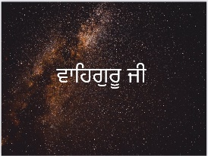 | gurmukh  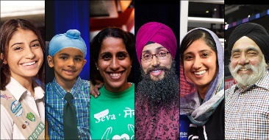 | sewa  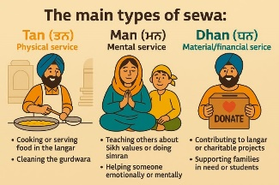
equality equity  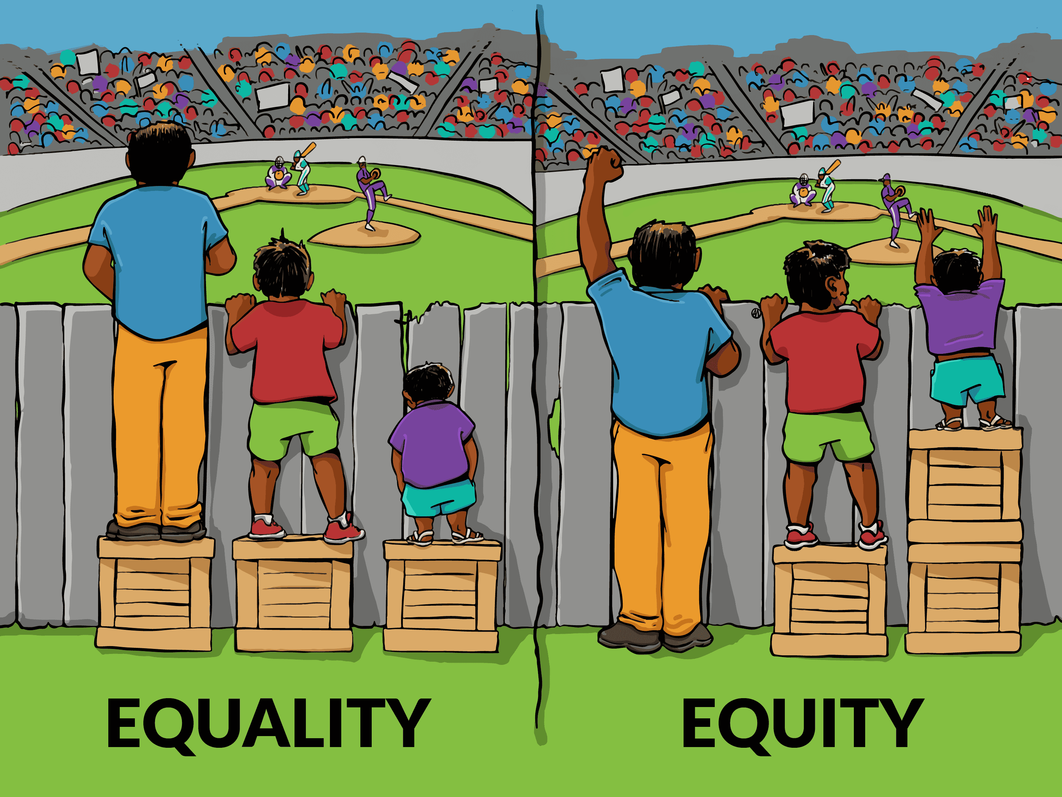 |  | Mata Khivi 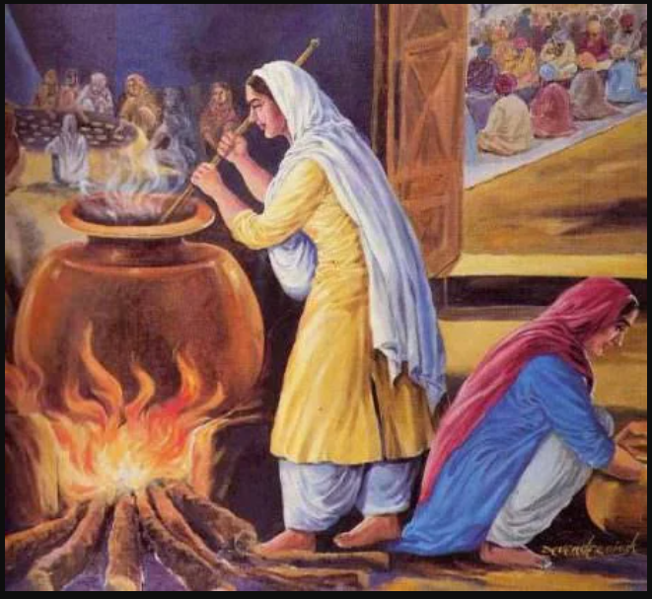 | Mai Bhago 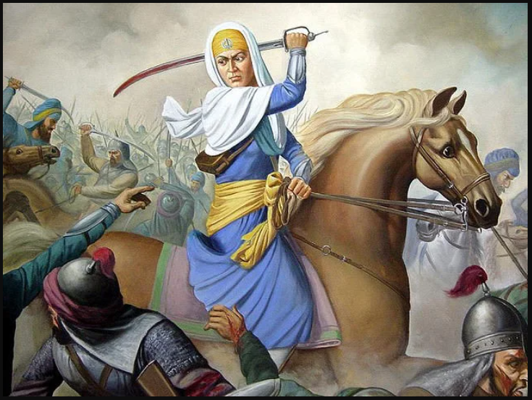
Guru  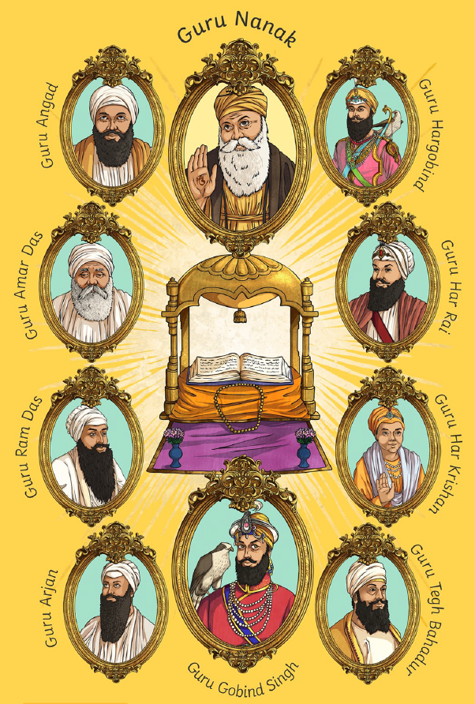    Theologians are interested in asking questions about religious and non-religious worldviews so that they can understand more about the things that people believe and value. | Guru Granth Sahib  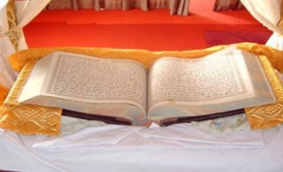 | Mool Mantra  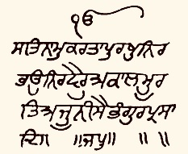 | maya  
 | Gurdwara   | Langar Hall  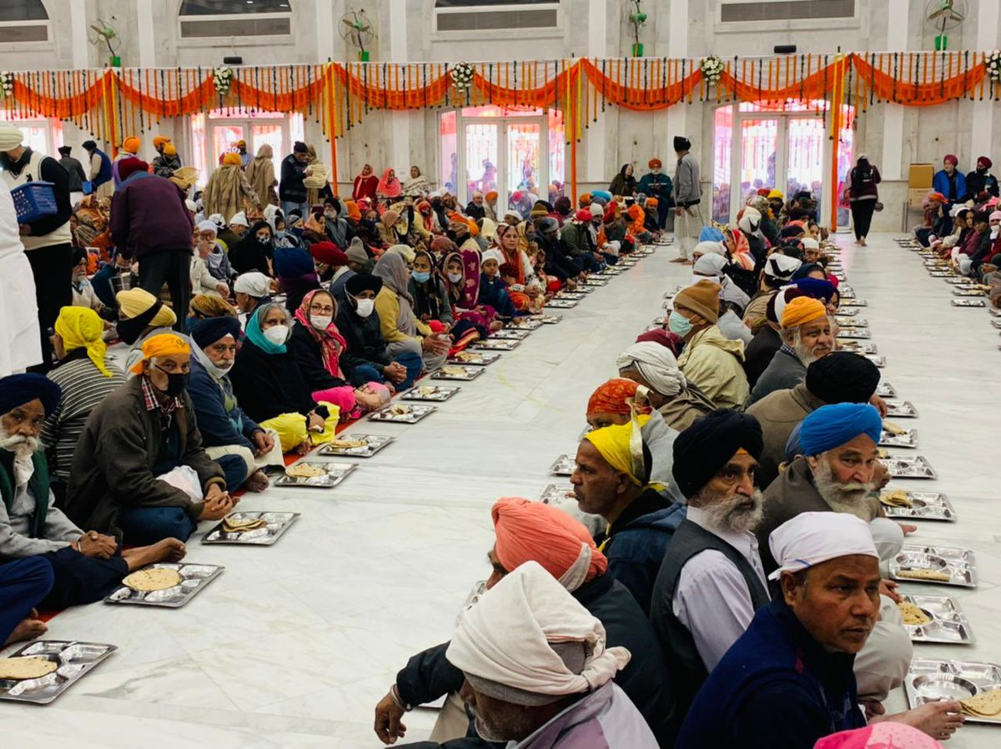  Human and social scientists are interested in asking questions about religious and non-religious world views so that they can understand what affects the ways in which people live out their worldviews.

Are all People Equal? (Sikhism)

Knowledge Goals
- We can better understand people’s worldviews when we find out more about context
- Waheguru is the Eternal Guru
- Satguru (the 'true guru') is another name for Waheguru
- Sikhi is the path of active learning from the Guru
- Gurmukh is achieving union with satguru
- Sikh people believe that all people can achieve gurmukh because all people are equal
- Some of the Sikh gurus strongly promoted equality
- Some Sikh women experience sexism
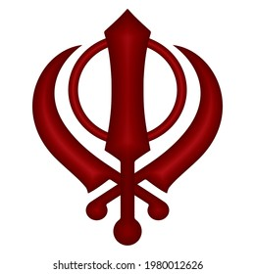
Philosophers ask questions so that they can understand more about the ways in which people think about themselves and the world around them.

