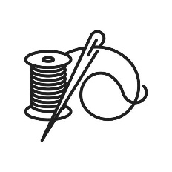

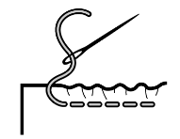

Summer Term ~ Year 5
Making a bag decorated with the appliqué/embroidery with a plaited handle for their own/a family member’s/a friend’s use at home
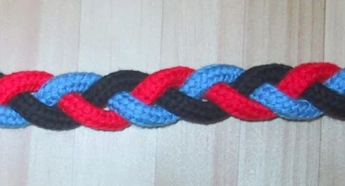  plait / braid | 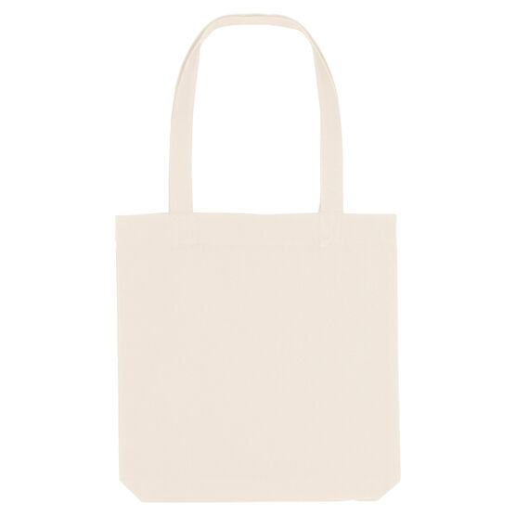  tote bag | 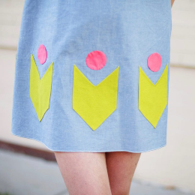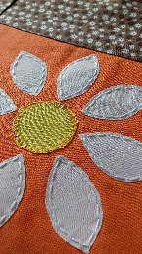applique
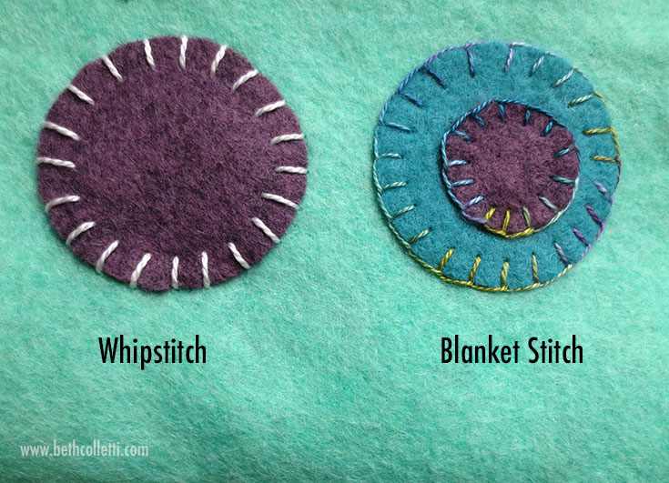  overcast stitch whip stitch | 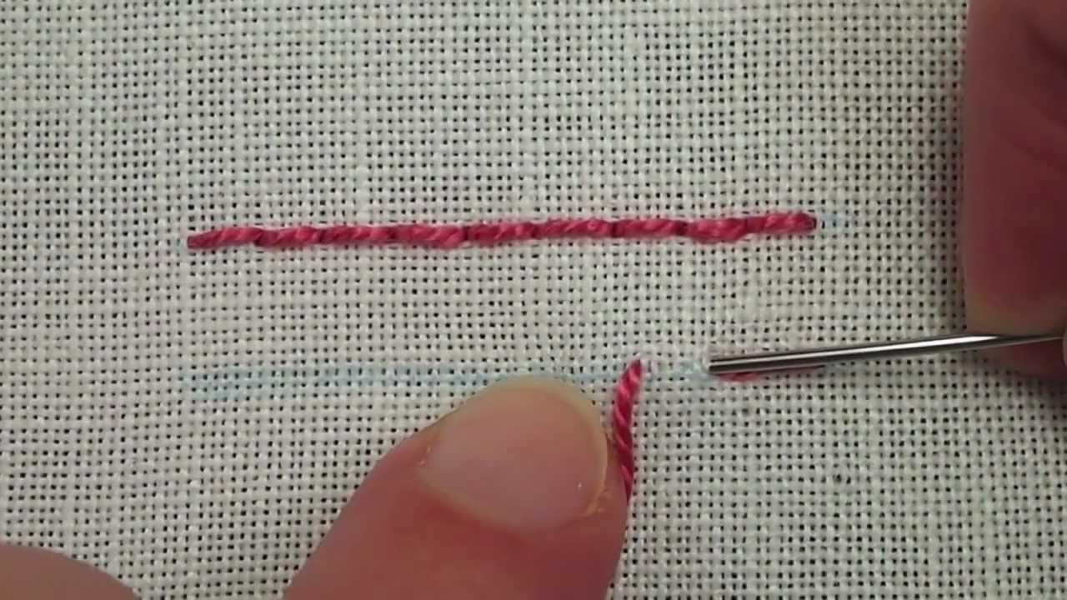backstitch | 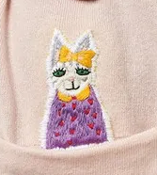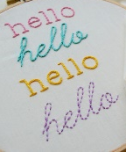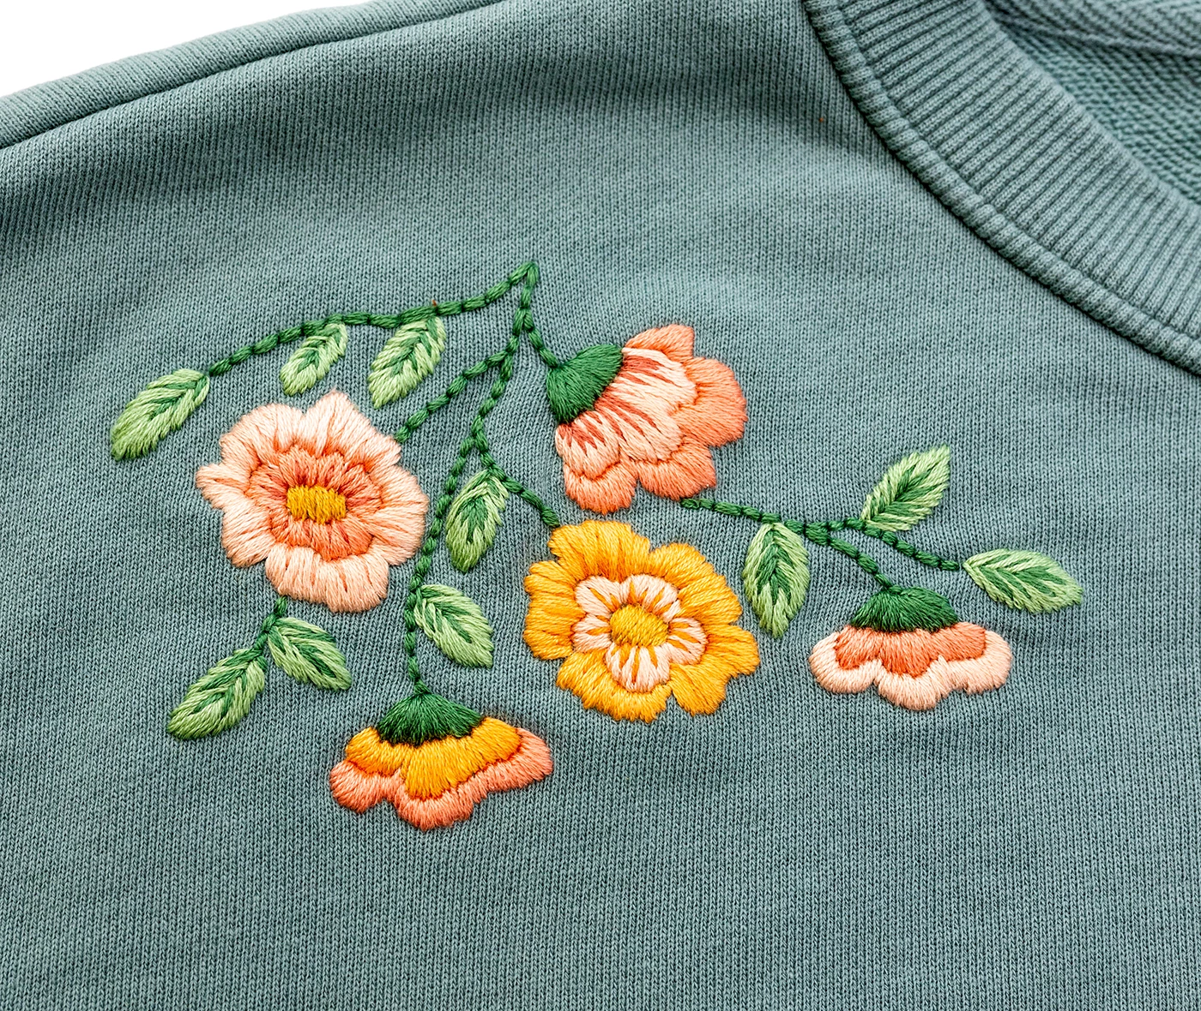embrodiary
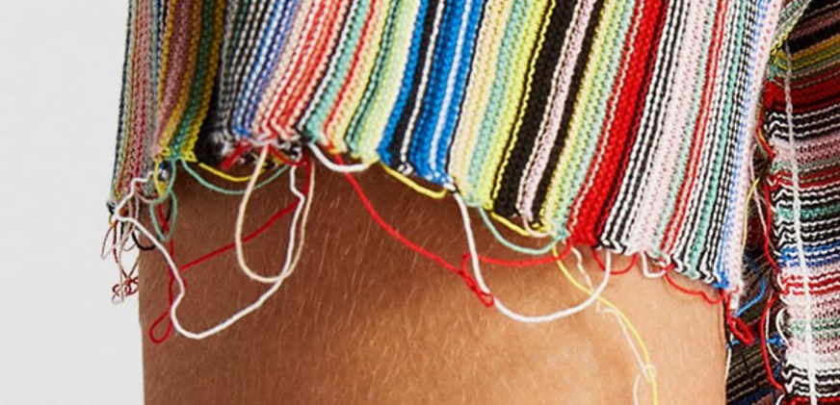hem | 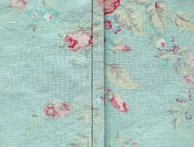  seam |  user
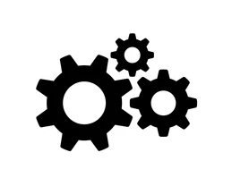function | 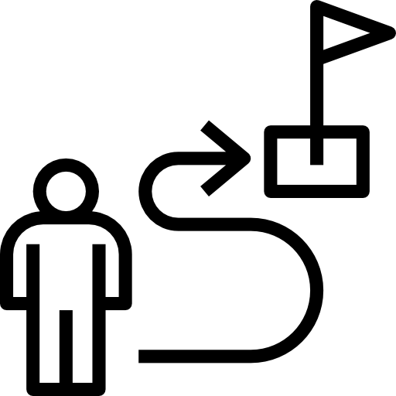purpose |   appeal
Knowledge Goals

Appliqué and embroidery can be used to decorate fabric.

Appliqué is a technique where pictures or patterns made from fabric are sewn onto a background.

Embroidery is a technique where pictures or patterns are made by stitches on fabric

Backstitch can be used for joining two pieces of fabric together to make a seam or a hem

Overcast stitch (or whip-stitch) can be used for appliqué

Skills

Research and Investigate Methods of decoration: appliqué, embroidery; bag design, materials and features

Design Devising criteria (user, purpose, function, appeal), generate/innovate/develop ideas, annotated drawings

Make Select tools/materials, drawing/cutting shapes, pinning, threading a needle, tying a knot, backstitch, overcast stitch (whipstitch), joining, embroidery, appliqué, plaiting

Use and Evaluate Written evaluation, photograph, film peer evaluation—against cri-teria and existing products

