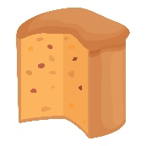
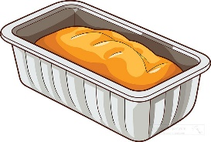
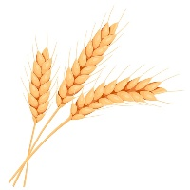
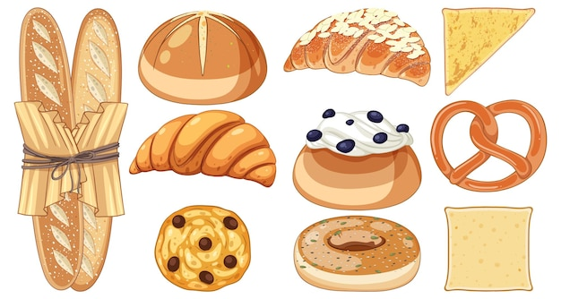
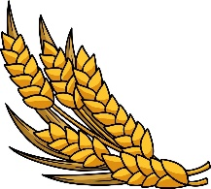
Spring Term ~ Year 5
Follow recipes to bake bread and cake for ourselves.
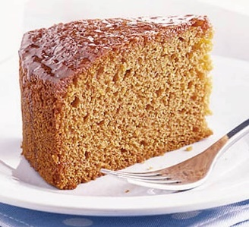  honey cake | 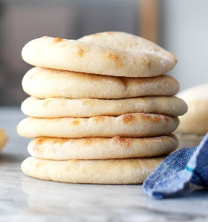  pitta bread | flatbread
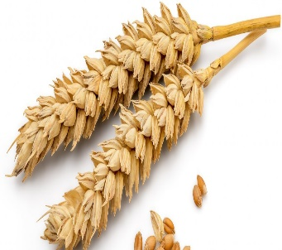wheat | 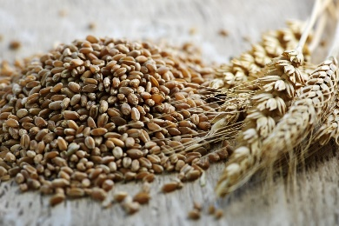  grain | 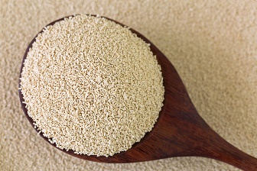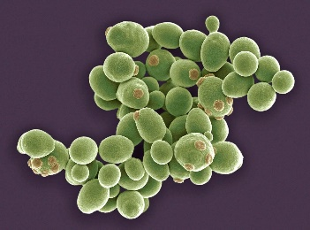  yeast  (a type of fungus)
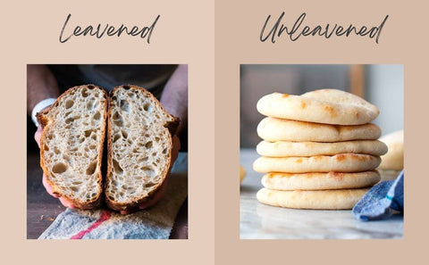leavened  (contains yeast, so that the dough rises) | unleavened  (doesn’t contains yeast, so that the dough doesn’t rise)
Knowledge Goals
Cooking and Nutrition
As part of their work with food, pupils should be taught how to cook and apply the principles of nutrition and healthy eating.
Learning how to cook is a crucial life skill that enables pupils to feed them-selves and others affordably and well, now and in later life.
• understand and apply the principles of a healthy and varied diet
• prepare and cook a variety of dishes using a range of cooking techniques
• know where and how a variety of ingredients are grown, reared, caught and processed

Skills
•Following a recipe
•Measuring using scales
•Activating yeast
•Mixing
•Making a dough, kneading
•Rolling and shaping
•Baking
•Cooling
• Cracking an egg
• Beating
• Pouring
• Sprinkling
• Baking
• Cooling

