Memorial 1: To Authorize the Presiding Bishop’s Foreword to Social
Statements and Social Messages
Action: Deferred to Council
The Western North Dakota Synod Assembly considered a Memorial to authorize the presiding bishop to prepare a foreword to each social statement of this Church.

Memorial 2: Superimposed Quotas
Action: Deferred to Council
The WND Synod Assembly considered a Memorial to conduct a systematic review of the ELCA quota systems, seeking to eliminate superimposed mandatory quotas that are not directly relevant to the task at hand.

Assembly Offerings
Thank you for your generosity!
Worship Offerings from Friday:
- CAR - $3588.30
- Bible Camps - $2260.34
- Quilt Silent Auction - $5515

Videos of the 2026 WND Synod Assembly can be found at – https://vimeo.com/showcase/12240258?share=copy&fl=sm&fe=fs

Watch E-News, the Synod website, and Facebook page for information about the 2027 Synod Assembly held on June 4-6, 2027.
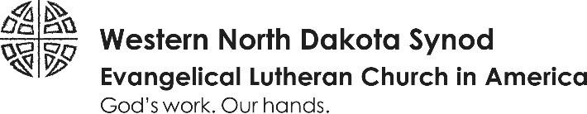

Synod Assembly
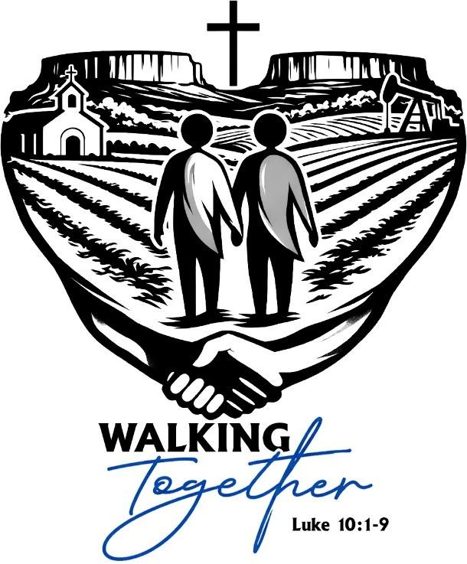

Nearly 300 m
embers of the
Western North Dakota Synod
gathered

in
Watford City
for

the
WND
Synod Assembly

from May
29
th

–

3
1
st
.

The
theme for the
202
6

WND
Synod
Assembly was
based on
Luke 10:1
-
9

and focused on
“Walking Together.”
As people
of faith who call the
congregations of this synod
their faith home, we are called
into relationship and sent into
the world two by two.
At this
year’s assembly, we gathered
for worship, holy conversation,
and faithful decision making.
We were invited to deepen our
connections
, strengthen our
common life, and recommit
ourselves to God’s mission of healing, hope, and peace in our congregations, communities, and across western North Dakota.

Pre-Assembly Events:
Stories shape faith, strengthen relationships, and help the gospel come alive in everyday life. And along the way, they often remind us to laugh and recognize God’s grace in ordinary moments.
Pastor Nathan led a practical and engaging workshop designed to help church leaders discover, shape, and share meaningful stories in congregational life.
Through live examples and a clear storytelling framework, participants learned how to:
- Identify and “mine” meaningful stories already present in their congregation
- Shape stories for sermons, ministry moments, and seasonal services
- Tell stories with clarity, authenticity, and confidence
- Highlight the impact of ministry and shared life together
- Cultivate a congregational culture that celebrates the stories of faith and everyday life
Together participants explored how stories can bring warmth, humor, and renewed connection as we walk together in faith.

Synod Assembly
Worship: Our opening worship was held at the Rough Rider Center in Watford City, on Friday evening and was filled with sounds of praise and thanksgiving. We give thanks for Deacon Kari Files who composed a liturgy for opening worship. Worship began with a Land Acknowledgement honoring our Indigenous siblings. Bishop Laura Barbins of NE Ohio preached, Bishop Amy Odgren of the Northeastern Minnesota, and Bishop Tessa Moon-Leiseth of Eastern North Dakota took part in leading worship. We give thanks for their calming presence and wisdom shared throughout the synod assembly.
Again, this year, Bishop Schweitzer shared a sermon via video or read by lay ministers in local congregations gathering in worship across the synod. This shared message offered an opportunity to celebrate our unity and connection even as we are dispersed in communities across this prairie.
Nick Kiger: Nick is the Director for Mission Support with the ELCA Churchwide expression. As well as acting as our Bishop election liaison, Nick provided information related to the last year in the ELCA. A video featuring Presiding Bishop Yeheil Curry was shared with the Assembly.
Conference Caucuses: Caucuses are a time for voting members from geographic areas of the synod to meet one another and engage in conversation and prayer about the hopes and challenges of ministry in their local communities. Relationships are forged, joys and struggles are shared, and discussions about the future are holy.
Assembly Workshops: A variety of workshops were offered Saturday afternoon and Sunday morning. Participants had the opportunity to choose from: “Best Stewardship Practices and Are you Ready for a Capital Campaign” with Paul Marsh from GSB, “Suicide Stigma in the Christian
Tradition: It’s Not Biblical” and “Christian Public Witness in an Age of
Partisanship” with the Rev. Sylvia Bull, “What we saw: A Border Immersion
Witness” with the Rev. Natasha Kolles and Bruce and Cindy Carlson, “Risk
Management – Best Practices” and “The Ins and Outs of Cemeteries” with
Synod Attorney, Murray Sagsveen, Portico Benefits – Tips & Tricks with your
Regional Representative” with the Rev. Tim Schroeder, “The Work of Being a
Neighbor” with Jen Engquist – Disaster Capacity Builder, and “The faith-filled Magic of Camp” offered jointly by our Western North Dakota Synod Bible Camps. Thank you to all who presented!

2026 Bishop Election:
The Rev. Lisa Lewton was elected as the new Western North Dakota Bishop on the 4th ballot of the 2026 Synod Assembly. Rev. Lewton has served at St. John’s Lutheran Church in Dickinson for the past 19 years. Rev. Lewton and her husband, Marcus, have three children: Tom, Sam, and Karis. We give thanks for Rev. Lewton and the other candidates who were willing to allow their names to go forward in the election process at the assembly.

Summary of the Work of the Synod in Plenary
Elected to Serve on WND Synod Council:
Conference Representatives: Western Prairie Rostered – Deacon Janie Hague;
Western Prairie Lay – Faye Beck; Heart River Lay – Paul Kadrmas; East
Missouri Rostered – Rev. Kevin Nelson

Resolution 1: Western ND Synod Ministry Financial Plan for 2027 Action: Passed
The Assembly adopted the fiscal plan for the 2027 fiscal year as proposed by Synod Council.

Resolution 2: 2027 Compensation Guidelines for Rostered Ministers Action: Passed with changes
The Assembly adopted the 2027 Compensation Guidelines for Rostered Ministers serving in the Western North Dakota Synod with amendments. The assembly voted to increase the multi-point $500 compensation to $1,000.

Resolution 3: Proposed Amendments to the Western North Dakota Synod
Constitution
Action: Passed
The Assembly considered and passed a recommendation from the Synod Council to approve the amendments to the constitution that were added during the 2025 Churchwide Assembly.

Resolution 4: Resolution on Forgoing Churchwide Assembly Approval of
Social Statements
Action: Deferred to Synod Council
The assembly considered a resolution asking the Synod Council send a letter to the ELCA Church Council to ask the Church Council to conduct a formal review of the process of developing social statements and specifically to reconsider the practice of having Churchwide Assemblies approve social statements, recognizing that individual members, pastors, bishops, and other expression of the Church will remain entirely free to address social issues as led by Scripture and the Holy Spirit.

