

Memorandum

To: Congregation Councils
Copy: Synod Council
From: Murray G. Sagsveen, Synod Attorney
Subject: Care of Rural Cemeteries
Date: October 27, 2025

INTRODUCTION

Many rural congregations own and care for associated cemeteries.

This memorandum includes my recommendations concerning compliance, best practices, and risk management.

Individuals with questions or comments may contact Synod Attorney Murray Sagsveen, Murray@wndsynod.org or 701-426-1905.

ISSUES AND RECOMMENDATIONS

1. Sexton. Congregations that care for cemeteries must designate a sexton or secretary. The Congregation Council could adopt a continuing resolution, such as the following:

C13.06.A__. The Congregation Council shall appoint a sexton for a three-year term and may reappoint the sexton for additional three-year terms. The sexton shall:
- Provide the sexton’s name and contact information to the North Dakota Department of Health and Human Services, ATTN: Darin Meschke, Vital Records, dmeschke@nd.gov.
- Provide the sexton’s name and contact information to local funeral directors.
- Endorse on each disposition transit permit the time and place of burial, then file the permit with the county recorder.
- Maintain permanent records of every burial or disinterment, which includes this information for each burial:
  - Full name of deceased
  - Age at death and sex
  - Date and place of death
  - Date of burial
  - Place of burial, block, lot and grave
  - Number of burial permit
  - Name and address of funeral practitioner

2. Cemetery Care Committee. A Congregation Council may establish a Cemetery Care Committee by adopting a continuing resolution, such as the following:

C13.06.B____. The Congregation Council shall appoint a Cemetery Care Committee of [three] members. The term shall be three years, and the terms shall be staggered so that one member is appointed annually. The Committee shall:
- Post a sign at the entrance to the cemetery that includes at least this information:
- Historical information about the cemetery (or where such information would be available)
- Information about donating memorials and gifts
- Name and address of the sexton
- Rules governing the cemetery (e.g., placement and removal of flowers on grave)
- Mow the cemetery during summer months
- Take corrective action concerning any tipped, fallen or broken monuments
- Submit a proposed annual budget to the Congregation Council prior to the congregation’s annual meeting
- Maintain any fencing around the cemetery grounds
- Post information about the cemetery and sexton on the congregation’s social media (e.g., website and Facebook)

3. Cemetery Registration. All cemeteries must be registered with the North Dakota Department of Health and Human Services, Vital Records Unit. State law prohibits burials in cemeteries that are not registered or have not been approved by the Department:

No dead human body may be buried in this state except in a properly registered cemetery or in some other place requested by the relatives and friends of the deceased if the same is authorized by the department of health and human services and all rules and regulations promulgated by the department in that connection have been complied with.

Most cemeteries associated with synod congregations have been registered with the Department of Health and Human Services. The Synod has notified, or will notify, the congregations that own or are caring for unregistered cemeteries.

4. Cemetery Plat. State law requires a survey and recorded plat for each cemetery to determine the boundaries and internal arrangement of existing and future graves. North Dakota Century Code § 23-06-21 states (at subsections 2 and 3):

All persons, corporations, municipalities, associations, and organizations owning, conducting, or maintaining a cemetery or plot for the burial of dead human bodies shall…
- Cause the lot or parcel of ground used and designated as a cemetery to be platted into orderly blocks and lots, alleys and streets or driveways, giving to each a distinctive name or number that must be a permanent designation of its location.
- File the original plat with the recorder of the county in which the cemetery or place of burial is located and the copy or blueprint thereof with the sexton or secretary.

North Dakota Administrative Code § 33-05-01-05(2) supplements the statute quoted above:

All cemeteries must be surveyed by a registered land surveyor prior to filing a plat of the cemetery with the recorder in the county in which the cemetery is located…

Most rural congregations have surveyed the cemetery and have filed a plat with the country recorder. The Synod has notified, or will notify, congregations that have not filed the required plat.

5. Minimum burial requirements. North Dakota Administrative Code § 33-05-01-04 outlines the depth of grave and requirement of above-surface interments:

1. No dead human body shall be interred in a public burial ground unless the distance from the top of the box containing the casket shall be at least three and one-half feet [106.68 centimeters] from the natural surface of the ground.

2. If the casket is placed in an approved metal, concrete, or similar vault, the distance from the top of the vault shall be at least eighteen inches [45.72 centimeters] from the natural surface of the ground.

3. If the casket is placed in a surface vault, the cover of the vault may be placed flush with the natural surface of the ground.

4. No person or persons, organizations, or associations shall place, establish, or construct wholly or partially above the natural surface of the ground any vault, crypt, columbarium, mausoleum, or other structure or device by whatever name for the interment of any dead human body without first meeting the cemetery registration requirements and submitting the plans and specifications for the proposed installation to the state department of health for preliminary inspection and recommendation. The plans and specifications shall be submitted to the state department of health in triplicate and shall be developed to assure conformance to the following basic requirements:
- Designation of the sections, halls, rooms, corridors, elevators, or other subdivisions and including descriptive names and numbers of the areas.
- Arrangement of the structure so that the cell, niche, or crypt may be readily examined by those legally authorized.
- Provision for hermetically and permanently sealing in a suitable manner each crypt or cell so that no fluid may escape therefrom after the placing of any dead human body therein.
- Provision of construction materials of the best quality and of a character best suited for the purposes intended.
- Construction to ensure durability, permanence and the protection of the safety, convenience, comfort, and health of the community in which it is located consistent with modern mausoleum construction and engineering science at the time.

6. Risk Management.

a. Insurance. Cemetery grounds, if properly maintained, should pose very little risk to visitors. However, cemetery grounds that include an abandoned church building could be an attractive nuisance – a high risk.

Church Mutual has advised that its church’s liability policy includes a cemetery if on the same property as the covered church building (i.e., a separate rider is unnecessary).

Coverage of other cemeteries owned or maintained by a church would require a separate policy or rider. Church Mutual has also stated:

It is an advisable best practice for a church to always consider liability coverage for a cemetery. If there is a building on the site which is thought valuable, property protection should also be continued. If the building on the site is abandoned or considered to have little or no value, it would be advisable to demolish it or remove it from the cemetery grounds.

b. Recreation land. North Dakota Century Code chapter 53-08 limits the liability of owners of land that is open to the public for “recreational purposes,” which is defined to include “any activity engaged in for the purpose of exercise, relaxation, pleasure, or education.” A cemetery could be considered, for the purpose of that statute, recreation land.

However, § 53-08-05 states, in part:

This chapter does not limit in any way any liability that otherwise exists for:
1. Willful and malicious failure to guard or warn against a dangerous condition, use, structure, or activity…

Recommendation. All potential hazards on cemetery grounds should be removed or corrected.

c. Liability of unpaid volunteers. State and federal laws protect individuals who volunteer for nonprofit corporations, including 501(c)(3) tax-exempt churches. The North Dakota laws state:

10-33-47. Immunity of officers, directors, and trustees.
Any person that serves as a director, officer, or trustee of a corporation that is, or would qualify as a nonprofit organization that is described in [501(c)(3)] of the Internal Revenue Code of 1954, as amended…, is immune from civil liability for any act or omission resulting in damage or injury if at the time of the act or omission all of the following are met:
- The officer, director, or trustee was acting in good faith and in the scope of that person's official duties as a director, officer, or trustee.
- The act or omission did not constitute willful misconduct or gross negligence on the part of the officer, director, or trustee.
- The officer, director, or trustee did not receive or expect to receive reimbursement for or payment of expenses in excess of two thousand dollars per year for expenses actually incurred as a result of providing services as a director, officer, or trustee, and did not receive or expect to receive compensation or anything in lieu of compensation as payment for services provided as a director, officer, or trustee.

10-33-48. Immunity of volunteers.
1. Any person who, on a volunteer basis, provides services or performs duties on behalf of a [nonprofit] corporation is immune from civil liability for any act or omission resulting in damage or injury if at the time of the act or omission all of the following are met:
- The person who caused the damage or injury was acting in good faith and in the scope of that person's duties as a volunteer for the corporation.
- The act or omission did not constitute willful misconduct or gross negligence.
2. This section does not grant immunity to any person causing damage as the result of the negligent operation of a motor vehicle.

Recommendation. A volunteer’s duties should be clearly defined, and the volunteer should be appropriately trained and supervised.

d. Workforce Safety & Insurance. A church is not required to carry WSI coverage for its employees and volunteers. If a church has purchased WSI coverage, WSI would compensate volunteers who would be injured caring for a cemetery. If a church has not purchased WSI coverage, the church could be responsible for compensating volunteers who would be injured caring for a cemetery.

7. Tax Issues.

a. Property tax. All cemeteries are exempt from property taxes. Article X, section 5, of the North Dakota Constitution states, in part: “property used exclusively for schools, religious, cemetery, charitable or other public purposes shall be exempt from taxation.”

b. Income tax. All churches in this synod are automatically 501(c)(3) tax-exempt organizations. If a church maintains a cemetery, all donations to the church for cemetery maintenance are not taxable as income and all contributions to the church as memorials or for cemetery care are deductible on the donor’s tax returns.

c. Exempt organization business income tax. Congregations that receive royalties from oil/gas production under the cemetery should consult a tax expert. The congregation may be required to file an IRS Form 990-T, Exempt Organization Business Income Tax Return.

7. Burials near or outside cemetery boundary. Catholic Canon Law previously influenced some Lutheran congregations concerning certain funeral and burial practices. For example, the 1917 Code of Canon Law stated:

Canon 1209, § 3 – “The little bodies of infants, insofar as this can be done conveniently, shall have a little space special and separate from the others and be buried there.”

Canon 1239, § 1 – “Those who die without baptism are not to be accorded ecclesiastical burial.”

Canon 1240, § 1 – “Unless they gave before death a sign of repentance, the following are deprived of ecclesiastical burial:
- Notorious apostates from the Christian faith, or those who notoriously gave their name to heretical sects or schismatic or masonic sects, or other societies of this sort;
- Excommunicates or those under interdict after a condemnatory or declaratory sentence;
- Those who killed themselves by deliberate counsel;
- Those who died in a duel, or from wounds related thereto;
- Those who ordered that their body be handed over for cremation;
- Other public and manifest sinners.

Graves have been discovered outside the boundaries of Lutheran cemeteries in western North Dakota. Accordingly, congregations should determine if marked or unmarked graves are located outside the fence or boundary of the church’s cemetery. If found, congregations should take appropriate corrective action.

8. Section lines. Cemeteries located next to section lines (and roads on section lines) present a special challenge because section lines are considered public roads open for public travel to the width of thirty-three feet on each side of the section lines. Accordingly, if a grave is located outside a cemetery fence and is located within thirty-three feet of a section line, the grave could be destroyed during construction or reconstruction of a road on the section line.

Many deeds concerning cemeteries convey title to the section line. However, some deeds only convey title to the boundary marking the easement. Accordingly, the owner of the cemetery may not own the 33’ strip of land between the cemetery grounds and the section line.

9. Contracted cemetery care. A Congregation Council may contract for care of its cemetery. If so, the Congregation Council should use a written agreement such as Enclosure 1.

If the payment to an independent contractor is more than $600, the Congregation Council must issue an IRS Form 1099-NEC to the contractor prior to February of the following year.

Congregation Councils may contract with council members or family members for care of cemeteries. If so, Congregation Councils should carefully comply with N.D.C.C. § 10-33-46.

10. Care of multiple cemeteries. Congregations that care for multiple, dispersed cemeteries may consider establishing a separate nonprofit corporation to care for the cemeteries, applying for 501(c)(13) tax-exempt status for the corporation, transferring ownership of the cemeteries to the cemetery corporation, and transferring any restricted funds (e.g., memorials and donations for care of the cemeteries) to the corporation.

11. Cemetery ownership. Congregations may be caring for cemeteries that, according to county records, are owned by former Lutheran churches. Congregations that would like to resolve the ownership issue should contact the synod attorney.

MGS:20251027v5

Enclosure 1

_________________ Lutheran Church

Cemetery Care Agreement

1. Parties. This agreement is between _______ Lutheran Church (“Church”), [address], and ____________ (“Contractor”), [address].

2. Purpose. Contractor will care for Church’s cemetery located at __________ pursuant to the terms of this agreement.

3. Responsibilities of Contractor. Contractor agrees to care for this Church’s cemetery, which is located at ______________. Specifically, Contractor will:
- Mow the grass and trim around the grave markers at least _____ times during the summer.
- Straighten any tipped or fallen grave markers.
- Remove any unauthorized items or debris from the cemetery grounds.
- _________________________

4. Compensation. Church will compensate Contractor as follows:
- The compensation will be ________.
- Contractor will provide an employer identification number or social security number on each invoice to the church.
- If required, the Church will issue an IRS Form 1099-NEC to Contractor.

5. Term. The term shall begin when both parties have signed this agreement and shall terminate December 31, 20__, or until terminated by either party by providing notice to the other party. Upon termination of this agreement, Contractor shall be entitled to compensation for services performed prior to the termination date.

6. Relationship of parties. The relationship between Church and Contractor shall be that of client and independent contractor. Contractor is not employee of the Church and is not entitled to any benefits provided by Church. Church may not exercise control over the manner in which Contractor performs services. Contractor is solely responsible for the payment of any federal income, state income, and other taxes.

7. Entire Agreement. This document constitutes the entire agreement between the parties with respect to this subject matter, and there are no representations, understandings or agreements that are not fully expressed herein. No amendment, change, waiver, or discharge shall be valid unless in writing and signed by both parties.

__________________________________ Date: ___________________
President
Congregation Council

__________________________________ Date: ___________________
Contractor

Enclosure 2
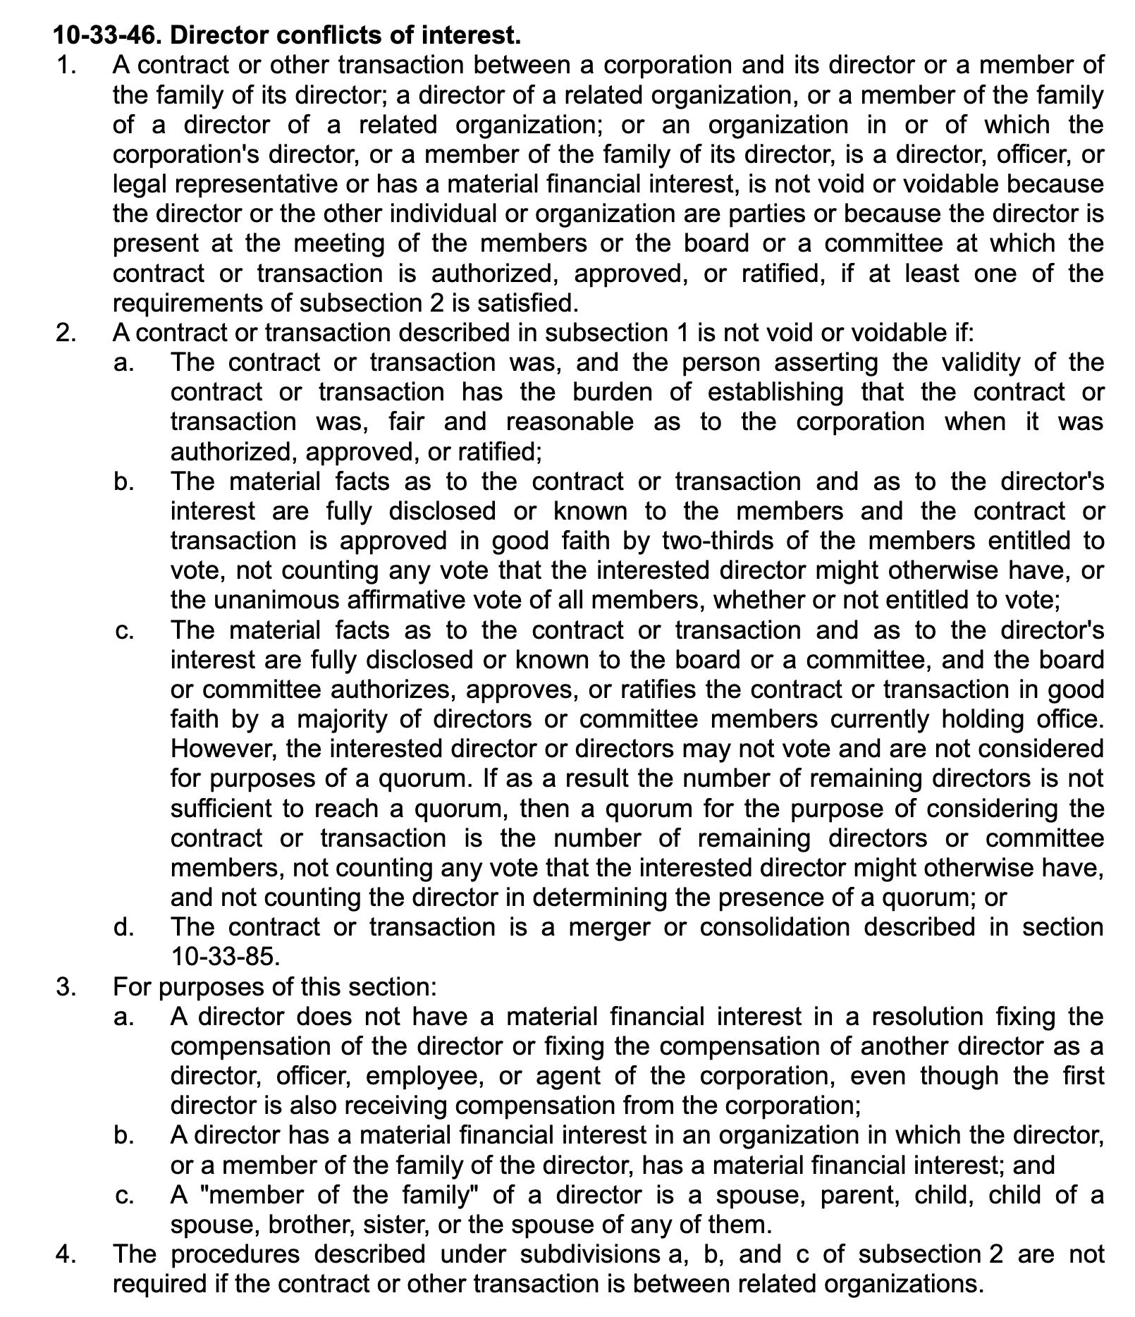

North Dakota Century Code (“N.D.C.C.”) § 23-06-21(1).
See the “Introduction to the Model Constitution for Congregations,” at p. 3, for an explanation concerning the numbering and placement of continuing resolutions. The congregation’s constitution, at *C18.02, addresses the process for adopting a continuing resolution.
Required by North Dakota Administrative Code § 33-05-01-05(4).
Required by North Dakota Administrative Code § 33-05-01-05(5).
N.D.C.C. 23-06-21(4). Also see N.D.A.C. 33-05-01-05(1).
N.D.C.C. § 23-06-20.
August 11, 2023, email from Dale Van De Loo, Church Mutual Insurance.
October 26, 2023, email from Dale Van de Loo, Church Mutual Insurance.
Volunteer Protection Act of 1997, Public Law 105-19, 111 Stat. 218, 42 U.S.C. 14501 – 14505.
October 30, 2023, email from Attorney Jodi Bjornson, ND Workforce Safety & Insurance.
In 1988, the IRS issued a group exemption letter to the ELCA, which exempts all subordinate organizations (e.g., synods and congregation on a list submitted to the IRS) from federal income tax. Congregations may obtain a certificate of tax exemption from the ELCA at 501(c)(3)@ELCA.org
N.D.C.C. § 24-07-03; Small v Burleigh County, 225 N.W.2d 295 (N.D. 1974).

