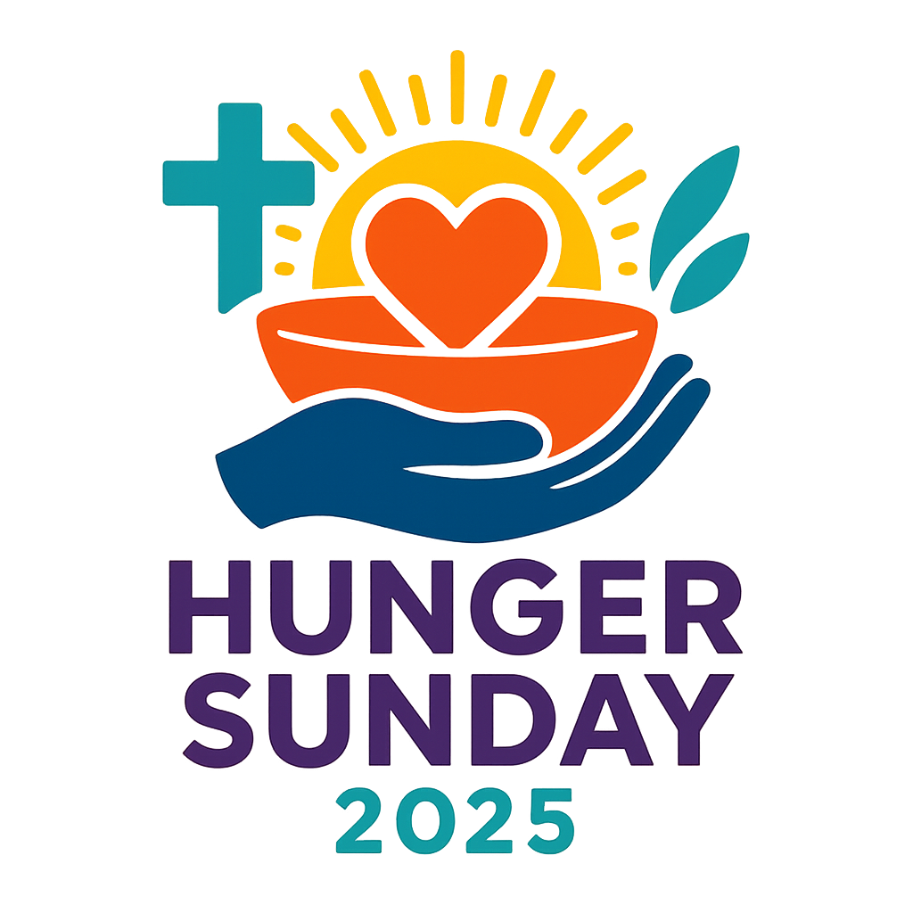

**ORDER OF WORSHIP**

***Confession:***

The Lord be with you.

**And also with you.**

Let us approach God with confidence, knowing that as we offer our personal prayers of confession, forgiveness is already occurring.

*Silent Moment of Personal Prayers of Confession*

**Holy God, forgive us for receiving so much from you and still turning away. Forgive us for times our thanks is absent. Forgive us for resisting transformation of our lives. Turn our hearts to you and to one another, in Jesus’ name we pray. Amen.**

***Forgiveness:***

Great is our God. Abundant is God’s mercy.

Rejoice this day. By the power of Jesus Christ your sins are forgiven. You are made new.

**Thanks be to God.**

***Passing of the Peace***

***Opening Hymn:*** ELW 461 - All Who Hunger, Gather Gladly

(alternate: ELW 479 - We Come to the Hungry Feast)

***Prayer of the Day:***

**Precious Lord, we are in awe of your power. Scripture rings with the wonders of your love in action; creating, blessing, restoring, forgiving, calling. Throughout history and still today your compassion meets needs, heals and restores with undeserved mercy. Ready us to join you in compassionate love and mercy in action. Amen.**

***First Reading:*** James 2:15-17 (alternate: Psalm 111)

15 If a brother or sister is naked and lacks daily food, 16 and one of you says to them, ‘Go in peace; keep warm and eat your fill’, and yet you do not supply their bodily needs, what is the good of that? 17 So faith by itself, if it has no works, is dead.

***Children’s Sermon***

***Gospel:*** Luke 17:11-19

11 On the way to Jerusalem Jesus was going through the region between Samaria and Galilee. 12 As he entered a village, ten lepers approached him. Keeping their distance, 13 they called out, saying, ‘Jesus, Master, have mercy on us!’ 14 When he saw them, he said to them, ‘Go and show yourselves to the priests.’ And as they went, they were made clean. 15 Then one of them, when he saw that he was healed, turned back, praising God with a loud voice. 16 He prostrated himself at Jesus’ feet and thanked him. And he was a Samaritan. 17 Then Jesus asked, ‘Were not ten made clean? But the other nine, where are they? 18 Was none of them found to return and give praise to God except this foreigner?’ 19 Then he said to him, ‘Get up and go on your way; your faith has made you well.’

***Sermon:*** Healing, Mercy and Hunger

***Hymn of the Day:*** ELW 453 - Baptized and Set Free

(alternate: ACS 1062 - Build a Longer Table)

***Prayers of Intercession:***

Lord, in your mercy,

**hear our prayer.**

***Minute for Mission***

***Invitation to the Offering:***

What a joy it is to worship, and a privilege to serve at our God’s good lead. Our offerings today strengthen the ministry of our church and extend God’s mercy and healing far beyond these walls. Your offering will now be received.

***Collection of Offering***

***Offering Prayer:***

**Mighty God, to a hungry world you sent your Son to preach, heal, forgive, and show mercy. In Jesus’ death and resurrection you brought salvation to all. Bless these offerings and those who worship, that having received your Living Word, we might be sent out with Christ to extend mercy and love. In partnership with you may we meet the needs of our neighbors and indeed this whole world that you love. Amen.**

***Invitation to Communion:***

The Bread of Life invites you to the table where simple bread and cup are transformed, and so are we.

***Great Thanksgiving, Words of Institution, Distribution, Blessing***

***Post Communion Prayer:***

**We give you thanks, O God, that you have filled us with good things in this meal. In your mercy, strengthen us to work for justice, that all may be fed, for the sake of Jesus Christ our Lord. Amen.**

***Commissioning & Blessing:***

Go with mercy. Give thanks.

Turn to God and one another.

May the love of God shape you,

the mercy of Christ direct you,

and the power of the Holy Spirit grant courage to you this day and forevermore. **Amen.**

***Closing Hymn:*** ELW 543 - Go My Children, With My Blessing

(alternate: ELW 535 - Hallelujah! We Sing Your Praises)

***Dismissal:***

Go in peace to serve the Lord.

**Thanks be to God!**

**************************************

Material prepared by Western North Dakota Synod,

Hunger Sunday Liturgy Team:

Pastor Mark Nygard, Pastor Elaine Sveet, Pastor Cole Bentley,

Pastor Sylvia Bull, Russell Martin, Deacon Cheryl Lantz

Permission is granted for use in worship. Please credit ‘Worship materials developed by WND Synod Hunger Sunday Liturgy Team 2025.’

Other Resources for Hunger Sunday

The first official Hunger Sunday will be celebrated in WND Synod this October 12th 2025. It is our hope that these worship resources could be used by congregations in October perhaps near Sun. Oct. 12th, so that in unity with other ELCA congregations we can pray and seek an answer to the crippling hunger needs of our time. You are welcome to use all or some of the liturgy, sermon, children’s sermon, hymn suggestions etc. to enhance your worship experience. They are offered in love from fellow pastors and congregation leaders to aid our worship together.

Feedback or questions welcome to:

Pastor Mark Nygard

(Chair of WND Synod Hunger and Justice Team)

[mnygard001@luthersem.edu](mailto:mnygard001@luthersem.edu)

***Minute for Mission/ Temple Talk:*** Hunger Sunday

*(This Minute for Mission is intended to increase awareness and to challenge your congregation to participate in alleviating hunger. It may be read out loud in worship or printed in your church bulletin or newsletter.)*

“For I was hungry and you gave me food.” In Matthew 25:35, Jesus instructs us to care for our neighbors by giving them food to eat. Did you know there **IS** **more than enough** food to feed the world? Sadly, it is not distributed well. According to ELCA World Hunger (elca.org) one in ten people in the world (733 million) experience hunger. In America alone, one in seven households suffers food insecurity ([foodrescue.us](http://foodrescue.us)).

How can we feed the hungry? Begin by being aware of hunger matters and praying for solutions. The challenge is to be creative about food distribution. Look at your local community; venture to support it, by volunteering time or finances. Programs like: a backpack program to feed school children who need support, or setting up a local workplace food drive to fill a food bank, or serving at a soup kitchen, or problem solving what can be done to salvage food that ordinarily is thrown away… are all worthy efforts! The “Feeding Ministries Guide” at ELCA.org website has more great ideas.

On a global scale, choosing to give to the Lutheran World Hunger program or purchasing items at the ELCA Good Gifts program like: a microloan to a woman starting a small business, supplying a month's worth of necessities for a refugee family, donating to a fruit-tree farm, or a safe water project; all make a beautiful difference to alleviate hunger. The Lutheran World Hunger program, officially known as ELCA World Hunger, was founded in 1974. It was established by Lutherans in the United States to address the global increase in hunger and poverty during that period. Over the past 50 years, ELCA World Hunger has mobilized significant resources to support its work, with over $650 million contributed by Lutherans to date. It collaborates with various partners, to maximize its impact. It is a joy to be partners in ministry together across the ELCA. Believe that our God is gracious and will make a way to end hunger!

***Prayers of Intercession:***

Together with all God’s hungry people, let us turn to the Lord in prayer, asking for the provision that only God can give:

Lord, you have set us in a world of incredible abundance, with food in a thousand shapes, colors, and flavors, in quantities beyond our imagining. Give us the will and the means to care for such an abundant world, that its blessings may nurture generations yet unborn.

Lord, in your mercy, **hear our prayer.**

Lord, you call farmers, ranchers, orchard growers, fisherpeople, food processing workers, and others to feed the nations. Bless them in their calling. Keep them safe in sometimes dangerous places. Grant them a sense of service and a good harvest.

Lord, in your mercy, **hear our prayer.**

Lord, we find ourselves enmeshed in economic systems that assure an abundance of bread to some people and a scarcity of bread to others. Open our minds to imagine fresh systems that enable the least among us to be well fed.

Lord, in your mercy, **hear our prayer.**

Lord, you showed mercy to ten untouchables, and you healed them, even when nine didn’t bother to return thanks. Grant us, who seek to be your disciples today, to show the same sort of mercy to the homeless, the outcast, the immigrant, and the stranger, even if thanks is not returned.

Lord, in your mercy, **hear our prayer.**

Dear Lord, war, famine, and oppression bring grinding hunger and starvation to millions. Have pity on your starving people in Gaza, South Sudan, Myanmar, Somalia, and other nations that we name aloud or in our hearts before you…. Show us ways we may press for change and for peace.

Lord, in your mercy, **hear our prayer.**

Dear Lord, there are well-fed people in well-fed nations who yet lead empty lives of self-service without you, the Bread of Life. Grant us to be refreshed by your Word of forgiveness and acceptance that heals the hungry soul, and help us to share that Word with all your people.

Lord, in your mercy, **hear our prayer.**

Trusting in the abundance of your grace, we commend our hunger and the hunger of all nations to your mercy, in the name of Jesus Christ our Savior. **Amen.**

***Communion Liturgy***

***Great Thanksgiving & Words of Institution:***

Holy God, holy and mighty, holy and merciful,

You called creation into being and called it good.

You made humankind in your own image and offered us every good thing for food.

And yet people went hungry.

You called your people out of slavery, gave them manna in the desert, and set before them a way of life where all could flourish.

And yet people went hungry.

You sent prophets to speak against the hoarding of wealth and the exploitation of the poor.

And yet people went hungry.

You put on flesh and were born among the poor and hungry to become our Bread of Life.

In Jesus, you do not keep your distance from us, but come close, feeding us once again.

With mercy you come to us, offering healing and wholeness.

In the night in which he was betrayed, our Lord Jesus took bread, and gave thanks; broke it, and gave it to his disciples, saying: Take and eat; this is my body, given for you. Do this for the remembrance of me.

Again, after supper, he took the cup, gave thanks, and gave it for all to drink, saying: This cup is the new covenant in my blood, shed for you and for all people for the forgiveness of sin. Do this for the remembrance of me.

Send your Spirit into this bread and cup that they may be for us the presence of the One who fed the multitudes, healed the sick, and offered mercy even to those who showed no thanks. Empower us through these gifts to offer our bread to the hungry, that all may be fed.

As our Savior Jesus taught us, we are bold to pray.

**Our Father, who art in heaven**

**Hallowed be thy name.**

**Thy kingdom come, thy will be done**

**On earth as it is in heaven**

**Give us this day our daily bread.**

**And forgive us our trespasses as we forgive those who trespass against us.**

**Lead us not into temptation but deliver us from evil.**

**For thine is the kingdom, and the power, and the glory, forever and ever. Amen.**

***Distribution:***

Body of Christ given for you. Blood of Christ shed for you.

(or) Jesus Christ the Bread of Life. Jesus Christ the Wine of Life.

***Blessing:***

May this holy meal strengthen and keep you in Christ’s grace, now and forever.

***Prayer after Communion:***

**We give you thanks, O God, that you have filled us with good things in this meal. In your mercy, strengthen us to work for justice, that all may be fed, for the sake of Jesus Christ our Lord. Amen.**

(or)

On this Hunger Sunday, O God, we are grateful for what we have received in worship and at this holy table. Equip and bless us for service in your name to a hungry world. Amen.

***Optional Communion Songs:***

ELW 469 - By Your Hand You Feed Your People

Alternate/Additional: ACS 966 - Loaves Were Broken, Words Were Spoken

**CHILDREN’S SERMON**

Materials: a lunch box or lunch bag

*Invite kids forward and welcome them.*

Today we are going to talk about lunch.

What is your favorite thing to eat for lunch?

Does anyone already know what they are going to have for lunch today? (For Sunday morning worship ask about lunch. For an evening service adjust and ask about dinner). If you don’t know, do you think mom or dad, grandma or grandpa know?

This talk about lunch makes me hungry. Does it make anyone else hungry? Do you ever get really, really hungry? How does it feel to be hungry?

Lets imagine we are going to make ourselves a lunch for a big, important day. We have a lot to do, and a lot to learn, and a lot of important things going on today. What are we going to put in our lunchbox to make sure we have enough energy to get through this important day? (Use imagination to “fill” the lunchbox. You can pretend to play each item the children suggest into the lunch box.)

All of those things sound like amazing things to help us have enough energy to get through a day!

But now, imagine that you didn’t have any food to put in your lunchbox. O man, that would be tough! What if you didn’t have anything to eat on your big day? How would you feel? Would you be tired? Would you feel sad? Would you be grumpy? I know I feel _________ when I don’t get something to eat.

Remember when I asked if you knew what you were having for lunch? There are some people that might have some food, but they don’t know when they will get to eat again, or where that food will come from. Maybe it will come from a friend or maybe a stranger. Or maybe it will come from a soup kitchen or food pantry. Or maybe they will have enough money to buy something, but they don’t know for sure. That might be hard too, right?

Today we are spending some time in church thinking about hunger. Some people in our world don’t have anything to eat today. Some people have a little bit but not enough. Some people don’t know if they will have something to eat. And all of that makes it hard to do all the things that a person is supposed to do in a day.

Jesus liked to meet people’s needs. He helped people if they were sick or hungry. Jesus used the power of God to heal the sick and feed the hungry. I try to follow Jesus, and do and love like Jesus.

There are a lot of things we can do to help. What are some things you can think of that could help someone who is hungry? (After children provide a few answers, share some of the ideas listed below.)

-sharing food if we see someone without their lunch

-helping at a food pantry or soup kitchen

-donating to a place that feeds people

Thanks! I know we can make a difference! Let’s pray.

(This works well as a “repeat after me” prayer)

**Thank you God,/ for loving us completely. / Help us to love as you love. / Help us to extend / your mercy and love / to others. / Help us to meet / the needs of others. / Amen.**

**SERMON:**

**‘Healing, Mercy, and Hunger’**

**Luke 17:11-19**

Our first Hunger Sunday synod-wide invites us to focus on the realities of hunger in this world, and to take seriously our role in bringing healing to a weary and hungry world. We follow the lead of our Lord Jesus. Let’s explore the theme: Healing, Mercy and Hunger.

The Gospel reading today is not one that we usually think about in terms of hunger. In fact, nutrition is not in any way the problem that is being addressed by Jesus in this story. The Gospel tells the story of Jesus healing ten people who have a terrible disease called leprosy, which damages their body in such a way that those afflicted with the disease are rejected by everyone around them. They become outcasts in society. They come to Jesus for healing, crying out, “have mercy on us!” Jesus sends them to the priests, and as they go, they are healed. One of the 10 returns to give thanks.

As often is the case with Scripture, there is more than meets the eye on first reading. “It is worth noting that the one who comes back to give thanks is a ‘double outcast’ [both a Samaritan and a leper]” Author Kimberly Bracken-Long notes. This doubly disadvantaged one returns to Jesus. There is deep meaning in this action too. It isn’t just that this person had something changed about themselves, but the WHOLE person has turned. There is transformation of the WHOLE person begun. More than their body has been healed. Somehow the power of God and this man’s faith intersect and he is made wholly, entirely, completely well. Salvation is at work. He turned but Jesus has transformed him in his going and in his turning.

This story in the Gospel of Luke is a strong reminder that healing happens, not just in a spiritual sense, not just to a small portion of the person, but to the whole person. These people, once ritually unclean, can show themselves to the priests because they are made whole. They can live once again in their community with dignity and hope. They can work with their hands, and trade in the market, and live their lives freed from this terrible disease. They are fully healed, in all aspects of their lives. What transformation! Jesus seeks to meet needs; he offers healing, mercy, hope.

We need healing and help in many ways. As we think about the problems that people in the world face, hunger is one of those problems needing help. Hunger is often the primary barrier to healing in so many other ways. UNICEF reports that globally 1 in 4 children live in food poverty. 1 in 10 people in the world (across all ages) suffer *severe* hunger, according to ELCA World Hunger. And in the United States 1 in 7 suffers food insecurity (meaning they do not know where the next meal will come from or they may not have food at the moment). Hunger is a problem for many, many people near and far. Hunger needs healing and mercy.

(We talked to the children about hunger and an imaginary lunch in the children’s sermon.) Being hungry changes you, it damages any chance you have of focusing on other problems that might be present. Try to go one day without lunch and see how easy it is to function. If you go days without food, it really doesn’t matter what other problems you face in the world, you can only think about the next meal.

Hunger in our world today can and must be addressed, especially by a church that is seeking to follow the lead of Jesus. By Christ’s lead of healing, mercy and love, we are called to feed the hungry of this world.

This could certainly sound daunting. Hunger is a HUGE problem. How can we make a difference? Fortunately, we have a brilliant starting place. The starting point for any response to the great ailments of the world is to look to Jesus. Our gospel reading today is part of that guidance.

Like the one in ten, we can make a grateful turn toward Jesus, and Jesus can then turn us toward the world He loves. Because of Christ who heals us and makes us new; one person, one church, or one community can absolutely make a difference.

One ND pastor shared this experience:

In a small North Dakota town, a woman came monthly to a food pantry run by the local Lutheran Church. This person was difficult to work with. She had a reputation in town as being unfriendly, short-tempered and ornery. She was in poor health and even poorer spirit. She didn’t have much, and struggled to take care of herself. And, she hadn’t grown up in that town, so was a bit of an outsider to begin with. Her status in the community, like the leper, was that of a double outcast.

At the food pantry in that town, guests were given time to fill boxes with items that they picked out. And the manager of the food pantry made it very clear that the food was for giving away, not for storage in the pantry, so people tended to leave with more than they expected. The food pantry was small, but generous. The “difficult” woman was very particular about what she ate. She never seemed satisfied with what the food pantry had to offer (and let the manager know about her displeasure). She didn’t take much food when she came, and didn’t often express gratitude.

One day, staff noticed this woman began selecting some items that she had never taken before. She was noticeably less picky, less concerned with what wasn’t there, and more concerned with what was there and what she could take, and even said thank you.

Around that time, a new family had moved to town with little kids. This family apparently had not received the community memo that the woman was difficult to deal with, and so they would stop to talk to her on the street. The new family was working hard, but even so, keeping up with groceries and all other things is a challenge for anyone with young ones in the house. Yet they never would have asked for anything, and didn’t utilize the food pantry because they were sure others needed it more. So the ‘difficult’ woman decided to take care of them, and though she had little, she knew she had all the resources in the world to do so. She would load up her boxes at the food pantry and then call that new family as soon she got home. She would invite them to share some of her food, because, you know, she accidentally took too much for just herself and she suggested that maybe their kids would enjoy it.

The generosity of the food pantry allowed her to be generous to a family that needed some help but would not ever ask for it. It softened her, somehow. Her body wasn’t healed in that moment, but her heart seemed to be. The food she once took with bitterness now entered her kitchen sweeter because some of it was going to someone else.

When we feed others, even one person, and when we are generous with what we have, it changes people. When we meet people’s needs; physically or emotionally, socially, financially, or spiritually, it changes a person. The goodness overflows from one part of us to the whole of us, and on to other people. Individual transformation happens. Family transformation happens. Community transformation happens.

Many times we won’t see the results of this. It can be hard work to feed and heal and be generous, when we don’t see the feedback we would like. Keep in mind that even Jesus only got a 10% return on his healing investment. But what happens when that one is met with the Gospel and with the living bread of Jesus?

An ELCA pastor had this experience in a ND hospital:

Working as a chaplain, one of things she would get paged for was for a patient requesting communion. It was unusual for the same patient to request communion again, as hospital stays were usually not too lengthy, and even for long-stays the request might be for weekly communion. One day a nurse apologetically reached out to the chaplain, saying that a certain patient had again requested communion. The nurse stated that she had explained that the chaplain had many patients to visit, but she would ask with the understanding that the chaplain might be dealing with emergencies. It had been three or four days in a row of communion for this patient, and not just communion but very lengthy conversation that seemed to touch on nothing of any significance. The chaplain approached the room again, with a deeper sigh than she might wish to admit. She had just spent some taxing time with patients and families in the Intensive Care unit. One patient dealing with a severe brain injury, another family coping with the grief of a family member’s organ failure due to extended alcohol overuse, and the list of those not visited yet loomed heavy. The chaplain entered this patient’s room with a smile, and was pleased to receive one back. The chatter began immediately, and the chaplain sought to be efficient this time opening up her home communion set promptly to begin setting up for the sacrament while he spoke. They shared the sacrament together and he prayed the Lord’s Prayer with their voices in perfect rhythm. As the chaplain moved to the door, the patient spoke. “Thank you. This is the only time in my day I’m not anxious. I feel at peace. Tomorrow they may take my foot. I’m scared. Communion brings me peace.” The chaplain stopped, lingered longer, and offered words of comfort and hope. She returned each day following with communion without being asked. It wasn’t just bread or conversation, the man needed, he needed peace. Peace which came through breaking bread, through a shared turning to the Lord. The patient was changed. The chaplain was changed.

In great mercy and grace, God has fed you. At the table with communion, the body of Christ is fed. At our tables of fellowship with each other, over cups of coffee and meaningful conversations, our hearts are made whole. We are changed.

All across our region, in small towns, large cities, and everywhere in between, the church plays an important role in the community, living generously in a way that is graceful, a way that brings healing to so many, in a way that transforms the hungry world. We are a blessed people, a generous people, called into action by the One who gives us everything. By those crumbs, we are fed, and sent out to feed others.

[In this community and in this church ______________

*\*Highlight some way(s) your church feeds others, is generous, or offers comfort or healing in your community or in the wider world. Be generous in praise for the things that are done. All things, even small ones can lead to great things perhaps unseen down the line.*]

We have a generous God who feeds us with Grace and Mercy so that we too might be generous in our lives as well. We are made in the image of a generous God. We are built into a world-wide community in the body of Christ. So we are given God’s grace, created for generosity, and well connected. How can we not succeed in ‘healing, mercy and ending hunger’?

God surely is at work with us. I pray you don’t grow weary or discouraged. God is at work; through a recovered leper, through a food pantry patron, through a hospital patient and a chaplain’s shared communion. One small turn, one small box of food, one communion set and a few minutes of time; God uses them for healing and hope. I pray we’ll find ways to offer some small action. Find ways to turn yourself toward God and then others. Find ways to share grace and mercy, not just with words, but with yourself and whatever you can give.

We stand on a history of promises and saving transformation; mustards move mountains, a few loaves and fish feed multitudes, bread and wine fill satisfy more than hunger. Let’s eagerly lean into God’s next great miracle as we turn toward Jesus and then one another, offering what we can in mercy and love for the healing of a hungry world. Amen.