RSCDS Ayr Branch
Nice & Easy Afternoon ~ Friday 2nd May 2025
St Ninian’s Church Hall, Troon 2.00 – 4.00pm

GRANVILLE MARKET (J8x32) 3C (4C set) 2nd Graded Bk SCDs
1- 8 1s+2s dance RH across & LH back
9-16 1s cross RH & cast off 1 place, 1s dance ½ Fig of 8 around 2s & end facing 1st corner
17-24 1s turn corners RH & pass RS to face 2nd corners, 1s turn 2nd corners RH & pass RS to end 2nd place own side
25-32 2s+1s+3s circle 6H round & back

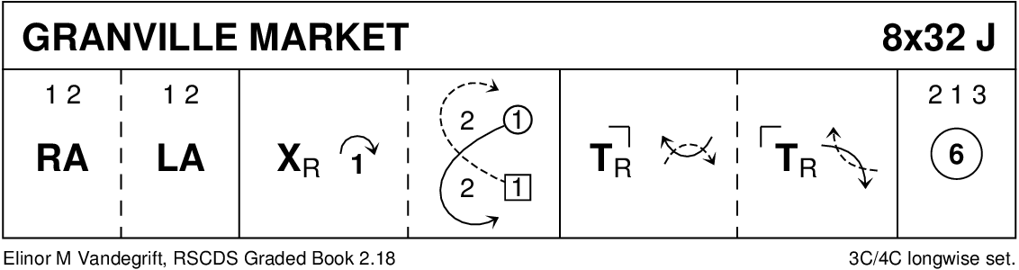

BACK TO THE FIRESIDE (R8x32) 3C (4C set) RSCDS Bk 38 1- 8 3s followed by 1s dance down for 2 steps & set to partners
1s dance up & cast off to 3rd place while 3s dance up to top place
9-16 1s cross RH to start reverse Snowball Grand Chain for 3 couples to end 1 (2) 3
17-24 1s+2s set advancing to form circle (hands joined) & petronella 1 place to right
Set hands joined & petronella turn to end on side
25-32 1L dances ½ Fig of 8 round 2s as 1M dances ½ Fig of 8 round 3s
2s+1s+3s turn RH

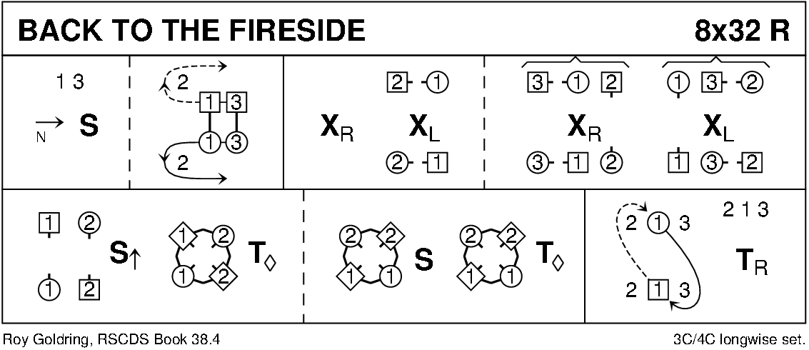

GANG THE SAME GATE (S8x32) 3C (4C set) RSCDS Bk 36
1- 8 1s cross RH & cast off 2 places, cross RH & cast up to 2nd place on own side
9-16 1s set advancing to partner & turn 1st corner BH to face 2nd corner
dance ½ reel of 4 with 2nd corners ending M between top couple facing down & L between bottom couple facing up
17-24 1s set advancing to partner & turn 2nd corner (in diagonally opposite place) BH to face own 1st corner position
dance ½ diagonal reel with 1st corners - ending in 2nd place opposite side
25-32 3s+1s+2s Set & Link for 3 – twice

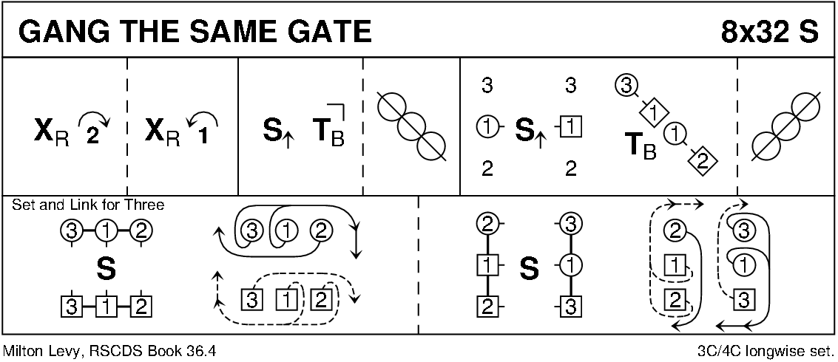

POSTIE'S JIG (J4x32) 4C set Clowes
1- 8 1+4s set, cast off/up 1 place & dance ½ figure of 8 round new end couples
9-12 1M+4M & 1L+4L cross (men making an arch) & turn corners with free hand to face up/down
13-16 1s+4s dance down/up (couple dancing up make the arch) & turn corners
17-24 Repeat bars 9-16 from new positions
25-32 1s+4s dance ½ R&L & turn partner RH

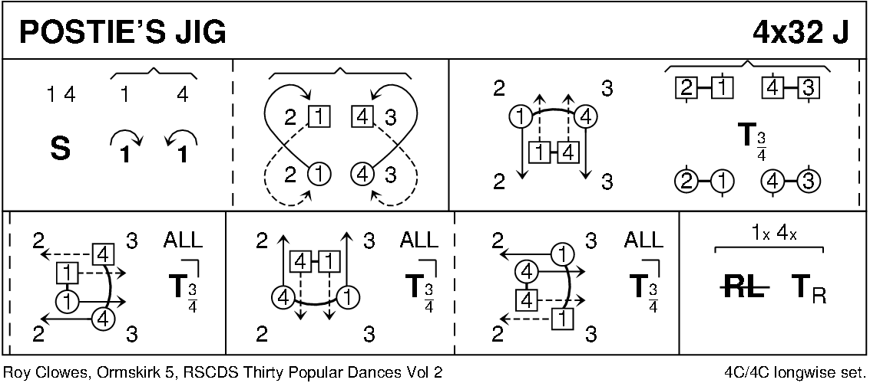

DUKE OF PERTH (R8x32) 3C (4C set) RSCDS Bk 1 1-8 1s turn RH, cast off 1 place, turn LH to face 1st corners
9-16 1s turn 1st corner RH, partner LH, 2nd corner RH & partner LH to face 1st corners
17-24 1s set & turn 1st corner BH, set to & turn 2nd corner BH
25-32 1s dance reel of 3 on opposite side giving LS to 1st corner & cross back to own side

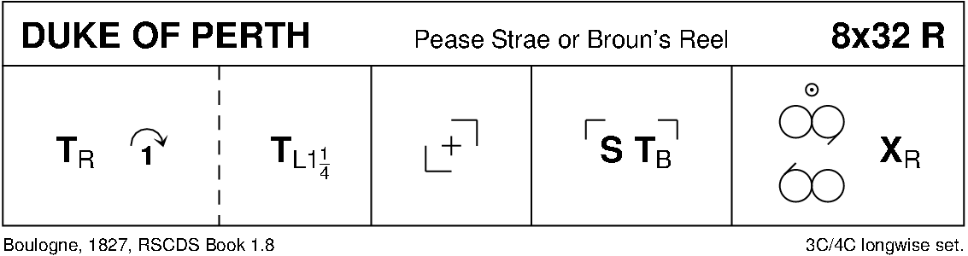

THE ISLE (J8x32) 3C (4C set) Bk of Graded SCDs
1- 8 1s dance RS reels of 3 on own side
9-16 1s cast behind 2s dance down between 3s, cast round 3s to face 1st corners
17-24 1s set to 1st corners, set to 2nd corners & end between corners
1s turn RH 1½ times to end 2nd place own side
25-32 2s+1s dance R&L

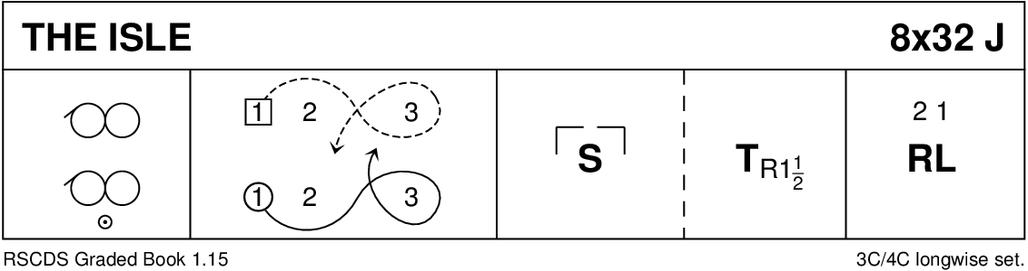

THE REVEREND JOHN MACFARLANE (R4x32) 4C set RSCDS Bk 37
1- 8 1s cross down to dance reels of 3 on opposite side ending in partner’s place
9-16 1s dance ½ figs of 8 round 2s, meet in centre & dance 4 slip steps down the middle to 3rd place & set (BH joined)
17-24 1s+4s dance the Poussette
25-32 2s+3s & 4s+1s dance RH across once round & turn partner LH

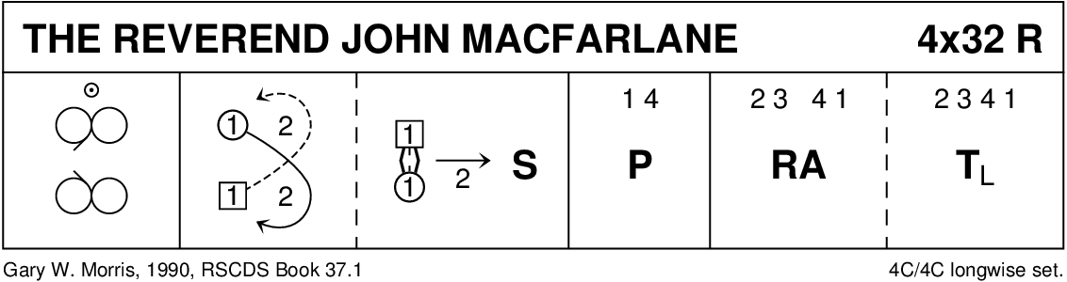

THE MINISTER ON THE LOCH (S3x32) 3C set RSCDS 4/2008
1- 8 1s+2s dance Diamond Poussette
9-16 1s dance down for 2 steps, turn BH, dance up to top & turn BH
17-24 1s+3s dance double Fig of 8 round 2s with 1s casting to start
25-32 1M+2M turn LH 1½ times while 1L+2L turn RH 1½ times
1M+3M turn RH 1½ times while 1L+3L turn LH 1½ times

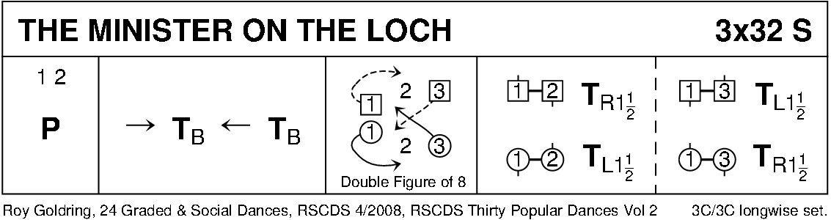

THE WILD GEESE (J8x32) 3C (4C set) RSCDS Bk 24
1- 8 1s+3s set advancing & Bal-in-Line, turn partners RH & 1s cast to 3rd place while 3s lead up to 1st place
9-16 3s+1s set advancing & Bal-in-Line, turn partners RH & 3s cast to 3rd place while 1s lead up to 1st place
17-24 1s lead down & back to 2nd place
25-32 2s+1s dance R&L

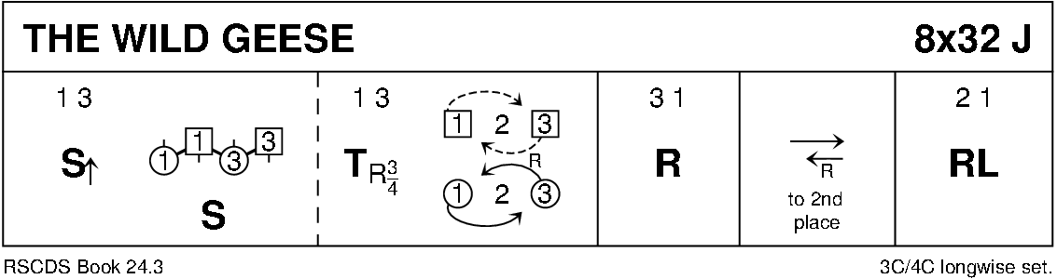

MAIRI'S WEDDING (R8x40) 3C (4C set) Cosh
1- 8 1s turn RH, cast off 1 place & turn LH to face 1st corner
9-16 1s dance ½ diagonal reel of 4 with 1st corners & ½ diagonal reel with 2nd corners
17-24 1s dance ½ diagonal reel with 3rd corner s & ½ diagonal reel with 4th corner s
25-32 1s dance reel of 3 across (1L+ 2s & 1M 3s (LS to 1st corner)
33-40 2s+1s+3s circle 6H round & back

