RSCDS Ayr Branch

Nice & Easy Afternoon ~ Friday 5th September 2025

St Ninian’s Church Hall, Troon 2.00 – 4.00pm

EH3 7AF (J8x32) 3C (4C set) RSCDS Bk 40

1- 8 1s lead down the middle & back to top

9-16 1s+2s+3s Promenade ending with 1s casting to 2nd place

17-24 1s pass by the right & turn 1st corners RH to end L between 2s & M between 3s

1s pass by the right & turn 2nd corners RH to end between corners

25-32 1M+2s and 1L+3s dance RH across

1L dances up between 2s & casts to 2nd place own side **as** 1M dances between 3s & casts up

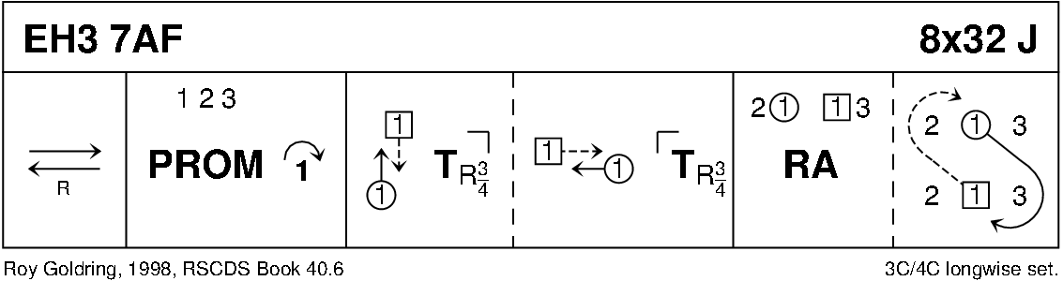

MARY ERSKINE (R8x32) 3C (4C set) Graded Book 2

1- 8 1s+2s turn on sides 1½ times (Men RH & Ladies LH)

1s cast down behind 3s, meet & dance up to 2nd place facing own sides ready for -

9-16 1s dance Double Triangles & end by turning right about to face each other (remaining in middle)

17-24 1s slip step down centre & back

25-32 1L dances LH across on Men's side **as** 1M dances RH across on Ladies side & dance ½ Fig of 8 round 2s

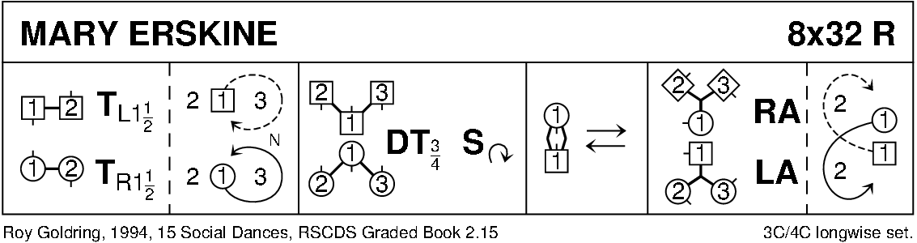

MISS GIBSON'S STRATHSPEY (S8x32) 3C (4C set) RSCDS Leaflet 10

1- 8 1s+2s set, turn partners BH opening out into 4H round

9-16 1s+2s dance the Knot, 1s turn LH to end facing 1st corner

17-24 1s turn corners RH, partner LH, 2nd corner RH & partner LH

25-32 1s dance RH across, (1M+3s & 1L+2s), pass partner RS & dance LH across with other couple, 1s end in 2nd place

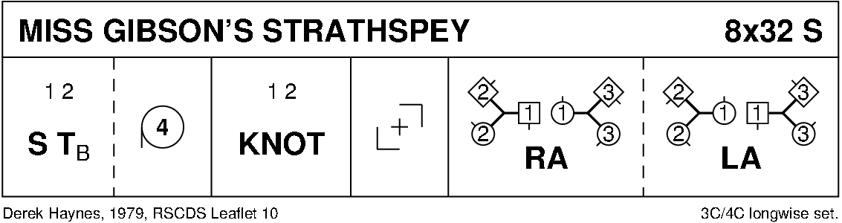

THE LUCKENBOOTH BROOCH (J8x32) 3C (4C RSCDS Bk 53

1- 8 1s in promenade hold (lady on man's left) dance reel of 3 with 2s (RS to 2M) & end facing 3M

9-16 1s dance reel with 3s (RS to 3M) ending with 1s dancing across to men’s side

17-24 2s+3s dance R&L

**while** 1s dance out, 1M casts up & 1L down into centre & dance out ladies’ side

1M cast up & 1L down to end 1M between 2s facing down & 1L+3s facing up

25-32 2s+1s+3s set twice, 1s turn RH 1¾ times to 2nd place

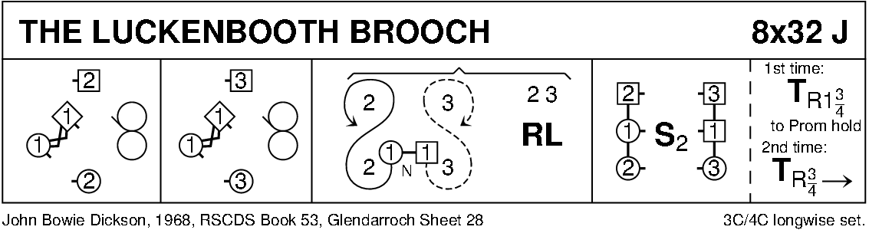

INVERNEILL HOUSE (R8x32) 3C (4C set) RSCDS Bk 35

1- 8 1s+2s dance ½ double Fig of 8 (1s cross down)

1s dance down between 3s **as** 2s dance out & up then 1s cast up to 2nd place opposite side

9-16 1s+3s dance ½ double Fig of 8 (1s cross down)

1s dance up between 2s & cast to 2nd place own side

17-24 1s Petronella to opposite side

25-32 2s+3s Petronellato own side

**while** 1s cast RS round 1st corner & cross between 2s/3s, 1s cast to 2nd place own sides & all set

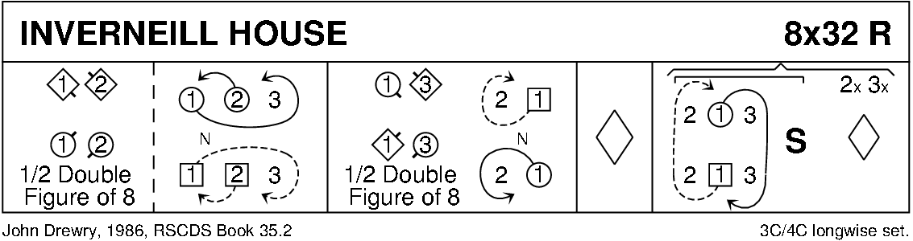

THE JUBILEE JIG (J8x32) 3C (4C set) Leaflet

1- 8 1M cast off one place, set to 3L, turn RH & dance back to 2nd place on own side

9-16 1L cast off one place, set to 3M, turn LH & dance back to 2nd place

* 1. 1L+2s & 1M+3s dance RH across - 1s end in centre LH joined

1s set in centre & dance out to 2nd place opposite side

* 1. 1M+2s & 1L+3s dance RH across - 1s end in centre LH joined

1s set in centre & dance out to 2nd place own side

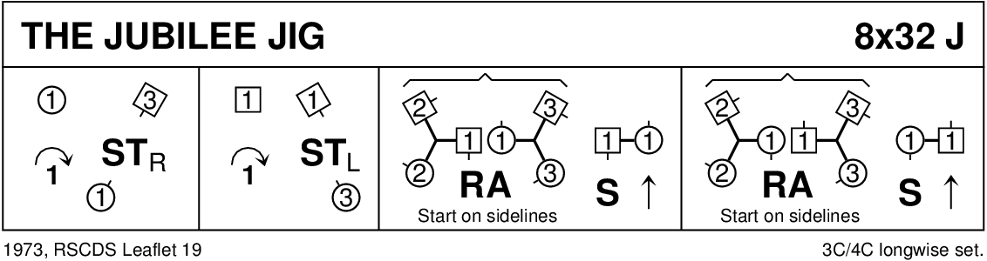

RAMADAN-CE (R8x32) 3C (4C set) Drewry

1- 8 1s dance Inveran Reels with 2s+3s

9-16 1s cross RH, cast off 1 place & turn RH to face 1st corners

17-24 1s dance RS round 1st corner, pass RS & dance RS round 2nd corner to end 2nd place opposite side

**while** 1st corners dance in, ½ turn RH, twirl & dance out to each other’s place ---

2nd corners dance similarly (3) (1) (2)

25-32 1s dance ½ LS reels of 3 across (1M at top with 3s & 1L at bottom with 2s)

1s dance ½ RS reels of 3 on own sides (Man Down, Lady up)

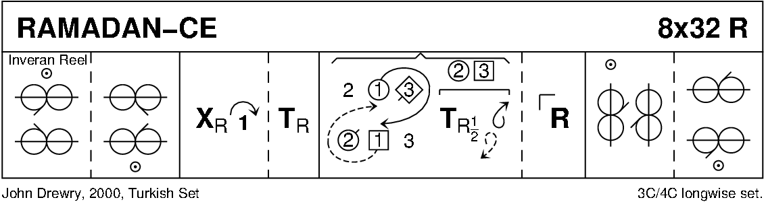

ST COLUMBA'S STRATHSPEY (S5x32) 5C set Gillan & Sproule

1- 8 2s+4s dance RH across

2s dance up **while** 4s dance down - 2s+4s casting round ends on own side to face 1st corners

9-16 2s+4s Pass+Turn with 1st corners, pass partner LS

Pass+Turn with 2nd corners & into centre facing partner (L facing down, M up)

17-24 2s+4s dance reel of 4 ending in original places on side

25-32 2s+4s set & cast off 1 place **while** 3s+5s set & dance up 1 place

1s+2s turn RH & cast off 1 place 3 1 5 2 4

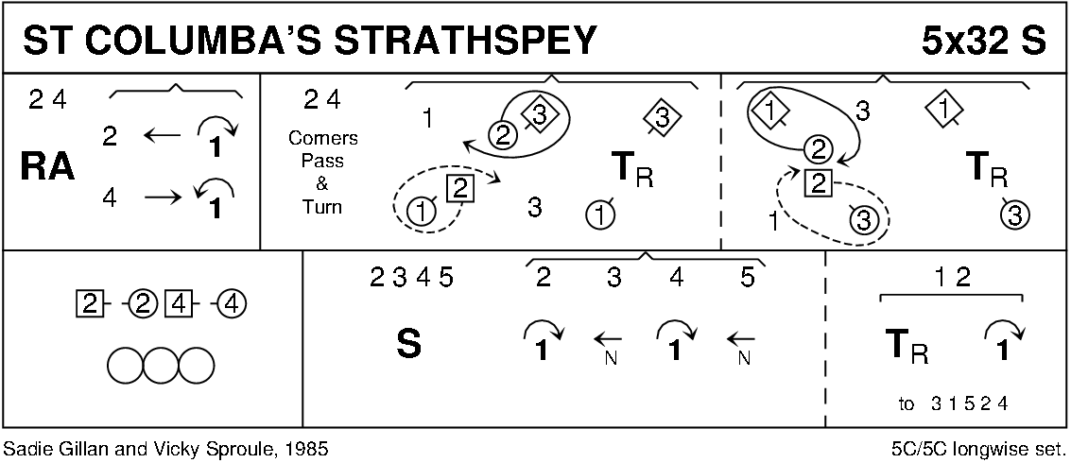

TRIBUTE TO THE BORDERS (J8x32) 3C (4C set) RSCDS Leaflet 11

1- 8 1s cross RH & cast off 1 place, turn RH 1½ times to end in promenade hold facing 2M

9-16 1s dance ½ RS reel of 3 on men’s side, cross to face 3L

1s dance ½ RS reel on ladies’ side - 1s end facing 3L (in top place)

17-24 1s set to 3L, turn & set to 2L, turn & set to 2M, turn & set to 3M ending with 3s+1s+2s in centre ready for Allemande

25-32 3s+1s+2s Allemande

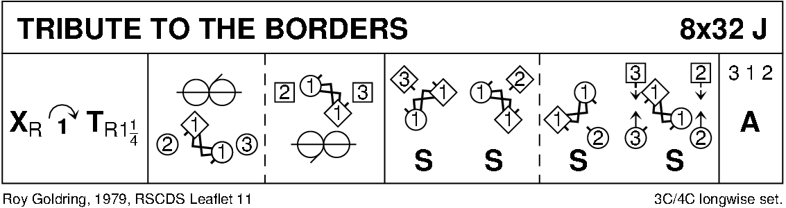

THE MONTGOMERIES' RANT (R8x32) 3C (4C set) RSCDS Bk 10

1- 8 1s cross RH & cast off 1 place, cross LH & 1L casts up **while** 1M casts down

9-16 1s dance reels of 3 across, 1L+ 2s & 1M+3s

17-24 1s with nearer hands joined (lady on man’s left) set to 2L & turn inwards to set to 3M;

Set to 3L, turn inward & set to 2M

25-32 2s+1s+3s dance reels of 3 on opposite side 1s giving RS to 2nd corner, 1s cross RH to 2nd place own side

