RSCDS Ayr Branch
Nice & Easy Afternoon ~ Friday 4th September 2026
St Ninian’s Church Hall, Troon 2.00 – 4.00pm

THE JUBILEE JIG (J8x32) 3C (4C set) Leaflet
1- 8 1M cast off one place, set to 3L, turn RH & dance back to 2nd place on own side
9-16 1L cast off one place, set to 3M, turn LH & dance back to 2nd place
  - 1L+2s & 1M+3s dance RH across - 1s end in centre LH joined
1s set in centre & dance out to 2nd place opposite side
  - 1M+2s & 1L+3s dance RH across - 1s end in centre LH joined
1s set in centre & dance out to 2nd place own side

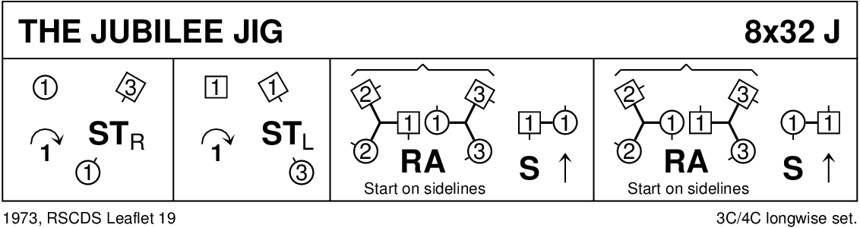

THE REVEREND JOHN MACFARLANE (R4x32) 4C set RSCDS Bk 37
1- 8 1s cross down to dance reels of 3 on opposite side ending in partner’s place
9-16 1s dance ½ figs of 8 round 2s, meet in centre & dance 4 slip steps down the middle to 3rd place & set (BH joined)
17-24 1s+4s dance the Poussette
25-32 2s+3s & 4s+1s dance RH across once round & turn partner LH

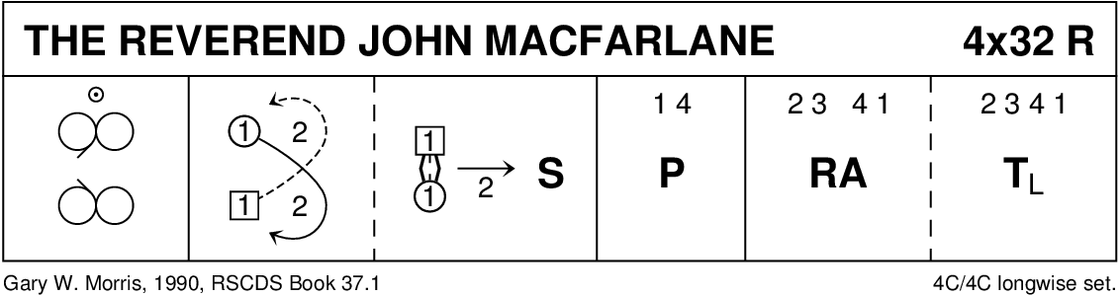

THE FALKIRK LASS (S8x32) 3C (4C set) RSCDS Bk 53
1- 8 1s turn RH, cast off 1 place, cross LH & cast round 2nd corners to
1M between 2s facing down & 1L between 3s facing up
9-16 All Adv+Ret (1 step), change places with opposite person RH
Adv+Ret again ~ 2s+3s change places RH while 1s turn RH to face 1st corners
17-24 1s dance Pass+Turn with 1st corners & pass RS to face 2nd corners, dance Pass+Turn with 2nd corners
25-32 2s+1s+3s circle 6H round & back

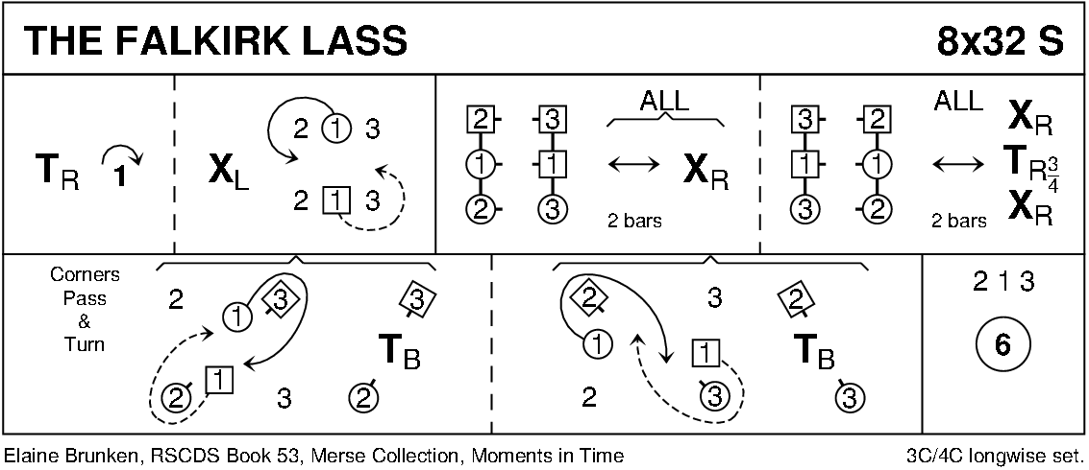

THE LUCKENBOOTH BROOCH (J8x32) 3C (4C RSCDS Bk 53
1- 8 1s in promenade hold (lady on man's left) dance reel of 3 with 2s (RS to 2M) & end facing 3M
9-16 1s dance reel with 3s (RS to 3M) ending with 1s dancing across to men’s side
17-24 2s+3s dance R&L
while 1s dance out, 1M casts up & 1L down into centre & dance out ladies’ side
1M cast up & 1L down to end 1M between 2s facing down & 1L+3s facing up
25-32 2s+1s+3s set twice, 1s turn RH 1¾ times to 2nd place

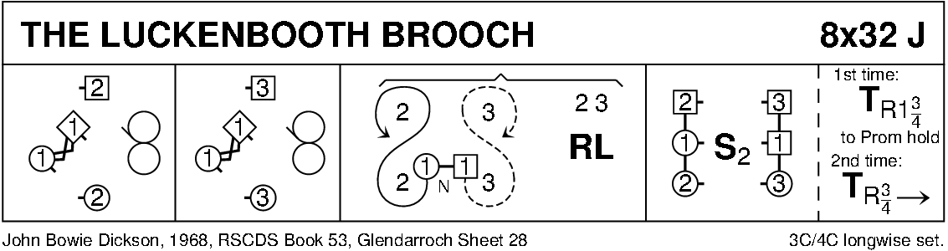

MRS MACLEOD (of Raasay) (R8x32) 3C (4C set) RSCDS Bk 6
1- 8 1s+2s dance RH across & LH back
9-16 1s lead down the middle & up to face 1st corners
17-24 1s set to 1st corners & turn BH, set & turn 2nd corners
25-32 1s dance reels of 3 on opposite sides giving LS to 1st corners & cross to 2nd place own sides

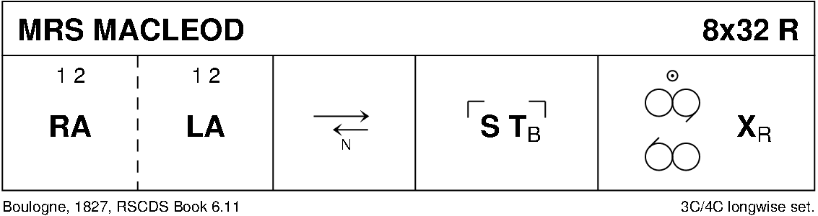

MRS STEWART'S JIG (J8x32) 3C (4C set) RSCDS Bk 35
1- 8 1s set, 1L followed by partner cast off 2 places, 1L crosses (below 3s) & casts up on men’s side to 2nd place facing down while 1M dances round 3L & up middle to 2nd place ladies’ side facing down
9-16 2s+1s+3s dance Grand Chain - end with 2M & 1M facing out
17-24 2s+1s dance Ladies’ Chain
25-32 2s+1s+3s Adv+Ret for 2 steps & 1s turn 1½ RH to own sides

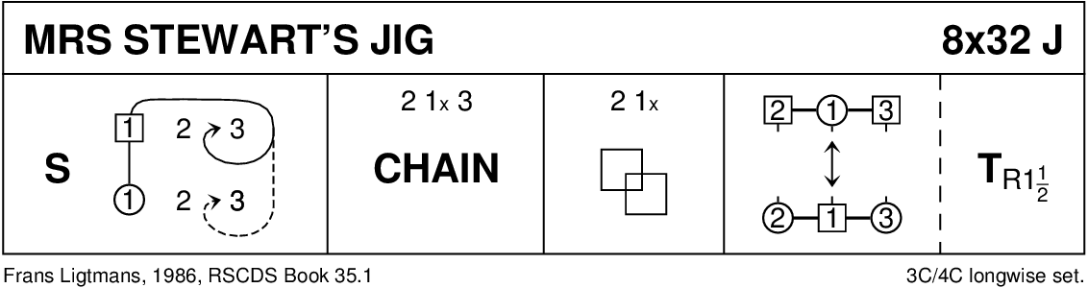

FESTIVAL FLING (R8x32) 3C (4C Set) RSCDS Bk 44
1- 8 1s set, cross RH, cast off two places & dance up to face 1st corners
9-12 1s set to 1st corner & change places RH, 1st corners pass LS to face 2nd corners (M facing M & L facing L)
  - Original 1st corners set to 2nd corners, change places RH & 2nd corners pass LS to face 1st corner (M face M & L face L)
17-20 Original 2nd corners set to 1st corners (1s), change places RH & 1s end facing opposite sides as for double triangles
21-24 All set, corners chase one place clockwise while 1s set round each other to face down (man with partner on left)
25-32 1s dance down between 3s, cast up to 2nd place, dance up between 2s & cast off to 2nd place

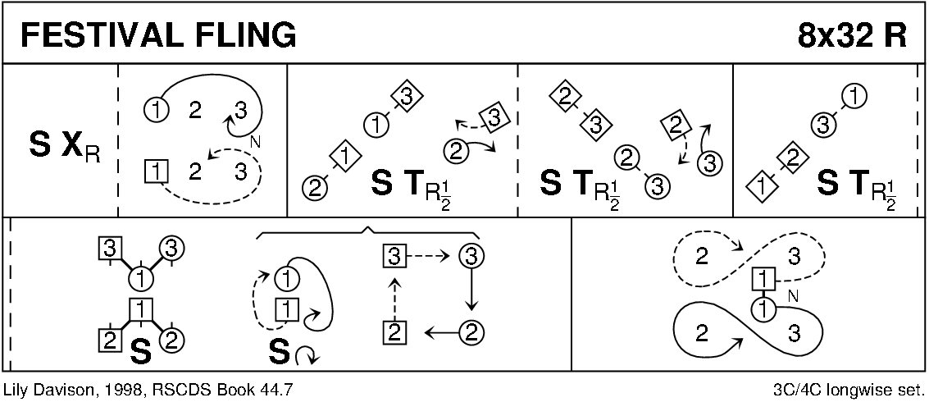

THE BYRON STRATHSPEY (S3x32) 3C set Drewry
1-8 All petronella turn into the centre & set to partner, turn BH 1¼ times back to places
9-16 1s+2L & 3s+2M dance RH across, 2s pass RS & dance LH across with other couple
17-24 2s in promenade hold dance reel of 3 with 1s passing 1L RS, end 2s in centre at top
25-32 2s+1s+3s dance Allemande

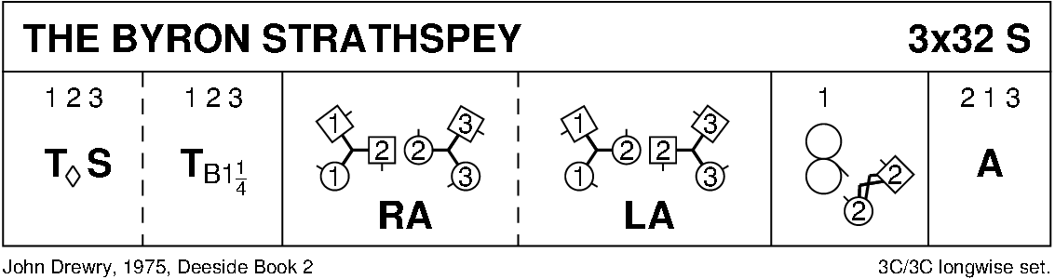

THE MILLER OF SESSNIE (J5x32) 5C set Goldring
1- 8 1s followed by 2s+3s+4s dance down and cast round 5s back to places
9-16 1s+5s dance Figs of 8 on own sides (1s down between 2s and 5s up behind 4s to start
17-24 1s+2s dance RH across, 1s cross down and ½ turn 3s (LH Men's side and RH Ladies' side)
25-32 1s+4s dance LH across, 1s cross down and ½ turn 5s (LH Men's side and RH Ladies' side) 23451

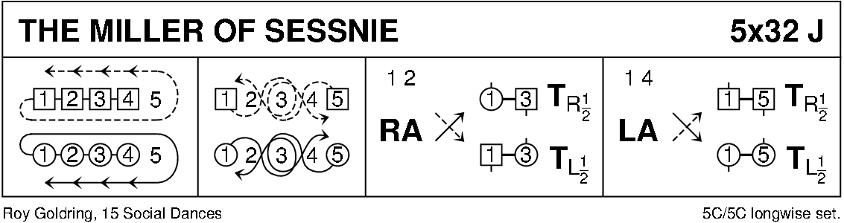

THE REEL OF THE ROYAL SCOTS (R8x32) 3C (4C set) RSCDS Leaflet
1- 8 1s ½ turn 2s on sides (M RH - L LH) to face out, 2s+1s+3s set
1s ½ turn 3s on sides (M LH - L RH) end 3s facing out & 2s+3s+1s set
9-16 1s followed by 3s dance up between 2s, cast off 1 place, dance in & 1s cast up to 2nd place, 3s end in 3rd place
17-24 1s turn 1st corners RH, pass partner RS turn 2nd corners RH & cross passing partner RS to 2nd place own side
25-32 2s+1s+3s circle 6H round & back

