RSCDS Ayr Branch

Nice & Easy Afternoon ~ Friday 3rd October 2025

St Ninian’s Church Hall, Troon 2.00 – 4.00pm

THE MACHINE WITHOUT HORSES (J8x32) 3C (4C set) RSCDS Bk 12

1- 8 1s set, cast off 1 place, dance RH across with 3s

9-16 1s set, cast up 1 place, dance LH across with 2s

17-24 1s followed by 2s dance down, cast up behind 3s, in & dance up to top & 1s cast back to 2nd place

25-32 2s+1s dance R&L

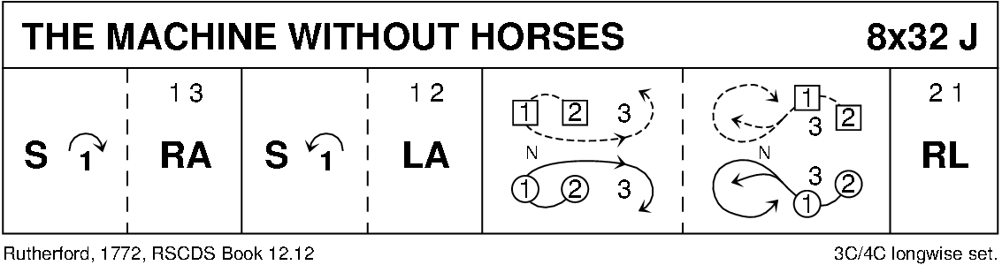

GAELFORCE WIND (J8x32) 3C (4C set) Graded Book 3

1- 8 1s set, cross RH

1s+2s Set+Link (Ladies face out)

9-16 2s+1s Men’s Chain

17-24 1s ½ Fig of 8 (L round 2s & M round 3s)

2s+1s+3s turn RH

25-32 2s+1s+3s circle 6H round & back

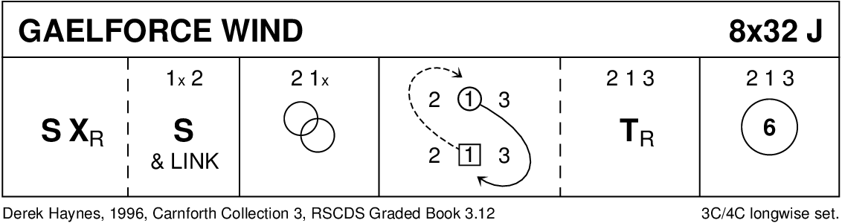

GANG THE SAME GATE (S8x32) 3C (4C set) RSCDS Bk 36

1- 8 1s cross RH & cast off 2 places, cross RH & cast up to 2nd place on own side

9-16 1s set advancing to partner & turn 1st corner BH to face 2nd corner

dance ½ reel of 4 with 2nd corners ending M between top couple facing down & L between bottom couple facing up

17-24 1s set advancing to partner & turn 2nd corner (in diagonally opposite place) BH to face own 1st corner position

dance ½ diagonal reel with 1st corners - ending in 2nd place opposite side

25-32 3s+1s+2s Set & Link for 3 – twice

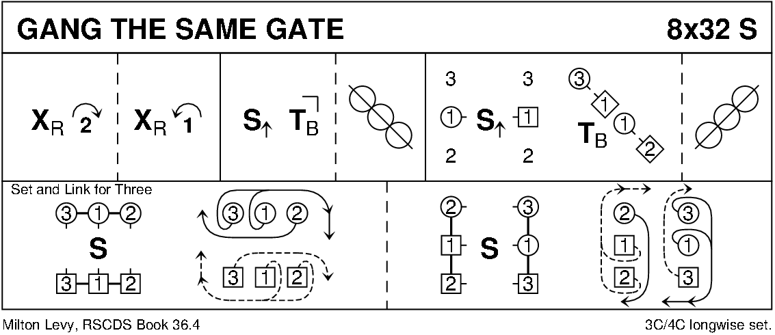

JOIE DE VIVRE (J8x32) 3C (4C set) RSCDS Bk 39

1- 8 1s set, cast off 1 place, 1s dance down between 3s & cast up to 2nd place on own side

9-16 2s+1s+3s turn RH & chase ½ way round clockwise

17-24 3s+1s+2s dance back to back, set & ½ turn partners RH for Allemande

25-32 3s+1s+2s dance Allemande

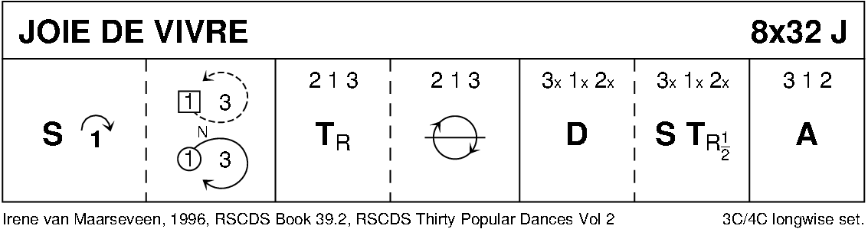

CATCH THE WIND (R8x32) 3C (4C set) RSCDS Bk 45

1- 8 1s set, cast off 1 place & dance ½ Fig of 8 round 2s

9-16 1s set twice with 1L turning to face out

1L followed by partner casts up & dances down the middle 1L to face 3M **while** 1M faces 2M

17-24 1s dance RS reels of 3 across (1M+2s & 1L+3s)

25-32 1L followed by partner dances down and casts up round 3M & crosses to end in 2nd place on own sides

1s turn RH (4 bars)

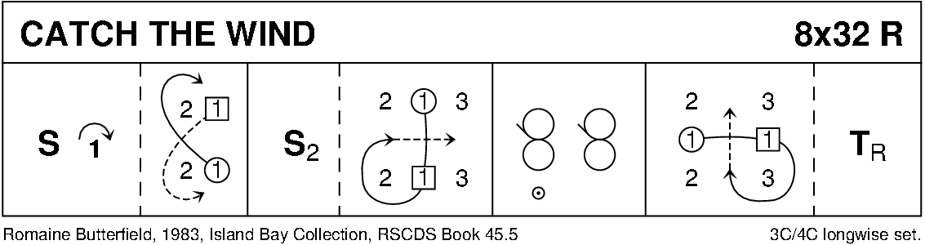

THE KELLOHOLM JIG (J8x32) 3C (4C set) RSCDS Leaflet

1- 8 1s set & cast off 1 place, set on side lines to 1st corners & change places with them RH

9-16 1L+3L **also** 2M+1M set to each other on sides & change places LH, 1s turn RH 1½ times to 2nd place on own side

17-24 1s set on side lines to 2nd corners & change places with them RH

1M+3M **also** 2L+1L set to each other on sides & change places LH

25-32 3s+1s+2s Adv+Ret, circle 6H round ½ way to left

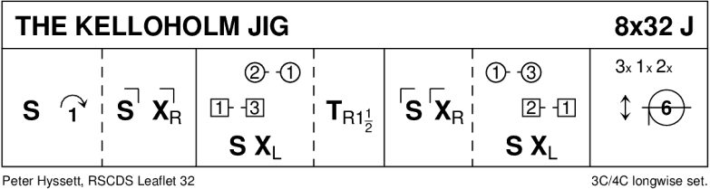

SCOTT MEIKLE (R4x32) 4C set RSCDS Bk 46

1- 8 1s cross RH & cast off 1 place, 1s dance ½ Fig of 8 round 2s

9-16 1s+3s dance RH across, LH back

17-24 1L followed by 3L dance Tandem reel of 3 across with 2s (1L ends 3rd place)

**while** 3M followed by 1M reel of 3 with 4s (3M to 2nd place)

25-32 1s+4s dance ½ R&L, turn partners RH 1½ times

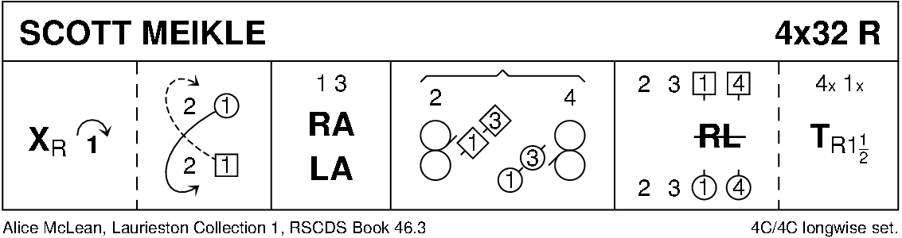

CITY OF BELFAST (S3x32) 3C set RSCDS Bk 48

1- 8 1s dance ½ Fig of 8 round 2s

1L+2M turn RH 1¼ times **while** 1M+2L turn LH 1¼ times - 1s end back to back facing 2s

9-16 1s+2s dance reel of 4 across - 2s end in 1st place **while** 1s pass LS to face 1st corners

17-24 1s set to 1st corner, set to 2nd corner ending between corners; all set & 1s cross RH

25-32 1s+3s dance Espagnole:-

`25-26 1s+3s cross (Ladies lead across RH passing between Men) with Ladies changing places RH

`27-28 1s+3s cross back (Men lead across RH between Ladies) with Men changing places RH

`29-32 3s turn RH **as** 1s turn LH to end 2 3 1

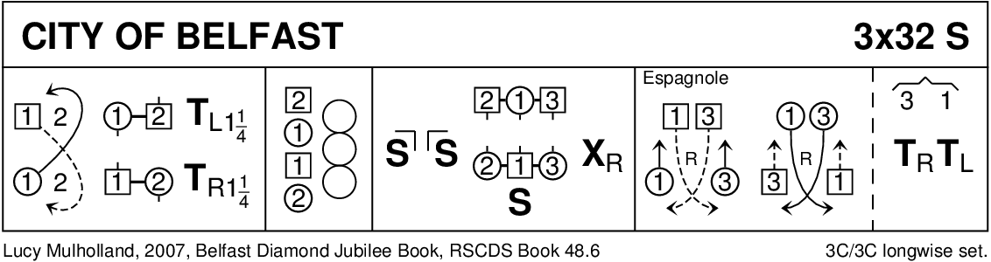

HOOPER'S JIG (J8x32) 3C (4C set) MMM ll 1- 8 All clap as 1s cross passing RS, cast to 2nd place & dance RH across with 3s

9-16 All clap as 1s cross passing RS, cast to 1st place & dance LH across with 2s

17-24 1M+3L change places RH, then 1L+3M change places RH (**as** 1M+3L loop round)

1M+3L change places RH (**as** 1L+3M loop round)

1L+3M cross LH 1L ending in 2nd place (as 1M casts to 2nd place)

25-32 2s+1s dance R&L

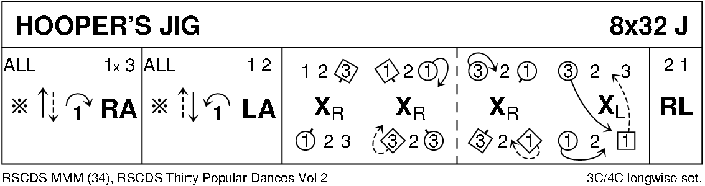

THE DEIL AMANG THE TAILORS (R8x32) 3C (4C set) RSCDS Bk 14

1- 8 1s+2s set & dance RH across ½ way, set & dance LH across ½ way back to place

9-16 1s lead down the middle & back to top

17-24 1s+2s dance Allemande

25-32 2s+1s+3s circle 6H round & back

