RSCDS Ayr Branch
Nice & Easy Afternoon ~ Friday 2nd October 2026
St Ninian’s Church Hall, Troon 2.00 – 4.00pm

JOIE DE VIVRE (J8x32) 3C (4C set) RSCDS Bk 39
1- 8 1s set, cast off 1 place, 1s dance down between 3s & cast up to 2nd place on own side
9-16 2s+1s+3s turn RH & chase ½ way round clockwise
17-24 3s+1s+2s dance back to back, set & ½ turn partners RH for Allemande
25-32 3s+1s+2s dance Allemande

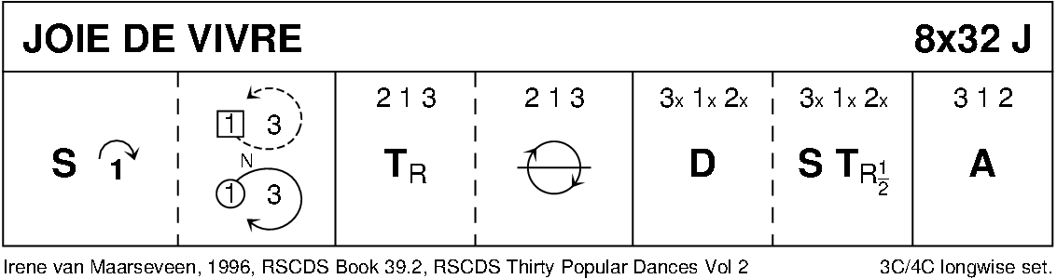

MISS JOHNSTONE OF ARDROSSAN (R5x32) 5C set Goldring
1- 8 1s set, cast off 1 place
1s followed by 3s dance up & cast - 1s to 3rd place & 3s to 2nd place
9-16 1s dance reels of 3 with 4s+5s on opposite sides - 1s end in 3rd place opposite side
17-24 1s dance reels of 3 on own side with 2s+3s - 1s ending in 3rd place own side
25-32 1s set, cast off 1 place
1s followed by 5s dance up between 4s & cast - 1s to 5th place & 5s to 4th place

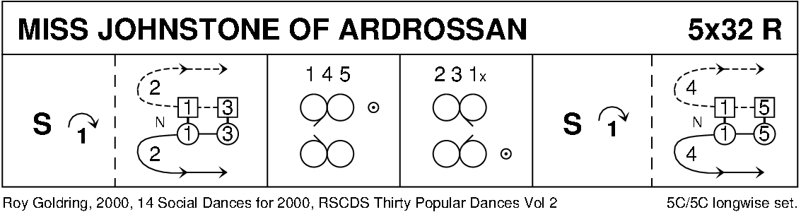

THE BONNIE TREE (S8x32) 3C (4C set) RSCDS Bk 46
1- 8 1s dance down below 3s, cast up behind 3s, dance up between 2s and cast off to 2nd place
9-16 2s+1s+3s ½ turn partner BH and twirl to opposite place
all circle 6H round to left ¾ way into lines across (men facing down at top, ladies facing up)
17-20 1s change places RH and cast to right to 2nd place own side while (bar 19) 3M+2L change places diagonally RH
21-24 1s cross RH and cast to right into middle while (bar 23) 2M+3L change places RH –
all end in lines across (ladies facing down, men facing up)
25-32 All ½ turn partner BH and twirl to opposite place
all circle 6H round to left to own side 2 1 3

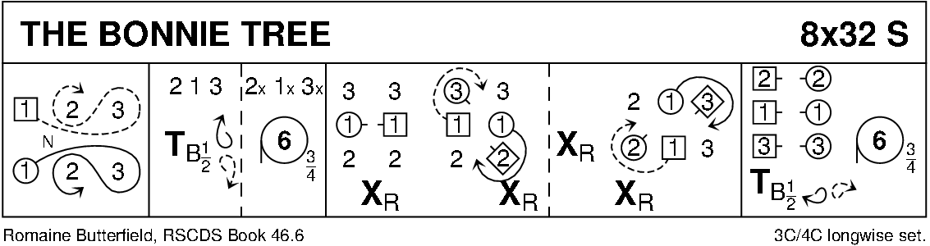

ROARING JELLY (J8x32) 3C (4C set) Foss
1- 8 1s cross RH, cast off 1 place, cross RH & cast (man up & lady down) into centre
9-16 1s+2s+3s circle 6H round & back (1s end in centre)
17-24 1s change places RH & dance to right into Figs of 8 (1L round 2s as 1M dances round 3s)
25-32 1s dance reels of 3 on opposite side giving RS to 2nd corners & cross RH

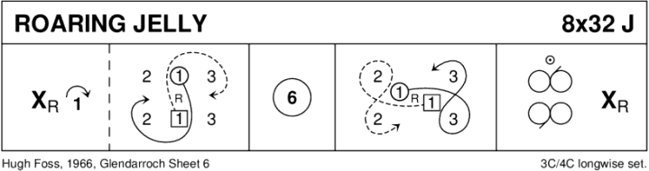

THE PIPER AND THE PENGUIN (R88) Sq.Set Scotia Suite
1- 8 Ladies dance RSh round their corners, dance RH across ending in centre
9-16 Ladies dance LSh round their partners, dance LH across and back to places
17-24 Men dance RSh round their partners, dance RH across ending in centre
25-32 Men dance LSh round corners, dance LH across and back to places
33-40 1s and 3s turn partners RH 1¼ times, Men followed by partners dance out to right between side couples and back to places (1M through 4s and 3M through 2s
41-48 1s+3s dance R&L
49-56 2s and 4s turn partners RH 1¼ times, Men followed by partners dance out to right between top/bottom couples and back to places (2M through 1s and 4M through 3s)
57-64 2s+4s dance R&L
65-72 Ladies dance in turning right about to dance out, cast clockwise to opposite Lady's place
73-80 Men dance in turning left about to dance out, cast anticlockwise to opposite places
81-88 All turn partners RH 1¼ times into prom hold, Promenade anticlockwise ½ way round to original places

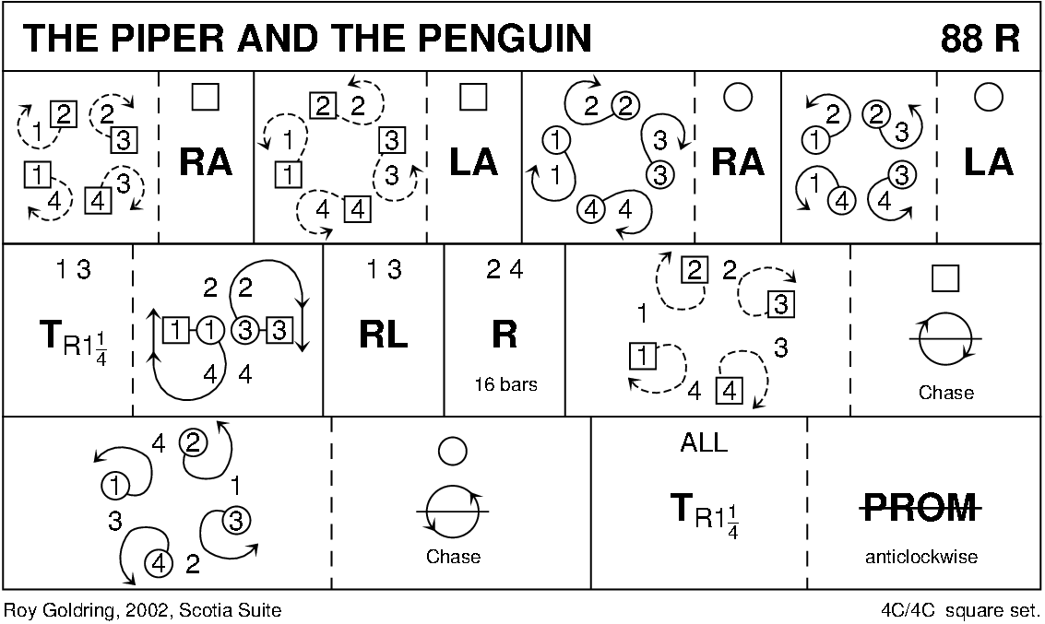

THE YOUNG ACCORDION MAN (R8x32) 3C (4C set) Taylor
1- 8 1s+2s+3s advance and retire; 1s dance in and cast (2s step up)
9-16 2s+1s+3s advance and retire; 1s turn RH (birl) to finish facing 1st corners
17-32 1s dance Corner Chain with 1st and 2nd corners:
1s change pl RH with 1st corners, 1st corners turn LH in centre and return to places giving RH to 1s who turn LH in centre to face 2nd corners
1s change places RH with 2nd corners, 2nd corners turn LH in centre and return to places giving RH to 1s and 1s end with a ½ turn LH to 2nd place own sides 213

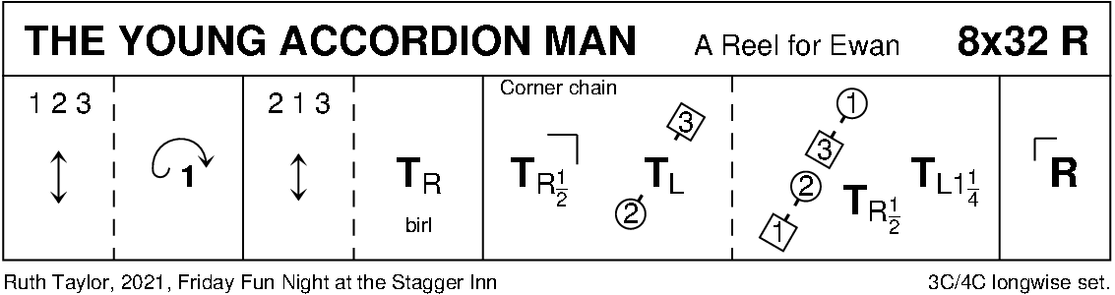

PELORUS JACK (J8x32) 3C (4C set) RSCDS Bk 41
1- 8 1s cross RH, cast off 1 place; dance RH across with 3s - 1M end facing 1st corner with partner behind
9-16 1s dance alternating tandem ½ reel of 3 with 1st corners & alternating tandem ½ reel with 2nd corners
  - 1s dance alternating tandem ½ reel of 3 with 3rd corner positions & alternating tandem ½ reel with 4th corner positions
  - 1M followed by partner dance into LH across with 2s
1s retain LH & ½ turn to own side, 2s+1s+3s set

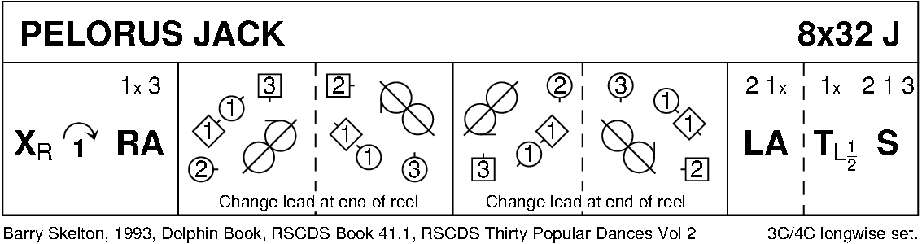

BROADWAY (S3x32) 3C set Ronald
1- 8 1s dance down (2 bars) & turn BH (2 bars), 1s dance up & cast off to 2nd place
9-16 2s+1s+3s Set+Link for 3, 1s dance ½ Diagonal R&L starting diagonally left
17-24 All Set+Link for 3, 1s dance ½ Diagonal R&L starting diagonally left (3)(1)(2)
25-32 All set & ½ turn RH, face partner and pull back RS, dance out to place & set 3 1 2

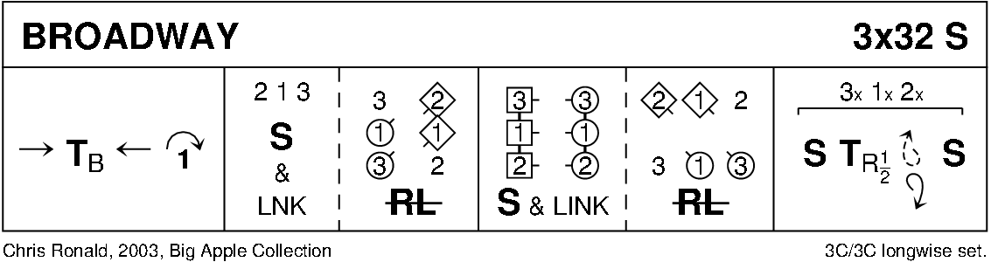

POSTIE'S JIG (J4x32) 4C set Clowes
1- 8 1+4s set, cast off/up 1 place & dance ½ figure of 8 round new end couples
9-12 1M+4M & 1L+4L cross (men making an arch) & turn corners with free hand to face up/down
13-16 1s+4s dance down/up (couple dancing up make the arch) & turn corners
17-24 Repeat bars 9-16 from new positions
25-32 1s+4s dance ½ R&L & turn partner RH

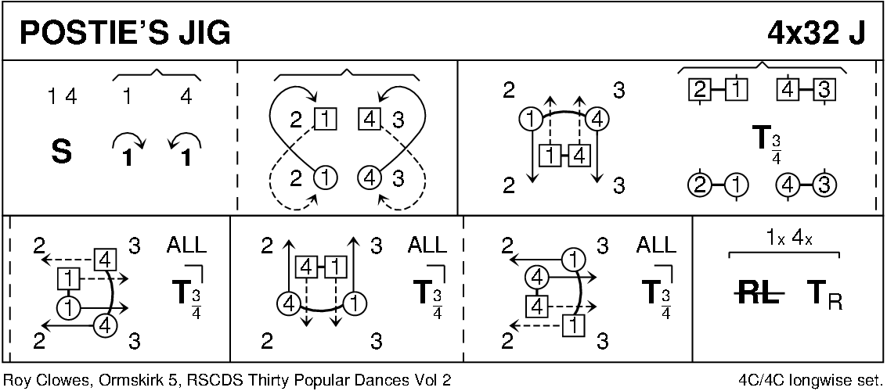

MAIRI'S WEDDING (R8x40) 3C (4C set Cosh
1- 8 1s turn RH, cast off 1 place & turn LH to face 1st corner
9-16 1s dance ½ diagonal reel of 4 with 1st corners & ½ diagonal reel with 2nd corners
17-24 1s dance ½ diagonal reel with 3rd corner s & ½ diagonal reel with 4th corner s
25-32 1s dance reel of 3 across (1L+ 2s & 1M 3s (LS to 1st corner)
33-40 2s+1s+3s circle 6H round & back

