RSCDS Ayr Branch

Nice & Easy Afternoon ~ Friday 7th November 2025

St Ninian’s Church Hall, Troon 2.00 – 4.00pm

WELCOME TO AYR (J8x32) 3C (4C set) RSCDS Bk 47

1- 8 1s+2s dance double Fig of 8 (1s cross down to start)

9-16 1s turn 2s on sides (Men RH, Ladies LH)

1s dance down to turn 3s on sides (Men RH, Ladies LH) ---1s end facing 1st corners

17-24 1s dance ½ reel of 4 with 1st corners & pass RS to face 2nd corner

1s dance ½ reel of 4 with 2nd corners & 1s end in middle LS to LS facing own side

25-28 1M+3s (at top) **also** 1L+2s dance RH across (1s end in 2nd place opposite side)

all chase clockwise ½ way to own side

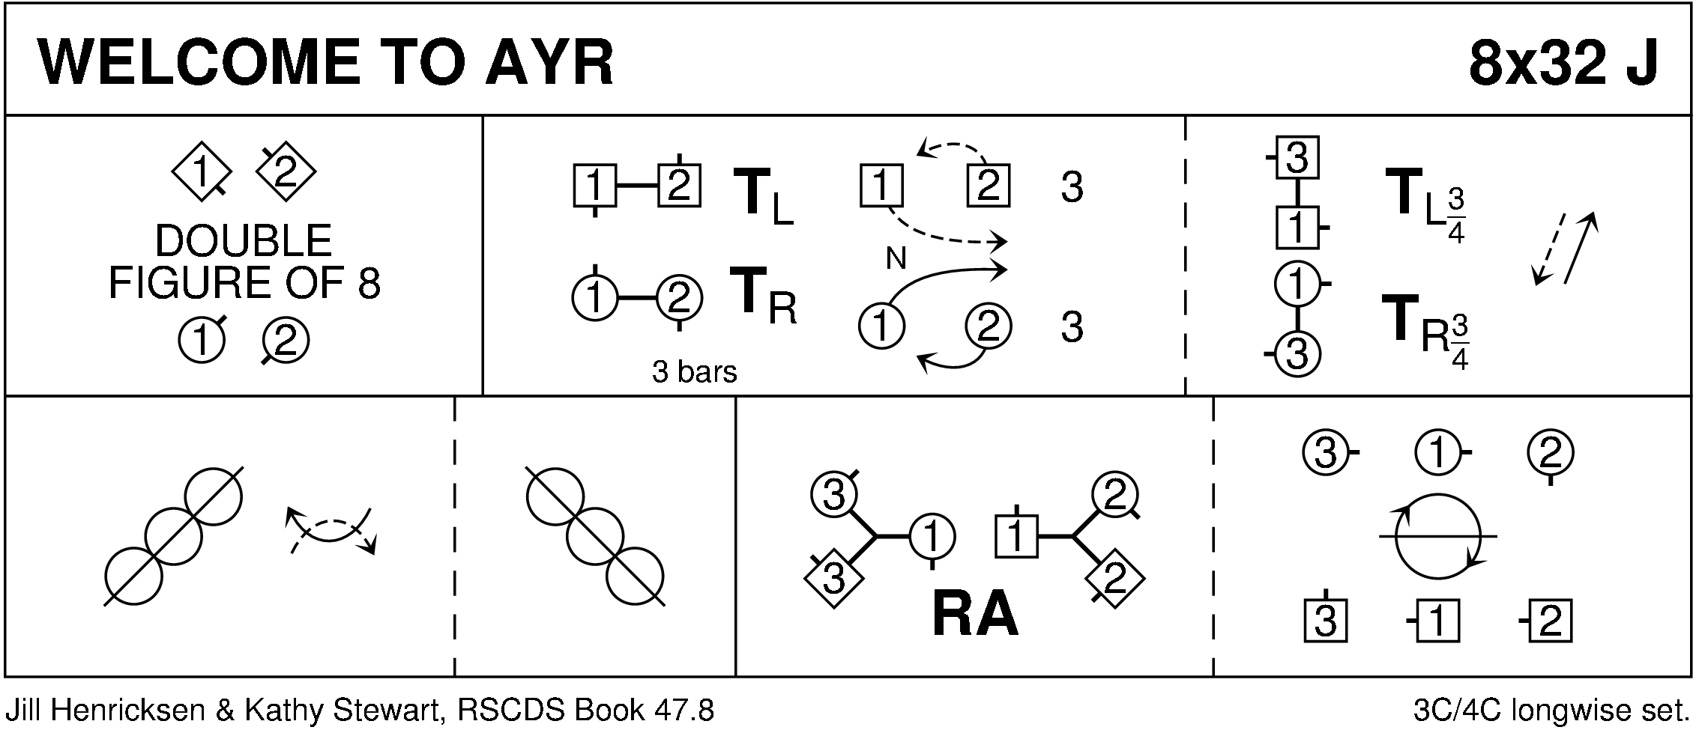

MISS JOHNSTONE OF ARDROSSAN (R5x32) 5C set Goldring

1- 8 1s set, cast off 1 place

1s followed by 3s dance up & cast - 1s to 3rd place & 3s to 2nd place

9-16 1s dance reels of 3 with 4s+5s on opposite sides - 1s end in 3rd place opposite side

17-24 1s dance reels of 3 on own side with 2s+3s - 1s ending in 3rd place own side

25-32 1s set, cast off 1 place

1s followed by 5s dance up between 4s & cast - 1s to 5th place & 5s to 4th place

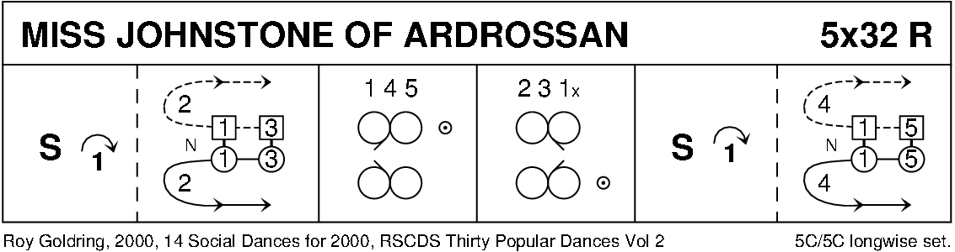

CITY OF BELFAST (S3x32) 3C set RSCDS Bk 48

1- 8 1s dance ½ Fig of 8 round 2s

1L+2M turn RH 1¼ times **while** 1M+2L turn LH 1¼ times - 1s end back to back facing 2s

9-16 1s+2s dance reel of 4 across - 2s end in 1st place **while** 1s pass LS to face 1st corners

17-24 1s set to 1st corner, set to 2nd corner ending between corners; all set & 1s cross RH

25-32 1s+3s dance Espagnole:-

`25-26 1s+3s cross (Ladies lead across RH passing between Men) with Ladies changing places RH

`27-28 1s+3s cross back (Men lead across RH between Ladies) with Men changing places RH

`29-32 3s turn RH **as** 1s turn LH to end 2 3 1

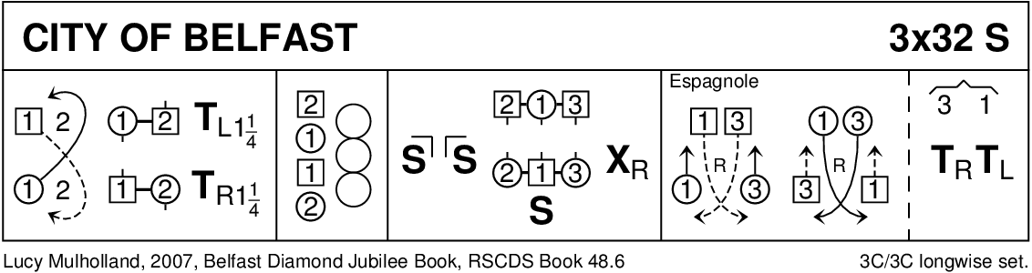

JOE MACDIARMID'S JIG (J4x32) 4C set 5 SCDs 1982

1- 8 All Adv+Ret, turn partners RH with 1s & 4s end facing up & down set

9-16 1s & 4s advance (up/down set) & retire, turn corner person with nearer hand

17-24 1s lead down crossing RH below 3s& cast to bottom, 1s dance 1/2 Fig of 8 round 4s

25-32 All circle 8H round & back

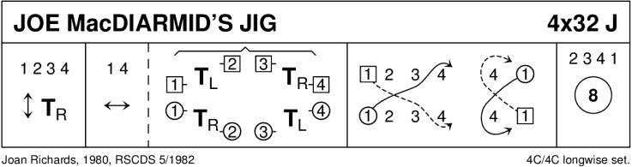

SHIFTIN' BOBBINS (R8x32) 3C (4C set) Clowes

1- 8 1s cross RH to double triangle position with 2s+3s & set

1s cast up to top & dance down until they are between 2s & 3s

9-16 1L dances RH across with 2M+3M **while** 1M dances LH across with 2L+3L

1s followed by 2s+3s dance down centre

17-24 3s followed by 2s+1s dance up --- 3s+2s cast down to place

1L dances LH across with 2M+3M **while** 1M dances RH across with 2L+3L

25-32 1s dance up to top & cast down to 2nd place opposite side

1s dance ½ Fig of 8 around 2s to end in 2nd place on own side

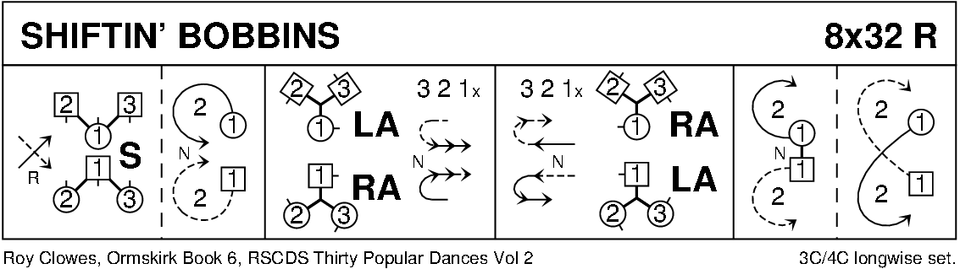

PELORUS JACK (J8x32) 3C (4C set) RSCDS Bk 41

1- 8 1s cross RH, cast off 1 place; dance RH across with 3s - 1M end facing 1st corner with partner behind

9-16 1s dance alternating tandem ½ reel of 3 with 1st corners & alternating tandem ½ reel with 2nd corners

* 1. 1s dance alternating tandem ½ reel of 3 with 3rd corner positions & alternating tandem ½ reel with 4th corner positions
  2. 1M followed by partner dance into LH across with 2s

1s retain LH & ½ turn to own side, 2s+1s+3s set

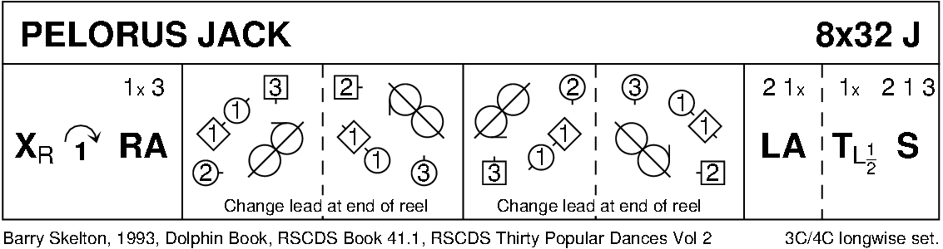

THE HIGHLAND RAMBLER (R8x40) 3C (4C set) Goldring 1- 8 1s dance in & cast off 1 place; dance RH across with 3s

9-16 2s+1s dance LH across

1L followed by partner cast up round 2L & dance down middle to 1L between 3s & 1M between 2s

17-24 1s+2s+3s dance down the middle & back

25-32 1M followed by partner cast up round 2L to 2nd place on own side & turn RH

33-40 2s+1s+3s circle 6H round & back

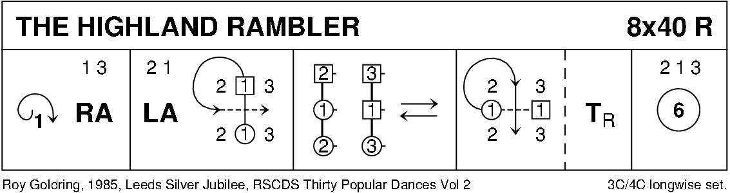

ST COLUMBA'S STRATHSPEY (S5x32) 5C set Gillan & Sproule

1- 8 2s+4s dance RH across

2s dance up **while** 4s dance down - 2s+4s casting round ends on own side to face 1st corners

9-16 2s+4s Pass+Turn with 1st corners, pass partner LS

Pass+Turn with 2nd corners & into centre facing partner (L facing down, M up)

17-24 2s+4s dance reel of 4 ending in original places on side

25-32 2s+4s set & cast off 1 place **while** 3s+5s set & dance up 1 place

1s+2s turn RH & cast off 1 place 3 1 5 2 4

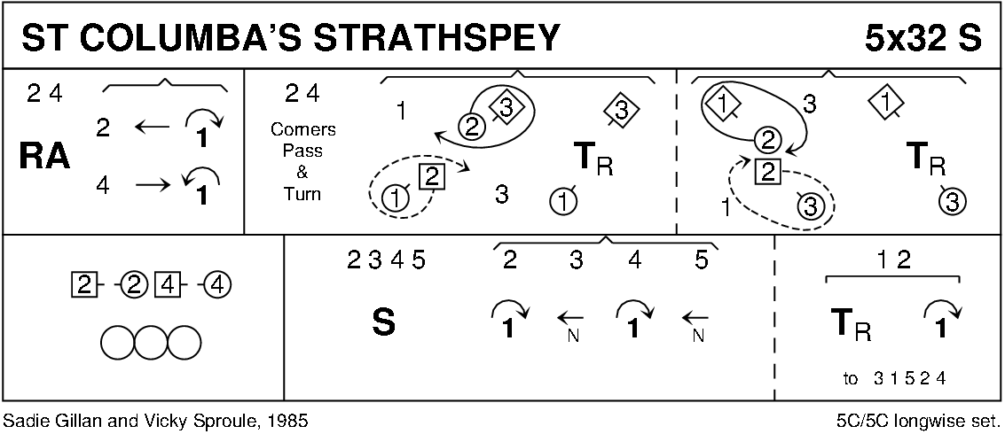

**MARK AND SUSIE'S JIG** **(J8x32) 3C (4C set) RSCDS Book 54**

1- 8 1s+2s set, dance ½ RH across

1s+2s set and dance ½ LH across  
9-16 1s+2s+3s dance reels of 3 on opposite side with each couple crossing down from the top through 2nd place (1)(2)(3)  
17-24 3s followed by 2s+1s lead down

on bar 20 each Lady turns under partner's right arm while Men dance below them to face up on own side ---

1s+2s lead up to finish in the middle of set with both hands joined

3s finish in 3rd place 1 2 3  
25-32 1s+2s dance Poussette

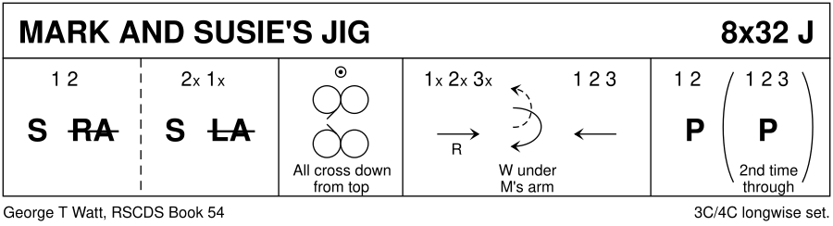

REEL OF THE 51ST DIVISION (R8x32) 3C (4C set) RSCDS Bk 13

1- 8 1s set & cast off 2 places, lead up to face 1st corners

9-16 1s set & turn 1st corners RH to balance in diagonal line, set & 1s turn LH to face 2nd corners

17-24 1s set & turn 2nd corners RH to Bal-in-Line, set & 1s turn LH to 2nd place own sides

25-32 2s+1s+3s circle 6H round & back

