RSCDS Ayr Branch
Nice & Easy Afternoon ~ Friday 1st May 2026
St Ninian’s Church Hall, Troon 2.00 – 4.00pm

THE FRISKY (J8x32) 3C (4C set) RSCDS Book 26 1-8 1s turn RH and cast 1 place, turn LH and cast down 1 place
9-16 2s+3s+1s circle 6H round and back
17-24 1s lead up to top and 1s+2s set twice
25-32 1s+2s dance ½ R&L, set and cross RH to own sides

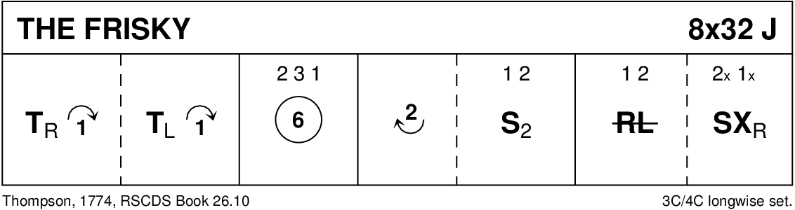

MRS MACLEOD (of Raasay) (R8x32) 3C (4C set) RSCDS Bk 6
1- 8 1s+2s dance RH across & LH back
9-16 1s lead down the middle & up to face 1st corners
17-24 1s set to 1st corners & turn BH, set & turn 2nd corners
25-32 1s dance reels of 3 on opposite sides giving LS to 1st corners & cross to 2nd place own side

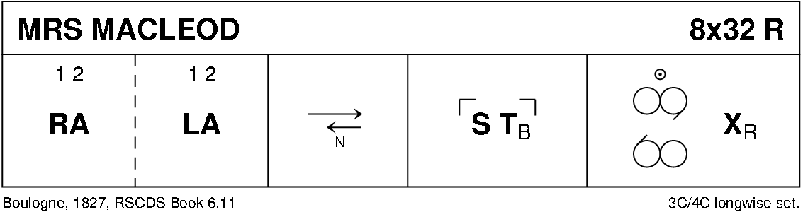

THE CASHMERE SHAWL (S8x32) 3C (4C set) Boyd
1- 8 1s turn RH and cast down 2 places, cross LH and cast up to 2nd place opposite sides
9-16 1s turn RH and turn 1st corners LH, turn 2nd corners RH and turn partner LH to face 1st corners
17-24 1s ½ diagonal reel of 4 with 1st corners, pass RSh and dance ½ diagonal reel with 2nd corners. (3)(1)(2)
25-32 1s (centre couple) change places RH with person diagonally to Right, New centre couple change LH with person diagonally to Left, New centre couple change RH with person diagonally to Right, All cross LH

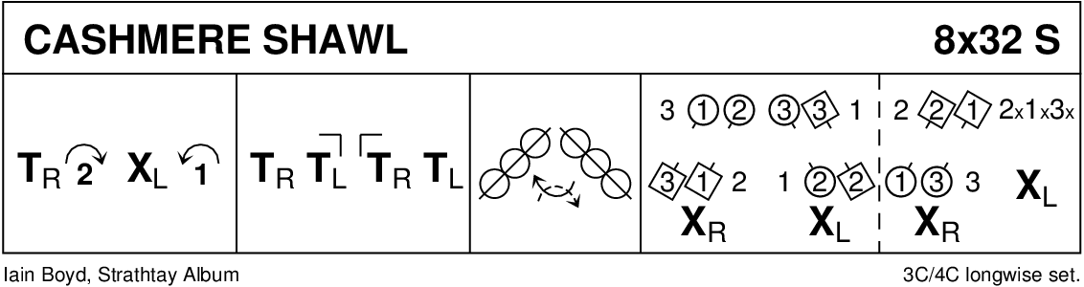

THE JUBILEE JIG (J8x32) 3C (4C set) Leaflet
1- 8 1M cast off one place, set to 3L, turn RH & dance back to 2nd place on own side
9-16 1L cast off one place, set to 3M, turn LH & dance back to 2nd place
  - 1L+2s & 1M+3s dance RH across - 1s end in centre LH joined
1s set in centre & dance out to 2nd place opposite side
  - 1M+2s & 1L+3s dance RH across - 1s end in centre LH joined
1s set in centre & dance out to 2nd place own side

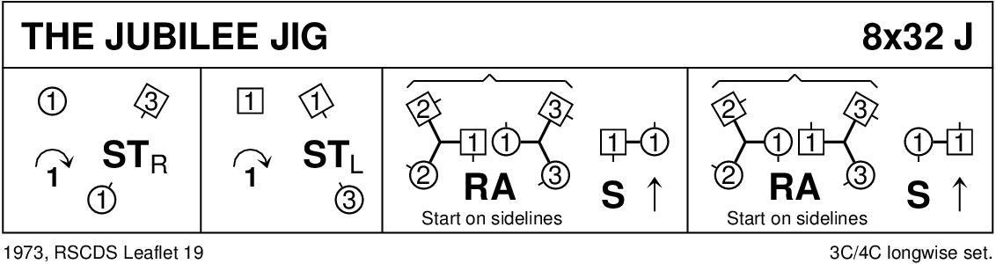

THE PIPER AND THE PENGUIN (R88) Sq.Set Scotia Suite
1- 8 Ladies dance RSh round their corners, dance RH across ending in centre
9-16 Ladies dance LSh round their partners, dance LH across and back to places
17-24 Men dance RSh round their partners, dance RH across ending in centre
25-32 Men dance LSh round corners, dance LH across and back to places
33-40 1s and 3s turn partners RH 1¼ times, Men followed by partners dance out to right between side couples and back to places (1M through 4s and 3M through 2s
41-48 1s+3s dance R&L
49-56 2s and 4s turn partners RH 1¼ times, Men followed by partners dance out to right between top/bottom couples and back to places (2M through 1s and 4M through 3s)
57-64 2s+4s dance R&L
65-72 Ladies dance in turning right about to dance out, cast clockwise to opposite Lady's place
73-80 Men dance in turning left about to dance out, cast anticlockwise to opposite places
81-88 All turn partners RH 1¼ times into prom hold, Promenade anticlockwise ½ way round to original places

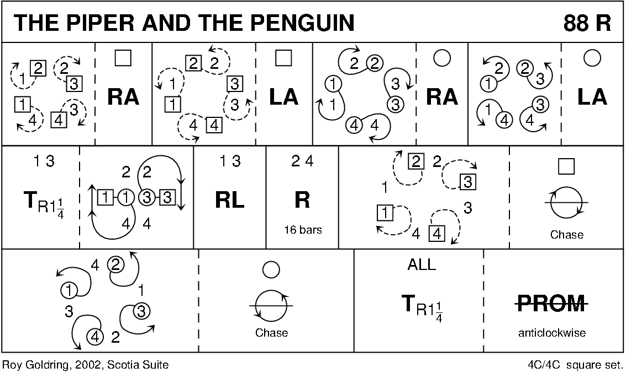

ROARING JELLY (J8x32) 3C (4C set) Foss
1- 8 1s cross RH, cast off 1 place, cross RH & cast (man up & lady down) into centre
9-16 1s+2s+3s circle 6H round & back (1s end in centre)
17-24 1s change places RH & dance to right into Figs of 8 (1L round 2s as 1M dances round 3s)
25-32 1s dance reels of 3 on opposite side giving RS to 2nd corners & cross RH

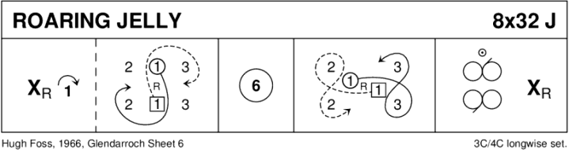

DAVY NICK NACK (R8x32) 3C (4C set) Glasgow Assembly
1- 8 1s+2s+3s cross RH to just in front of side lines, set, cross back RH and set again
9-16 1s turn RH 1½ times, cast 1 place (2s step up 13-14) and turn LH once round to face 1st corners
17-24 1s change places RH with corners and set
Change places with corner person RH and turn partner LH to face 2nd corners
25-32 1s change places RH with corners and set
Change places with corner person RH and cross LH with partner to places
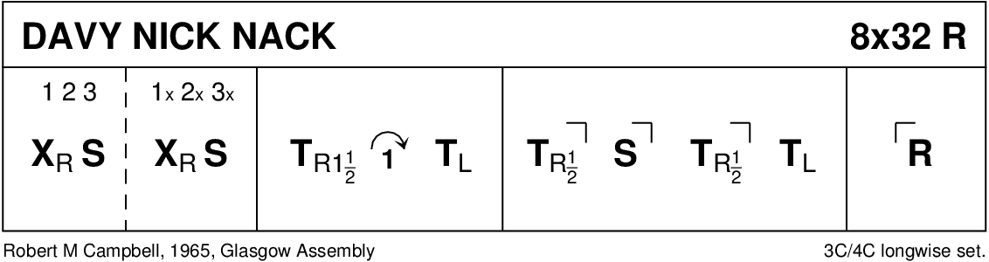

THE DREAM CATCHER (S96) Sq.Set RSCDS Bk 45
1- 8 All circle 8H round & back
9-16 1s+3s dance the Swirl:-
Turn partner RH into allemande hold & dance LS round other couple ½ way
dance LH across ¾ way & swirl to face side couples (back to back with partner & lady facing man)
17-24 All dance reels of 4 across
25-32 All set, dancing couples dance out between side couples, cross & cast, change places RH with partner back to place
33-40 All set, advance with partner, retire diagonally with corner & set
41-48 1L+4M dance R&L with 3L+2M (on diagonal)
49-56 1M+2L dance R&L with 3M+4L (other diagonal)
57-64 All set with corners, advance & retire with partner & set
65-88 2s+4s repeat bars 9-32
89-96 All circle 8H round & back

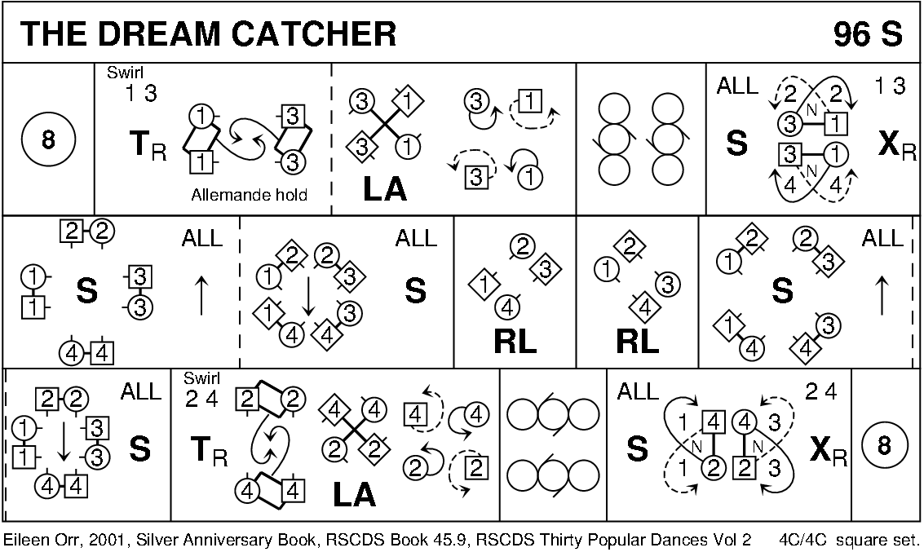

JOIE DE VIVRE (J8x32) 3C (4C set) RSCDS Bk 39
1- 8 1s set, cast off 1 place, 1s dance down between 3s & cast up to 2nd place on own side
9-16 2s+1s+3s turn RH & chase ½ way round clockwise
17-24 3s+1s+2s dance back to back, set & ½ turn partners RH for Allemande
25-32 3s+1s+2s dance Allemande

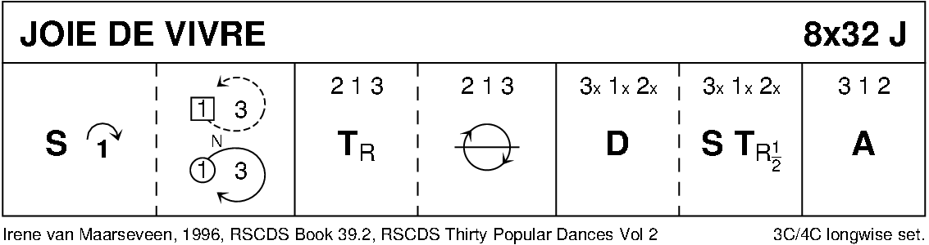

SHIFTIN' BOBBINS (R8x32) 3C (4C set) Clowes
1- 8 1s cross RH to double triangle position with 2s+3s & set
1s cast up to top & dance down until they are between 2s & 3s
9-16 1L dances RH across with 2M+3M while 1M dances LH across with 2L+3L
1s followed by 2s+3s dance down centre
17-24 3s followed by 2s+1s dance up --- 3s+2s cast down to place
1L dances LH across with 2M+3M while 1M dances RH across with 2L+3L
25-32 1s dance up to top & cast down to 2nd place opposite side
1s dance ½ Fig of 8 around 2s to end in 2nd place on own side

