RSCDS Ayr Branch
Nice & Easy Afternoon ~ Friday 6th March 2026
Portland Church Hall, Troon 2.00 – 4.00pm

GOOD HEARTED GLASGOW (J8x32) 3C (4C set) Knapman
1- 8 1s turn RH & cast off 1 place, turn partner LH 1¼ times to end man facing down & lady facing up
9-16 1s dance RH across (1L+2s & 1M+3s), 1s pass RS & dance LH across with other couple
17-24 1s lead down the middle & back to 2nd place own side
25-32 2s+1s+3s circle 6H round & back

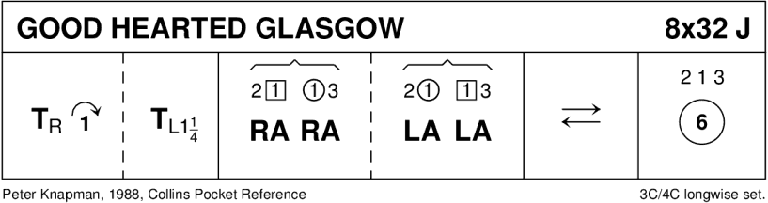

SHIFTIN' BOBBINS (R8x32) 3C (4C set) Clowes
1- 8 1s cross RH to double triangle position with 2s+3s & set
1s cast up to top & dance down until they are between 2s & 3s
9-16 1L dances RH across with 2M+3M while 1M dances LH across with 2L+3L
1s followed by 2s+3s dance down centre
17-24 3s followed by 2s+1s dance up --- 3s+2s cast down to place
1L dances LH across with 2M+3M while 1M dances RH across with 2L+3L
25-32 1s dance up to top & cast down to 2nd place opposite side
1s dance ½ Fig of 8 around 2s to end in 2nd place on own side

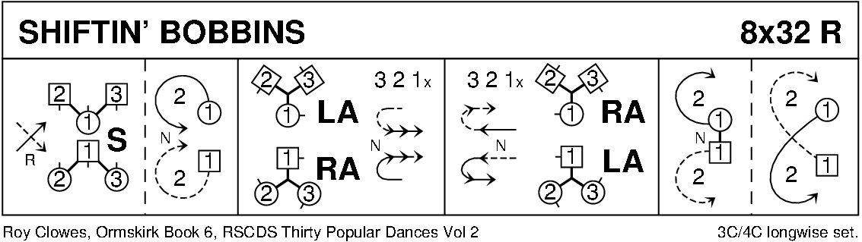

THE DREAM CATCHER (S96) Sq.Set RSCDS Bk 45
1- 8 All circle 8H round & back
9-16 1s+3s dance the Swirl:- Turn partner RH into allemande hold & dance LS round other couple 1/2 way
dance LH across ¾ way & swirl to face side couples (back to back with partner & lady facing man)
17-24 All dance reels of 4 across
25-32 All set, dancing couples dance out between side couples, cross & cast, change places RH with partner back to place
33-40 All set, advance with partners, retire diagonally with corners & set
41-48 1L+4M dance R&L with 3L+2M (on diagonal)
49-56 1M+2L dance R&L with 3M+4L (other diagonal)
57-64 All set with corners, advance & retire with partners & set
65-88 2s+4s repeat bars 9-32
89-96 All circle 8H round & back

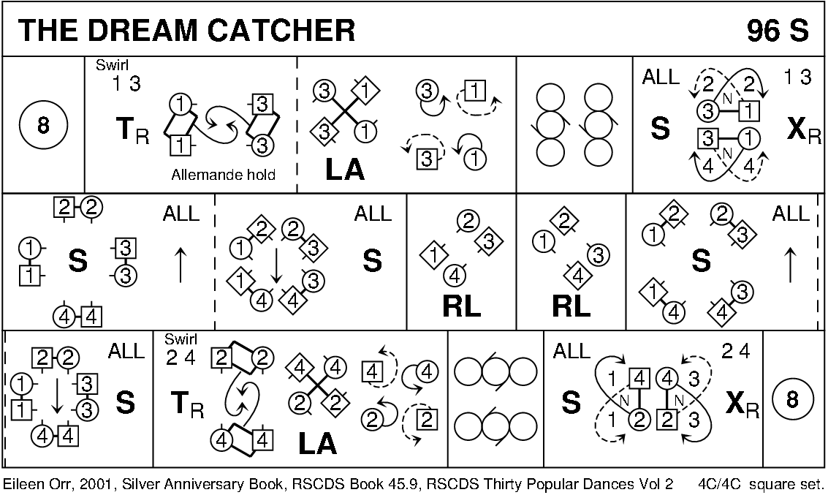

INCHMICKERY (J5x32) 5C set RSCDS Bk 53
1- 8 1s+2s circle 4H round to left, 1s dance in & cast to 3rd place
9-16 1s dance RH across (1L with 3s & 1M with 4s), pass RSh & dance LH across with other couple 2 3 1 4 5
17-24 1L+2M (at top) also 1M+5L (at bottom) turn RH, 1s pass RSh & 1L+5M (at bottom) also 1M+2L (at top) turn LH (1s end 3rd place own side)
25-32 1s dance in & cast to 5th place, 5s+1s circle 4H round to right. 2 3 4 5 1

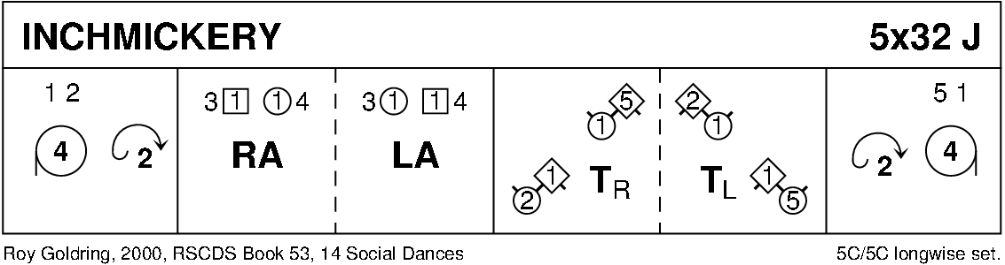

THE FALLS OF ROGIE (R8x32) 3C (4C set) Attwood
1- 8 1s cross RH & cast off 1 place, 1s cross RH & cast off 1 place (man up, lady down)
9-16 1s dance ½ reels of 3 across (1M+2s & 1L+3s), set in lines across & change places RH with opposite person
17-24 2s+1s+3s chase clockwise ½ way
1s dance in & turn RH to face 1st corner positions as 2s+3s continue to chase on to place (as bar 16)
25-32 1s dance ½ reel of 4 with 1st corners
passing RS dance ½ reel with 2nd corners & cross passing RS to 2nd place own side

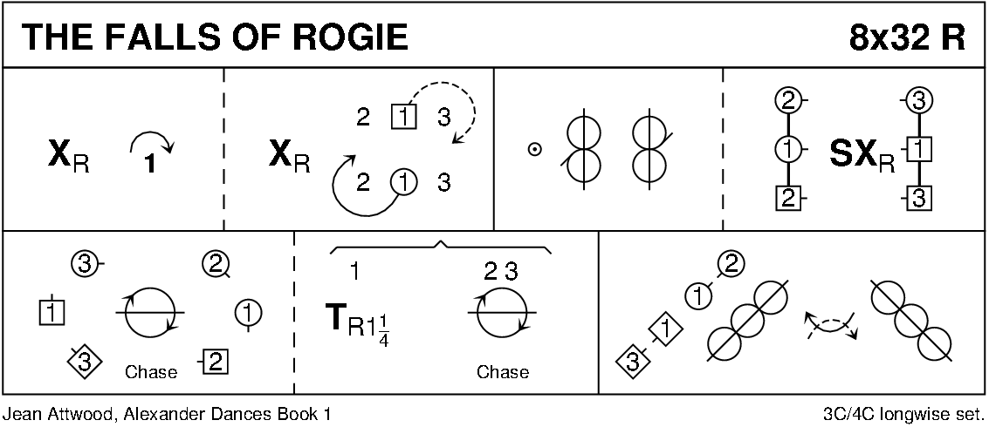

HOOPER'S JIG (J8x32) 3C (4C set) MMM
1- 8 All clap as 1s cross passing RS, cast to 2nd place & dance RH across with 3s
9-16 All clap as 1s cross passing RS, cast to 1st place & dance LH across with 2s
17-24 1M+3L change places RH, then 1L+3M change places RH (as 1M+3L loop round)
1M+3L change places RH (as 1L+3M loop round)
1L+3M cross LH 1L ending in 2nd place (as 1M casts to 2nd place)
25-32 2s+1s dance R&L

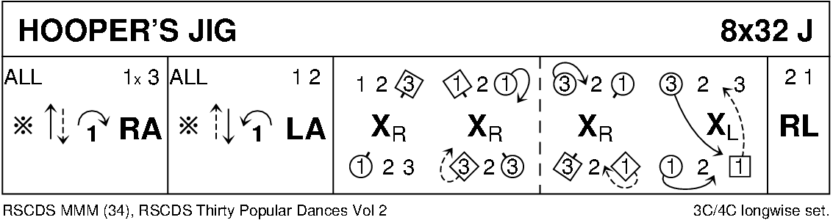

SCOTT MEIKLE (R4x32) 4C set RSCDS Bk 46
1- 8 1s cross RH & cast off 1 place, 1s dance ½ Fig of 8 round 2s
9-16 1s+3s dance RH across, LH back
17-24 1L followed by 3L dance Tandem reel of 3 across with 2s (1L ends 3rd place)
while 3M followed by 1M reel of 3 with 4s (3M to 2nd place)
25-32 1s+4s dance ½ R&L, turn partners RH 1½ times

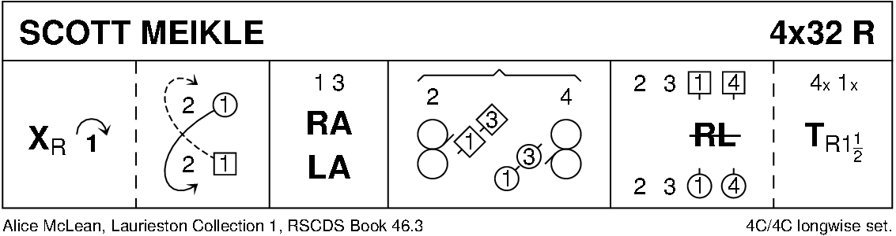

CAPE TOWN WEDDING (S8x32) 3C (4C set) RSCDS Bk 39
1- 8 1s cross (no hands) to 2nd place - face out & change places with 3s with nearer hand
1s (in 3rd place) ½ turn RH & lead up to top ending in promenade hold (2s+3s step down)
9-16 1s in promenade hold dance reel of 3 with 2s (RS to 2L to start)
1s end in middle at top facing down (lady on man’s left) & 3s step in & face up
17-24 1s+2s+3s set, 1s+3s Petronella-in-tandem to sides as 2s petronella into middle
1s+2s+3s (join hands in circle) set & cast back to places
25-32 1s+2s dance the Knot

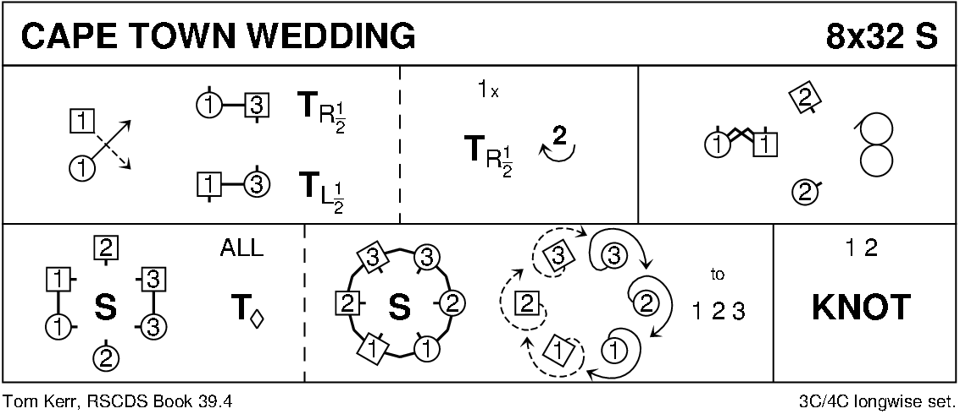

THE LAIRD OF MILTON'S DAUGHTER (J8x32) 3C (4C set) RSCDS Bk 22
1- 8 1s set, cross RH, cast off 1 place & turn LH to face 1st corners
9-16 1s change places RH with 1st corner
1st corners turn LH in centre & return to places giving RH to 1s who turn LH in centre to face 2nd corners
17-24 1s repeat bars 9-16 with 2nd corners ending in 2nd place own side
25-32 2s+1s+3s circle 6H round & back

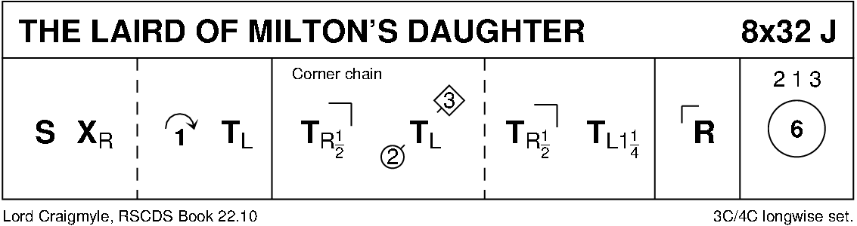

THE MONTGOMERIES' RANT (R8x32) 3C (4C set) RSCDS Bk 10
1- 8 1s cross RH & cast off 1 place, cross LH & 1L casts up while 1M casts down
9-16 1s dance reels of 3 across, 1L+ 2s & 1M+3s
17-24 1s with nearer hands joined (lady on man’s left) set to 2L & turn inwards to set to 3M;
Set to 3L, turn inward & set to 2M
25-32 2s+1s+3s dance reels of 3 on opposite side 1s giving RS to 2nd corner, 1s cross RH to 2nd place own side

