RSCDS Ayr Branch
Nice & Easy Afternoon ~ Friday 5th June 2026
St Ninian’s Church Hall, Troon 2.00 – 4.00pm

THE SHETLAND SHEPHERDESS (J8x32) 3C (4C set) RSCDS Graded 3
1- 8 1s dance down between 2s, cast back to place
1s dance ½ Fig 8 round 2s
9-16 1s+2s+3s dance reels of 3 on sides
(1s cross to 2nd place own side to begin, 2s out & up, 3s in & up) --- 2s finish facing out
17-20 1s+2s change places on side (Men RH, Ladies LH)
1s+3s turn on side (Men LH, Ladies RH) - 1s ending in middle facing up, 3s in original place
21-24 1s dance up to top and cast off to 2nd place
25-32 2s+1s+3s Adv+Ret - all clap end bar 28
2s+1s+3s turn partner RH once round

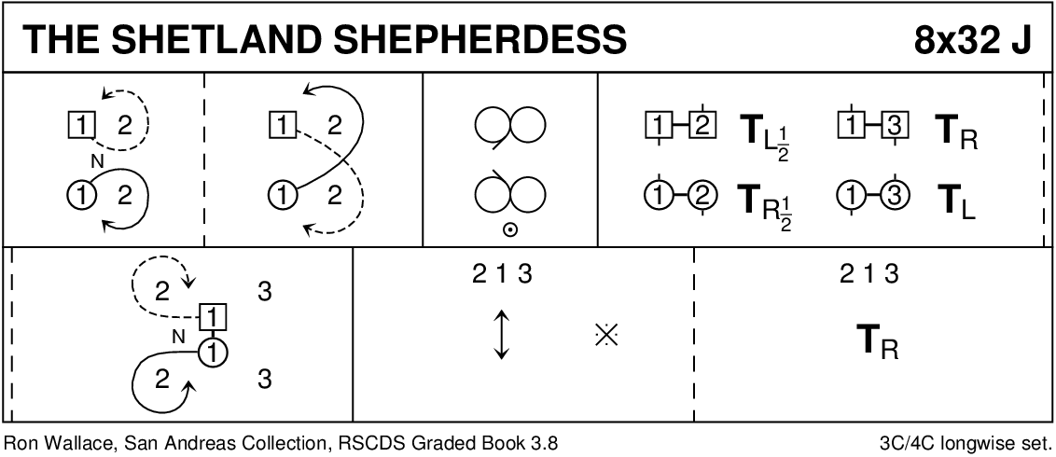

CATCH THE WIND (R8x32) 3C (4C set) RSCDS Bk 45
1- 8 1s set, cast off 1 place & dance ½ Fig of 8 round 2s
9-16 1s set twice with 1L turning to face out
1L followed by partner cast up & dance down the middle 1L to face 3M while 1M faces 2M
17-24 1s dance RS reels of 3 across (1M+2s & 1L+3s)
25-32 1L followed by partner dance down and cast up round 3M & cross to end in 2nd place on own side
1s turn RH (4 bars)

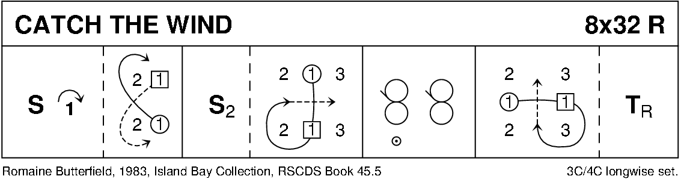

BROADWAY (S3x32) 3C set Ronald
1- 8 1s dance down (2 bars) & turn BH (2 bars), 1s dance up & cast off to 2nd place
9-16 2s+1s+3s Set+Link for 3, 1s dance ½ Diagonal R&L starting diagonally left
17-24 All Set+Link for 3, 1s dance ½ Diagonal R&L starting diagonally left (3)(1)(2)
25-32 All set & ½ turn RH, face partner and pull back RS, dance out to place & set 3 1 2

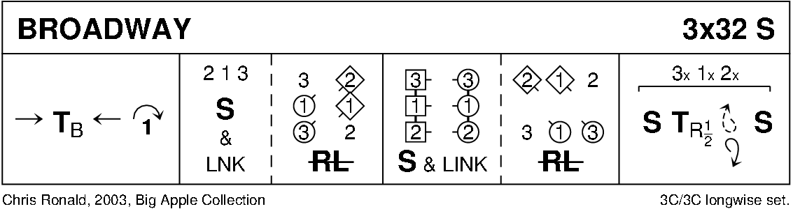

CUTTY SARK (J8x32) 3C (4C set) RSCDS Bk 40
1- 8 1s cast behind own line and cast back to 2nd place (2s step up 3-4)
9-16 2s+1s dance RH across and LH back
17-24 1s turn RH to face 1st corner, turn 1st corner LH, turn 2nd corner RH and cross LH to 2nd place own side
25-32 2s+1s+3s advance and retire and turn RH 2 1 3

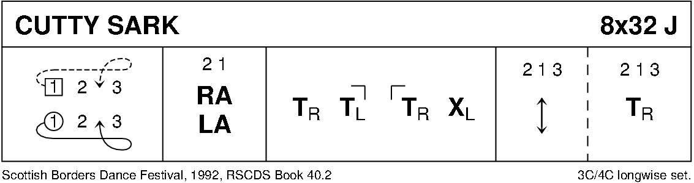

THE DEIL AMANG THE TAILORS (R8x32) 3C (4C set) RSCDS Bk 14
1- 8 1s+2s set & dance RH across ½ way, set & dance LH across ½ way back to place
9-16 1s lead down the middle & back to top
17-24 1s+2s dance Allemande
25-32 2s+1s+3s circle 6H round & back

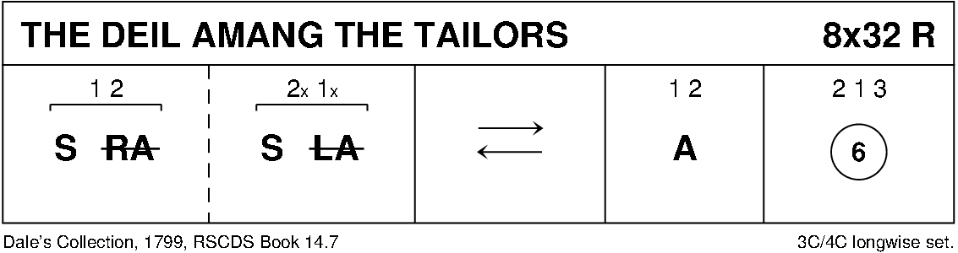

FAREWELL TO BALFOUR ROAD (J1x96) 5C set RSCDS Bk 52
1- 8 1s+2s circle 4H round & back
9-16 1s+2s Set+Link; 1s+3s Set+Link
17-24 *2s start* while 1s+4s+5s dance mirror reels of 3 on sides (1s in/down to start)
25-32 1s set, cross down RH to 4th place (4s step up)
1s set, cross down LH to 5th place (5s step up)
*New top couple start every 16 bars
Dance ends with 1s back in 1st place and 5s back in 5th place

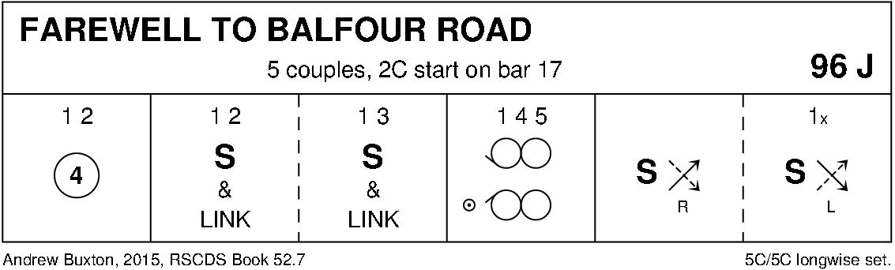

SCOTT MEIKLE (R4x32) 4C set RSCDS Bk 46
1- 8 1s cross RH & cast off 1 place, 1s dance ½ Fig of 8 round 2s
9-16 1s+3s dance RH across, LH back
17-24 1L followed by 3L dance Tandem reel of 3 across with 2s (1L ends 3rd place)
while 3M followed by 1M reel of 3 with 4s (3M to 2nd place)
25-32 1s+4s dance ½ R&L, turn partners RH 1½ times

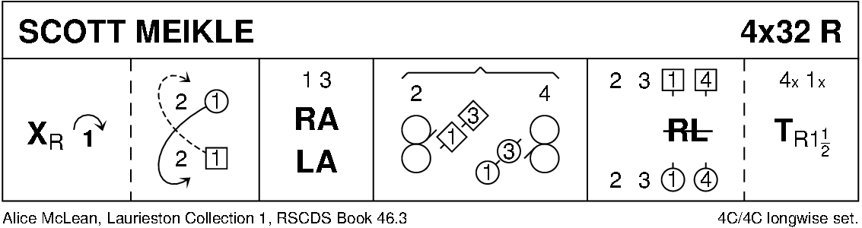

THE BONNIE TREE (S8x32) 3C (4C set) RSCDS Bk 46
1- 8 1s dance down below 3s, cast up behind 3s, dance up between 2s and cast off to 2nd place
9-16 2s+1s+3s ½ turn partner BH and twirl to opposite place
all circle 6H round to left ¾ way into lines across (men facing down at top, ladies facing up)
17-20 1s change places RH and cast to right to 2nd place own side while (bar 19) 3M+2L change places diagonally RH
21-24 1s cross RH and cast to right into middle while (bar 23) 2M+3L change places RH –
all end in lines across (ladies facing down, men facing up)
25-32 All ½ turn partner BH and twirl to opposite place
all circle 6H round to left to own side 2 1 3

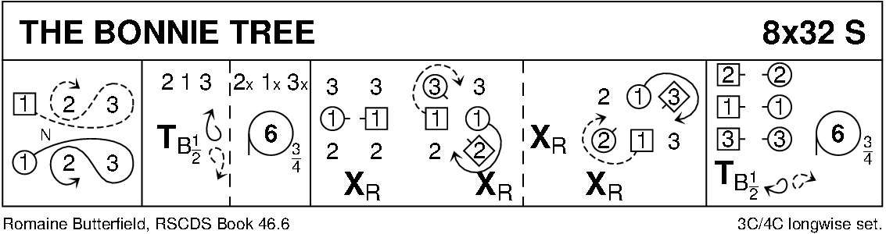

THE WILD GEESE (J8x32) 3C (4C set) RSCDS Bk 24
1- 8 1s+3s set advancing & Bal-in-Line, turn partner RH & 1s cast off to 3rd place while 3s lead up to 1st place
9-16 3s+1s set advancing & Bal-in-Line, turn partner RH & 3s cast off to 3rd place while 1s lead up to 1st place
17-24 1s lead down & back to 2nd place
25-32 2s+1s dance R&L

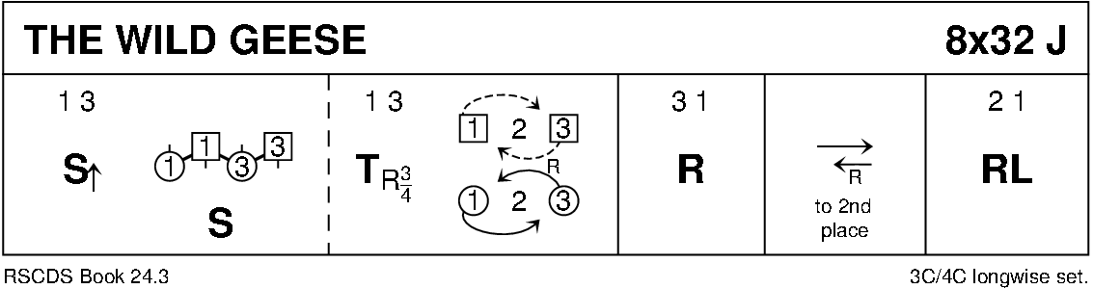

DUKE OF PERTH (R8x32) 3C (4C set) RSCDS Bk 1
1-8 1s turn RH, cast off 1 place, turn LH to face 1st corner
9-16 1s turn 1st corner RH, partner LH, 2nd corner RH & partner LH to face 1st corner
17-24 1s set & turn 1st corner BH, set to & turn 2nd corner BH
25-32 1s dance reel of 3 on opposite side giving LS to 1st corner & cross back to own side

