RSCDS Ayr Branch
Nice & Easy Afternoon ~ Friday 3rd July 2026
St Ninian’s Church Hall, Troon 2.00 – 4.00pm

EH3 7AF (J8x32) 3C (4C set) RSCDS Bk 40 1- 8 1s lead down the middle & back to top
9-16 1s+2s+3s Promenade ending with 1s casting to 2nd place
17-24 1s pass by the right & turn 1st corners RH to end L between 2s & M between 3s
1s pass by the right & turn 2nd corners RH to end between corners
25-32 1M+2s and 1L+3s dance RH across
1L dances up between 2s & casts to 2nd place own side as 1M dances between 3s & casts up

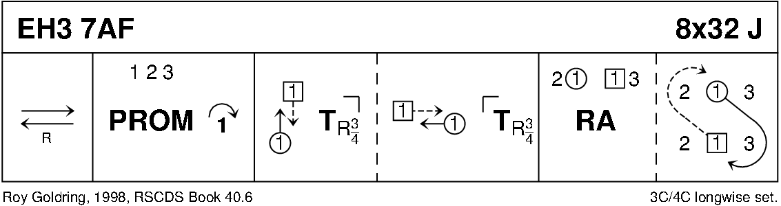

THE PIPER AND THE PENGUIN (R88) Sq.Set Scotia Suite
1- 8 Ladies dance RS round their corner, dance RH across ending in centre
9-16 Ladies dance LS round their partner, dance LH across and back to place
17-24 Men dance RS round their partner, dance RH across ending in centre
25-32 Men dance LS round corner, dance LH across and back to place
33-40 1s+3s turn partner RH 1¼ times, Men followed by partner dance out to right between side couples and back to place (1M through 4s and 3M through 2s)
41-48 1s+3s dance R&L
49-56 2s+4s turn partner RH 1¼ times, Men followed by partner dance out to right between top/bottom couples and back to places (2M through 1s and 4M through 3s)
57-64 2s+4s dance R&L
65-72 Ladies dance in turning right about to dance out, cast clockwise to opposite lady's place
73-80 Men dance in turning left about to dance out, cast anticlockwise to opposite place
81-88 All turn partners RH 1¼ times into promenade hold
Promenade anticlockwise ½ way round to original place

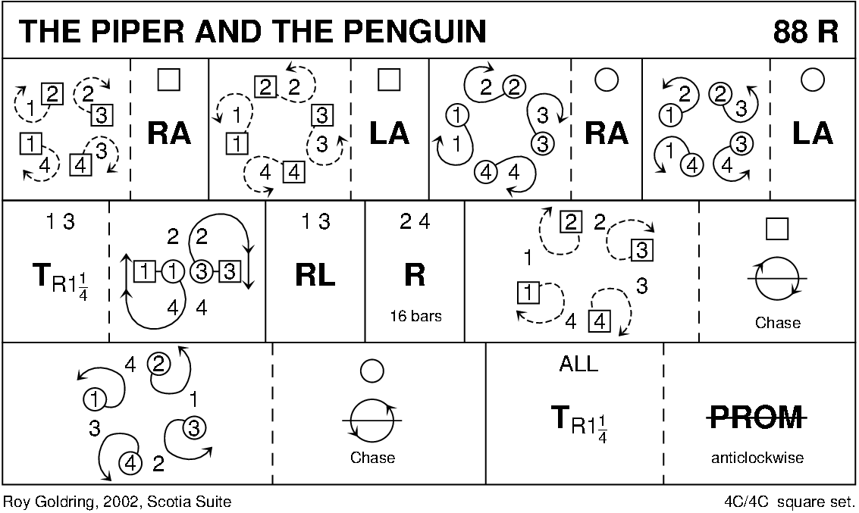

MATHILDE IS A DELIGHT (S3x32) 3C set RSCDS Book 50
1-8 1s+2s+3s dance Grand Chain
9-16 1L followed by 1M casts to 2nd place opposite side (2s step up)
1M followed by 1L casts to 3rd place own side (3s step up)
17-24 2s+3s+1s set, turn partner RH half way, pull back RS and dance out to opposite side, all set
25-26 2s+3s+1s circle 6H ½ round to left 1 3 2
27-32 1s+2s dance The Capstan:
27-28 1s nearer hands joined dance down 2 places while 2s cast up to 1st place
29-30 2s nearer hands joined dance down 2 places while 1s cast up to 1st place
31-32 1s nearer hands joined dance down 2 places curving into 3rd place while 2s cast up to first place

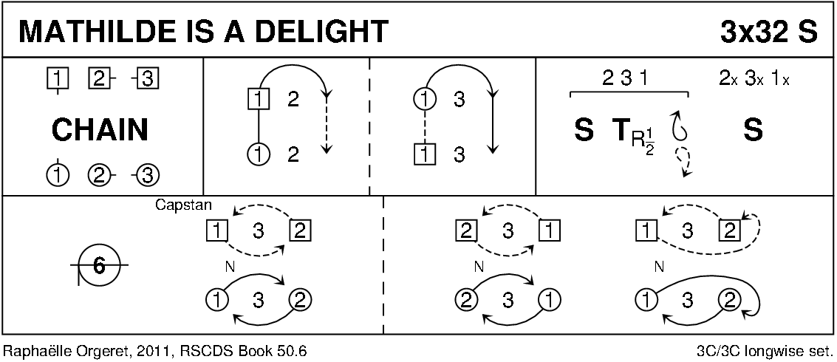

THE WILD GEESE (J8x32) 3C (4C set) RSCDS Bk 24
1- 8 1s+3s set advancing & Bal-in-Line, turn partner RH & 1s cast off to 3rd place while 3s lead up to 1st place
9-16 3s+1s set advancing & Bal-in-Line, turn partner RH & 3s cast off to 3rd place while 1s lead up to 1st place
17-24 1s lead down & back to 2nd place
25-32 2s+1s dance R&L

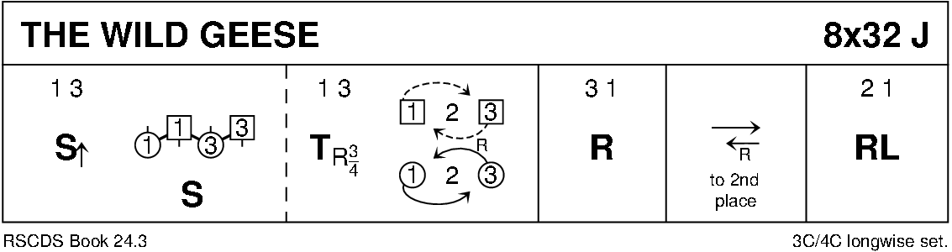

TAMBOURINE (R8x32) 3C (4C set) Bowlen
1- 8 1s lead down the middle & back to 2nd place own side
9-16 1s dance ½ reels of 3 across (1L+2s & 1M+3s) & ½ reels of 3 on opposite side
17-24 1s dance ½ reels of 3 across (man up/ lady down) & ½ reels on own side
25-32 2s+1s+3s circle 6H round & back

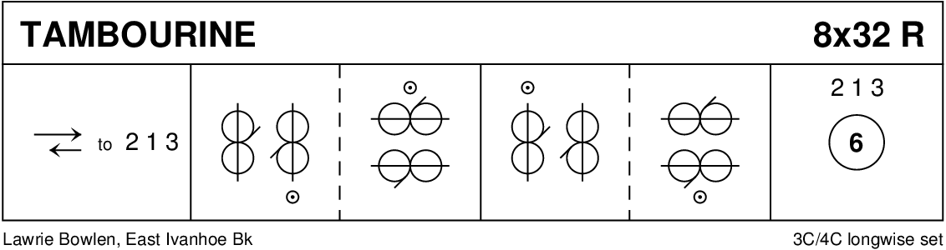

THE YORKSHIRE ROSE (J8x32) 3C (4C set) RSCDS Bk 54
1- 8 1s+2s+3s set & cross RH, repeat back to places
9-16 1s lead down the middle then lead up to 2nd places (2s step up 11-12)
17-24 2s+1s turn (Men RH, Ladies LH), 1s+3s turn (Men LH, Ladies RH)
25-32 2s+1s+3s dance reels of 3 on sides with 1s out/up, 2s in/down to start
(2nd time through the 1s continue the reel into 4th place)
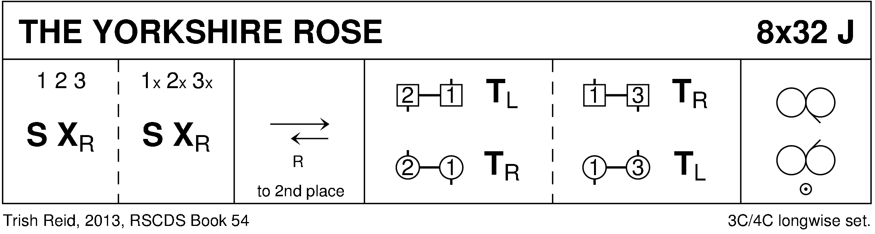

RAMADAN-CE (R8x32) 3C (4C set) Drewry
1- 8 1s dance Inveran Reels with 2s+3s
9-16 1s cross RH, cast off 1 place & turn RH to face 1st corner
17-24 1s dance RS round 1st corner, pass RS & dance RS round 2nd corner to end 2nd place opposite side
while 1st corners dance in, ½ turn RH, twirl & dance out to each other’s place ---
2nd corners dance similarly (3) (1) (2)
25-32 1s dance ½ LS reels of 3 across (1M at top with 3s & 1L at bottom with 2s)
1s dance ½ RS reels of 3 on own sides (Man Down, Lady up)

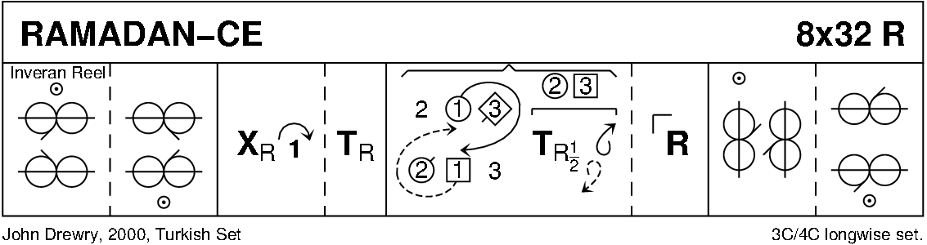

AYRSHIRE LASSES (S5x32) 5C set Haynes
1-8 1s+3s cross RH, cast 1 place, cross LH, cast (Lady up, Man down) and end in the middle (1M+3L passed LS)
9-16 Reels across: 1M+3L+4s reel of 4 in centre while 1L+2s and 3M+5s reels of 3, all giving RS to 1st corner
17-24 1s+3s turn 1st corner, partner, 2nd corner and partner into...
25-32 All dance RH across (2s+1L and 1M+4s+3L and 3M+5s)
1s+3s turn partner LH and cast off 1 place on own side 2 4 1 5 3

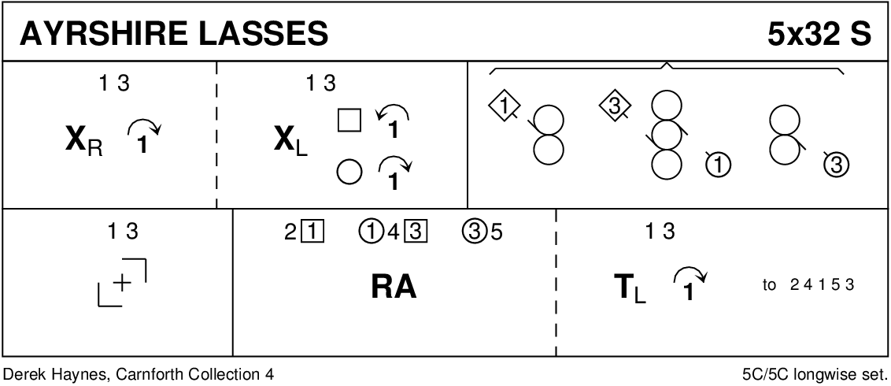

POSTIE'S JIG (J4x32) 4C set Clowes
1- 8 1+4s set, cast off/up 1 place & dance ½ figure of 8 round new end couples
9-12 1M+4M & 1L+4L cross (men making an arch) & turn corners with free hand to face up/down
13-16 1s+4s dance down/up (couple dancing up make the arch) & turn corners
17-24 Repeat bars 9-16 from new positions
25-32 1s+4s dance ½ R&L & turn partner RH

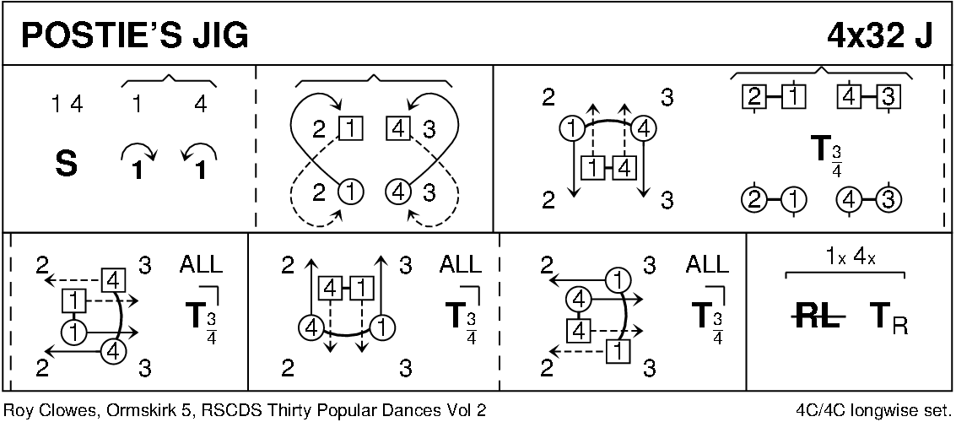

MAIRI'S WEDDING (R8x40) 3C (4C set Cosh
1- 8 1s turn RH, cast off 1 place & turn LH to face 1st corner
9-16 1s dance ½ diagonal reel of 4 with 1st corners & ½ diagonal reel with 2nd corners
17-24 1s dance ½ diagonal reel with 3rd corner s & ½ diagonal reel with 4th corner s
25-32 1s dance reel of 3 across (1L+ 2s & 1M 3s (LS to 1st corner)
33-40 2s+1s+3s circle 6H round & back

