RSCDS Ayr Branch
Nice & Easy Afternoon ~ Friday 6th February 2026
St Ninian’s Church Hall, Troon 2.00 – 4.00pm

EH3 7AF (J8x32) 3C (4C set) RSCDS Bk 40 1- 8 1s lead down the middle & back to top
9-16 1s+2s+3s Promenade ending with 1s casting to 2nd place
17-24 1s pass by the right & turn 1st corners RH to end L between 2s & M between 3s
1s pass by the right & turn 2nd corners RH to end between corners
25-32 1M+2s and 1L+3s dance RH across
1L dances up between 2s & casts to 2nd place own side as 1M dances between 3s & casts up

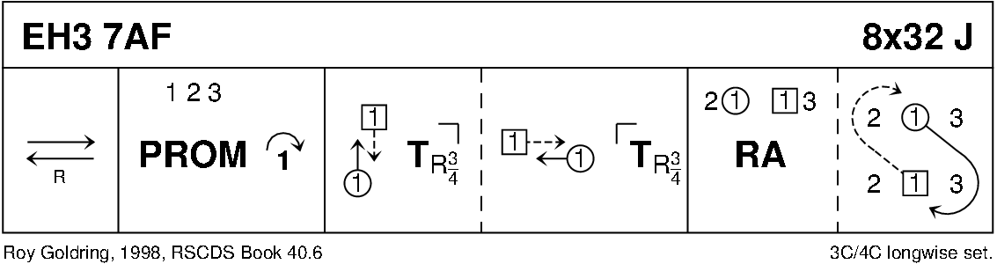

THE YOUNG ACCORDION MAN (R8x32) 3C (4C set) Ruth Taylor Stagger Inn
1-8 1s+2s+3s advance and retire; 1s dance in and cast (2s step up)
9-16 2s+1s+3s advance and retire; 1s turn RH (birl) to finish facing 1st corners
17-32 1s dance Corner Chain with 1st and 2nd corners:
1s change RH with 1st corners, 1st corners turn LH, change RH with 1s, 1s turn LH to 2nd corners
1s change RH with 2nd corners, 2nd corners turn LH, change RH with 1s,
1s end with ½ turn LH to 2nd place own sides 213

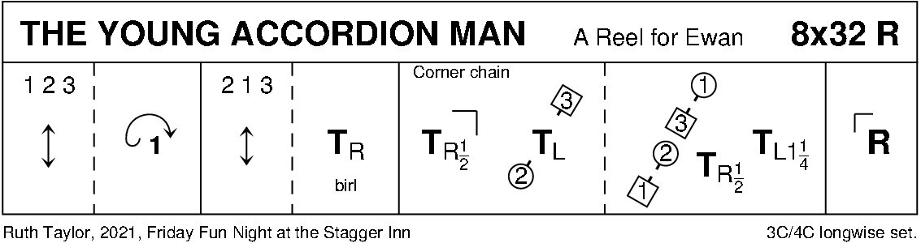

CAPE TOWN WEDDING (S8x32) 3C (4C set) RSCDS Bk 39
1- 8 1s cross (no hands) to 2nd place - face out & change places with 3s with nearer hand
1s (in 3rd place) ½ turn RH & lead up to top ending in promenade hold (2s+3s step down)
9-16 1s in promenade hold dance reel of 3 with 2s (RS to 2L to start)
1s end in middle at top facing down (lady on man’s left) & 3s step in & face up
17-24 1s+2s+3s set, 1s+3s Petronella-in-tandem to sides as 2s petronella into middle
1s+2s+3s (join hands in circle) set & cast back to places
25-32 1s+2s dance the Knot

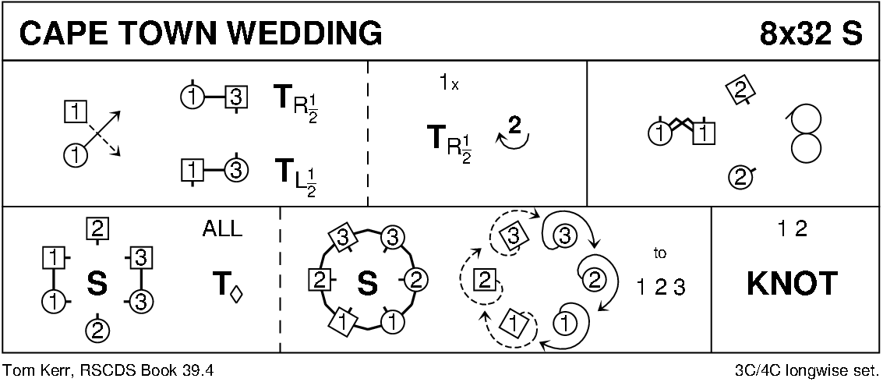

THE YORKSHIRE ROSE (J8x32) 3C (4C set) RSCDS Bk 54
1- 8 1s+2s+3s set & cross RH, repeat back to places
9-16 1s lead down the middle then lead up to 2nd places (2s step up 11-12)
17-24 2s+1s turn (Men RH, Ladies LH), 1s+3s turn (Men LH, Ladies RH)
25-32 2s+1s+3s dance reels of 3 on sides with 1s out/up, 2s in/down down to start
(2nd time through the 1s continue the reel into 4th place)
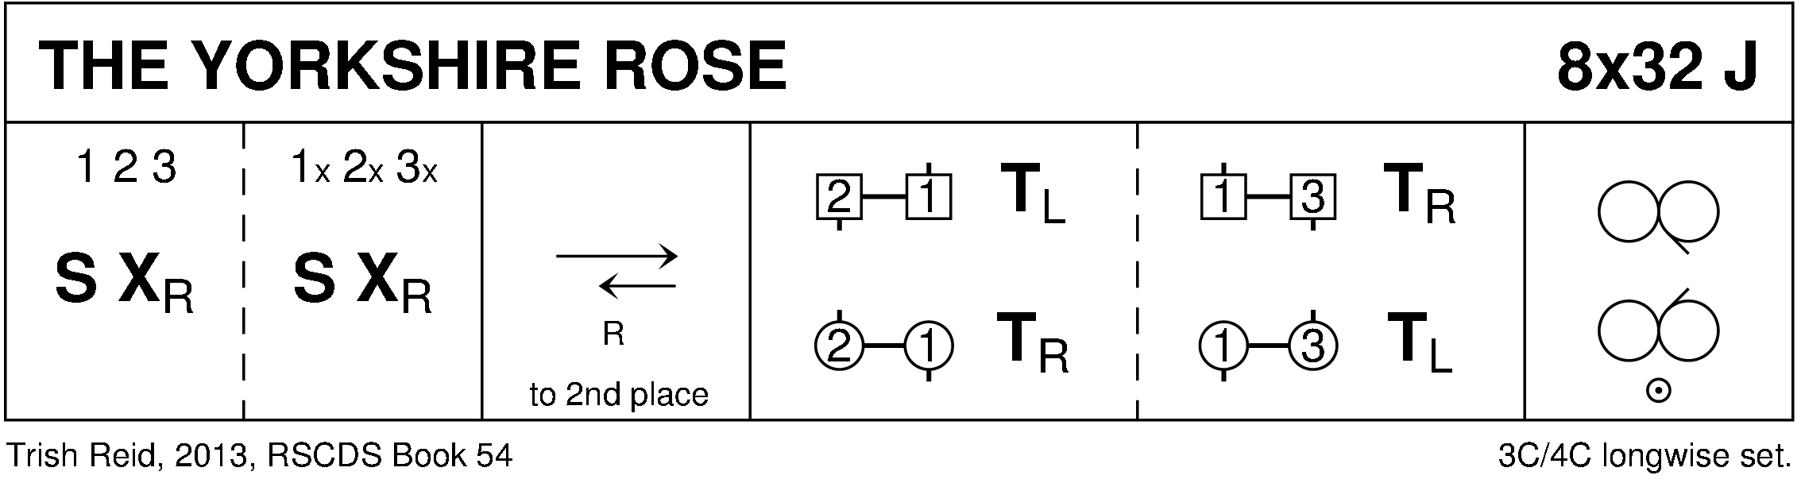

MISS JOHNSTONE OF ARDROSSAN (R5x32) 5C set Goldring
1- 8 1s set, cast off 1 place
1s followed by 3s dance up & cast - 1s to 3rd place & 3s to 2nd place
9-16 1s dance reels of 3 with 4s+5s on opposite sides - 1s end in 3rd place opposite side
17-24 1s dance reels of 3 on own side with 2s+3s - 1s ending in 3rd place own side
25-32 1s set, cast off 1 place
1s followed by 5s dance up between 4s & cast - 1s to 5th place & 5s to 4th place

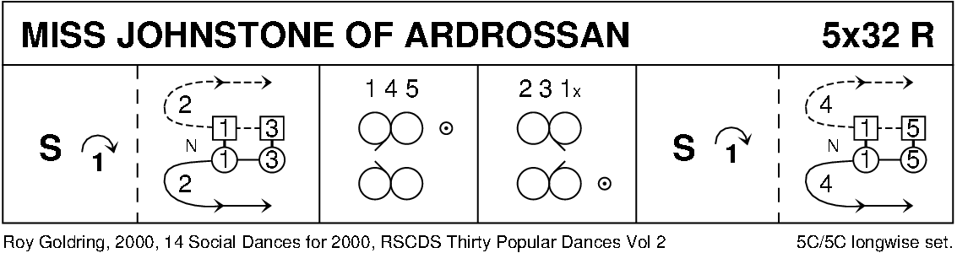

PELORUS JACK (J8x32) 3C (4C set) RSCDS Bk 41
1- 8 1s cross RH, cast off 1 place; dance RH across with 3s - 1M end facing 1st corner with partner behind
9-16 1s dance alternating tandem ½ reel of 3 with 1st corners & alternating tandem ½ reel with 2nd corners
  - 1s dance alternating tandem ½ reel of 3 with 3rd corner positions & alternating tandem ½ reel with 4th corner positions
  - 1M followed by partner dance into LH across with 2s
1s retain LH & ½ turn to own side, 2s+1s+3s set

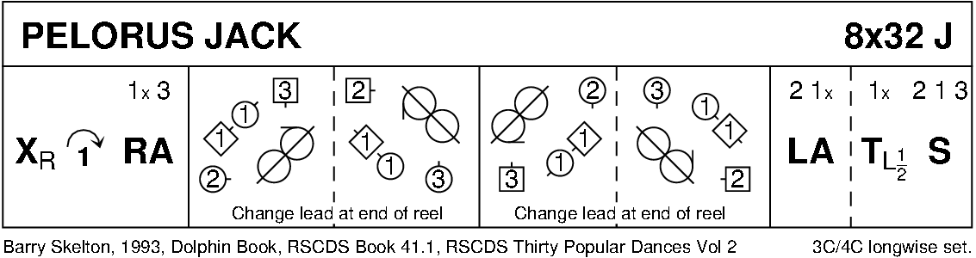

DOMINO FIVE (R5x32) 5 person Square set with 5th person in centre Gr Bk 2
1- 8 5+1+2 dance RH across, 5+3+4 dance LH across
9-16 5+1+3 dance RS reel of 3 (5+1 pass RS to start)
17-24 5+4+2 dance LS reel of 3 (5+4 pass LS to start)
25-32 5 change place with 1 (pass RS)
1 change place with 4
4 change place with 3
3s change place with 2 --- 2 becomes new 5 (similar to Fisherman's Reel)

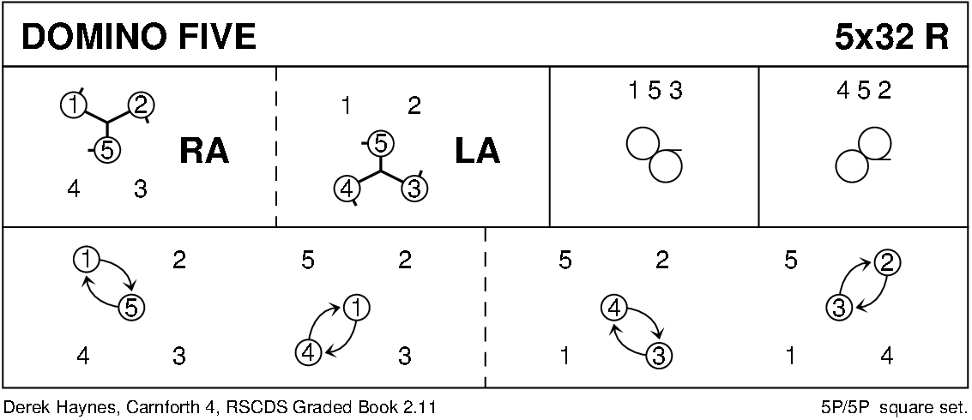

RANNOCH MOOR (S5x32) 5C set Roy Goldring Graded Book 3
1- 4 1s cross down to dance ½ Fig of 8 round 2s and 1s dance into middle (2nd place) as 2s step up
5- 8 1L+2M+3M dance RH across as 1M+2L+3L dance LH across and end in Prom hold facing 3M
9-16 1s dance RS reel of 3 across with 3s ending in 2nd place with 1s facing 4M
17-24 1s dance reel of 3 with 4s into middle with 4s ending in 3rd place and 1s end in middle in 4th place
25-28 1L dances RH across with 4M+5M as 1M dances LH across with 4L+5L
29-32 1s cast up round 5s and cross down to 5th place own sides (5s step Up)

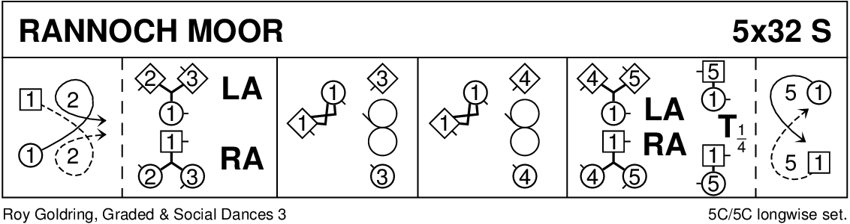

JOIE DE VIVRE (J8x32) 3C (4C set) RSCDS Bk 39
1- 8 1s set, cast off 1 place, 1s dance down between 3s & cast up to 2nd place on own side
9-16 2s+1s+3s turn RH & chase ½ way round clockwise
17-24 3s+1s+2s dance back to back, set & ½ turn partners RH for Allemande
25-32 3s+1s+2s dance Allemande

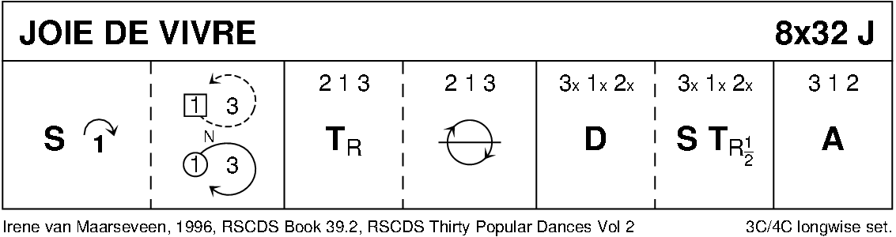

MAIRI'S WEDDING (R8x40) 3C (4C set Cosh
1- 8 1s turn RH, cast off 1 place & turn LH to face 1st corner
9-16 1s dance ½ diagonal reel of 4 with 1st corners & ½ diagonal reel with 2nd corners
17-24 1s dance ½ diagonal reel with 3rd corner s & ½ diagonal reel with 4th corner s
25-32 1s dance reel of 3 across (1L+ 2s & 1M 3s (LS to 1st corner)
33-40 2s+1s+3s circle 6H round & back

