RSCDS Ayr Branch

Nice & Easy Afternoon ~ Friday 1st August 2025

St Ninian’s Church Hall, Troon 2.00 – 4.00pm

ROARING JELLY (J8x32) 3C (4C set) Foss

1- 8 1s cross RH, cast off 1 place, cross RH & cast (man up & lady down) into centre

9-16 1s+2s+3s circle 6H round & back (1s end in centre)

17-24 1s change places RH & dance to right into Figs of 8 (1L round 2s **as** 1M dances round 3s)

25-32 1s dance reels of 3 on opposite side giving RS to 2nd corners & cross RH

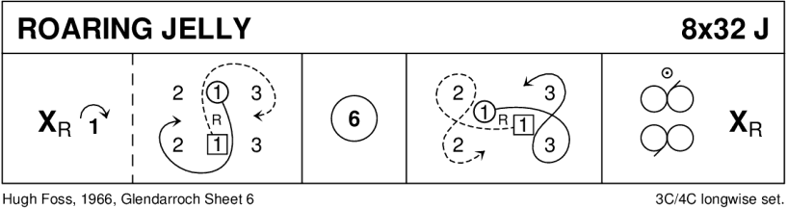

THE HIGHLAND RAMBLER (R8x40) 3C (4C set) Goldring 1- 8 1s dance in & cast off 1 place; dance RH across with 3s

9-16 2s+1s dance LH across

1L followed by partner cast up round 2L & dance down middle to 1L between 3s & 1M between 2s

17-24 1s+2s+3s dance down the middle & back

25-32 1M followed by partner cast up round 2L to 2nd place on own side & turn RH

33-40 2s+1s+3s circle 6H round & back

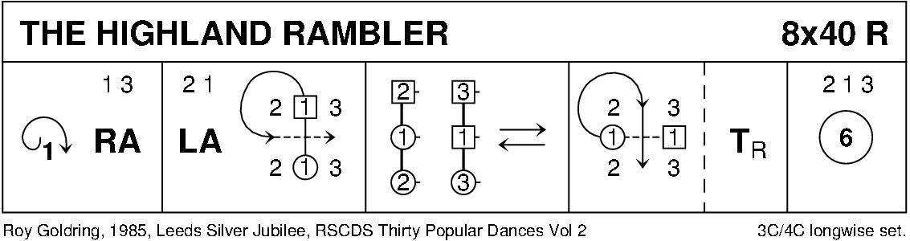

CAPE TOWN WEDDING (S8x32) 3C (4C set) RSCDS Bk 39

1- 8 1s cross (no hands) to 2nd place - face out & change places with 3s with nearer hand

1s (in 3rd place) ½ turn RH & lead up to top ending in promenade hold (2s+3s step down)

9-16 1s in promenade hold dance reel of 3 with 2s (RS to 2L to start)

1s end in middle at top facing down (lady on man’s left) & 3s step in & face up

17-24 1s+2s+3s set, 1s+3s Petronella-in-tandem to sides **as** 2s petronella into middle

1s+2s+3s (join hands in circle) set & cast back to places

25-32 1s+2s dance the Knot

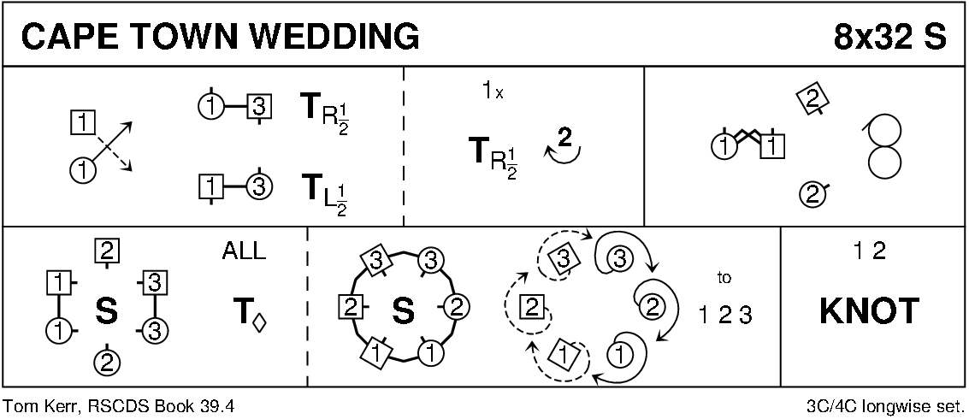

MRS STEWART'S JIG (J8x32) 3C (4C set) RSCDS Bk 35

1- 8 1s set, 1L followed by partner cast off 2 places, 1L crosses (below 3s) & casts up on men’s side to 2nd place facing down **while** 1M dances round 3L & up middle to 2nd place ladies’ side facing down

9-16 2s+1s+3s dance Grand Chain - end with 2M & 1M facing out

17-24 2s+1s dance Ladies’ Chain

25-32 2s+1s+3s Adv+Ret for 2 steps & 1s turn 1½ RH to own sides

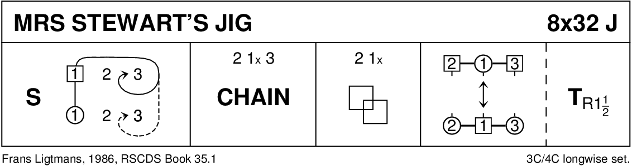

BACK TO THE FIRESIDE (R8x32) 3C (4C set) RSCDS Bk 38 1- 8 3s followed by 1s dance down for 2 steps & set to partners

1s dance up & cast off to 3rd place **while** 3s dance up to top place

9-16 1s cross RH to start reverse Snowball Grand Chain for 3 couples to end 1 (2) 3

17-24 1s+2s set advancing to form circle (hands joined) & petronella 1 place to right

Set hands joined & petronella turn to end on side

25-32 1L dances ½ Fig of 8 round 2s **as** 1M dances ½ Fig of 8 round 3s

2s+1s+3s turn RH

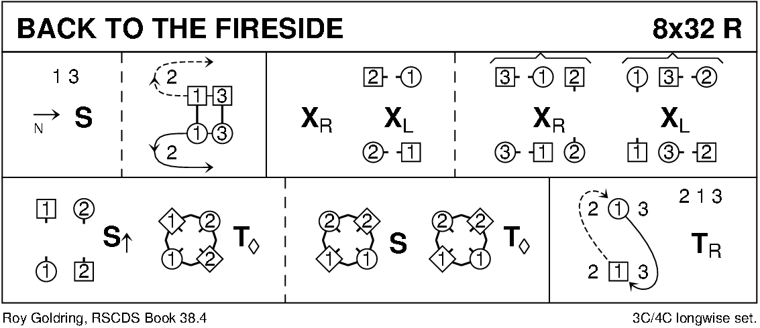

THE FRISKY (J8x32) 3C (4C set) RSCDS Bk 26

1- 8 1s turn RH & cast off 1 place, turn LH & cast off 1 place

9-16 2s+3s+1s circle 6H round & back

17-24 1s lead up to top; 1s+2s set twice

25-32 1s+2s dance ½ R&L; set & cross RH to own side

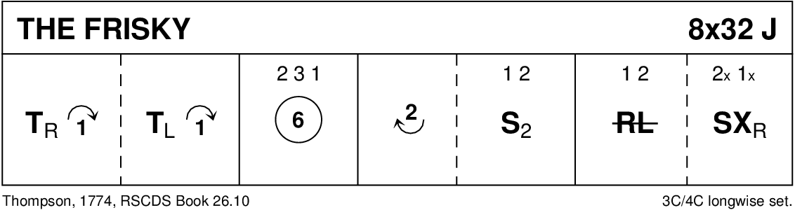

THE LOCHALSH REEL (R8x40) 3C (4C set) RSCDS Bk 53

1- 8 1s turn RH, cast off 1 place, cross LH, cast off 1 place to meet partner in promenade hold facing 3M (Lady on Man's left)

9-16 1s dance LS reel of 3 across with 3s

17-24 1s separate to dance reels of 3 on opposite side

25-32 1s dance up to top, turn 2s with other hand, cross down between 3s & cast up to 2nd place own side

33-40 1s dance RH across (1L+2s & 1M+ 3s), pass RS to dance LH across with other couple

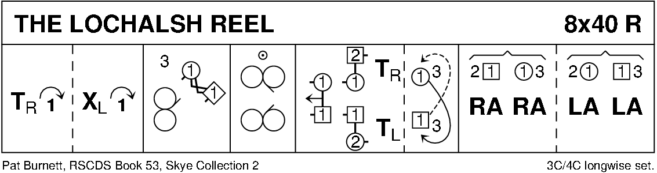

THE BYRON STRATHSPEY (S3x32) 3C set Drewry

1-8 All petronella turn into the centre & set to partner, turn BH 1¼ times back to places

9-16 1s+2L & 3s+2M dance RH across, 2s pass RS & dance LH across with other couple

17-24 2s in promenade hold dance reel of 3 with 1s passing 1L RS, end 2s in centre at top

25-32 2s+1s+3s dance Allemande

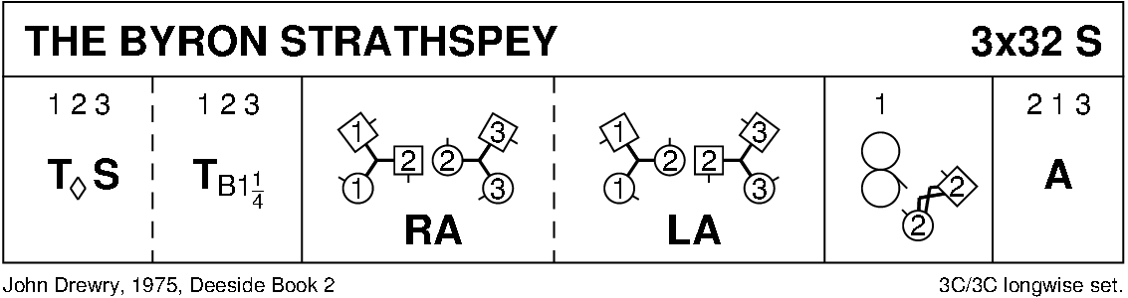

WELCOME TO AYR (J8x32) 3C (4C set) RSCDS Bk 47

1- 8 1s+2s dance double Fig of 8 (1s cross down to start)

9-16 1s turn 2s on sides (Men RH, Ladies LH)

1s dance down to turn 3s on sides (Men RH, Ladies LH) ---1s end facing 1st corners

17-24 1s dance ½ reel of 4 with 1st corners & pass RS to face 2nd corner

1s dance ½ reel of 4 with 2nd corners & 1s end in middle LS to LS facing own side

25-28 1M+3s (at top) **also** 1L+2s dance RH across (1s end in 2nd place opposite side)

all chase clockwise ½ way to own side

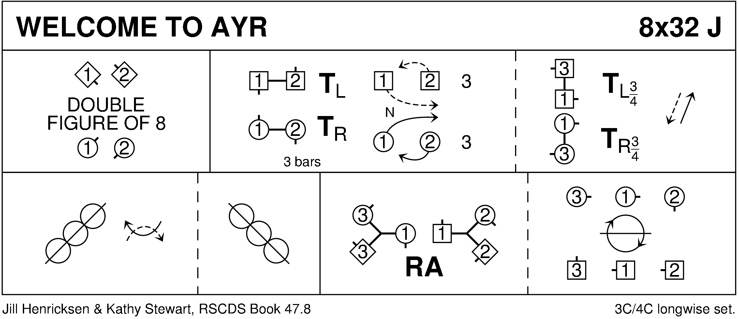

MAIRI'S WEDDING (R8x40) 3C (4C set) Cosh

1- 8 1s turn RH, cast off 1 place & turn LH to face 1st corner

9-16 1s dance ½ diagonal reel of 4 with 1st corners & ½ diagonal reel with 2nd corners

17-24 1s dance ½ diagonal reel with 3rd corner s & ½ diagonal reel with 4th corner s

25-32 1s dance reel of 3 across (1L+ 2s & 1M 3s (LS to 1st corner)

33-40 2s+1s+3s circle 6H round & back

