RSCDS Ayr Branch
Nice & Easy Afternoon ~ Friday 3rd April 2026
St Ninian’s Church Hall, Troon 2.00 – 4.00pm

ROARING JELLY (J8x32) 3C (4C set) Foss
1- 8 1s cross RH, cast off 1 place, cross RH & cast (man up & lady down) into centre
9-16 1s+2s+3s circle 6H round & back (1s end in centre)
17-24 1s change places RH & dance to right into Figs of 8 (1L round 2s as 1M dances round 3s)
25-32 1s dance reels of 3 on opposite side giving RS to 2nd corners & cross RH

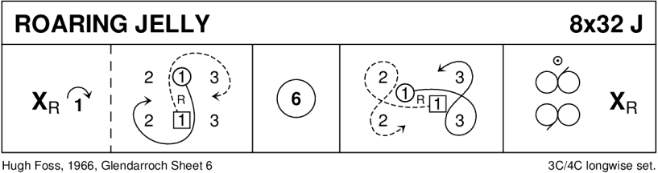

MISS JOHNSTONE OF ARDROSSAN (R5x32) 5C set Goldring
1- 8 1s set, cast off 1 place
1s followed by 3s dance up & cast - 1s to 3rd place & 3s to 2nd place
9-16 1s dance reels of 3 with 4s+5s on opposite sides - 1s end in 3rd place opposite side
17-24 1s dance reels of 3 on own side with 2s+3s - 1s ending in 3rd place own side
25-32 1s set, cast off 1 place
1s followed by 5s dance up between 4s & cast - 1s to 5th place & 5s to 4th place

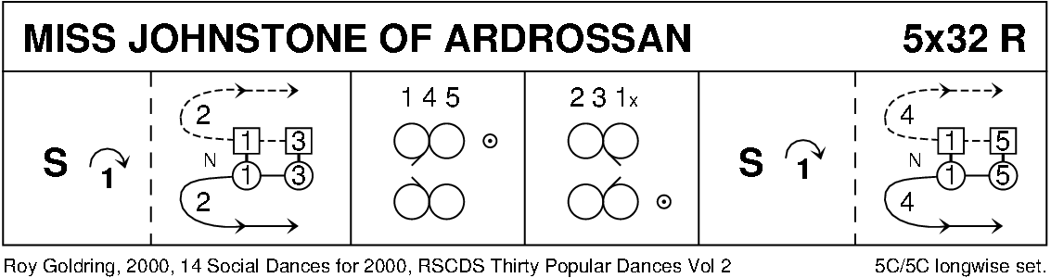

MISS GIBSON'S STRATHSPEY (S8x32) 3C (4C set) RSCDS Leaflet 10
1- 8 1s+2s set, turn partners BH opening out into 4H round
9-16 1s+2s dance the Knot, 1s turn LH to end facing 1st corner
17-24 1s turn corners RH, partner LH, 2nd corner RH & partner LH
25-32 1s dance RH across, (1M+3s & 1L+2s), pass partner RS & dance LH across with other couple, 1s end in 2nd place

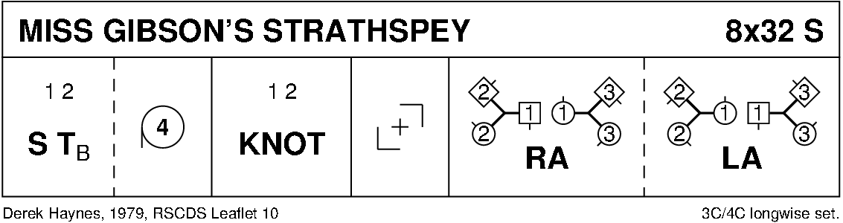

MISS HADDEN'S REEL (J8x32) 3C (4C set) RSCDS Book 23
1- 8 1s+2s+3s circle 6H round and back
9-16 1s set and cast off 1 place (2s step up); 2s+1s+3s all turn RH to end in Allemande hold ready for...
17-24 2s+1s+3s dance Allemande
25-32 3s+1s+2s advance and retire for 2 steps
3s cast to 3rd place while 1s+2s dance up, 1s casting to 2nd place 213
* 2nd turn bars 29-32: 3s cast to bottom and dance up to 3rd place, original 1s cast to bottom, 2s dance up to place

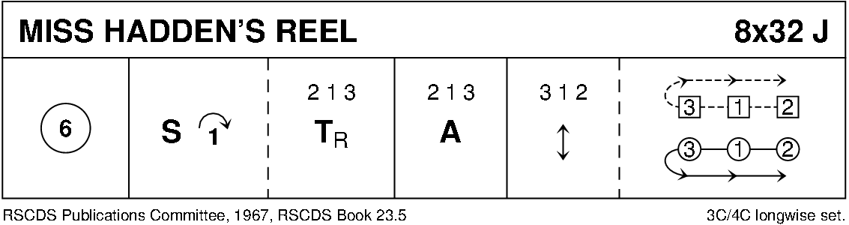

MAXWELL'S RANT (R8x32) 3C (4C set) RSCDS Bk 18
1- 8 1s dance reels of 3 on opposite side
9-16 1s dance reels of 3 on own side
17-24 1s cross RH, cast off one place & dance ½ Fig of 8 round 2s
25-32 1s dance down between the 3s, cast up to 2nd place
2s+1s+3s turn partners RH

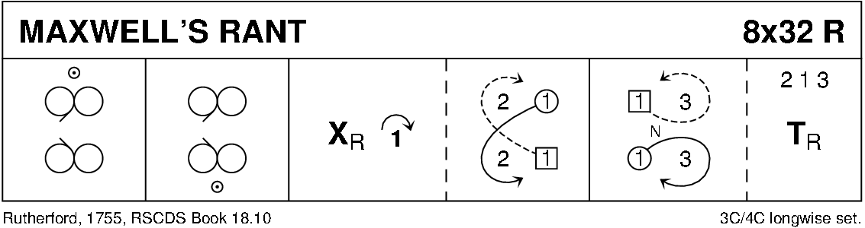

MRS STEWART'S JIG (J8x32) 3C (4C set) RSCDS Bk 35
1- 8 1s set, 1L followed by partner cast off 2 places, 1L crosses (below 3s) & casts up on men’s side to 2nd place facing down while 1M dances round 3L & up middle to 2nd place ladies’ side facing down
9-16 2s+1s+3s dance Grand Chain - end with 2M & 1M facing out
17-24 2s+1s dance Ladies’ Chain
25-32 2s+1s+3s Adv+Ret for 2 steps & 1s turn 1½ RH to own sides

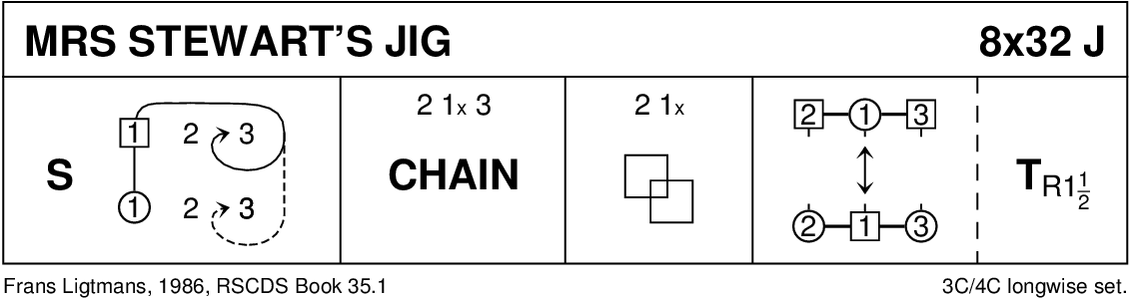

THE HIGHLAND RAMBLER (R8x40) 3C (4C set) Goldring 1- 8 1s dance in & cast off 1 place; dance RH across with 3s
9-16 2s+1s dance LH across
1L followed by partner cast up round 2L & dance down middle to 1L between 3s & 1M between 2s
17-24 1s+2s+3s dance down the middle & back
25-32 1M followed by partner cast up round 2L to 2nd place on own side & turn RH
33-40 2s+1s+3s circle 6H round & back

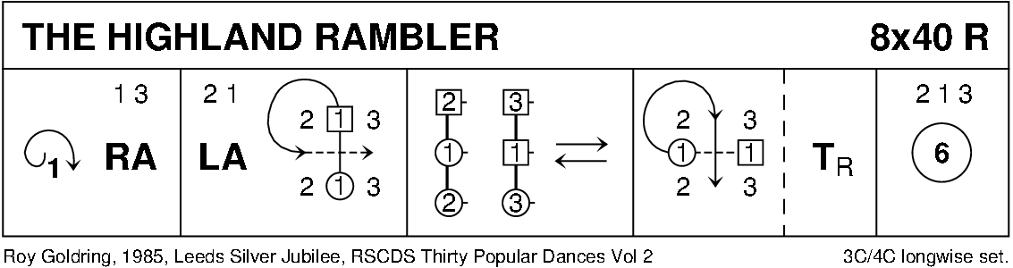

ST COLUMBA'S STRATHSPEY (S5x32) 5C set Gillan & Sproule
1- 8 2s+4s dance RH across
2s dance up while 4s dance down - 2s+4s casting round ends on own side to face 1st corners
9-16 2s+4s Pass+Turn with 1st corners, pass partner LS
Pass+Turn with 2nd corners & into centre facing partner (L facing down, M up)
17-24 2s+4s dance reel of 4 ending in original places on side
25-32 2s+4s set & cast off 1 place while 3s+5s set & dance up 1 place
1s+2s turn RH & cast off 1 place 3 1 5 2 4

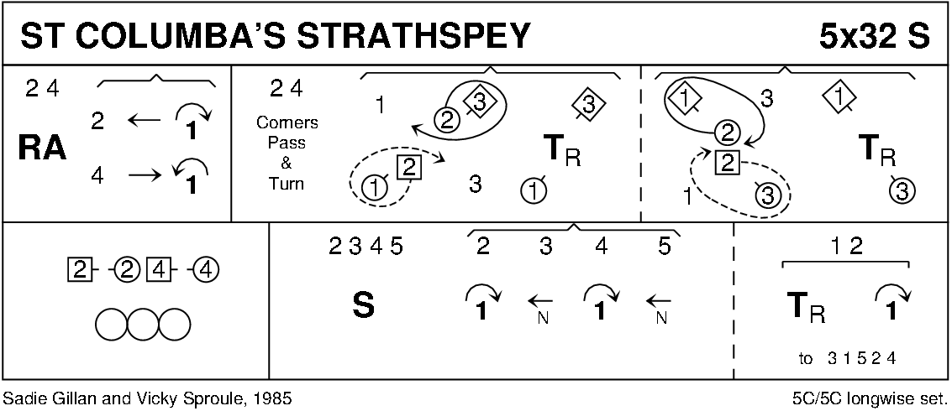

AUCHINELLAN JIG (J8x32) 3C (4C set) Alice McLean Auchinellan Collection
1- 8 1s+2s set, dance RH across once round, 1s cast to 2nd place as 2s dance up
9-16 1s dance reel of 3 on own sides (down between 3s to start)
17-24 1s dance ½ Figs of 8 (1M up with 2s and 1L down with 3s), 2s+1s+3s chase clockwise ½ way
25-32 1s dance diagonal R&L (1M crossing down and 1L crossing up to start)

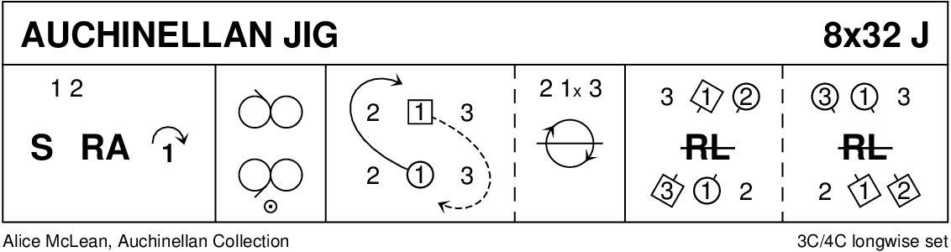

THE DEIL AMANG THE TAILORS (R8x32) 3C (4C set) RSCDS Bk 14
1- 8 1s+2s set & dance RH across ½ way, set & dance LH across ½ way back to place
9-16 1s lead down the middle & back to top
17-24 1s+2s dance Allemande
25-32 2s+1s+3s circle 6H round & back

