RSCDS Ayr Branch Branch Dance – Friday 20th March 2026
Crib Sheet 2.00 – 5.00pm

GRANVILLE MARKET (J8x32) 3C (4C set) 2nd Graded Bk SCDs 1- 8 1s+2s dance RH across & LH back 9-16 1s cross RH & cast off 1 place, 1s dance ½ Fig of 8 around 2s & end facing 1st corner 17-24 1s turn 1st corner RH & pass RS to face 2nd corner, 1s turn 2nd corner RH & pass RS to end 2nd place own side 25-32 2s+1s+3s circle 6H round & back

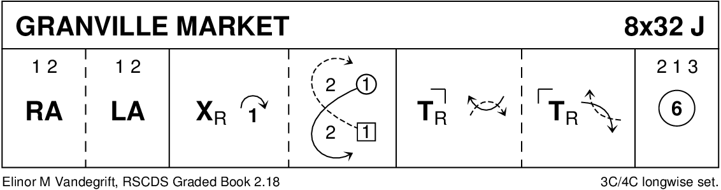

THE SAILOR (R8x32) 3C (4C set) RSCDS Bk 24
1- 8 1s cross down RH to face out between 2s & 3s giving hands to each corner & set
1s cast round 1st corner to form lines of 3 across with 2s/3s & 2s+1s+3s set
9-16 1s (turning to right) dance RS reels of 3 across & 1s end passing LS to 2nd place on opposite side
17-24 1s lead down for 2 bars & lead up, cross at the top & cast to 2nd place on own side
25-32 2s+1s dance R&L

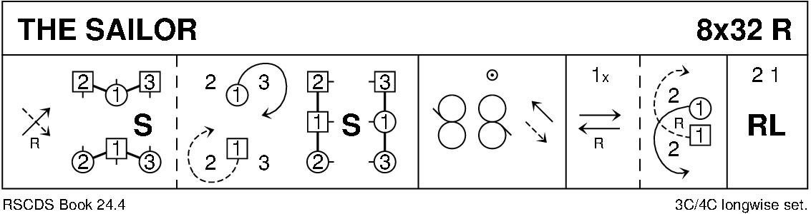

TRIPLE HAPPINESS (S3x32) 3C RSCDS Bk 52
1- 8 1s Adv+Ret (1 step each) touching hands
1s ½ turn LH
1s cross down between 2s & 3s, cast up to place
9-16 1s+2s dance the Knot --- 1s end facing 1st corners
17-24 Corners Pass & Turn with 1st corners
Repeat with 2nd corner
1s pass RS into 2nd place own sides (corners turn 2H in centre)
25-32 All chase clockwise ½ round to opposite side
all ½ turn RH, pull back RS & dance out to own sides 3 1 2

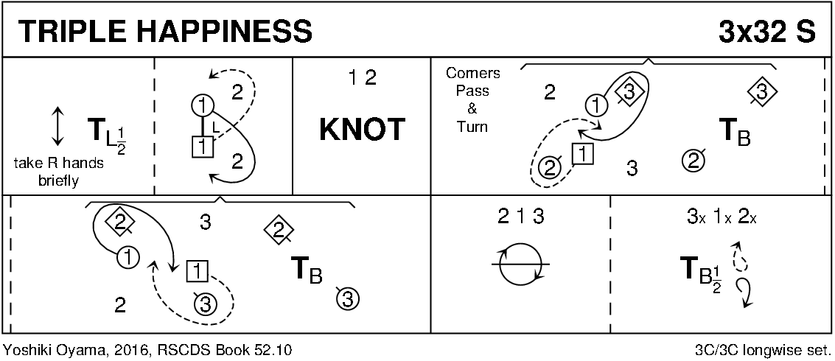

THE YORKSHIRE ROSE (J8x32) 3C (4C set) RSCDS Bk 54
1- 8 1s+2s+3s set & cross RH, repeat back to places
9-16 1s lead down the middle then lead up to 2nd places (2s step up 11-12)
17-24 2s+1s turn (Men RH, Ladies LH), 1s+3s turn (Men LH, Ladies RH)
25-32 2s+1s+3s dance reels of 3 on sides with 1s out/up, 2s in/down down to start
(2nd time through the 1s continue the reel into 4th place)

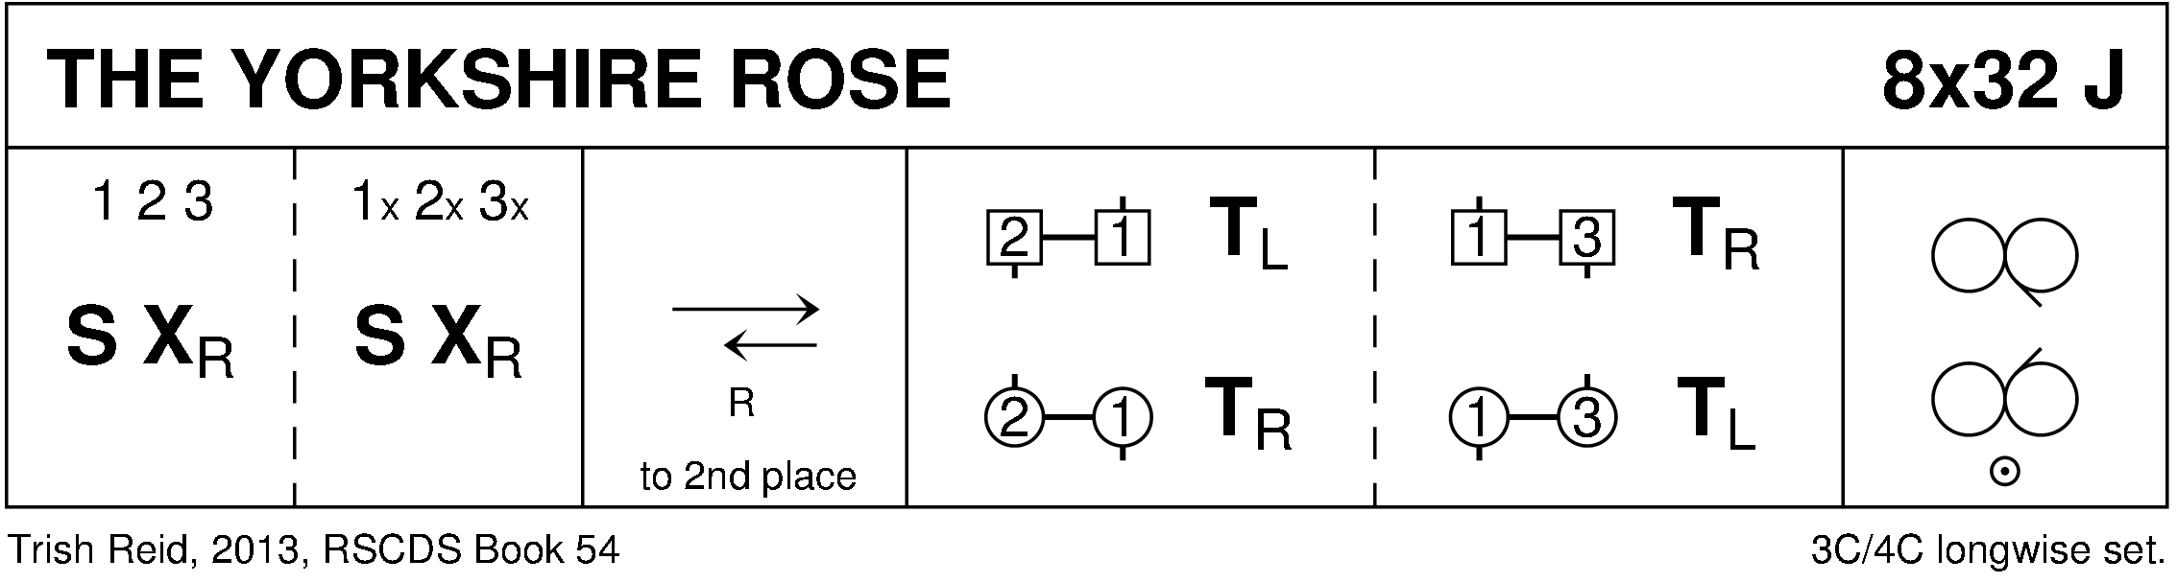

THE CUCKOO CLOCK (R8x32) 3C (4C set) Barbour
1- 8 1s+2s+3s dance reels on own side --- 1s dancing in & down, 2s dance out & up, 3s in & up to start
9-16 1s+2s dance double Fig of 8
17-20 "Muirland Wille" figure:
1s dance down middle, cross over & cast up to 2nd place on opposite
while 2s set & cross RH to 3rd place on opposite side
while 3s cast up to 1st place & cross RH to opposite side
21-24 3s+1s+2s turn partners RH once round
25-32 3s+1s+2s Set+Link for 3 twice

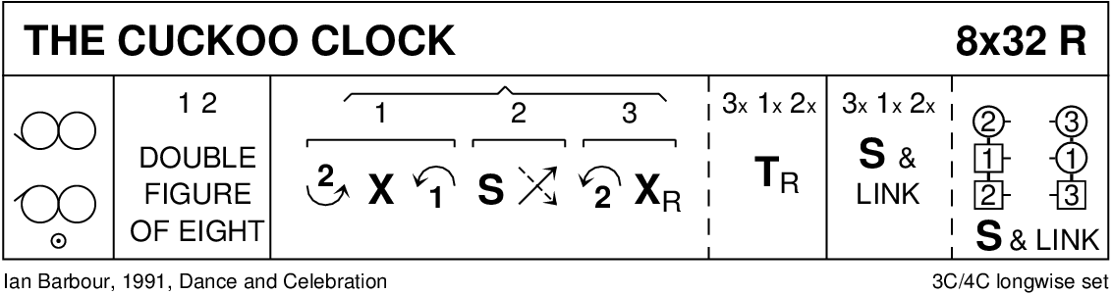

HELLO-GOODBYE (S8x32) 3C (4C set) RSCDS Bk 51
1- 8 1s set cross RH, cast & turn ¾ RH to face opposite side (2s step up 5-6)
9-16 1M+2s also 1L+3s dance LH across
1s pass LS to dance RH across with other couple --- 1s end BtoB in middle facing 1st corners
17-24 1s dance 'Hello-Goodbye' setting, clap & petronella turn to 2nd place own side
25-32 2s+1s+3s circle 6H round & back

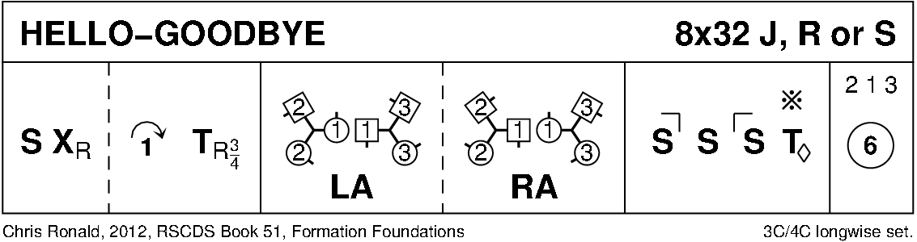

THE WATERNISH TANGLE (J8x32) 3C (4C set) RSCDS Bk 54
1- 8 1s cross down RH & set (2s step up 1-2): 1s cross down LH & set (3s step up 5-6)
9-16 1s cross RH, change places on sides with 3s LH; 2s+1s cross RH & 3/4 turn LH on sides to form line of 4 across
17-24 2s+1s dance the Targe : -
`17-18 1st & 2nd Ladies 3/4 turn RH while Men dance 1/4 way round anticlockwise
`19-20 1st Man with 2nd Lady & 1st Lady with 2nd Man full turn LH
`21-22 1st & 2nd Ladies 3/4 turn RH while Men dance 1/4 way round anticlockwise
`23-24 1st Man with 2nd Lady & 1st Lady with 2nd Man turn 3/4 LH to end on sides to 2(1)3
25-32 1s cross down below 3s, cast up, dance up between 2s & cast to 2nd place

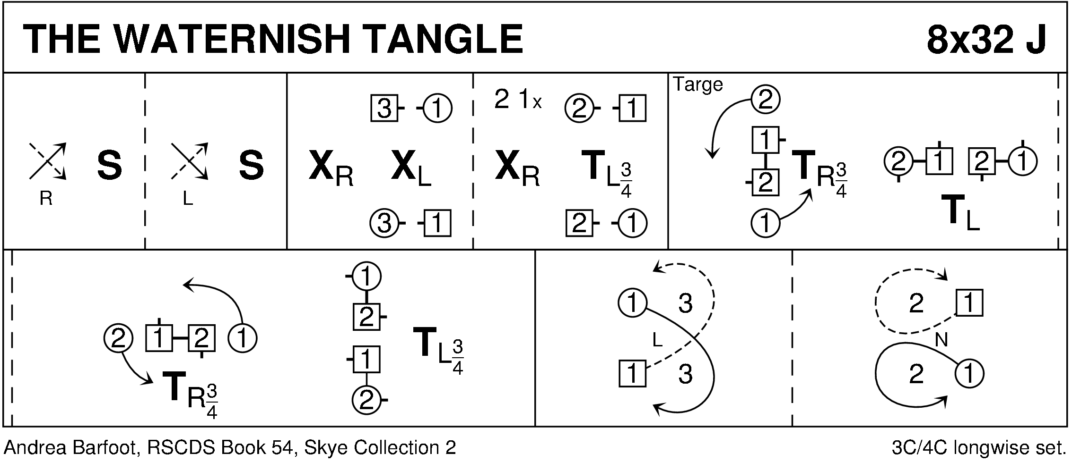

THE IRISH ROVER (R8x32) 3C (4C set) Cosh
1- 8 1s dance down between 3s & cast up to 2nd place own side
1L dances RH across with 2s while 1M dances RH across with 3s
9-16 1s dance ½ diagonal reel of 4 with 1st corners then ½ reel with 2nd corners & ½ turn LH in centre to face 1st corners
17-24 1s dance reels of 3 across giving LS to 1st corners ending in 2nd place own side
25-32 1s dance diagonal R&L (1M crossing down & 1L crossing up to start)

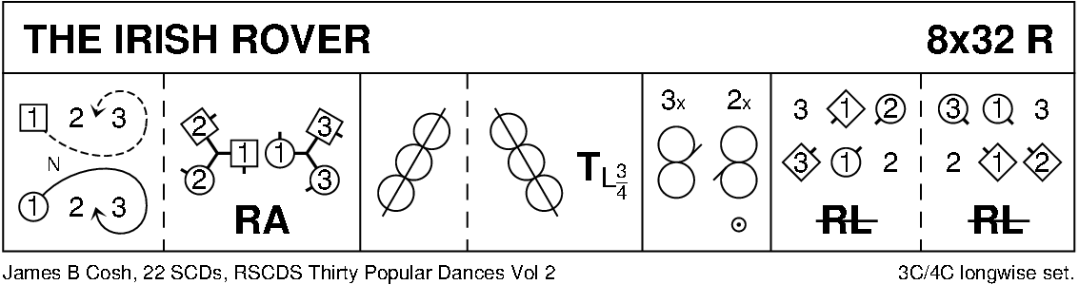

THE FRISKY (J8x32) 3C (4C set) RSCDS Bk 26
1- 8 1s turn RH & cast off 1 place, turn LH & cast off 1 place
9-16 2s+3s+1s circle 6H round & back
17-24 1s lead up to top; 1s+2s set twice
25-32 1s+2s dance ½ R&L; set & cross RH to own side

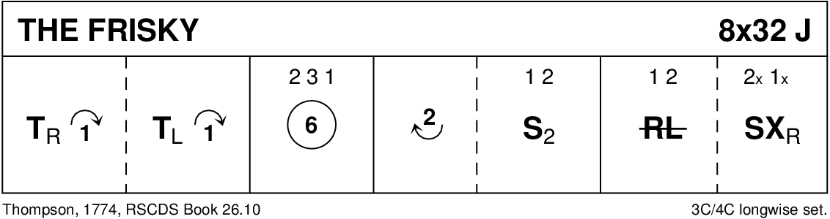

A TRIP TO BAVARIA (R4x32) 4C set MacGregor-Brown ~ Collins
1- 4 1s+4s cross RH while 2s+3s dance ½ RH across, 1s+3s & 2s+4s change places LH on sides
5- 16 Repeat 1-4 another 3 times (end couples cross RH, middle couples ½ RH across; couples in 1st+2nd place also 3rd+4th place change places LH) --- All finish in original places
17-24 1s set to 2s & cross over to face 3s, set & cross to face 4s
25-32 1s set to 4s & cross over to 4th place on opposite sides
all Advance + Retire 2 steps --- 1s change places BH to retire to own side

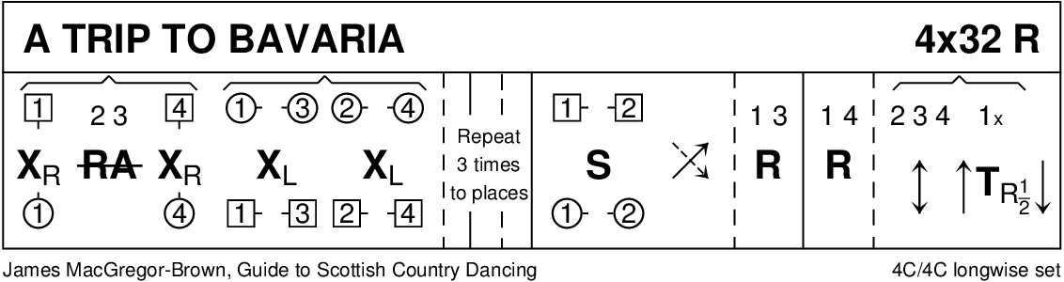

SUGAR CANDIE (S8x32) 3C (4C set) RSCDS Bk 26
1- 8 1s set & cast off 1 place, cross passing LS & cast RS round their 1st corner into centre ending BtoB (Lady facing up, Man down)
9-16 1L+2s & 1M+3s circle left &, 1s turn to face partner & set, ¾ turn partner BH to end facing 1st corners
17-24 1s turn 1st corner RH, partner LH, 2nd corner RH, partner LH & end facing 1st corners
25-32 1s dance Reel of 3 on opposite side passing 1st corner LS & cross RH to 2nd place own side

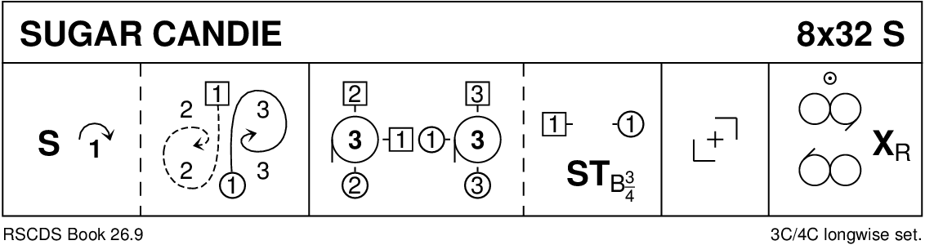

FAREWELL TO BALFOUR ROAD (J1x96) 5C set RSCDS Bk 52
1- 8 1s+2s circle 4H round & back
9-16 1s+2s Set+Link; 1s+3s Set+Link
17-24 *2s start* while 1s+4s+5s dance mirror reels of 3 on sides (1s in/down to start)
25-32 1s set, cross down RH to 4th place (4s step up)
1s set, cross down LH to 5th place (5s step up) *New top couple start every 16 bars
Dance ends with 1s back in 1st place and 5s back in 5th place
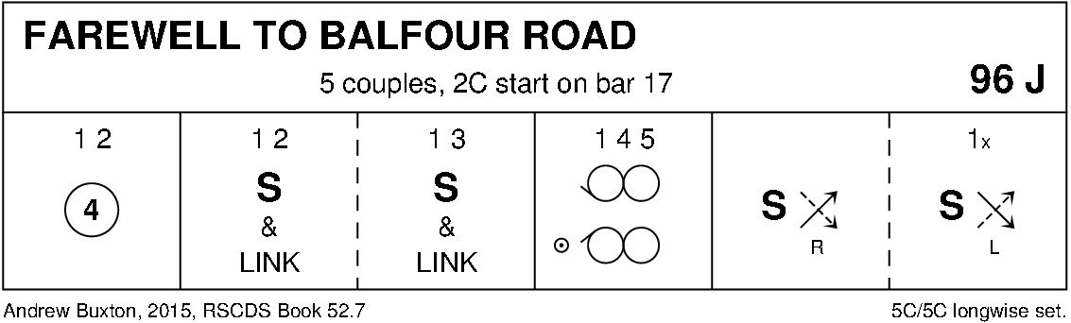

THE COUNTESS OF DUNMORE'S REEL (R8x32) 3C (4C set) RSCDS Bk 49
1- 8 1s set, dance down below 3s, cast up to 2nd place and set advancing to face 1st corners (2s step up 3-4)
9-16 1s turn 1st corners RH, pass RS, turn 2nd corners RH, pass RS to 2nd place own side facing out (corners dance 4 bars)
17-24 Promenade (Chaperoned) Chain progression:
17-18 1M casts up, 1L casts down as 2s+3s turn ¾ RH into line up/down set
19-22 1M+2L and 1L+3M, in prom hold dance clockwise to opposite end of line as 2M+3L (in middle) turn 1½ LH
23-24 1s dance clockwise to 2nd place own side as 3s+2s turn partners ¾ RH to own sides. All face clockwise. 312
25-32 3s+1s+2s dance clockwise ½ way round set. All set, cross RH to own sides. 213

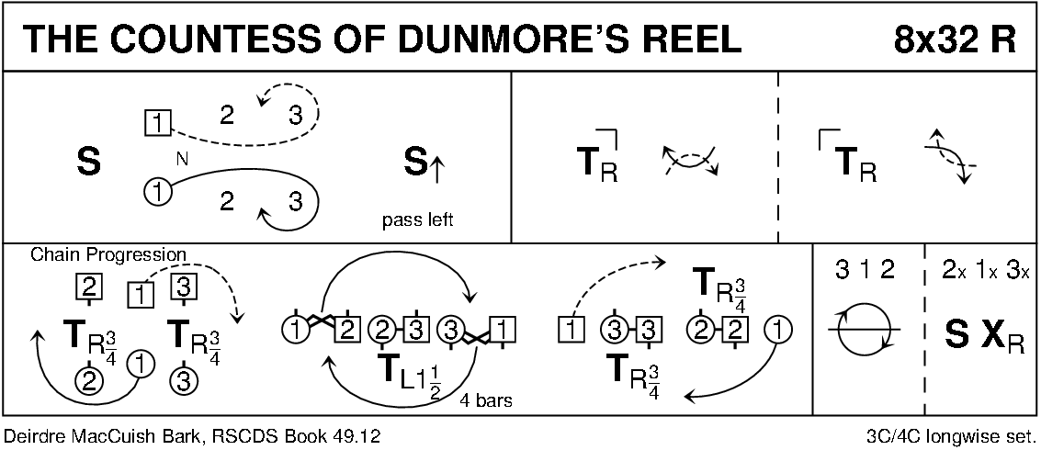

THE DREAM CATCHER (S96) Sq.Set RSCDS Bk 45
1- 8 All circle 8H round & back
9-16 1s+3s dance the Swirl:- Turn partner RH into allemande hold & dance LS round other couple 1/2 way
dance LH across ¾ way & swirl to face side couples (back to back with partner & lady facing man)
17-24 All dance reels of 4 across
25-32 All set, dancing couples dance out between side couples, cross & cast, change places RH with partner back to place
33-40 All set, advance with partners, retire diagonally with corners & set
41-48 1L+4M dance R&L with 3L+2M (on diagonal)
49-56 1M+2L dance R&L with 3M+4L (other diagonal)
57-64 All set with corners, advance & retire with partners & set
65-88 2s+4s repeat bars 9-32
89-96 All circle 8H round & back

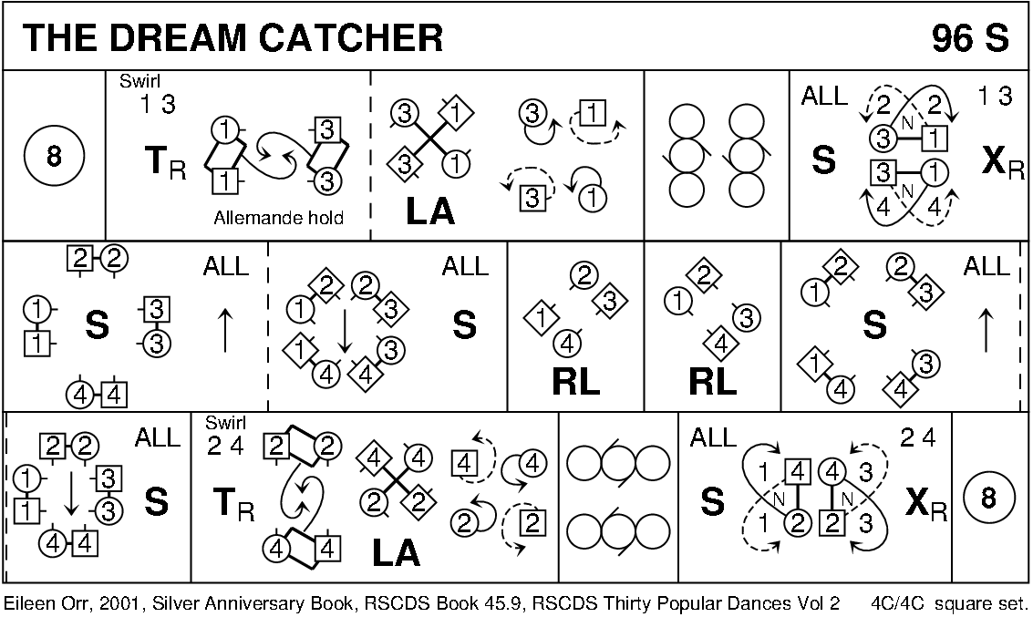

GAELFORCE WIND (J8x32) 3C (4C set) Graded Book 3
1- 8 1s set, cross RH
1s+2s Set+Link (Ladies face out)
9-16 2s+1s Men’s Chain
17-24 1s ½ Fig of 8 (L round 2s & M round 3s)
2s+1s+3s turn RH
25-32 2s+1s+3s circle 6H round & back

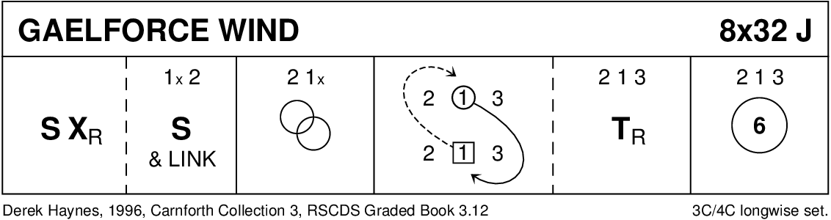

MAXWELL'S RANT (R8x32) 3C (4C set) RSCDS Bk 18 1- 8 1s dance reels of 3 on opposite side
9-16 1s dance reels of 3 on own side
17-24 1s cross RH, cast off one place & dance ½ Fig of 8 round 2s
25-32 1s dance down between the 3s, cast up to 2nd place; 2s+1s+3s turn partners RH

