
Ayr Branch
Branch Dance
Friday 21st November 2025
Walker Hall, Troon 2.00 – 5.00pm

THE MACHINE WITHOUT HORSES (J8x32) 3C (4C set) RSCDS Bk 12
1- 8 1s set, cast off 1 place, dance RH across with 3s
9-16 1s set, cast up 1 place, dance LH across with 2s
17-24 1s followed by 2s dance down, cast up behind 3s, in & dance up to top & 1s cast back to 2nd place
25-32 2s+1s dance R&L

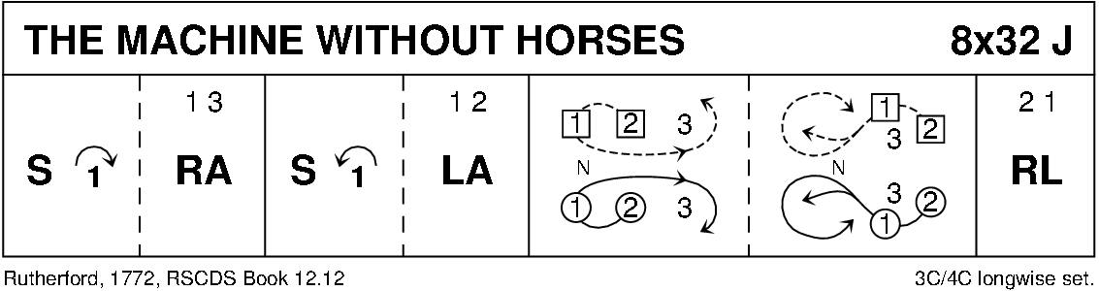

FESTIVAL FLING (R8x32) 3C (4C Set) RSCDS Bk 44
1- 8 1s set, cross RH, cast off two places & dance up to face 1st corners
9-12 1s set to 1st corner & change places RH, 1st corners pass LS to face 2nd corners (M facing M & L facing L)
  - Original 1st corners set to 2nd corners, change places RH & 2nd corners pass LS to face 1st corner (M face M & L face L)
17-20 Original 2nd corners set to 1st corners (1s), change places RH & 1s end facing opposite sides as for double triangles
21-24 All set, corners chase one place clockwise while 1s set round each other to face down (man with partner on left)
25-32 1s dance down between 3s, cast up to 2nd place, dance up between 2s & cast off to 2nd place

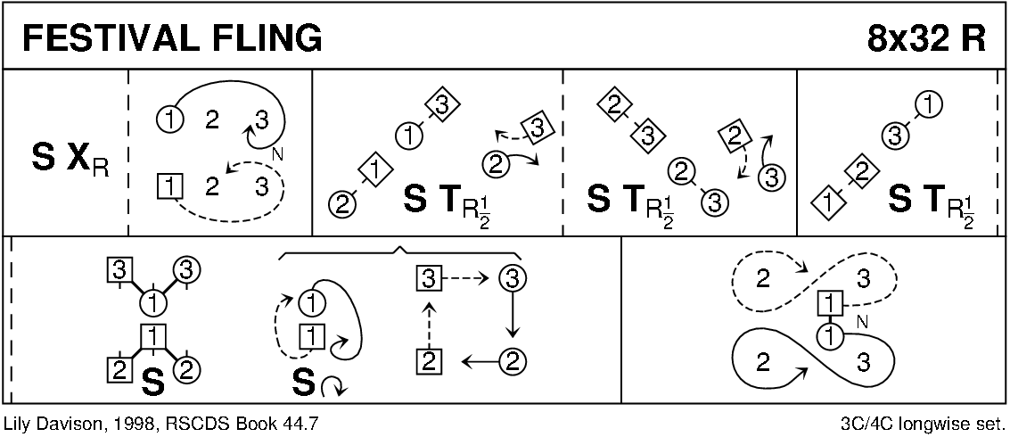

THE BYRON STRATHSPEY (S3x32) 3C set Drewry
1-8 All petronella turn into the centre & set to partner, turn BH 1¼ times back to places
9-16 1s+2L & 3s+2M dance RH across, 2s pass RS & dance LH across with other couple
17-24 2s in promenade hold dance reel of 3 with 1s passing 1L RS, end 2s in centre at top
25-32 2s+1s+3s dance Allemande

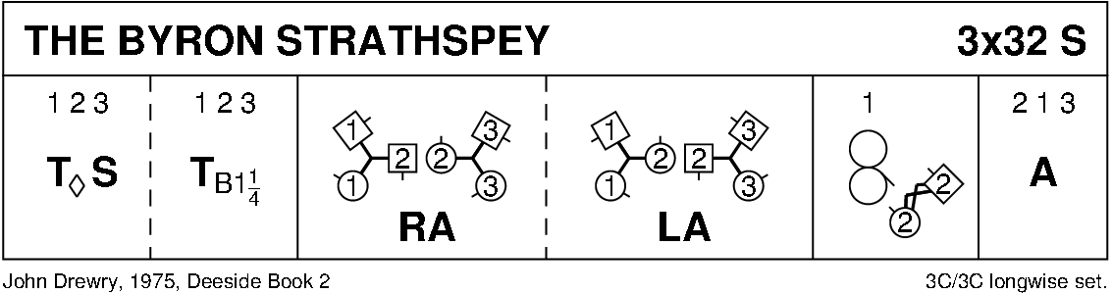

THE STARRY EYED LASSIE (J8x32) 3C (4C set) RSCDS Bk 23
1- 8 1s+2s dance RH across, 1s cast off 1 place & turn about for Double Triangles while 2s lead up
9-16 2s+1s+3s dance Double Triangles, ending 1st Lady between 2s & 1st Man between 3s - facing own side
17-24 2s+1s+3s dance RS reels of 3 across, 1s end in 2nd place opposite side
25-32 2s+1s+3s circle 6H round to left (6 bars) & 1s cross RH to 2nd place own side

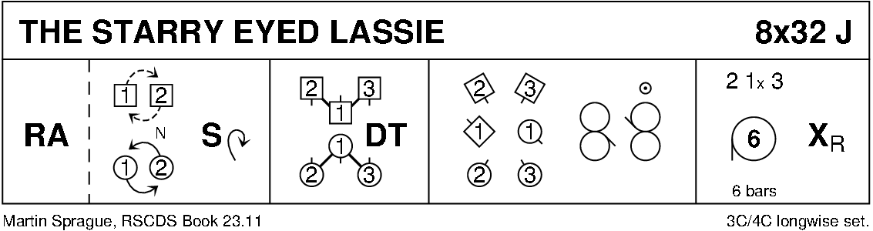

A TRIP TO BAVARIA (R4x32) 4C set MacGregor-Brown ~ Collins
1- 4 1s+4s cross RH while 2s+3s dance ½ RH across, 1s+3s & 2s+4s change places LH on sides
5- 16 Repeat 1-4 another 3 times (end couples cross RH, middle couples ½ RH across; couples in 1st+2nd place also 3rd+4th place change places LH) --- All finish in original places
17-24 1s set to 2s & cross over to face 3s, set & cross to face 4s
25-32 1s set to 4s & cross over to 4th place on opposite sides
all Advance + Retire 2 steps --- 1s change places BH to retire to own side

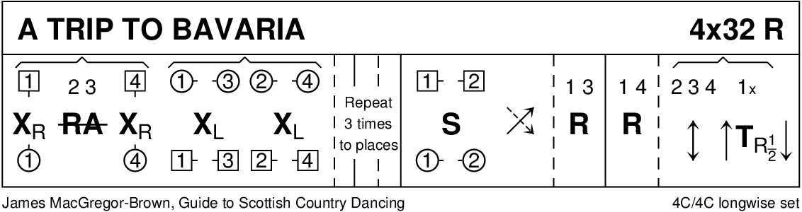

THE FALKIRK LASS (S8x32) 3C (4C set) RSCDS Bk 53
1- 8 1s turn RH, cast off 1 place, cross LH & cast round 2nd corners to
1M between 2s facing down & 1L between 3s facing up
9-16 All Adv+Ret (1 step), change places with opposite person RH
Adv+Ret again ~ 2s+3s change places RH while 1s turn RH to face 1st corners
17-24 1s dance Pass+Turn with 1st corners & pass RS to face 2nd corners, dance Pass+Turn with 2nd corners
25-32 2s+1s+3s circle 6H round & back

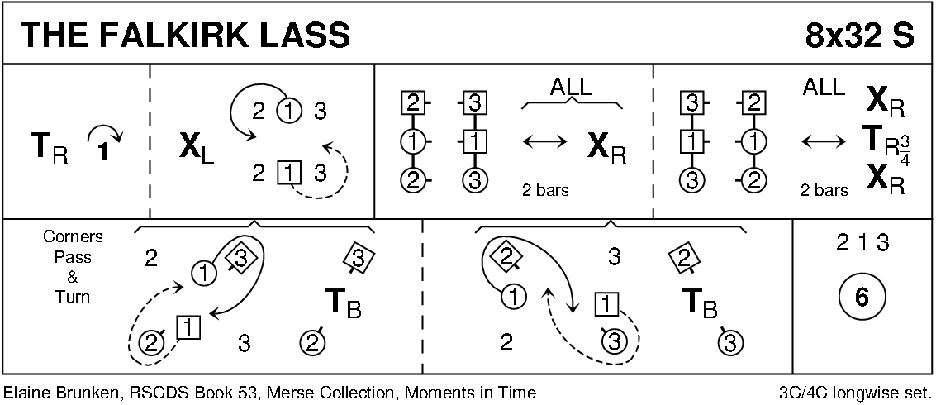

THE JUBILEE JIG (J8x32) 3C (4C set) RSCDS Leaflet
1- 8 1M cast off one place, set to 3L, turn RH & dance back to 2nd place on own side
9-16 1L cast off one place, set to 3M, turn LH & dance back to 2nd place
  - 1L+2s & 1M+3s dance RH across - 1s end in centre LH joined
1s set in centre & dance out to 2nd place opposite side
  - 1M+2s & 1L+3s dance RH across - 1s end in centre LH joined
1s set in centre & dance out to 2nd place own side

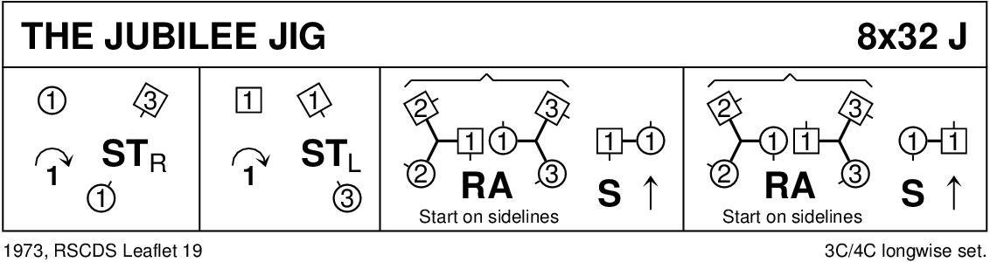

BACK TO THE FIRESIDE (R8x32) 3C (4C set) RSCDS Bk 38
1- 8 3s followed by 1s dance down for 2 steps & set to partners
1s dance up & cast off to 3rd place while 3s dance up to top place
9-16 1s cross RH to start reverse Snowball Grand Chain for 3 couples to end 1 (2) 3
17-24 1s+2s set advancing to form circle (hands joined) & petronella 1 place to right
Set hands joined & petronella turn to end on side
25-32 1L dances ½ Fig of 8 round 2s as 1M dances ½ Fig of 8 round 3s
2s+1s+3s turn RH

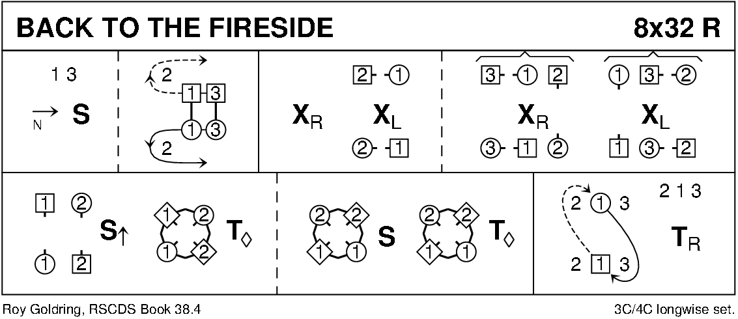

EH3 7AF (J8x32) 3C (4C set) RSCDS Bk 40 1- 8 1s lead down the middle & back to top
9-16 1s+2s+3s Promenade ending with 1s casting to 2nd place
17-24 1s pass by the right & turn 1st corners RH to end L between 2s & M between 3s
1s pass by the right & turn 2nd corners RH to end between corners
25-32 1M+2s and 1L+3s dance RH across
1L dances up between 2s & casts to 2nd place own side as 1M dances between 3s & casts up

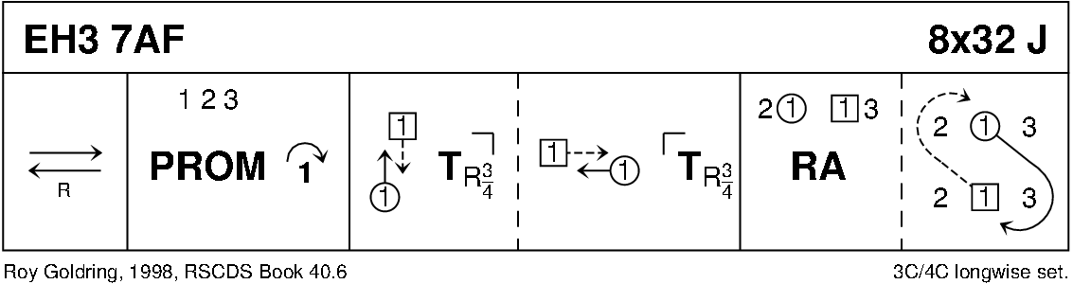

CATCH THE WIND (R8x32) 3C (4C set) RSCDS Bk 45
1- 8 1s set, cast off 1 place & dance ½ Fig of 8 round 2s
9-16 1s set twice with 1L turning to face out
1L followed by partner casts up & dances down the middle 1L to face 3M while 1M faces 2M
17-24 1s dance RS reels of 3 across (1M+2s & 1L+3s)
25-32 1L followed by partner dances down and casts up round 3M & crosses to end in 2nd place on own sides
1s turn RH (4 bars)

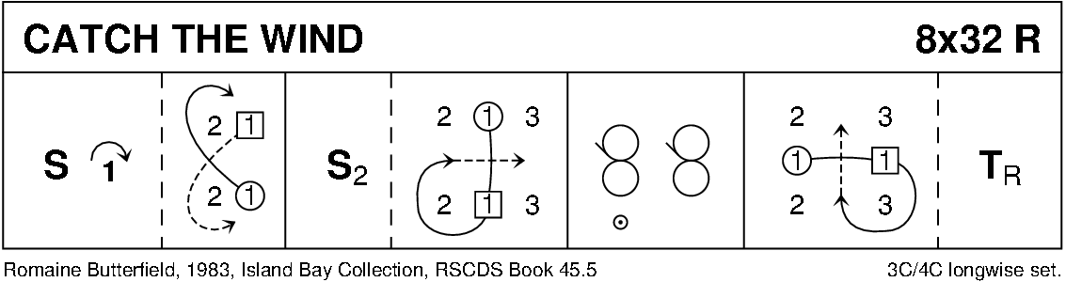

BUTTERSCOTCH & HONEY (S4x32) 4C set Attwood
1- 8 1s set & ½ turn RH into promenade hold, 1s dance ½ RS reel of 3 with 2s (2s end on opposite side)
9-16 1s dance ½ LS Reel of 3 with 3s & ½ RS reel of 3 with 4s
17-24 1s followed by 4s+3s+2s cast up on opposite side to top,
cross over to own side each lady passing in front of partner & down own side
25-32 All set to partners & turn BH into 4H round (2s+3s & 4s+1s)

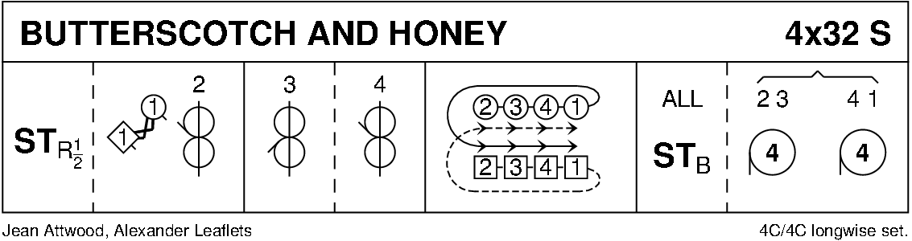

THE KELLOHOLM JIG (J8x32) 3C (4C set) RSCDS Leaflet
1- 8 1s set & cast off 1 place, set on side lines to 1st corners & change places with them RH
9-16 1L+3L also 2M+1M set to each other on sides & change places LH, 1s turn RH 1½ times to 2nd place on own side
17-24 1s set on side lines to 2nd corners & change places with them RH
1M+3M also 2L+1L set to each other on sides & change places LH
25-32 3s+1s+2s Adv+Ret, circle 6H round ½ way to left

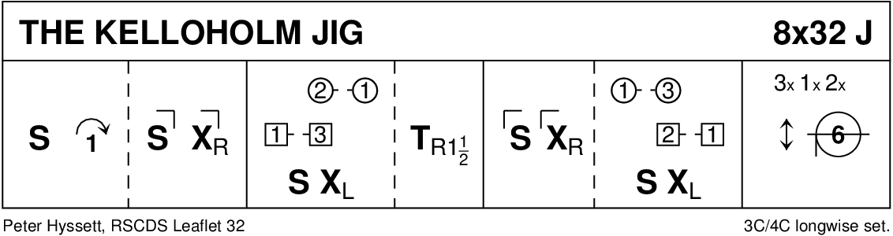

BALDOVAN REEL (R4x32) 4C set RSCDS Book 53
1- 8 1s dance RS round each other, dance Crown Triangles (start with Man facing 3s & Lady facing 2s)
9-16 1s dance reel of 4 with 2nd corners passing RS
17-24 1s dance reel of 4 with 1st corners passing RS ending in 2nd place on opposite side
25-32 1s set & cast off 1 place, cross over RH & change places LH on side with 4s

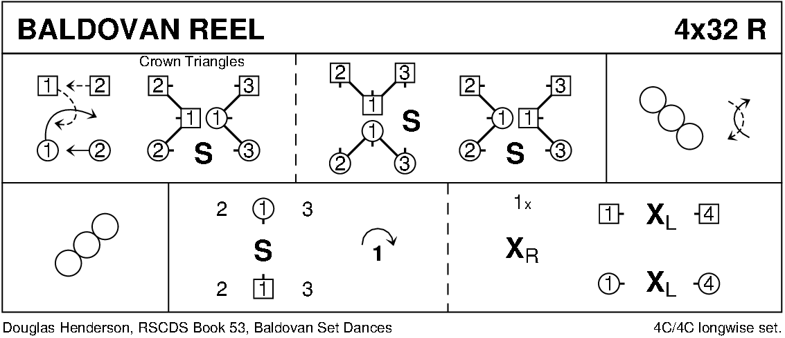

THE CASHMERE SHAWL (S8x32) 3C (4C set) Boyd
1- 8 1s turn RH & cast off 2 places; cross LH & cast up to 2nd place opposite side
9-16 1s turn RH, turn 1st corner LH, turn 2nd corner RH & turn partner LH to face 1st corner
17-24 1s dance ½ diagonal reel of 4 with 1st corners; 1s dance ½ diagonal reel with 2nd corners (3)(1)(2)
25-32 Top 2 on men’s side change RH with bottom 2 on ladies’ side
Top 2 on ladie’s side change LH with bottom 2 on men’s side
Top 2 on men’s side change RH with bottom 2 on ladies’ side
2+1+3 cross LH

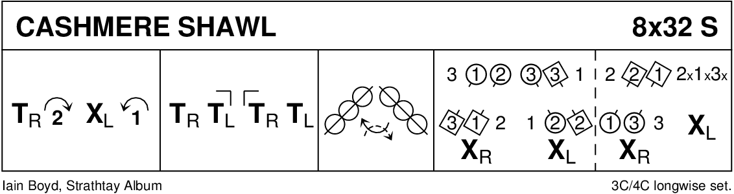

FOLLOW ME HOME (J8x32) 3C (4C set) RSCDS Bk 38
1- 8 1s set, cross RH, cast off 1 place & turn LH (ending in a diagonal line LH to partner & RH with 1st corner)
9-16 1s Bal-in-Line with 1st corners, ½ turn corners then 1s followed by corners chase clockwise to 3rd corner (position) --- 1s dance in to give LH to 2nd corners
17-24 1s Bal-in-Line with 2nd corners, ½ turn corners then 1s followed by corners chase anticlockwise to 4th corner (position) --- 1s end in 2nd place opposite side
25-32 3s+1s+2s dance ½ reels of 3 on the sides - 1s giving LS to 2nd corner (position), set & cross RH

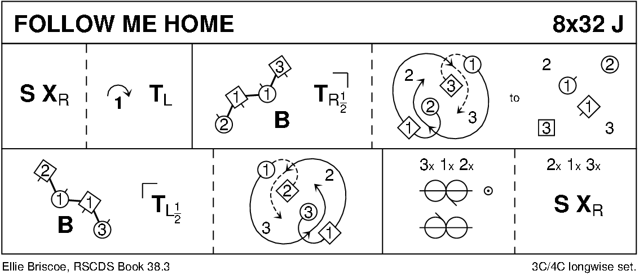

THE REEL OF THE ROYAL SCOTS (R8x32) 3C (4C set) RSCDS Leaflet
1- 8 1s ½ turn 2s on sides (M RH - L LH) to face out, 2s+1s+3s set
1s ½ turn 3s on sides (M LH - L RH) end 3s facing out & 2s+3s+1s set
9-16 1s followed by 3s dance up between 2s, cast off 1 place, dance in & 1s cast up to 2nd place, 3s end in 3rd place
17-24 1s turn 1st corners RH, pass partner RS turn 2nd corners RH & cross passing partner RS to 2nd place own side
25-32 2s+1s+3s circle 6H round & back

