
Hospice Dance Ayr Branch
Monday 25th August ~ Wardlaw

GRANVILLE MARKET (J8x32) 3C (4C set) 2nd Graded Bk SCDs
1- 8 1s+2s dance RH across & LH back
9-16 1s cross RH & cast off 1 place, 1s dance ½ Fig of 8 around 2s & end facing 1st corner
17-24 1s turn corners RH & pass RS to face 2nd corners, 1s turn 2nd corners RH & pass RS to end 2nd place own side
25-32 2s+1s+3s circle 6H round & back

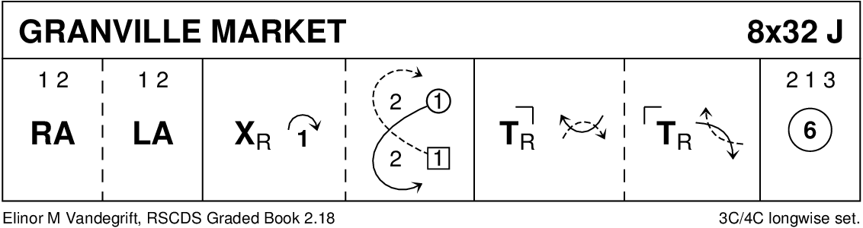

THE SALTIRE SOCIETY REEL (R8x32) 3C (4C set) RSCDS Leaflet
1- 8 1s cross down & dance out between 2s+3s turning 3s by near hand to meet partner
1s dance up & turn 2s by nearest hand to 2nd place opposite side
9-16 1s cross down to 3rd place & dance reel of 3 own side (2s dance out & down as 3s dance in & up between 2s) ---
1s end (hold LH) facing 1st corners
17-24 1s set to 1st corners, turn inwards & set to 3rd corner as 3rd corners set advancing to dance RH across with 1s ---
1s end turning to face 2nd corners
25-32 1s repeat bars 17-24 with 2nd/4th corners but dancing LH across

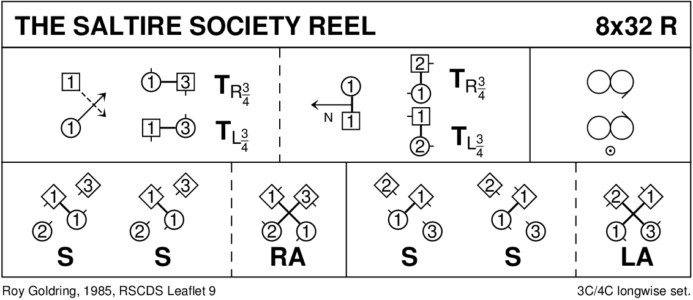

MISS MILLIGAN'S STRATHSPEY (S8x32) 3C (4C set) Leaflet
1- 8 1s+2s circle 4H round to left, 1s turn to face 2s & set, 1s cast while 2s dance up
9-16 2s+1s+3s dance reels of 3 on own side 1s dancing in between 3s to start
17-24 2s+1s+3s set, 2s+1s ½ turn LH, 1s followed by 2s lead down between 3s, cross & cast up on own side
25-32 1s+2s dance the Knot

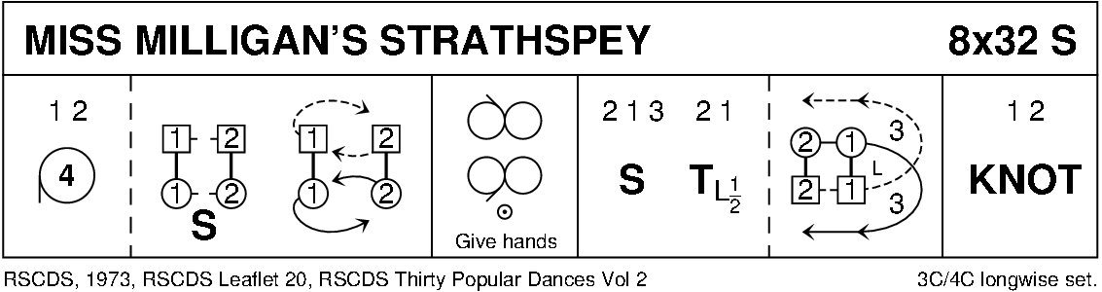

A CAPITAL JIG (J8x32) 3C (4C set) 5 dances 2009
1- 8 1s+2s Set & Rotate (end 1s facing up, 2s down)
9-16 1s dance reels of 3 on own side (RS to 2s)
17-24 1s set & turn RH to face own side in centre
1s dance LH across (1L+2s, 1M+3s) to end 2nd place opposite side
25-32 1s set & turn RH to face opposite side in centre
1s dance LH across (1M+2s, 1L+3s) ending 2nd place own side

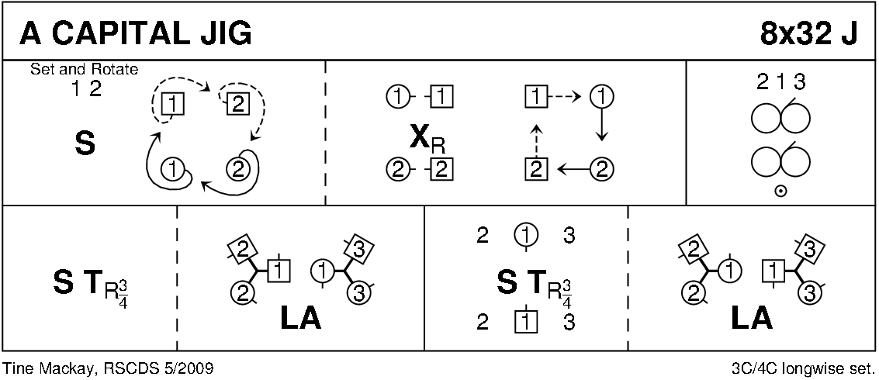

BACK TO THE FIRESIDE (R8x32) 3C (4C set) RSCDS Bk 38
1- 8 3s followed by 1s dance down for 2 steps & set to partners
1s dance up & cast off to 3rd place while 3s dance up to top place
9-16 1s cross RH to start reverse Snowball Grand Chain for 3 couples to end 1 (2) 3
17-24 1s+2s set advancing to form circle (hands joined) & petronella 1 place to right
Set hands joined & petronella turn to end on side
25-32 1L dances ½ Fig of 8 round 2s as 1M dances ½ Fig of 8 round 3s
2s+1s+3s turn RH

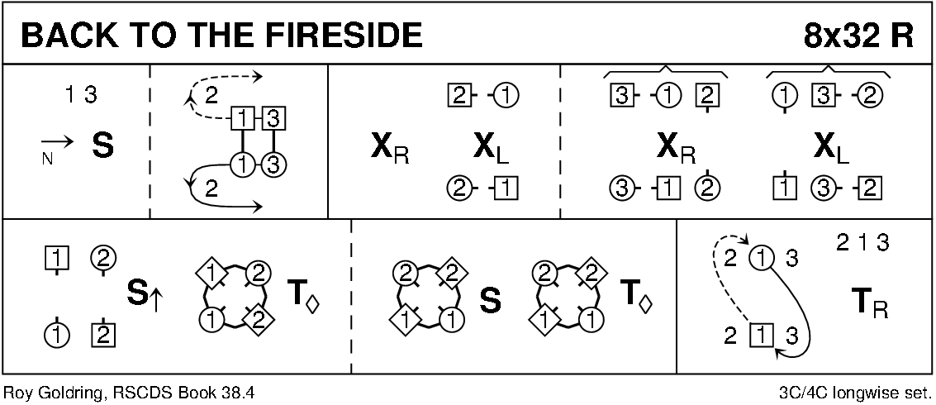

THE DREAM CATCHER (S96) Sq.Set RSCDS Bk 45
1- 8 All circle 8H round & back
9-16 1s+3s dance the Swirl:- Turn partner RH into allemande hold & dance LS round other couple 1/2 way
dance LH across ¾ way & swirl to face side couples (back to back with partner & lady facing man)
17-24 All dance reels of 4 across
25-32 All set, dancing couples dance out between side couples, cross & cast, change places RH with partner back to place
33-40 All set, advance with partners, retire diagonally with corners & set
41-48 1L+4M dance R&L with 3L+2M (on diagonal)
49-56 1M+2L dance R&L with 3M+4L (other diagonal)
57-64 All set with corners, advance & retire with partners & set
65-88 2s+4s repeat bars 9-32
89-96 All circle 8H round & back

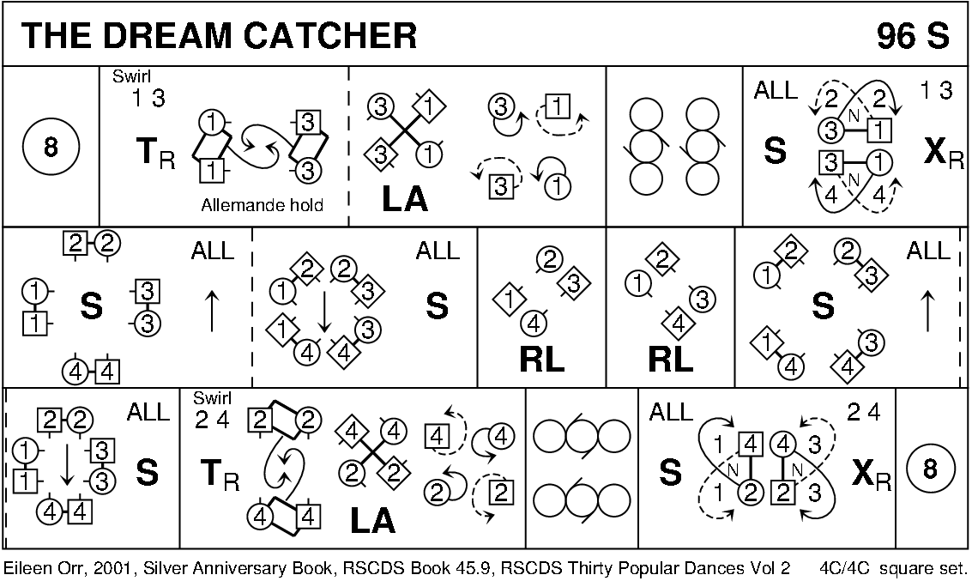

THE CORNER HOUSE JIG (J8x32) 3C (4C set) Haynes
1- 8 1s cross RH, cast off 1 place, dance ½ Figs of 8 (Lady round 2s & Man round 3s) to end facing 1st corners
9-24 1s dance 4 x ½ reels with corners (as Mairi's Wedding)
while standing corners in each ½ reel chase round clockwise to opposite corner
25-32 1s pass LS to dance RH across (1L+2s & 1M+3s)
1s pass RS to dance LH across with other couple - 1s end in 2nd place own side

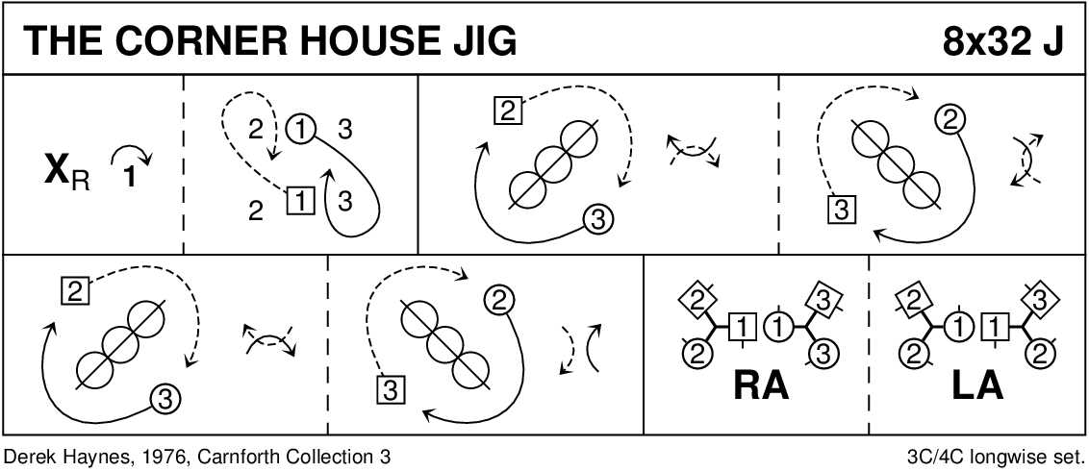

THE COLLEGE HORNPIPE (R8x32) 3C (4C set) RSCDS Bk 20
1- 8 1s+2s+3s circle 6H round & back
9-16 1s+2s+3s promenade
17-24 1s cross RH, cast off 1 place, cross LH, cast off to 3rd place & lead up to face 1st corners
25-32 1s dance 'Hello-Goodbye' setting ending with a clap & turn into 2nd place own side

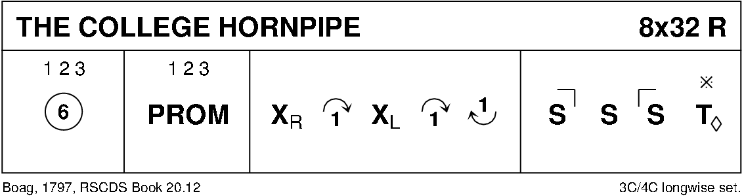

BEST SET IN THE HALL (J8x32) 3C (4C Set) RSCDS Bk 46
1- 8 1s set & 1L followed by partner casts below 3s
1L crosses & casts up to face her 1st corner while 1M dances up the middle to face 1st corner
9-12 1s set to 1st corners & dance RS round each other into 3rd corner (position)
while 1st corners dance in & turn right about to face their original position
13-16 1s+1st corner person set & 1st corner persons dance R round each other into diagonal opposite corners
while 1s dance in & pivot to right to face 2nd corners
17-24 1s repeat bars 9-16 with 2nd corners & end passing RS to 2nd place opposite side (3)(1)(2)
25-32 2s+1s+3s chase clockwise ½ way & turn partners RH

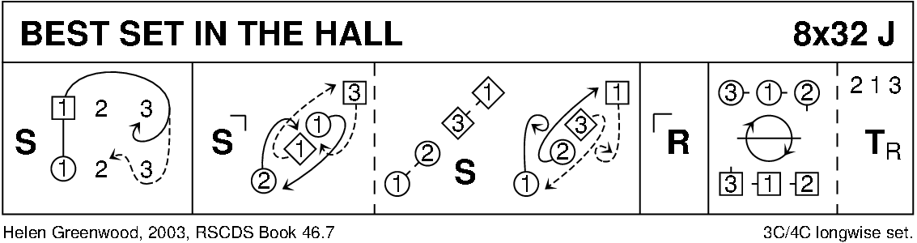

POLHARROW BURN (R5x32) (5C set) Foss
1- 8 1s+3s cross RH, cast off 1 place & dance ½ Fig of 8 round couple above them
9-16 1s+3s turn RH then LH (long turns) to face 1st corners while 2s+5s ½ turn RH & chase clockwise to other end of set
17-24 1s+3s dance ½ Reels of 4 with 1st corners then 2nd corners
25-32 1s+3s dance ½ Reel of 4 with 3rd corner, turn partner LH & cast off 1 place own side 2 4 1 5 3

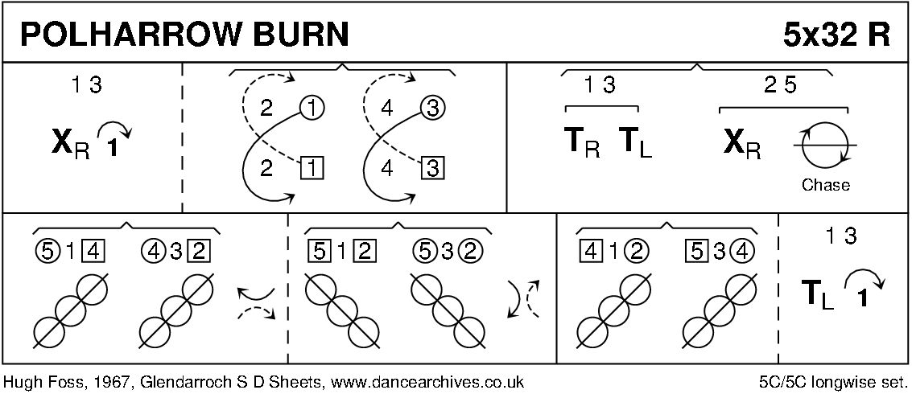

MISS ELEANOR (S3x32) 3C (3C set) RSCDS Book 49
1- 8 1s+2s+3s dance reels of 3 on sides (1s in/down to start)
9-16 1s set, cast off 1 place (2s step up) & turn RH --- 1L casts to 3rd place, 1M casts up to 1st place (2M steps down & 3L steps up)
17-24 All dance 3 couple Bourrel:-
17-20 1M+3L also 2M+1L set advancing & ¾ turn BH to line up/down middle then pull back RS turning to face own partner
as 3M & 2L chase anticlockwise to face them
21-24 All set & turn BH to own side 3 1 2
25-32 3s+1s+2s circle 6H round & back

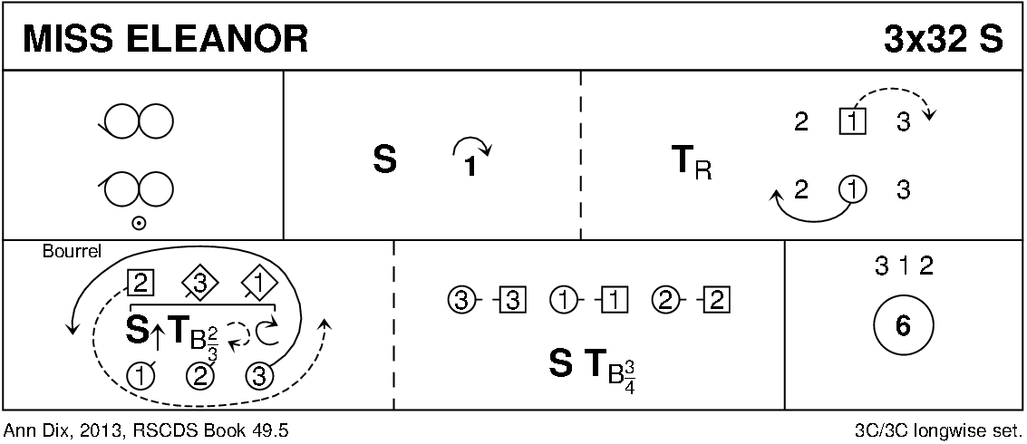

THE HAZEL TREE (J8x32) 3C (4C set) Drewry
1-8 1s+2s dance the espagnole:
1s+2s cross (Ladies RH passing between Men) with Ladies changing places RH
1s+2s cross back (Men cross RH between Ladies) with Men changing places RH
2s turn RH as 1s turn LH to face 1st corner
9-16 1s turn 1st corner RH, pass RS, turn 3rd corner LH & pass LS to face 2nd corner
17-24 1s turn 2nd corner RH, pass RS, turn 4th corner LH ---
1s pass LS to face down in middle (opposite side) left hands joined
25-32 1s lead down below 3s, cross, cast up to 2nd place own side
2s+1s+3s turn RH

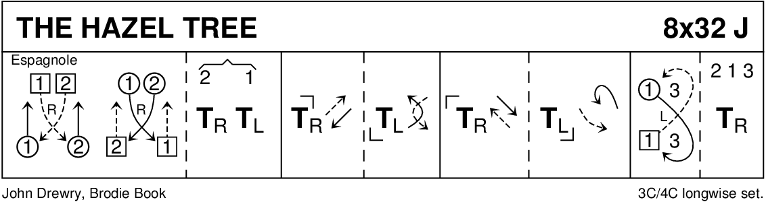

SCOTT MEIKLE (R4x32) 4C set RSCDS Bk 46
1- 8 1s cross RH & cast off 1 place, 1s dance ½ Fig of 8 round 2s
9-16 1s+3s dance RH across, LH back
17-24 1L followed by 3L dance Tandem reel of 3 across with 2s (1L ends 3rd place)
while 3M followed by 1M reel of 3 with 4s (3M to 2nd place)
25-32 1s+4s dance ½ R&L, turn partners RH 1½ times

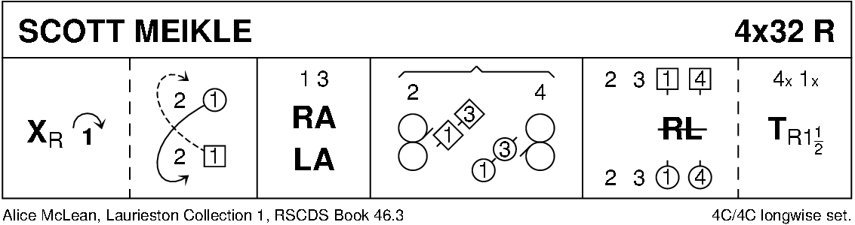

SANDS OF MORAR (S8x32) 3C (4C set) RSCDS Bk 45
1- 8 1s dance figure of 8 round 2s giving hands when meeting
9-16 1s dance reels of 3 on own side (1s dance down between 2s to begin)
  - 1s turn BH, dance down to 3rd place (in middle) as 2s+3s dance up & down behind them
All set facing down
1s followed by 2s+3s cast up to original places
25-32 1s+2s dance the Tourbillon

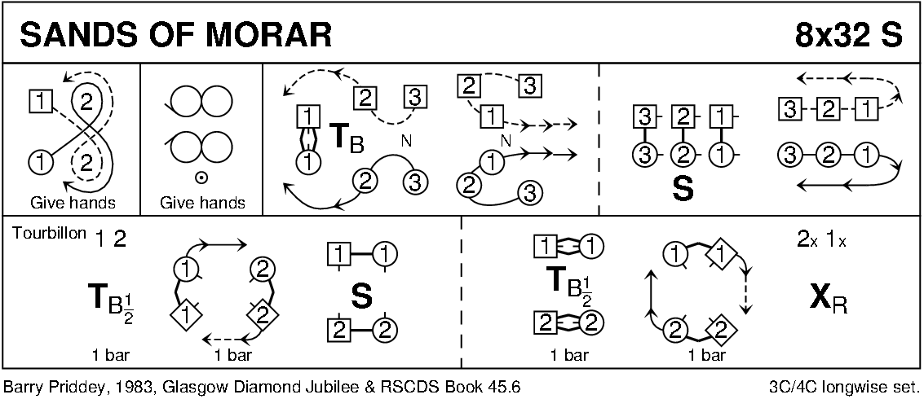

POSTIE'S JIG (J4x32) 4C set Clowes
1- 8 1+4s set, cast off/up 1 place & dance ½ figure of 8 round new end couples
9-12 1M+4M & 1L+4L cross (men making an arch) & turn corners with free hand to face up/down
13-16 1s+4s dance down/up (couple dancing up make the arch) & turn corners
17-24 Repeat bars 9-16 from new positions
25-32 1s+4s dance ½ R&L & turn partner RH

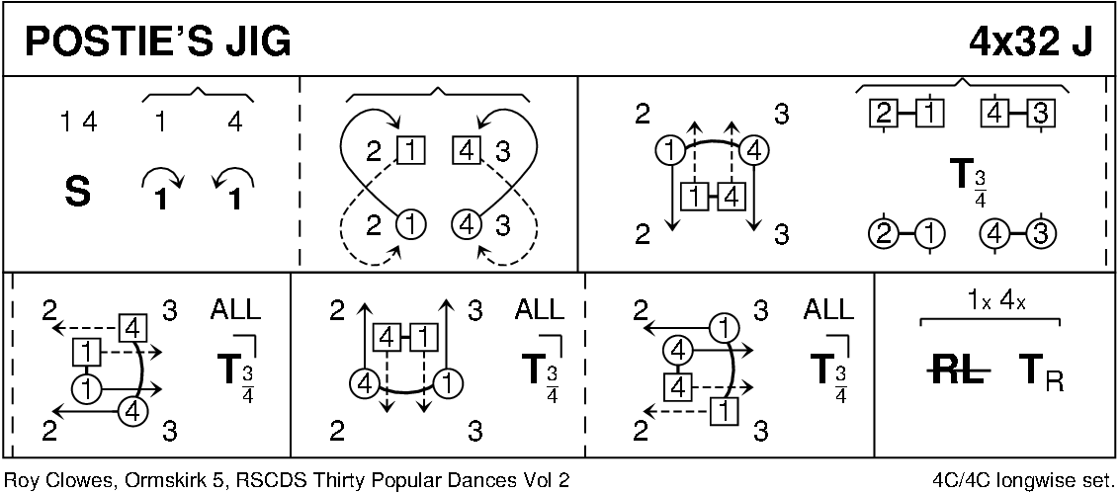

TAMBOURINE (R8x32) 3C (4C set) Bowlen
1- 8 1s lead down the middle & back to 2nd place own side
9-16 1s dance ½ reels of 3 across (1L+2s & 1M+3s) & ½ reels of 3 on opposite side
17-24 1s dance ½ reels of 3 across (man up/ lady down) & ½ reels on own side
25-32 2s+1s+3s circle 6H round & back

