Festive Dance ~ Friday 20th November Ayr Branch Concert Hall, Troon ~~~~ 2.00 – 5.00pm
GAY GORDONS
THE CHRISTMAS TREE (R4x48) 4C set Barlow 1- 8 1s dance down between 2s, behind 3s, in front of 4s and up behind 4s, in front of 3s and behind 2s back to place
9-16 1s+2s dance RH across and LH back
17-24 1s+2s also 3s+4s circle 4H round and back
25-32 1s slip step down the room and back up to 4th place
33-40 2L followed by 3L+4L+1L dance across (with hands joined), down behind Men and up own side
41-48 2M followed by 3M+4M+1M dance across (with hands joined), down behind Ladies and up own side
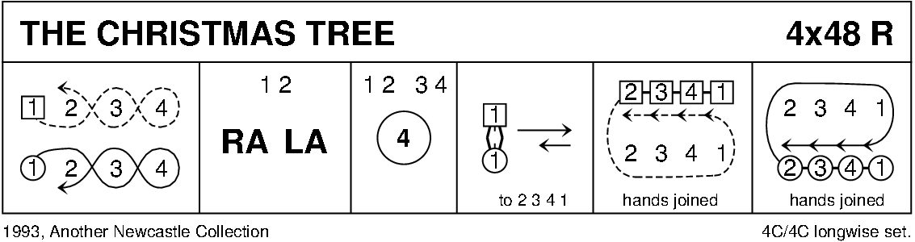
THE JUBILEE JIG (J8x32) 3C (4C set) Leaflet
1- 8 1M cast off one place, set to 3L, turn RH & dance back to 2nd place on own side
  - 1L cast off one place, set to 3M, turn LH & dance back to 2nd place
17-24 1L+2s & 1M+3s dance RH across - 1s end in centre LH joined
1s set in centre & dance out to 2nd place opposite side
25-32 1M+2s & 1L+3s dance RH across - 1s end in centre LH joined
1s set in centre & dance out to 2nd place own side

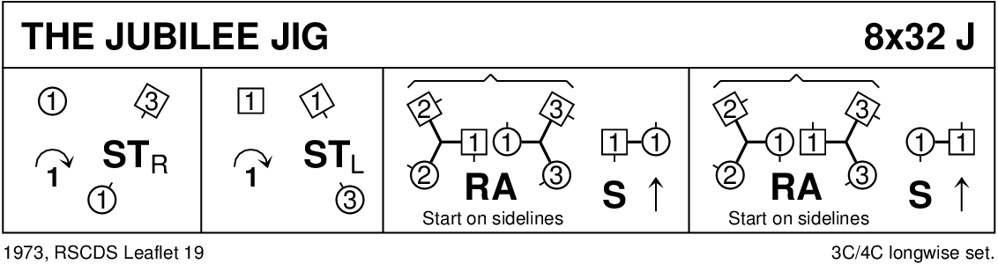

MISS MILLIGAN'S STRATHSPEY (S8x32) 3C (4C set) Leaflet
1- 8 1s+2s circle 4H round to left, 1s turn to face 2s & set, 1s cast while 2s dance up
9-16 2s+1s+3s dance reels of 3 on own side 1s dancing in between 3s to start
17-24 2s+1s+3s set, 2s+1s ½ turn LH, 1s followed by 2s lead down between 3s, cross & cast up on own side
25-32 1s+2s dance the Knot

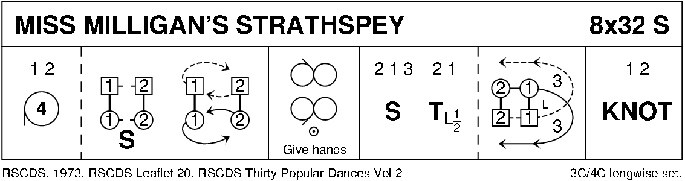

THE AYRSHIRE WHEELIE BIN (J8x32) 3C (4C set) Finley
1- 8 1L dances RH across with 1M+2M while 3M dances RH with 2L+3L
1s circle 3H round to left with same dancers
9-16 1L+3M dance out between 1M+2M/2L+3L, cast to left,
¾ turn LH to face opposite sides and dance RH across all end in original places
17-24 1L also 3M followed by partners chase clockwise ½ way to 3s facing down and 1s up in centre
3s+1s dance ½ R&L and 1s end turning LH to face 1st corners
25-32 1s turn 1st corners RH, partner LH, 2nd corner RH and partner LH to 2nd place own side

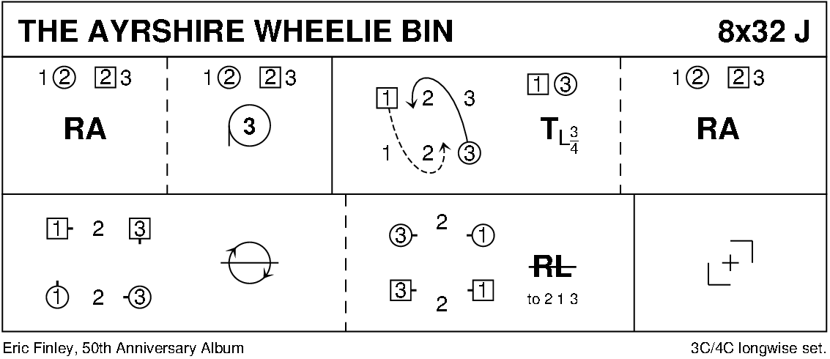

BACK TO THE FIRESIDE (R8x32) 3C (4 cp set) RSCDS Bk 38 1- 8 3s followed by 1s dance down for 2 steps & set to partner
1s dance up & cast off to 3rd place while 3s dance up to top place
9-16 1s cross RH to start reverse Snowball Grand Chain for 3 couples to end 1 (2) 3
17-24 1s+2s set advancing to form circle (hands joined) & petronella 1 place to right
Set hands joined & petronella turn to end on side
25-32 1L dances ½ Fig of 8 round 2s as 1M dances ½ Fig of 8 round 3s
2s+1s+3s turn RH

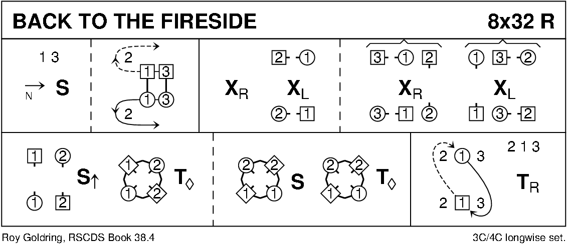

BUTTERSCOTCH AND HONEY (S4x32) 4C set Attwood
1- 8 1s set and ½ turn RH into prom hold, 1s dance ½ RS reel of 3 with 2s (2s end on opposite sides)
9-16 1s dance ½ LS Reel of 3 with 3s and ½ RS reel of 3 with 4s
17-24 1s followed by 4s+3s+2s cast up on opposite sides to top,
cross over to own sides each Lady passing in front of partner and down own side 2 3 4 1
25-32 All set to partner and turn BH into 4H round (2s with 3s and 4s with 1s)

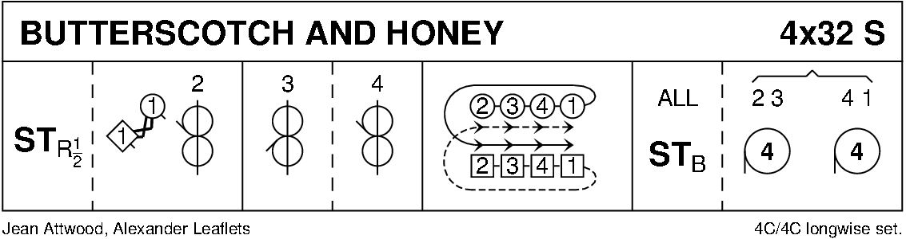

MUIRLAND WILLIE (J8x32) 3C (4C set) RSCDS Bk 21
1- 4 1s lead down middle & cross over to cast up to 2nd place
while 2s set & cross RH to 3rd place while 3s cast up to 1st place & cross RH
5- 8 All set & ½ turn BH to own side
9-16 Repeat bars 1- 8 from new positions
17-24 1s lead up to 1st place & set, 1s+2s set advancing
25-32 1s+2s dance Poussette 2 1 3

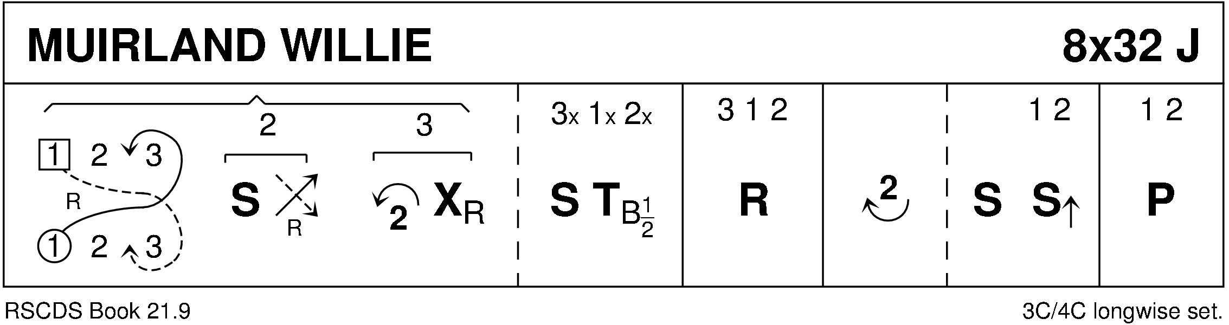

SHIFTIN' BOBBINS (R8x32) 3C (4C set) Clowes
1- 8 1s cross RH to double triangle position with 2s+3s & set
1s cast up to top & dance down until they are between 2s & 3s
9-16 1L dances RH across with 2M+3M while 1M dances LH across with 2L+3L
1s followed by 2s+3s dance down centre
17-24 3s followed by 2s+1s dance up --- 3s+2s cast down to place
1L dances LH across with 2M+3M while 1M dances RH across with 2L+3L
25-32 1s dance up to top & cast down to 2nd place opposite side
1s dance ½ Fig of 8 around 2s to end in 2nd place on own side

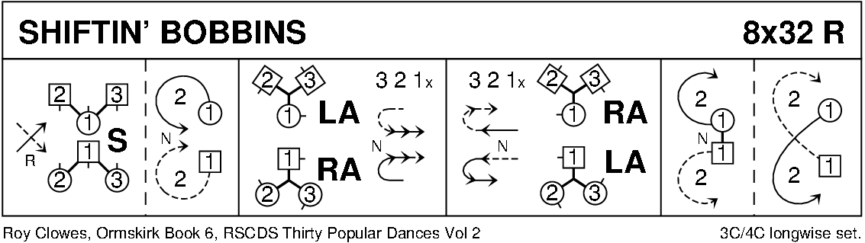

ST BERNARD’S WALTZ

MILITARY TWO STEP

POSTIE'S JIG (J4x32) 4C set Clowes
1- 8 1+4s set, cast off/up 1 place & dance ½ figure of 8 round new end couples
9-12 1M+4M & 1L+4L cross (men making an arch) & turn corners with free hand to face up/down
13-16 1s+4s dance down/up (couple dancing up make the arch) & turn corners
17-24 Repeat bars 9-16 from new positions
25-32 1s+4s dance ½ R&L & turn partner RH

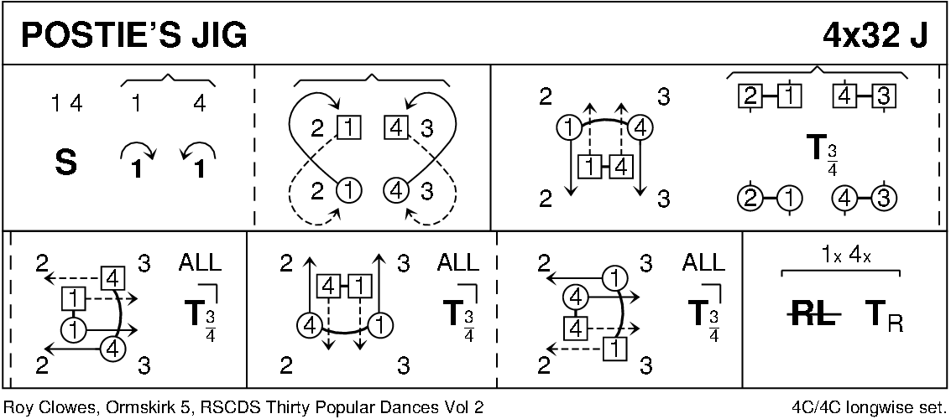

THE FALLS OF ROGIE (R8x32) 3C (4C set) Attwood
1- 8 1s cross RH & cast off 1 place, 1s cross RH & cast off 1 place (man up, lady down)
9-16 1s dance ½ reels of 3 across (1M+2s & 1L+3s)
set in lines across & change places RH with opposite person
17-24 2s+1s+3s chase clockwise ½ way
1s dance in & turn RH to face 1st corner positions as 2s+3s continue to chase on to place (as bar 16)
25-32 1s dance ½ reel of 4 with 1st corners
passing RS dance ½ reel with 2nd corners & cross passing RS to 2nd place own side
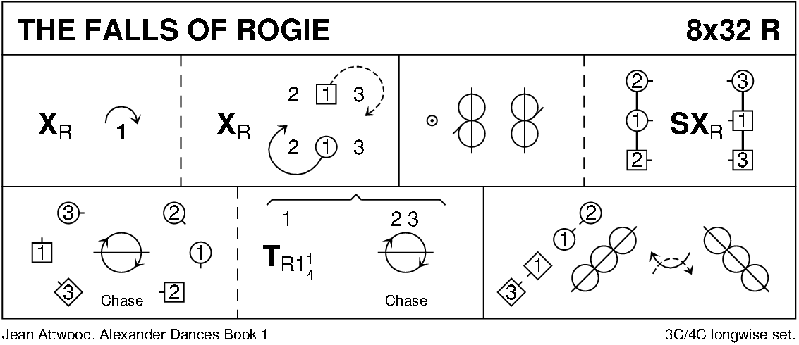

SANDS OF MORAR (S8x32) 3C (4C set) RSCDS Bk 45
1- 8 1s dance figure of 8 round 2s giving hands when meeting
` 9-16 1s dance reels of 3 on own side (1s dance down between 2s to begin)
17-24 1s turn BH, dance down to 3rd place (in middle) as 2s+3s dance up & down behind them
All set facing down
1s followed by 2s+3s cast up to original places
25-32 1s+2s dance the Tourbillon

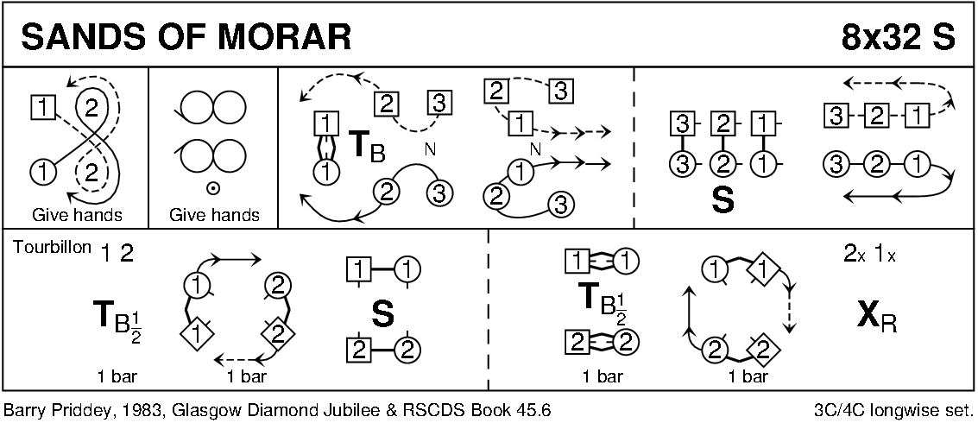

MEOPHAM GREEN (J5x48) 5C set Howard
1-8 1s+3s ¾ turn RH into prom hold (Lady on left) and cast 1 place on Ladies' side
1s+3s ½ turn RH into middle (1s facing down, 3s up)
9-16 1s+4s+3s circle 6H round and back
17-24 1s+3s dance RH across
1s+3s cast to ends and cross down/up into double triangle positions facing opposite side
25-28 All set (as in Double Triangles) 1s+3s dance out and turn right about to face in
while 2s+4s+5s dance in and turn right about to face out
29-32 All set (Inverted Triangle formation)
1s+3s petronella turn into line up/down in middle while 2s+4s+5s dance to places
33-40 1s+3s dance reel of 4 up/down middle
41-48 1s+3s turn RH, cast down 1 place opposite side and cross RH to new places 2 4 1 5 3

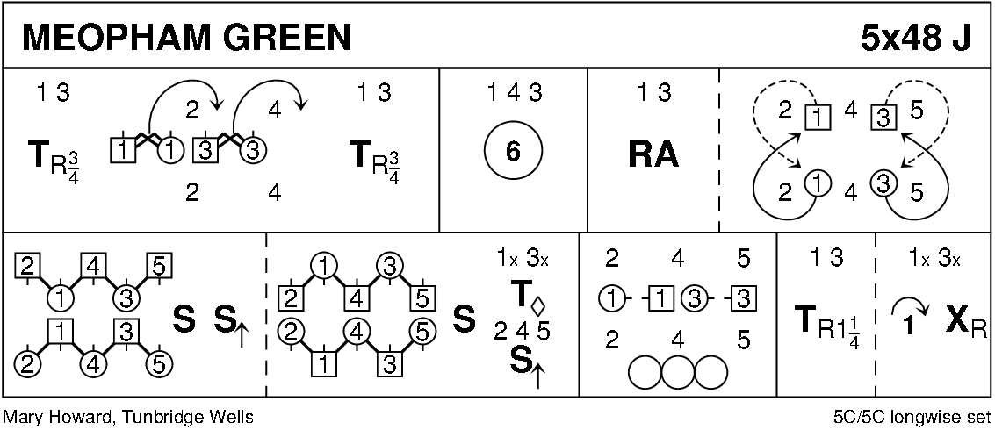

THE HIGHLAND RAMBLER (R8x40) 3C (4C set) Goldring 1- 8 1s dance in & cast off 1 place; dance RH across with 3s
9-16 2s+1s dance LH across
1L followed by partner cast up round 2L & dance down middle to 1L between 3s & 1M between 2s
17-24 1s+2s+3s dance down the middle & back
25-32 1M followed by partner cast up round 2L to 2nd place on own side & turn RH
33-40 2s+1s+3s circle 6H round & back

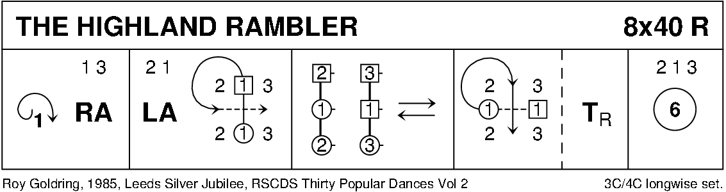

GANG THE SAME GATE (S8x32) 3C (4C set) RSCDS Bk 36
1- 8 1s cross RH & cast off 2 places, cross RH & cast up to 2nd place on own side
9-16 1s set advancing to partner & turn 1st corner BH to face 2nd corner
dance ½ reel of 4 with 2nd corners ending M between top couple facing down & L between bottom couple facing up
17-24 1s set advancing to partner & turn 2nd corner (in diagonally opposite place) BH to face
own 1st corner position
dance ½ diagonal reel with 1st corners - ending in 2nd place opposite side
25-32 3s+1s+2s Set & Link for 3 – twice

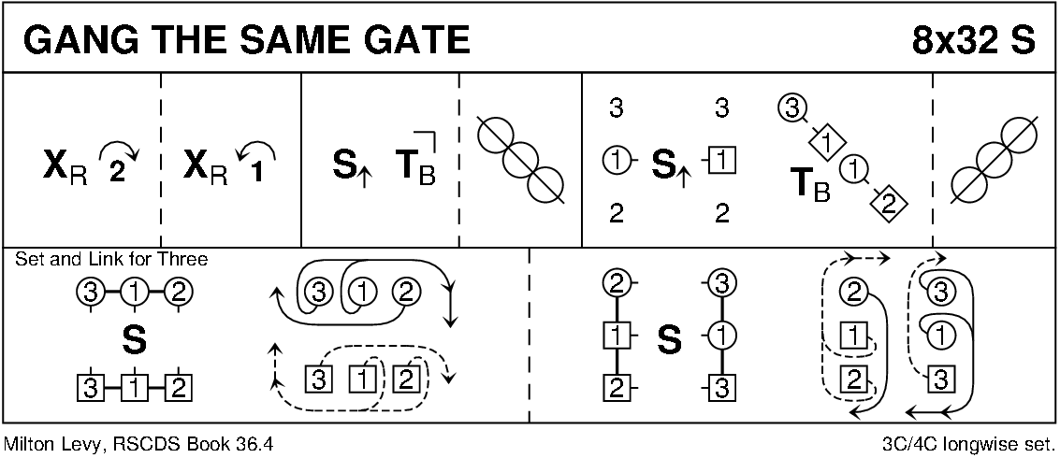

QUARRIES' JIG (J8x32) 3C (4C set) RSCDS Bk 36
1- 8 1s set, cast off 1 place & dance round 1st corners passing corners LS
9-16 1s dance reels of 3 across (1M+ 2s & 1L+ 3s), 1s turn LH to face 1st corners
17-18 Centre dancers change with 1st corners RH while 2nd corners set
19-20 1st corners (in centre) change places LH while new 1st & 2nd corners dance clockwise round to next corner place
21-24 Repeat the Fig in bars 17-20 from new places
25-32 Repeat 17-20 from new places
1s end by turning LH to 2nd place on opposite side; 2s+1s+3s set on sides & 1s cross back RH

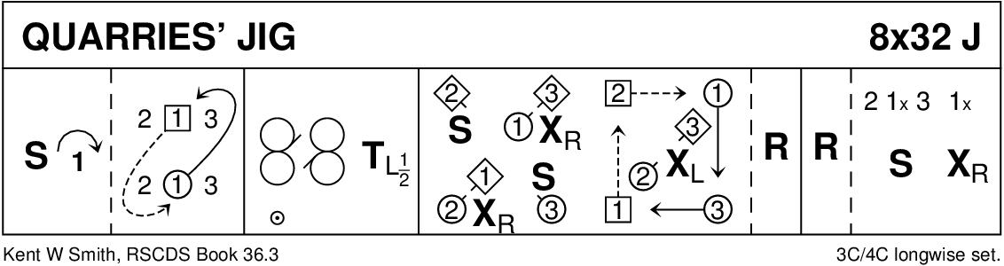

THE IRISH ROVER (R8x32) 3C (4C set) Cosh
1- 8 1s dance down between 3s & cast up to 2nd place own side
1L dances RH across with 2s while 1M dances RH across with 3s
9-16 1s dance ½ diagonal reel of 4 with 1st corners then
½ reel with 2nd corners & ½ turn LH in centre to face 1st corners
17-24 1s dance reels of 3 across giving LS to 1st corners ending in 2nd place own side
25-32 1s dance diagonal R&L (1M crossing down & 1L crossing up to start)

