
Branch Dance ~ 23rd January 2026 Ayr Branch

WELCOME TO AYR (J8x32) 3C (4C set) RSCDS Bk 47
1- 8 1s+2s dance double Fig of 8 (1s cross down to start)
9-16 1s turn 2s on sides (Men RH, Ladies LH)
1s dance down to turn 3s on sides (Men RH, Ladies LH) ---1s end facing 1st corners
17-24 1s dance ½ reel of 4 with 1st corners & pass RS to face 2nd corner
1s dance ½ reel of 4 with 2nd corners & 1s end in middle LS to LS facing own side
25-28 1M+3s (at top) also 1L+2s dance RH across (1s end in 2nd place opposite side)
all chase clockwise ½ way to own side

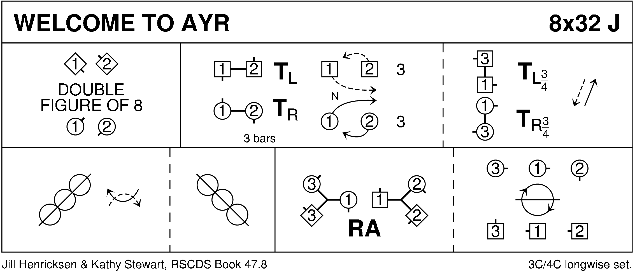

NEWTON SHORE (R8x40) 3C (4c set) Ayr 75th
1-4 1s set and cast off 1 place
5-8 1M+3s & 1L+2s dance RH across --- 1s pass LS to face 1st corner
9-12 1s+1st corners dance corners pass and turn --- 1s pass RS to face 2nd corner
13-16 1s repeat with 2nd corners
17-20 1s repeat with 3rd corners
21-24 1s repeat with 4th corners --- 1s finish back to back in centre facing own side
25-32 2+1+3 dance double triangles --- 1s finish on own side in 2nd place
33-40 2+1+3 dance six hands round and back
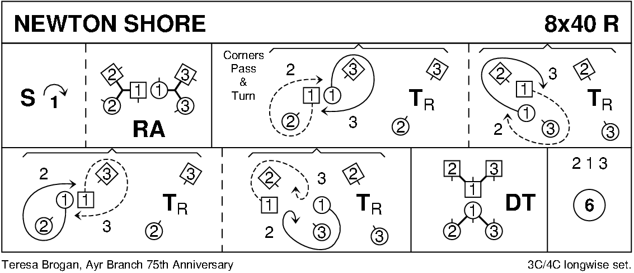

MACDONALD OF THE ISLES (S3x32) 3C Set Haynes 1- 8 2s dance full diagonal Reel of 4 with 1st corners, passing by the LS to face 2nd corner
9-16 2s dance full diagonal Reel of 4 with 2nd corners to end in original place
17-24 All dance Snowball Grand Chain for 3 couples to end 3 (2) 1:
`1s cross RH & change places LH on side with 2s
`1s change places RH with 3s while 2s cross over RH
`1s cross LH while 2s & 3s change places LH. 3 (2) 1
25-32 3s+2s dance ½ R&L, 3s dance ½ fig of 8 round end couples (3M up & 3L down) to end in 2nd place
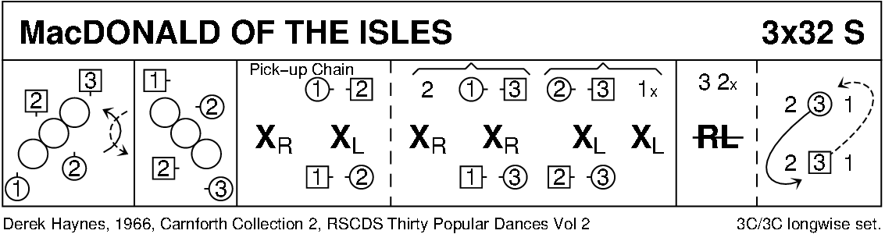

MARK AND SUSIE’S JIG (J8x32) 3C (4C set) RSCDS Book 54
1- 8 1s+2s set, dance ½ RH across, set & dance ½ LH across
9-16 1s+2s+3s dance reels of 3 on opposite side with each couple crossing down from the top through 2nd place (1) (2) (3)
17-24 3s followed by 2s+1s lead down, on bar 20 each Lady turns under partner’s right arm, while Men dance below them, to face up on own sides, 1s+2s lead up to finish in the middle of set with both hands joined, 3s finish in 3rd place 1 2 3
25-32 1s+2s dance Poussette

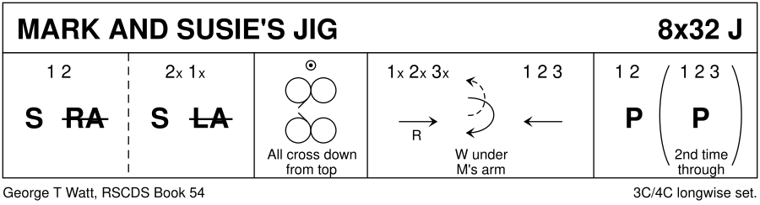

A TRIP TO APPLECROSS (6x32) 2C (3C set) RSCDS Bk 50
1- 8 1s set
1M sets twice while 1L dances round 1M passing RS & back to place
1s cross RH ~ 1L ends facing up
9-16 1s+2s dance Man's Chain up/down set finishing on sidelines
17-24 1s+2s set, pull back RS, dance 1 place clockwise
1s+2s dance RH across
25-32 1s+2s change places RH on sides with partner
chase 1 place clockwise
1s turn 1½ RH
Repeat having passed a couple but on each 2nd repetition the first 16 bars are modified as follows:
1-8 1s set
1L sets twice while 1M dances round 1L passing LS & back to place –
1s cross LH ~ 1M ends facing up
9-16 1s+2s dance Ladies' Chain up/down set finishing on sidelines

Note: Bars 3-6 1M or 1L may use highland setting
Bars 29-32 1s may use pivot turn (Right elbow grip)
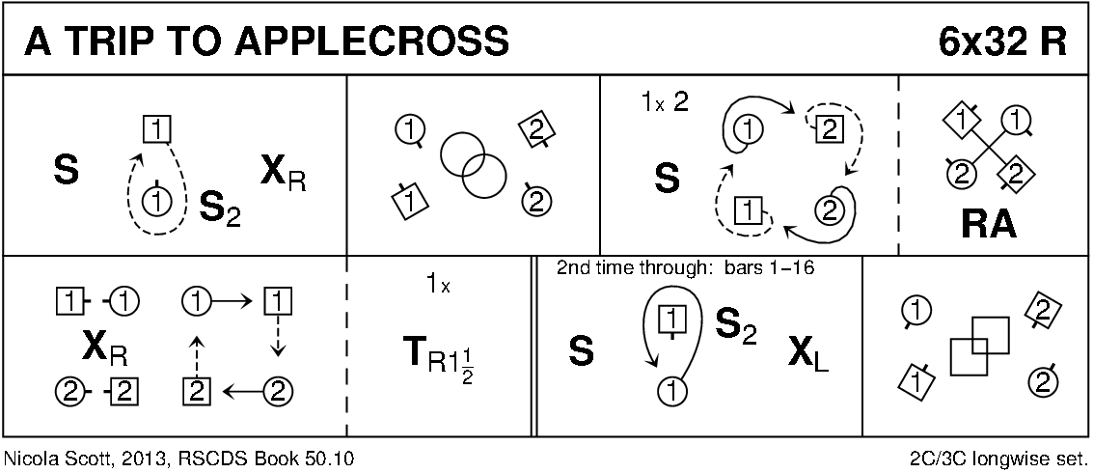

ST COLUMBA'S STRATHSPEY (S5x32) 5C set Gillan & Sproule
1- 8 2s+4s dance RH across
2s dance up while 4s dance down - 2s+4s casting round ends on own side to face 1st corners
9-16 2s+4s Pass+Turn with 1st corners, pass partner LS
Pass+Turn with 2nd corners & into centre facing partner (L facing down, M up)
17-24 2s+4s dance reel of 4 ending in original places on side
25-32 2s+4s set & cast off 1 place while 3s+5s set & dance up 1 place
1s+2s turn RH & cast off 1 place 3 1 5 2 4
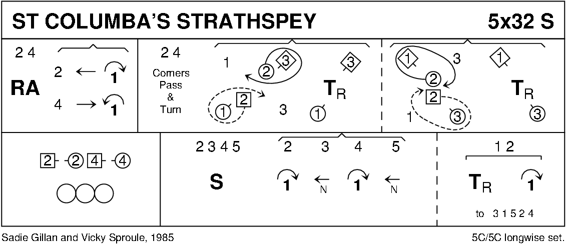

GOOD HEARTED GLASGOW (J8x32) 3C (4C set) Knapman
1- 8 1s turn RH & cast off 1 place, turn partner LH 1¼ times to end man facing down & lady facing up
9-16 1s dance RH across (1L+2s & 1M+3s), 1s pass RS & dance LH across with other couple
17-24 1s lead down the middle & back to 2nd place own side
25-32 2s+1s+3s circle 6H round & back

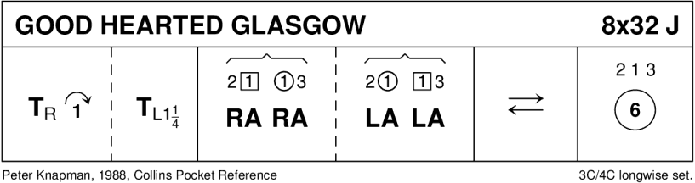
THE SALTIRE SOCIETY REEL (R8x32) 3C (4C set) RSCDS Leaflet
1- 8 1s cross down & dance out between 2s+3s turning 3s by near hand to meet partner
1s dance up & turn 2s by nearest hand to 2nd place opposite side
9-16 1s cross down to 3rd place & dance reel of 3 own side (2s - out & down as 3s - in & up between 2s) --- 1s end (hold LH) facing 1st corners
17-24 1s set to 1st corners, turn inwards & set to 3rd corner as 3rd corners set advancing to dance RH across with 1s --- 1s end turning to face 2nd corners
25-32 1s repeat bars 17-24 with 2nd/4th corners but dancing LH across

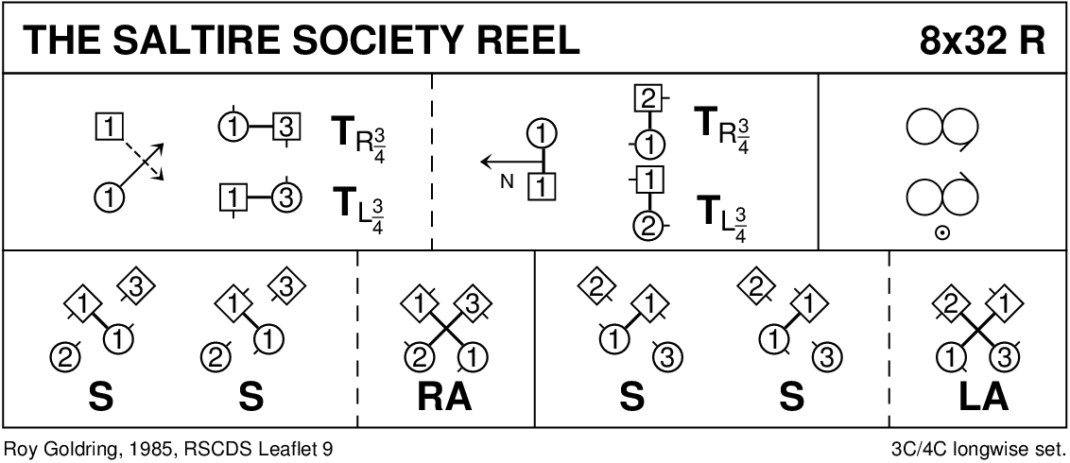

TRIBUTE TO THE BORDERS (J8x32) 3C (4C set) RSCDS Leaflet
1- 8 1s cross RH & cast off 1 place, turn RH 1½ times to end in promenade hold facing 2M
9-16 1s dance ½ RS reel of 3 on men’s side, cross to face 3L
1s dance ½ RS reel on ladies’ side - 1s end facing 3L (in top place)
17-24 1s set to 3L, turn & set to 2L, turn & set to 2M, turn & set to 3M ending with 3s+1s+2s in centre ready for Allemande
25-32 3s+1s+2s Allemande

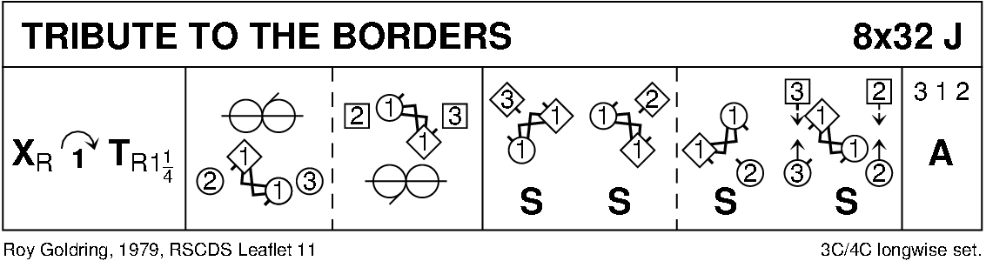

THE FALLS OF ROGIE (R8x32) 3C (4C set) Attwood
1- 8 1s cross RH & cast off 1 place, 1s cross RH & cast off 1 place (man up, lady down)
9-16 1s dance ½ reels of 3 across (1M+2s & 1L+3s), set in lines across & change places RH with opposite person
17-24 2s+1s+3s chase clockwise ½ way
1s dance in & turn RH to face 1st corner positions as 2s+3s continue to chase on to place (as bar 16)
25-32 1s dance ½ reel of 4 with 1st corners
passing RS dance ½ reel with 2nd corners & cross passing RS to 2nd place own side
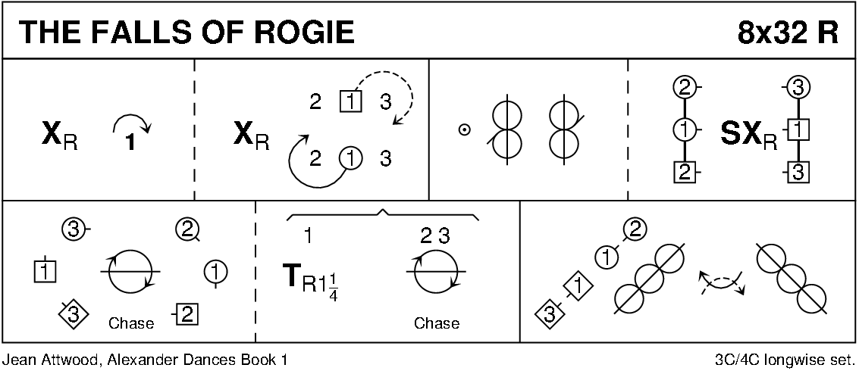

THE SILVER TASSIE (S8x32) 3C (4C set0) Drewry
1- 8 1s+2s+3s cross RH & set, cross back RH & set
9-16 1s+3s dance double Fig of 8 round 2s (3s casting)
17-24 1s followed by 2s+3s dance down, 1s followed by 2s+3s (who part to let 1s thru) dance back to top
25-32 1s+2s dance the Rondel
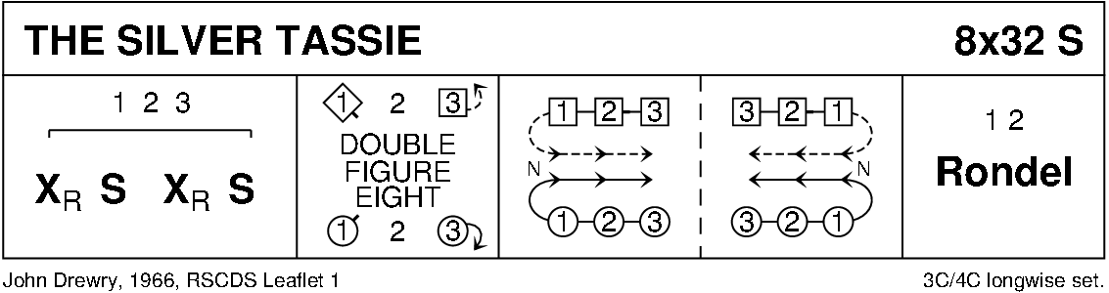

KATHY'S FASCINATOR (J3x32) 3C Set RSCDS Book 54
1- 8 1s+2s dance Set & Rotate ~ 1M & 2L face out
9-16 2s+1s dance RH across
1s+3s dance LH across ~ 1s face up
17-24 2s+1s+3s dance RS reels of 3 on sides (1s pass 2s RS to start)
25-32 1s+3s dance the Knot 2 3 1

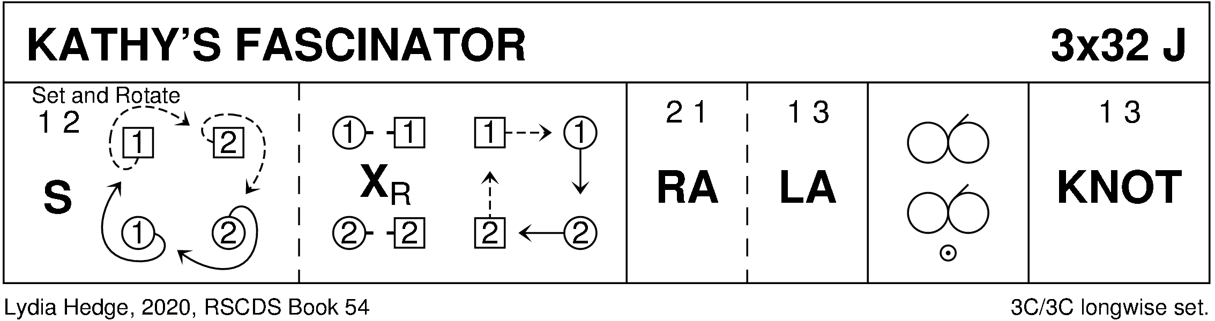

THE LOCHALSH REEL (R8x40) 3C (4C set) RSCDS Bk 53
1- 8 1s turn RH, cast off 1 place, cross LH, cast off 1 place to meet partner in promenade hold facing 3M (Lady on Man's left)
9-16 1s dance LS reel of 3 across with 3s
17-24 1s separate to dance reels of 3 on opposite side
25-32 1s dance up to top, turn 2s with other hand, cross down between 3s & cast up to 2nd place own side
33-40 1s dance RH across (1L+2s & 1M+ 3s), pass RS to dance LH across with other couple

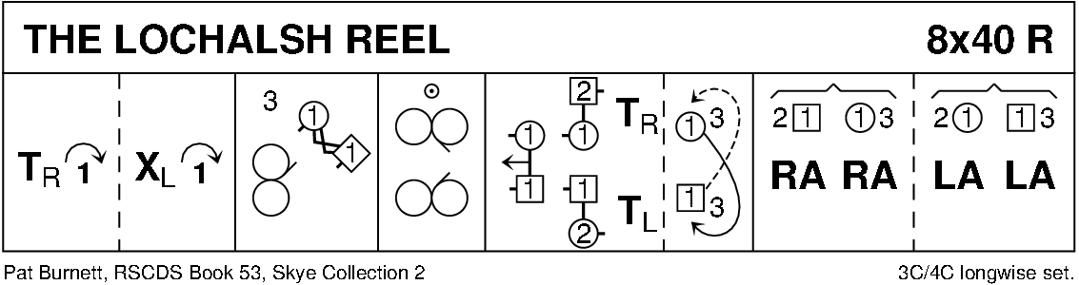

THE MINISTER ON THE LOCH (S3x32) 3C set RSCDS 4/2008
1- 8 1s+2s dance Diamond Poussette
9-16 1s dance down for 2 steps, turn BH, dance up to top & turn BH
17-24 1s+3s dance double Fig of 8 round 2s with 1s casting to start
25-32 1M+2M turn LH 1½ times while 1L+2L turn RH 1½ times
1M+3M turn RH 1½ times while 1L+3L turn LH 1½ times

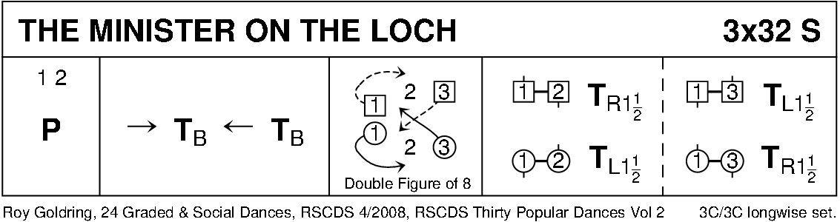

THE HAZEL TREE (J8x32) 3C (4C set) Drewry
1-8 1s+2s dance the espagnole:
1s+2s cross (Ladies RH passing between Men) with Ladies changing places RH
1s+2s cross back (Men cross RH between Ladies) with Men changing places RH
2s turn RH as 1s turn LH to face 1st corner
9-16 1s turn 1st corner RH, pass RS, turn 3rd corner LH & pass LS to face 2nd corner
17-24 1s turn 2nd corner RH, pass RS, turn 4th corner LH ---1s pass LS to face down in middle (opposite side) left hands joined
25-32 1s lead down below 3s, cross, cast up to 2nd place own side
2s+1s+3s turn RH

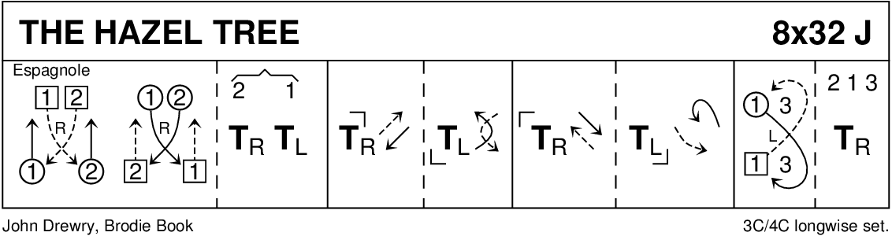

DUKE OF PERTH (R8x32) 3C (4C set) RSCDS Bk 1 1-8 1s turn RH, cast off 1 place, turn LH to face 1st corners
9-16 1s turn 1st corner RH, partner LH, 2nd corner RH & partner LH to face 1st corners
17-24 1s set & turn 1st corner BH, set to & turn 2nd corner BH
25-32 1s dance reel of 3 on opposite side giving LS to 1st corner & cross back to own side

