Jevon Kirkem
Jevon Kirkem is a Clifton Park, New York native whose journey through athletics has been shaped by perseverance, leadership, and a commitment to impacting the next generation of student-athletes.
A 2020 graduate of Shenendehowa High School, Jevon continued his football career at the collegiate level, beginning at Erie Community College before transferring to Hudson Valley Community College, where he competed on the offensive line. His journey then took him to the University of Tennessee, where he joined the Volunteers football program as a walk-on and earned recognition on the Dean’s List.
Jevon eventually returned to New York and continued his academic and athletic career at SUNY Cortland. As an offensive lineman for the Red Dragons, he continued developing as a student, athlete, and leader while pursuing his degree in Sport Management. During his time at Cortland, Jevon was also involved with Fellowship of Christian Athletes and served others through Best Buddies.
Today, Jevon’s journey has brought him back to where it began at Shenendehowa High School. He currently serves as an Athletic Director Intern while also coaching football as the JV Offensive Line Coach. In these roles, Jevon is gaining hands-on experience in athletic administration while investing directly in young athletes and helping them develop both on and off the field.
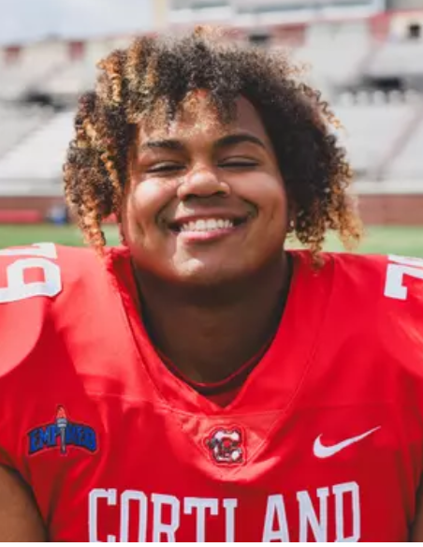
From Shenendehowa to junior college, the University of Tennessee, SUNY Cortland, and now back to Shen, Jevon’s story has come full circle. His experiences as a collegiate athlete, coach, mentor, and emerging athletic administrator have given him a unique perspective on the impact athletics can have in developing young people and building stronger communities.

