How to Download our app!
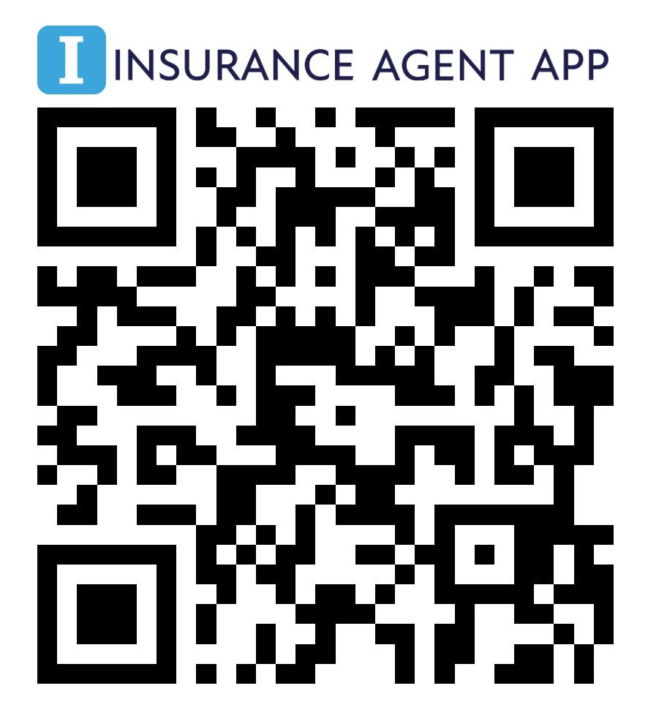
https://x5b7.app.link/insurance-agent-app

- Scan this QR code with your smartphone camera or click the link
- Download Insurance Agent App
- Register with the email used with your insurance agency account
- Set your password

