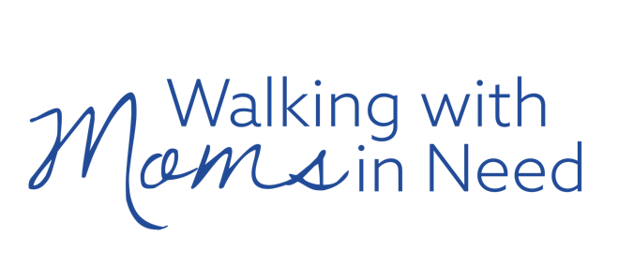
BABY SHOWER WISH LIST 10/2025

Please bring wish list items to Mass on Saturday & Sunday October 18th & 19th
for our 1st annual baby shower for moms in need. Thanks in advance for your generosity!

NEW ITEMS ONLY, PLEASE


- diapers
- baby wipes
- tear free baby shampoo
- tear free body wash
- baby lotion
- diaper rash creme
- pacifiers
- bottles w/ nipples
- bottle brushes
- nursery water
- powdered formula
- sippy cups
- teething toys
- small laundry basket

BABY EQUIPMENT SPECIFIC REQUESTS - NEW ONLY, PLEASE

- Graco TriRide 3-in-1 Reclining Car Seat $199.99 @ Amazon & Meijer St. Charles
Neutral Color Options: Kipling 2.0 OR Clybourne 2.0
can accommodate 5-pound newborn up to 100-pound child
- Graco Pack ‘n Play Close2Baby Bassinet Playard $189.99 @ Amazon
may be used instead of crib, can accommodate newborn to 2+ yrs

NEW OR LIKE NEW ITEMS - CLEAN, NO STAINS OR TEARS

- bibs
- burp cloths
- clothing - newborn to 24 months or 2T including onesies, sleepers, outfits
- shoes - socks - mittens
- baby towels & washcloths
- pack ‘n play sheets to fit Graco products
- swaddle/receiving blankets
- knitted or crocheted blankets
- small toys - no batteries

WE ALSO NEED VOLUNTEERS

Women willing to be new life companions – Pregnancy & Infancy
Do you have a desire to take part in an outreach to moms? Volunteers will be trained to offer peer support, companionship, and friendship. Flexible scheduling! Initially, you and a partner will meet with a woman who has called our hotline requesting assistance. You will give her a gift provided by the ministry. The relationship between a woman in need and this ministry could be a one-time only meeting or could continue throughout pregnancy and infancy.

Interpreters & Translators
There is currently a need for English and Spanish speaking/writing volunteers.

Other Resources
Do you have a talent or skill that can help? Let us know!

To volunteer or obtain more information, please reach out to us at walkingwithmoms@stpeterrlm.org

