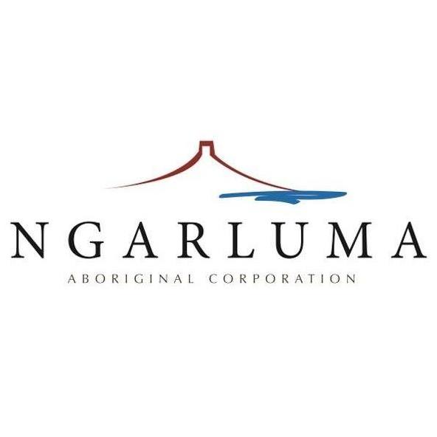
Application for Endorsement as a Ngarluma Business

Contact Details
Contact Full Name
Position
Phone Number
Mobile Number
Email Address

Business Information
Registered Business Name
Trading Name
ABN
Registered Business Address
Company Type
Business Website

Business Overview
Business Industry
Description of Products and/or Services Offered
Description of Current or Potential Customers

Ownership Details
How many owners does the business have?
What percentage of the business is owned by Ngarluma people? | %
How many of the owner/s are Ngarluma members?
If multiple owners are Ngarluma members, please provide their name and position

Attached Supporting Documents Checklist
Copy of Business Registration Certificate | 
Any other additional supporting documents
Comments about additional documents attached

Declaration
I declare that the information provided in this application is true and correct to the best of my knowledge. I understand that providing false or misleading information may result in the rejection of this application.
Applicant's Signature
Full Name
Date

