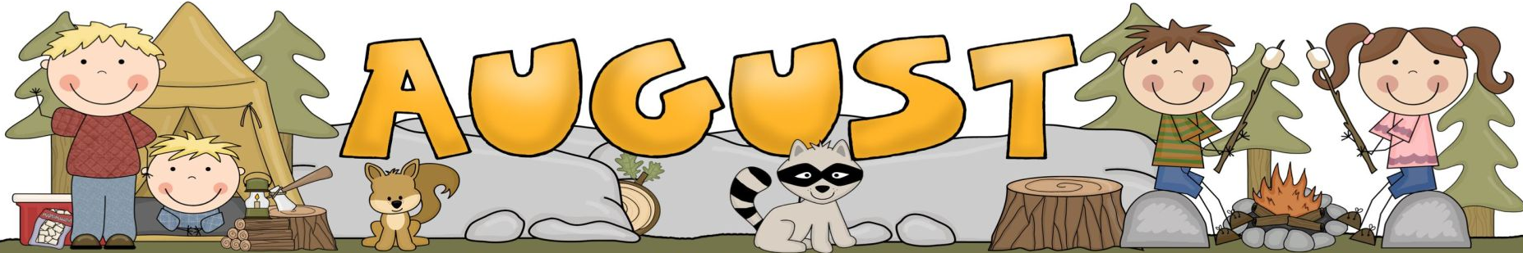
2026
First Steppers
Ms. Noemi

Sunday | Monday | Tuesday | Wednesday | Thursday | Friday | Saturday
2  Chopping  Block | 3  Ice Cream  Delight | 4  Kitchen  Play  Wear A Food Themed Shirt | 5  Corn on the Cob  Fingerprint | 6  Yellow  And  Yummy | 7  Fruit  Salad  With the  Wiggles | 8
9  Incredible  Athletes | 10  Bean Bag  Toss | 11  Practice  Kicking  The Ball | 12  Stop  And  Go | 13  Let’s Go  Bowling  Wear Your Favorite Sports Team Shirt | 14  Catch  That  Ball | 15
16  Dream It  Build It | 17  Build  A  House | 18  Play dough  Castles | 19  Let’s  Play | 20  Lego  Towers | 21  Three Little Pig Puppet Show & Story  Pajama Day | 22
23 | 24  Parachute  Fun | 25  Stop  And  Go | 25  Bubbles  All Around | 27  Running With  Ribbons | 28  Story:  Brown Bear | 29
30 | 31  Kitchen Play





