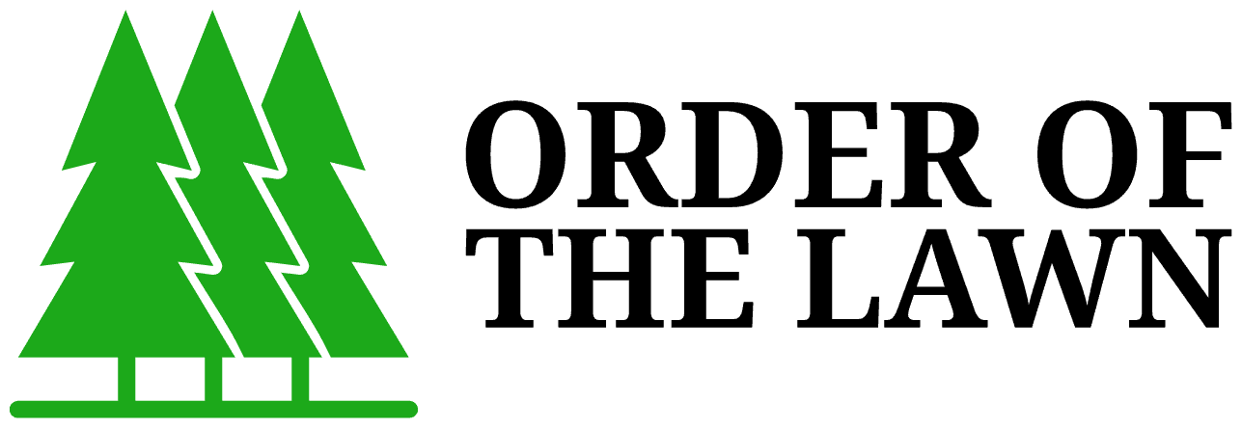
SL 001 - Service List

Lawn Care Services
    - Residential Lawn Mowing
    - Residential Edging / Line Trimming
    - Residential Hedging / Trimming
    - Residential Weed Spraying / Control
    - Residential Yard Clean-up
    - Residential Mulching
    - Residential Waste Removal
    - Body Corporate Edging / Line Trimming
    - Body Corporate Hedging / Trimming
    - Body Corporate Lawn Mowing
    - Body Corporate Waste Removal
    - Body Corporate Yard Clean-up
    - Body Corporate Mulching
    - Commercial Edging / Line Trimming
    - Commercial Hedging / Trimming
    - Commercial Lawn Mowing
    - Commercial Waste Removal
    - Commercial Weed Spraying / Control
    - Commercial Yard Clean-up
    - Commercial Mulching
    - Real Estate Edging / Line Trimming
    - Real Estate Hedging / Trimming
    - Real Estate Lawn Mowing
    - Real Estate Waste Removal
    - Real Estate Yard Clean-up
    - Real Estate Mulching
    - Industrial Lawn Mowing
    - Industrial Edging / Line Trimming
    - Industrial Hedging / Trimming
    - Industrial Weed Spraying / Control
    - Industrial Yard Clean-up
    - Industrial Mulching
    - Industrial Waste Removal

