1988 Transpacific Marine 46’ Corsican
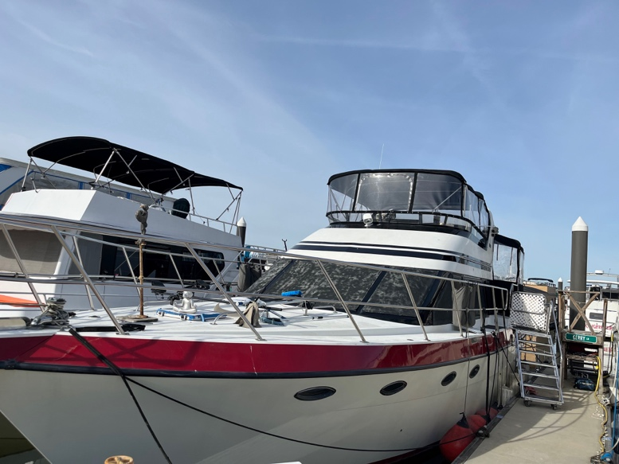
(Liveaboard Rights Included)
Jamie, owner
(602) 492-5376
Spacious Liveaboard with Flybridge, Aft Deck & Liveaboard Rights Included
Meet Sans Stress, a beautifully laid-out 46’ Corsican that lives up to its name. Perfect for liveaboard or plan to swap it out for the boat of your dreams at your leisure. Priced to sell, this well-cared for motor yacht is an ideal liveaboard with room to relax, entertain, and enjoy the marina lifestyle. Enjoy world-class views from the shaded aft deck, entertain guests from a wide salon, and cook up gourmet meals in a galley that truly feels like home.
With two staterooms, two heads, a generous 15.5’ beam, and thoughtful upgrades, this boat is ready to welcome its next captain. Liveaboard rights at The Wharf DC convey with the sale, which means you can either keep this boat or swap it for the boat of your dreams and still live at the Wharf. Any way you float it, the Liveaboard Rights alone are a steal at this price. Motivated seller—bring your offer!

Key Features & Specs:
- Length Overall (LOA): 45’5”
- Beam: 15’5” | Draft: 3.5’
- Hull: Fiberglass | Deep Vee
- Cabins: 2 | Heads: 2 | Sleeps: 4
- Staterooms:
  - Forward V-berth with storage and full head with separate shower
  - Aft full-beam primary stateroom with queen bed, ample locker space, full head with shower and bath
- Salon: Extra-wide thanks to beam, large windows, lots of light
- Galley:
  - Granite countertops, hammered copper farm sink
  - Full-size refrigerator, oven, stovetop, microwave, and ample cabinetry
  - Cozy wrap-around lounge for dining or entertaining
- Deck & Exterior:
  - Flybridge with isinglass enclosure
  - Shaded aft deck with hardtop and panoramic views
- Air Conditioning: Yes
- Engine:
  - Twin Caterpillar 3208 Inboard Diesels (1988)
  - Direct drive | 375 HP each (750 HP total) | 279.64 kW

Why Sans Stress
Sans Stress stands out as a perfect opportunity to see what living on a boat is like. It’s a spacious and beautiful boat with wood trim in all the right places. Keep it or trade it for another floating home. For this price, it is worth the liveaboard rights alone!



Floating Homes DC | Live Your Dreams on the Water
650 Wharf Street SW, Unit 36, Washington, DC 20024
(252) 549-2252

