Sojourner — 1982 President 41’ Trawler
(Liveaboard Rights Included)
Contact:
Kathy Heet, Broker
(661) 400-4487

Classic Trawler Living with Timeless Teak, Modern Upgrades & Liveaboard Rights
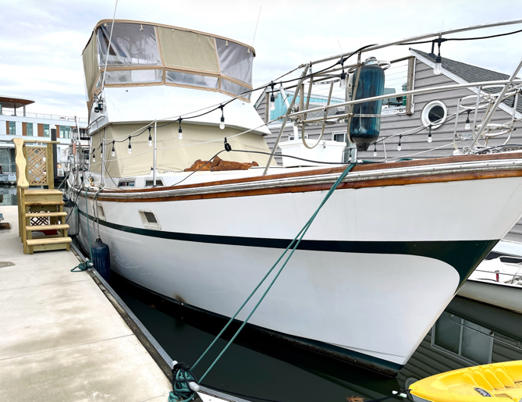
Welcome aboard Sojourner, a beautifully maintained 1982 President 41’ Trawler offering the perfect blend of classic craftsmanship and modern comfort. Located at The Wharf Marina, this vessel comes with liveaboard rights included—a rare and highly valuable opportunity in one of DC’s most desirable waterfront communities.
This trawler has been thoughtfully updated for comfortable, year-round living, with extensive teak refinishing throughout, upgraded galley appliances (2024), and a newly refreshed enclosed flybridge with canvas and isinglass (2024). Designed for both cruising and dockside living, Sojourner delivers a spacious layout, reliable diesel power, and inviting indoor/outdoor living spaces that make life on the water feel effortless.
With two staterooms, two heads, ample storage, and dependable twin Volvo Penta TAMD 60B diesel engines, this vessel is equally suited for extended cruising or as a full-time floating home. Combined with liveaboard rights—often valued near or above this price alone—Sojourner represents a compelling and hard-to-find opportunity to liveaboard at The Wharf.

Key Features & Specifications
Vessel Name: Sojourner
Builder: President Boat International
Model: 41’ Trawler
Year: 1982
Type: Power Boat
Length Overall (LOA): 41’
Beam: (Typical ~14’ for this class)
Propulsion: Power
Engines:
- Twin Volvo Penta TAMD 60B diesel engines
- Inline 6-cylinder
- Approx. 2,490 hours
- Known for reliability and cruising efficiency
Tanks:
- (2) Fresh water tanks – 170 gallons each
- (2) Holding tanks – 30 gallons each
Safety:
- Safety inspection completed February 2026

Interior & Accommodations
- Two staterooms / Two heads
- Aft Captain’s Quarters with double bed and en-suite bath with full-size shower
- Forward cabin with twin bed and private en-suite
- Hydraulic lift beds with generous under-bed storage
- Raritan electric flush toilets with macerator pumps
- Spacious salon with full-size sofa and large windows for natural light
- Beautiful refinished teak interior throughout

Galley & Dining
- Updated galley with modern appliances (2024):
  - Stainless steel under-counter refrigerator with freezer
  - Built-in stainless microwave
  - Deep single-basin sink
- Thoughtful layout for cooking and entertaining
- Banquette dining area for comfortable meals aboard

Deck & Outdoor Living
- Enclosed flybridge with new canvas & isinglass (2024)
- Aft deck ideal for outdoor dining and relaxing
- Built-in grill for entertaining
- Classic trawler walkaround design with strong lines and presence
- Extensive refinished exterior teak

Systems & Navigation
- Diesel-powered efficiency for long-range cruising
- GPS and radar systems onboard
- Solid access to mechanical and utility spaces
- Well-organized storage throughout vessel

Why Sojourner
Sojourner stands out as a true liveaboard-ready trawler—combining classic design, meaningful upgrades, and a layout that works beautifully for everyday life on the water. Whether you’re enjoying quiet mornings on deck, hosting friends aboard, or planning your next cruise, this vessel offers both comfort and capability.
With liveaboard rights at The Wharf included, this is more than just a boat—it’s an opportunity to step directly into one of DC’s most unique and sought after lifestyles.


Floating Homes DC | Live Your Dreams on the Water
650 Wharf Street SW, Unit 36, Washington, DC 20024
(252) 549-2252

