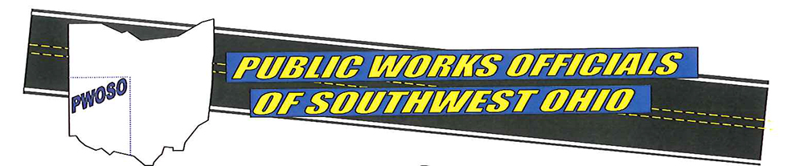

2026 PWOSO Golf Outing
Friday, June 6, 2025
Glenview Golf Course
Shotgun Start – 9:00 a.m.
__ Corporate Sponsor – Level Gold - $1000
Includes 18 Hole Scramble for four (4) with carts, dinner, hole sponsorship sign at tee box, company name on sponsorship banner and advertising on the PWOSO website.

__ Corporate Sponsor – Level Silver - $500
Includes 18 Hole Scramble for two (2) with carts, dinner, hole sponsorship sign at tee box.

__ Hole Sponsor – Level Bronze - $250
Hole sponsorship sign at tee box

__ Individual Golf Entry - $100
Includes 18 Hole Scramble with cart and dinner.

NOTE: Checks must be received by Friday, May 29, 2026 or before the outing is FULL to be guaranteed a tee time
__ Donation of merchandise, gift card, etc. to be used as raffle prizes.
Make Check Payable to: PWOSO
Mail check and entry form to: Or
Mike Carlson, City of Sharonville Public Works Department VENMO
10900 Reading Road ( Contact Mike Carlson or Steve Busam for VENMO Link )
Sharonville, OH 45241

