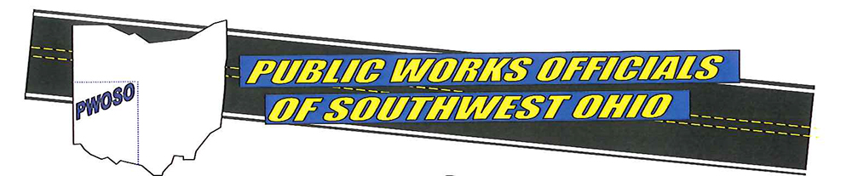

2026 PWOSO Golf Outing
Friday, June 5, 2026
Glenview Golf Course
Shotgun Start – 9:00 a.m.

Team Name: ____________________ Contact #: ____________________

Golfer #1 _______________________ Email: _______________________

Golfer #2 _______________________ Email: _______________________

Golfer #3 _______________________ Email: _______________________

Golfer #4 _______________________ Email: ________________________
Circle Sponsorship Level- Gold $1000 Silver: $500 Individual: $100 Hole $250
Individual Entry Fee - includes 18 Hole Scramble with cart and food.
Make Check Payable to: PWOSO
Mail check and completed form to:
Mike Carlson, Sharonville Public Works Department
10900 Reading Road
Sharonville, OH 45241
OR
VENMO
(Contact Mike Carlson or Steve Busam for VENMO Link)

