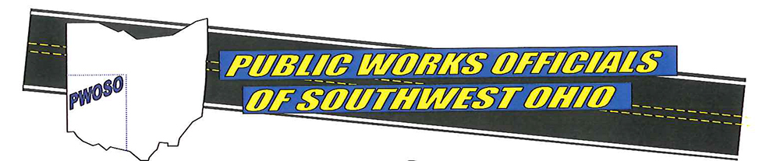2026 PWOSO Golf Outing

The Public Works Officials of Southwest Ohio would like to invite you to join us on Friday, June 5, 2026, for a golf outing. We welcome you to participate in this event to support the efforts of Public Works employees around our region.
This event will also benefit Matthew 25: Ministries and their work with the poorest of the poor and disaster victims.
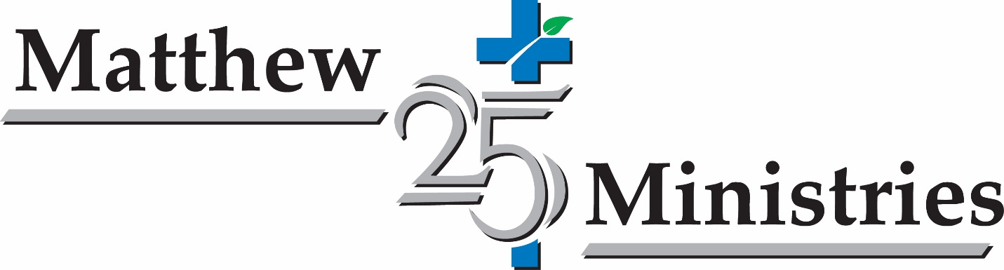
Enclosed is our registration form indicating several different ways to help support this great event. As a sponsor, participant, or both we welcome and appreciate your support and generosity.
We will have a great day of golf and fellowship at The Glenview Golf Course located at 10965 Springfield Pike Cincinnati, Ohio 45246. A shotgun start at 9:00 a.m. (Team Check in will begin at 7:00 a.m.) Hamburger/Brat/Hotdog and a bagged snack at the turn. And a Southern BBQ Buffet dinner at the end of your round. Raffle drawings for prizes, split the pot. Most of all don’t miss out on our Special Raffles. More information on raffles will be coming soon.
Any questions please contact; Mike Carlson @ 513-563-1177 or email mcarlson@cityofsharonville.com, ; Steve Busam @ 513-563-1177 or email sbusam@cityofsharonville.com, Bill Pitman @ 513-623-5993 or email bpitman@symmestownship.org
Sincerely,
PWOSO Golf Event Committee

