Module 6 Equilibrium
HSC Chemistry — Complete Summary
Prepared by Dr Andrew Wotherspoon · Tutorio Tutoring, Camperdown

A note before you begin.
This is the same resource I work through in every Camperdown Strategy Session. It is not a textbook chapter. It is a precision tool — designed to build the conceptual understanding that NESA actually rewards, not the surface familiarity that lets students down under exam pressure.
Work through it slowly. Mark what you don’t yet understand. Bring your questions to your next session.
— Dr Andrew Wotherspoon

SECTION 1
What is Chemical Equilibrium?
A reversible reaction reaches chemical equilibrium when the rate of the forward reaction equals the rate of the reverse reaction. At this point, the concentrations of reactants and products remain constant — but the reaction has not stopped. Both forward and reverse reactions continue to occur simultaneously.

The critical distinction NESA tests:
Equilibrium is dynamic, not static. The concentrations are constant because the rates are equal — not because the particles have stopped moving. Many students lose marks by writing ‘the reaction stops’. It never does.

For a general reversible reaction:
aA + bB ⇌ cC + dD
Equilibrium is established when:
rate(forward) = rate(reverse)

Visualising Equilibrium
The diagram below represents what happens to reaction rates as a system moves toward equilibrium from the moment reactants are mixed:

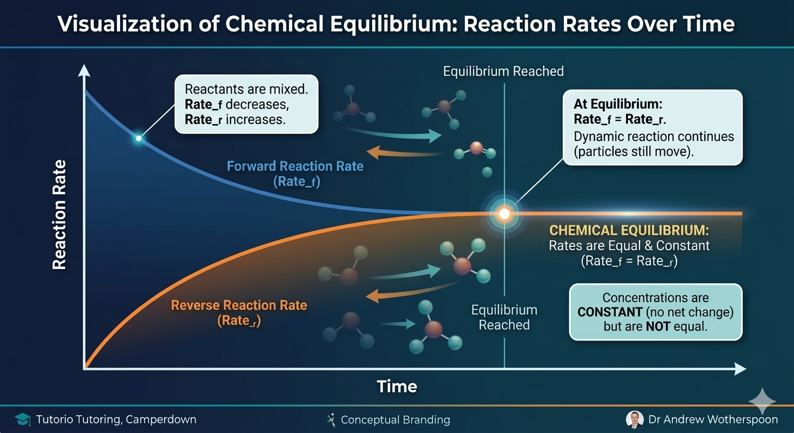

SECTION 2
The Equilibrium Constant Kc
Note on notation: NESA and university chemistry use Kc (concentration equilibrium constant) rather than Keq. Both refer to the same value — but use Kc in your exam responses.

The equilibrium constant expression is derived from the balanced equation. For the reaction above:
Kc = [C]ᶜ [D]ᵈ ÷ [A]ᵃ [B]ᵇ

Rules for writing Kc expressions
- Pure solids and pure liquids are NOT included in the expression
- Aqueous solutions and gases ARE included
- Concentrations are raised to the power of their stoichiometric coefficients
- The value of Kc is temperature-dependent — it changes only when temperature changes

Interpreting Kc values

Kc value | What it tells you
Kc >> 1 (e.g. 10⁶) | Equilibrium lies to the right. Products are favoured.
Kc ≈ 1 | Reactants and products present in roughly equal concentrations.
Kc << 1 (e.g. 10⁻⁶) | Equilibrium lies to the left. Reactants are favoured.

SECTION 3
The Reaction Quotient Q
Q is calculated using the same expression as Kc, but using the current concentrations rather than equilibrium concentrations. Comparing Q to Kc tells you which direction the reaction will shift to reach equilibrium.

Q = [C]ᶜ [D]ᵈ ÷ [A]ᵃ [B]ᵇ (using current concentrations)

Comparison | Meaning | Direction of shift
Q < Kc | Too many reactants relative to equilibrium | Shift right — forward reaction favoured
Q = Kc | System is at equilibrium | No shift
Q > Kc | Too many products relative to equilibrium | Shift left — reverse reaction favoured

How to use Q in an exam response:
Calculate Q using the given concentrations. Compare to Kc. State the direction of shift with reasoning. This is a common source of marks in calculation-based extended responses — and a common place students lose them by skipping the comparison step.

SECTION 4
Le Chatelier’s Principle
Le Chatelier’s Principle states: when a system at equilibrium is subjected to a change in conditions, the system will respond in such a way as to partially oppose that change and re-establish equilibrium.

How to apply this in extended responses:
NESA markers want to see three things: (1) identify the stress, (2) state the direction of shift, (3) explain the effect on concentrations using particle-level reasoning. Students who write only ‘equilibrium shifts right’ without explanation lose the available marks.

Effect of changes on equilibrium position

Change applied | System response
Increase reactant concentration | Shift right — more product formed to reduce [reactant]
Decrease reactant concentration | Shift left — reactants reform to restore [reactant]
Increase product concentration | Shift left — reactants form to reduce [product]
Decrease product concentration | Shift right — more product forms to restore [product]
Increase temperature (exothermic rxn) | Shift left — reverse reaction absorbs the added heat
Increase temperature (endothermic rxn) | Shift right — forward reaction absorbs the added heat
Decrease temperature | Shift toward the exothermic direction
Increase pressure (gas phase) | Shift toward fewer moles of gas
Decrease pressure (gas phase) | Shift toward more moles of gas
Add a catalyst | No shift — Kc unchanged, equilibrium reached faster only

Temperature is the only change that alters Kc.
Concentration and pressure changes shift the equilibrium position but leave Kc unchanged. This is one of the most commonly tested distinctions in HSC Chemistry extended responses.

Reading Concentration–Time Graphs
NESA frequently presents graphs showing how concentrations change over time. You must be able to identify what stress was applied and explain the response.

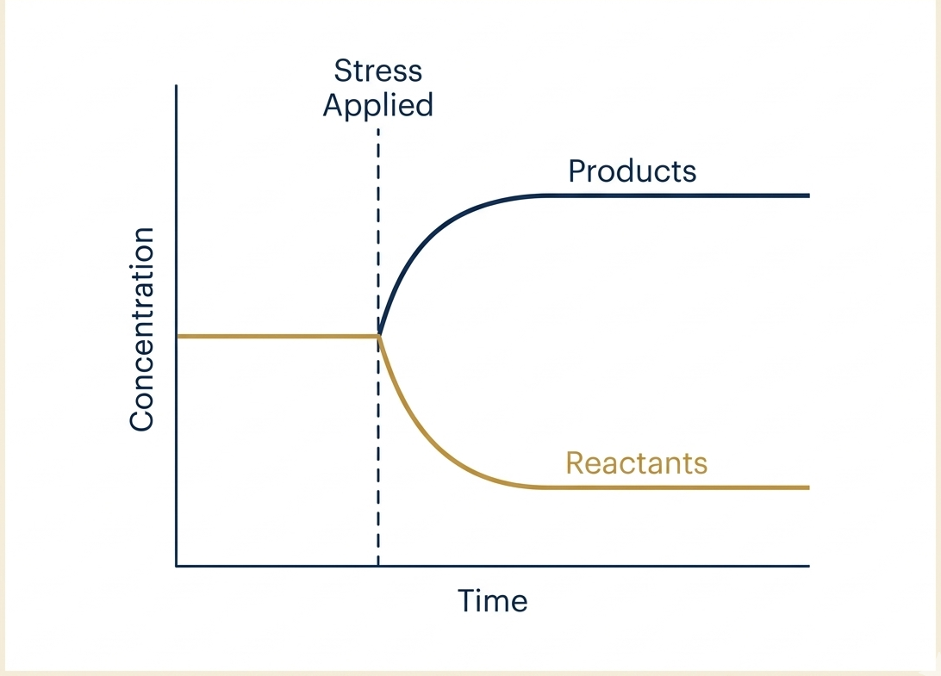

Key features to identify in any concentration–time graph:
- The flat regions before and after the stress — these represent equilibrium
- The point of change — this is where the stress was applied
- Whether concentrations increase or decrease after the stress — this tells you the direction of shift
- Whether the new equilibrium concentrations are higher or lower than the original

SECTION 5
ICE Tables — Calculating Equilibrium Concentrations
ICE stands for Initial, Change, Equilibrium. It is the systematic method for calculating equilibrium concentrations from initial conditions.

The method — step by step
- Step 1. Write the balanced equation
- Step 2. Set up a three-row table: Initial concentrations, Change (using ‘x’), Equilibrium
- Step 3. Write the Kc expression
- Step 4. Substitute equilibrium expressions into Kc and solve for x
- Step 5. Check: substitute back to confirm Kc is satisfied

Worked example

H₂(g) + I₂(g) ⇌ 2HI(g) Kc = 49.0 at 458°C
Initial: [H₂] = 0.500 mol/L, [I₂] = 0.500 mol/L, [HI] = 0.000 mol/L

 | H₂ | I₂ | HI
Initial | 0.500 | 0.500 | 0.000
Change | −x | −x | +2x
Equilibrium | 0.500 − x | 0.500 − x | 2x

Kc = [HI]² ÷ ([H₂][I₂]) = (2x)² ÷ (0.500−x)² = 49.0
Taking the square root of both sides: 2x ÷ (0.500−x) = 7.00
2x = 3.500 − 7x → 9x = 3.500 → x = 0.389 mol/L
Therefore: [H₂] = [I₂] = 0.111 mol/L [HI] = 0.778 mol/L

Verification: (0.778)² ÷ (0.111 × 0.111) = 0.605 ÷ 0.0123 ≈ 49.0 ✔

SECTION 6
Solubility Equilibria and Ksp
Slightly soluble ionic compounds establish a solubility equilibrium between the solid and its dissolved ions. The equilibrium constant for this process is called the solubility product constant, Ksp.

AgCl(s) ⇌ Ag⁺(aq) + Cl⁻(aq)
Ksp = [Ag⁺][Cl⁻]

Note: the pure solid AgCl is NOT included in the Ksp expression — the same rule applies as for Kc.

Using Ksp
- If the ionic product Q < Ksp, the solution is unsaturated. More solid will dissolve.
- If Q = Ksp, the solution is at equilibrium (saturated). No net change.
- If Q > Ksp, the solution is supersaturated. Precipitation will occur.

Worked example — calculating molar solubility:
For AgCl, Ksp = 1.8 × 10⁻¹⁰ at 25°C.
Let molar solubility = s mol/L. Then [Ag⁺] = s and [Cl⁻] = s.
Ksp = s × s = s² → s = √(1.8 × 10⁻¹⁰) → s = 1.34 × 10⁻⁵ mol/L

Common Ksp values (for reference)

Compound | Ksp (25°C)
AgCl | 1.8 × 10⁻¹⁰
BaSO₄ | 1.1 × 10⁻¹⁰
CaCO₃ | 3.3 × 10⁻⁹
Fe(OH)₂ | 4.9 × 10⁻¹⁷
PbI₂ | 9.8 × 10⁻⁹

SECTION 7
Weak Acid Equilibrium — Ka and pKa
Weak acids partially dissociate in water. The extent of dissociation is described by the acid dissociation constant, Ka.

For a weak acid HA:
HA(aq) + H₂O(l) ⇌ H₃O⁺(aq) + A⁻(aq)
Ka = [H₃O⁺][A⁻] ÷ [HA]

Note: water is a pure liquid and is NOT included in the Ka expression.

Interpreting Ka values
- A larger Ka means a stronger weak acid — more dissociation at equilibrium
- A smaller Ka means a weaker acid — less dissociation
- Ka values are very small numbers, so we use pKa for convenience

pKa = −log₁₀(Ka)

A lower pKa means a stronger acid. This is the inverse of what students expect — memorise it.

Acid | Ka | pKa | Relative strength
Hydrofluoric acid (HF) | 6.8 × 10⁻⁴ | 3.17 | Stronger weak acid
Acetic acid (CH₃COOH) | 1.8 × 10⁻⁵ | 4.74 | Moderate weak acid
Hypochlorous acid (HClO) | 2.9 × 10⁻⁸ | 7.54 | Weaker weak acid
Hydrogen cyanide (HCN) | 6.2 × 10⁻¹⁰ | 9.21 | Very weak acid

SECTION 8
pH Calculations Involving Equilibrium
pH is defined as the negative logarithm of the hydrogen ion concentration:
pH = −log₁₀[H₃O⁺]
[H₃O⁺] = 10⁻ᵖᴴ

Calculating pH of a weak acid solution — ICE method

Find the pH of 0.100 mol/L acetic acid (Ka = 1.8 × 10⁻⁵).

CH₃COOH(aq) + H₂O(l) ⇌ H₃O⁺(aq) + CH₃COO⁻(aq)

 | CH₃COOH | H₃O⁺ | CH₃COO⁻
Initial | 0.100 | 0.000 | 0.000
Change | −x | +x | +x
Equilibrium | 0.100 − x | x | x

Ka = x² ÷ (0.100 − x) = 1.8 × 10⁻⁵

Since Ka is very small, x << 0.100, so we simplify: x² ÷ 0.100 ≈ 1.8 × 10⁻⁵
x² = 1.8 × 10⁻⁶ → x = 1.34 × 10⁻³ mol/L = [H₃O⁺]
pH = −log₁₀(1.34 × 10⁻³) = 2.87

Verification of simplification: x ÷ 0.100 × 100 = 1.34% < 5% ✔ (simplification valid)

The 5% rule:
If x is less than 5% of the initial concentration, the simplification (ignoring x in the denominator) is valid. If x exceeds 5%, you must solve the full quadratic. Always check and always show the check in your working — NESA markers look for it.

pH of a strong acid vs weak acid — the key comparison

Property | Strong acid (e.g. HCl 0.1M) | Weak acid (e.g. CH₃COOH 0.1M)
Dissociation | Complete (100%) | Partial (< 5% typically)
[H₃O⁺] | 0.100 mol/L | ~1.34 × 10⁻³ mol/L
pH | 1.00 | 2.87
Kc or Ka expression | Not applicable | Ka = [H₃O⁺][A⁻] ÷ [HA]

SECTION 9
The Haber Process — Industrial Application
The Haber Process is the primary industrial application of Le Chatelier’s Principle in the HSC Chemistry syllabus. It synthesises ammonia from nitrogen and hydrogen:

N₂(g) + 3H₂(g) ⇌ 2NH₃(g) ΔH = − 92 kJ/mol

Condition | Value used | Reason for compromise
Temperature | 450–500°C | Lower T favours products (exothermic) but rate too slow. Higher T gives acceptable rate with tolerable yield.
Pressure | 150–300 atm | High P favours products (fewer moles of gas). Upper limit set by engineering cost and safety.
Catalyst | Iron (Fe) | Does not shift equilibrium but dramatically increases rate, reducing time to reach equilibrium.

The exam question NESA loves to ask:
Why is a temperature of 450°C used rather than a lower temperature? The answer must address both yield (lower T gives better yield) and rate (lower T gives unacceptably slow rate) — and explain that 450°C represents the industrial compromise between the two.

SECTION 10
Exam Technique — The CORE™ Method Applied
Module 6 questions consistently test the same four cognitive skills. Here is how to approach each using the CORE™ framework:

C — Concept Clarity
- Know the definitions exactly: dynamic equilibrium, Le Chatelier’s Principle, Kc, Ka, Ksp, Q
- Understand why Kc changes only with temperature — not concentration or pressure
- Distinguish between equilibrium position (where the balance sits) and equilibrium constant (the mathematical ratio)

O — Observation and Data Analysis
- Read Kc and Q values and determine direction of shift immediately
- Identify moles of gas on each side of a gaseous equilibrium
- Interpret concentration–time graphs: identify the stress, direction of shift, and new equilibrium

R — Reasoning and Application
- Apply Le Chatelier’s Principle to novel industrial contexts you have not seen before
- Work through ICE table calculations for both Kc and Ka problems, showing all working
- Explain industrial compromises with explicit reference to both yield and rate

E — Evidence-Based Expression
- Use precise language: ‘equilibrium position shifts to the right’ not ‘it goes right’
- Reference particle-level reasoning in extended responses
- Structure multi-mark responses: identify change → state shift → explain why → state outcome
- Always show the 5% check when simplifying Ka or Ksp ICE calculations

A final word.
The students who perform best in Module 6 are not the ones who have memorised the most — they are the ones who can look at an unfamiliar reaction and reason through what will happen using the underlying principles.
If you can sit in front of a question you have never seen before and think: what are the conditions, what is the stress, what does Le Chatelier’s Principle predict, and how do I express that precisely — you are ready.
That is what we build together in every session.
— Dr Andrew Wotherspoon · Tutorio Tutoring, Camperdown

tutorio.com.au · andrew.wotherspoon@tutorio.com.au · 0410 749 346

