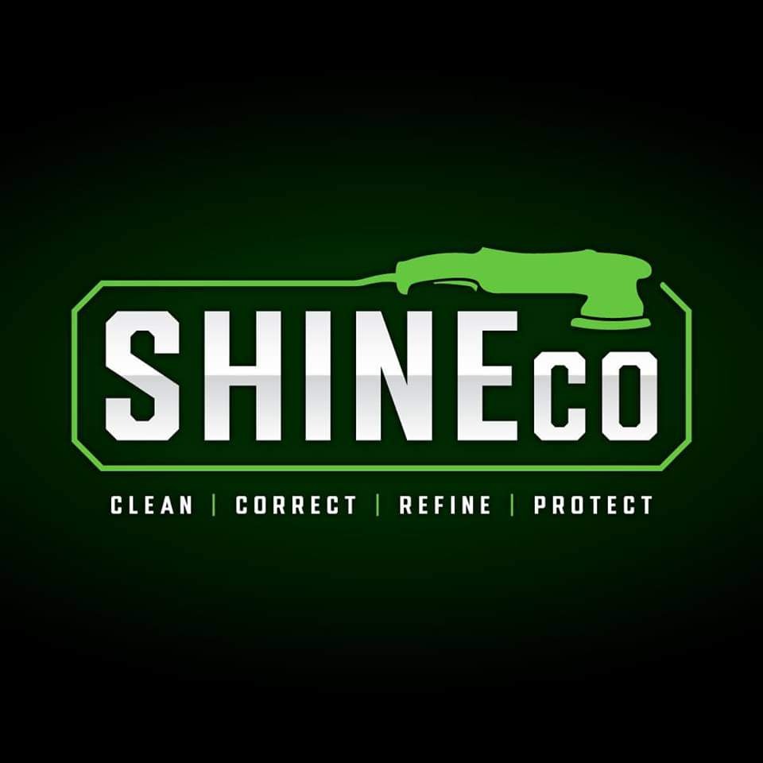

Customer Release Form/Disclaimer
Thank you for choosing ShineCo/TintCo! We would like you to have some background knowledge on auto glass tinting, prior to your appointment.
Dust
Dust is all around us and is next to impossible to keep out of the air. This also makes it impossible to completely keep off the film. However, we take every precaution to do so. We are not responsible for any excessive dust that may show up, and small dust specs are not covered under warranty. Each glass always has the potential to have a few pieces of dust. If the interior of the car is excessively dirty, we may need to clean it to keep the environment as dust free as possible. We will only do so if necessary, but needing to do so will incur a fee. This also includes things like animal hair or anything else that will get under the film during installation.
Dot Matrix
Dot Matrix is a series of small dots the factory puts around the edge of some windows and along the back glass as a visual cosmetic border. These dots are basically raised bumps on the glass that may cause the film to stick on the dots instead of the window. This will not cause the film to peel, but will seem silver in appearance. This is normal and will not disappear. Once the film dries, it will usually settle in a uniform position and is sometimes possible to press them down to some degree.
Harmonic Distortion
If you are wearing polarized sunglasses or glasses, you may see anomalies on the glass, (rainbows, lines, or marks are a few examples) which are an inherent result of the glass tempering processes. This is amplified with the installation in tint. ShineCo is not responsible for these anomalies. If you wish to have tint removed there will be an additional fee.
Electrical Issues After Install
Modern cars have more electrical components than ever. Although every precaution is taken to avoid damage, there are inherent risks while tinting as water is sprayed onto the windows, exposing these systems to moister and water runoff. This is especially true for windshield installations as water runoff behind the dash can damage the vehicle ECU. We do use panel covers and absorbing devices to catch 99% of liquids. Given the precautions we take, we are not responsible for damages that may occur to these electrical systems.
Please ask before having the installation to understand your risk before work begins.
Legality
The state of South Carolina does not allow vehicles that will be driven on public roads to have tint on the front windows (driver and passenger door, forward of the B pillar) darker than 27% VLT. The windshield may not legally have shaded tint, with the exception of above the “AS1” line. The rear section, including rear window, can legally be tinted any darkness (if it is a truck or SUV, sedan rear windows must be 27% VLT) and colored tint is not restricted. No window is allowed to have a mirrored or metallic appearance. If the rear window is tinted, the vehicle must have dual side mirrors.

Defrost Lines
Removal of tint on windows that have defrost lines can cause damage to the defrost lines, and this is out of our control. Understand that removing tint from rear windows with defrost lines can cause damage to the lines.

By signing this form, you acknowledge that you understand the laws and agree to abide by them. Any tint that does not follow these laws will be for a show car or off road vehicle that will not be driven on South Carolina public roads. ShineCo is not responsible for any tickets or accidents that occur due to tint or illegal operation of a tinted vehicle. If tint needs to be removed, there will be an additional fee.
Warranty
Our Carbon and Ceramic Tint comes with a lifetime manufacturer and installation warranty. This covers fading or discoloration of the film as well as peeling or bubbling. The warranty does not cover physical damage, such as scratches or tears, or dust particles, as stated previously.
Please inspect your windows and address any concerns before leaving when you come to pick up your vehicle.

