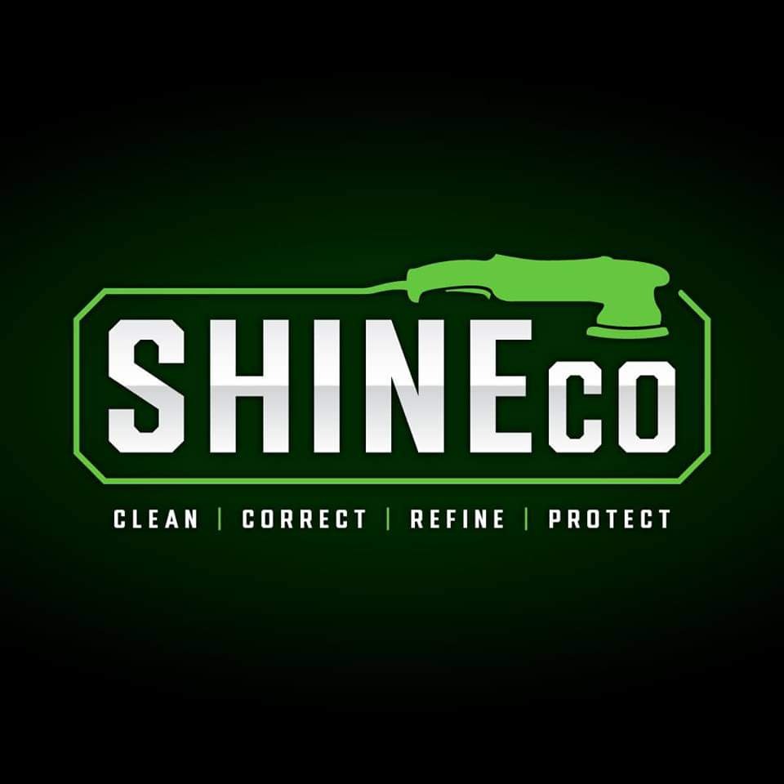

Paint protection film is a complicated installation procedure. This document is set to serve your expectations regarding your installation here at ShineCo, while also serving as a reference for future installations.

- Imperfections: We strive for perfection here at ShineCo. We say with all of our paint protection film installations, “it’s paint protection and not paint perfection”. It’s likely to some degree that you will see some debris under the film after installation such as dust particles and other potential contaminants. We attempt to take every precaution possible to make a near perfect install with the understanding of the reality that nothing will ever be perfect. Please note that the older the vehicle, the more likely it will have dirt and or contaminants in hard to access areas without complete disassembly of the vehicle. This will increase the likelihood of having slightly more specs of dust under the film after installation. We will make every attempt in our power to mitigate this with our installation processes. Please note that if the goal is to find imperfections in the film, you will undoubtedly find something. We urge our clients to consider this paint protection film and not a completely invisible film with no imperfections. Even brand new vehicles straight from the factory have their own contaminants.
- Existing rock chips: Please note that that existing rock chips will appear as PPF imperfections if PPF is installed over them. This is especially true for dark colored vehicles ( Black, Dark Blue, Dark Grey, etc). Contrary to popular belief, touch ups cannot be performed prior to PPF install due to the stickiness of the film and the likelihood of the paint chip repair lifting.
- Existing coatings: Please notify a ShineCo employee of existing coatings on the vehicle that will be receiving paint protection film from us. PPF WILL NOT bond long-term to ceramic coated areas, which will result in the film lifting on certain places such as edges and or corners. We will do our best to remove any coatings in the area that the PPF installation may be.
- Computer Software/ Bulking: We install PPF by using computer software. Each pattern is vehicle year, make, model, and package specific to each vehicle. There will be slight exposed edges in certain areas that are unavoidable although we try to minimize this as much as possible in several different ways. We do our best during every installation to make it as seamless as possible. Some vehicles can have complicated body lines which sometimes require multiple pieces to be seamed together. This can be more noticeable on lighter colored vehicles (White, Yellow, Red, etc).
- Badge and Trim Removal: In some instances we may be required to remove badging or other parts of the vehicle during installation. An example of this would be wrapping the entire hood which would usually would require us to remove a hood emblem. The customer is responsible for the cost to replace the badge if the manufacturer requires it as a one time usage. All attempts at ShineCo will be made to retain all OEM badges or lettering unless notified from vehicle owner. Please let us know prior to installation process if you wish for emblems and or badges to not be removed.
- Curing time/ Dry Time/ Lifting: Your new paint protection film will take 3-4 weeks to fully dry, this can vary due to temperature, sun exposure, rain, low temperatures, etc. Do NOT wash the vehicle within the first 7 days after pick up. You may notice some small water/air bubbles. Please do not press, massage, or poke these bubbles. It will evaporate under its own power. We make every effort to have it completely dry prior to pickup but unfortunately it doesn't always happen. You may also notice the film lifting within the 2 week mark, it is possible and also not abnormal for this to happen. We may have to go back and trim certain areas to correct this issue, please do NOT panic, give us a call and we will prioritize getting you on the schedule.
- Relief Cuts: You may notice some “relief” cuts in certain areas. Unfortunately, due to the films thickness, we have to bend/stretch the film over certain areas. Most of our patterns are generated via computer software and are precut and may have necessary relief cuts built in.
- Removal of Pre-existing Film: Regardless of how long paint protection film has been on your vehicle, there IS a chance that it removes the paint/clear-coat from the vehicle along with the film, The longer the film has been on the vehicle increases these odds.
- Aftermarket Paint: No matter how good your body shop is, aftermarket paint can lift during the install process. We do our best to prevent this issue from happening. ShineCo is NOT held liable and isn't required to pay for these damages if they were to occur. ShineCo is also NOT held liable to issue a refund if this incident happens.
I, ________________________________ have read the information above. I understand that if any of these instances or damages are to occur, ShineCo is NOT held liable and is NOT required to pay for any damages that may occur during this process. Date:____________________
Witness: ___________________________________ Date:____________________

