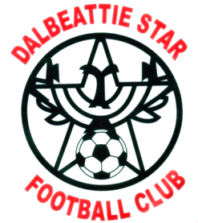

ISLECROFT STADIUM DALBEATTIE DG5 4HE

01556 611151

**POLICY REGARDING UNACCEPTABLE CONDUCT FOR SEASON 2025/26**

As a family and community club, open to everyone, the committee are keen to ensure that all supporters, players and officials do not engage in any form of unacceptable conduct. That is, conduct which is violent or disorderly.

Violent conduct includes any actual, attempted or threatened physical violence against any person, or intentional damage to property.

Disorderly conduct includes:

Conduct which stirs up or sustains, or is likely or is designed to stir up or sustain hatred or ill will against or towards individuals or groups of people because of:

* Gender
* Age
* Colour, race, nationality (including citizenship) or ethnic or national origin
* Membership or presumed membership, of a religious group or of a social or cultural group with perceived religious affiliation
* sexual orientation
* transgender identity
* disability
* using threatening, abusive or insulting words or conduct
* displaying writing or any other thing which is threatening, abusive or insulting

**ANY PERSON ENGAGING IN UNACCEPTABLE CONDUCT MAY BE SUBJECT TO ANY, OR A COMBINATION OF THE FOLLOWING:**

* Removal from the Stadium
* Suspension from attending matches or events involving Dalbeattie Star Football Club
* Indefinite ban from attending matches or events involving Dalbeattie Star Football Club
* Report to the police and possible criminal proceedings

Whilst it is appreciated that behaviour such as that listed above involves the minority of individuals in our society, the club wishes to ensure that we continue to maintain the highest standards both on and off the field of play and that the name ‘Dalbeattie Star’ is associated with sporting behavior at all times.

To be reviewed June 2026 (Reviewed Annually AGM)