White Paper: The Case for Decentralized School Safety Reporting
Prepared for Education Stakeholders
This white paper explores the disadvantages of centralized anonymous alert systems and contrasts them with the advantages of decentralized, school-driven models such as SchoolResponder.

Segment 1 – The Nature of Centralized Anonymous Alerts
Anonymous alert systems, widely marketed as solutions for school safety, rely on central intake points that route information through multiple layers before it reaches anyone positioned to act. While they appear simple—students can report via text, web, or hotline—the hidden complexity slows response. Reports are handled by third-party contractors or state-level agencies who lack direct familiarity with the reporting community. Each extra step dilutes urgency and context. By the time a message arrives to the right hands, valuable minutes have been lost, which matters when incidents involve threats of violence or self-harm. The DOE emphasizes immediacy and contextual awareness in effective school safety programs, yet centralized anonymous systems by design create bottlenecks. This model unintentionally puts schools in a reactive stance, waiting for outside actors to filter information.
For further details see WellnessResponder (a 501c3 non-profit) http://WellnessResponder.com
This white paper explores the disadvantages of centralized anonymous alert systems and contrasts them with the advantages of decentralized, school-driven models such as SchoolResponder.



Segment 2 – The Cost of Anonymity: Misdirection and Hoaxes
One of the largest flaws of anonymous alerts is that they attract false reporting. Swatting—where individuals make fraudulent claims of active shooters or bomb threats—has surged in U.S. schools, wasting police resources and terrifying communities. Because anonymity shields the reporter, accountability is nonexistent. Local staff cannot assess credibility because they don’t know who made the claim or their motivations. Research from the NIMH highlights that false alarms can contribute to heightened anxiety among students and staff, eroding trust in legitimate alerts. The more hoaxes circulate, the harder it is for responders to distinguish real danger from noise. This paradox undermines the very safety these systems are supposed to ensure.
For further details see WellnessResponder (a 501c3 non-profit) http://WellnessResponder.com
This white paper explores the disadvantages of centralized anonymous alert systems and contrasts them with the advantages of decentralized, school-driven models such as School Responder.


Segment 3 – Lack of Local Knowledge in Centralized Systems
Another weakness is the lack of context for those answering anonymous tips. Hotline operators or call center staff often have no direct connection to the school. They do not know the names of students, the layout of buildings, or the nuances of community relationships. A tip saying “John is in the library” means nothing if the responder doesn’t know which John or which library. In contrast, school-based staff—counselors, teachers, safety officers—bring personal familiarity and situational awareness. DOE best practice guidance stresses that successful safety interventions are local, community-driven, and relationship-based. Centralized anonymity cuts schools out of that process.
For further details see WellnessResponder (a 501c3 non-profit) http://WellnessResponder.com
This white paper explores the disadvantages of centralized anonymous alert systems and contrasts them with the advantages of decentralized, school-driven models such as School Responder.
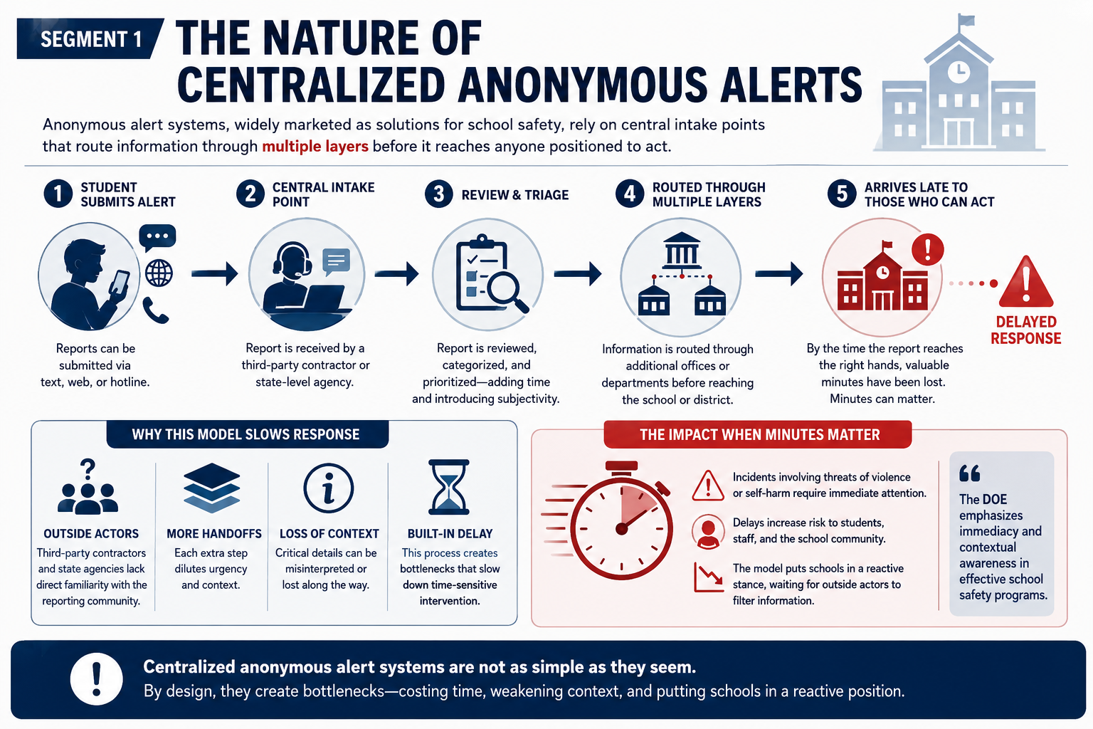

Segment 4 – Slower Response Times
Every handoff in a centralized chain adds delay. An alert may go from a student to a call center, to a state agency, to a district office, and finally to a school principal or SRO (School Resource Officer). During that lag, situations can escalate. Seconds matter when lives are at stake. Centralized systems inadvertently replicate the “telephone game”—messages are passed along and risk being distorted. SchoolResponder’s decentralized design bypasses this inefficiency, connecting the report directly to the right person at the right time.
For further details see WellnessResponder (a 501c3 non-profit) http://WellnessResponder.com
This white paper explores the disadvantages of centralized anonymous alert systems and contrasts them with the advantages of decentralized, school-driven models such as SchoolResponder.

This white paper explores the disadvantages of centralized anonymous alert systems and contrasts them with the advantages of decentralized, school-driven models such as School Responder.
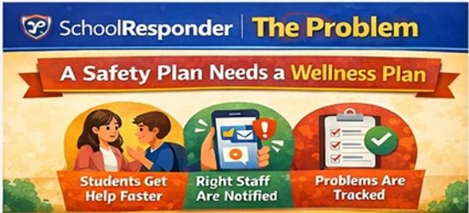

Segment 5 – SchoolResponder’s Decentralized Approach
SchoolResponder takes the opposite approach: each school governs its own reporting. Students’ tips are tied to their authenticated identity and location, allowing staff to know who raised the concern and where. This doesn’t mean confidentiality is lost—schools can configure layers of discretion—but it ensures accountability. Because reports go straight to staff who know the students by name, trust is built into the process. The staff member receiving the report isn’t a stranger in a distant office; it’s a teacher, counselor, or administrator already familiar with the child’s context.
For further details see WellnessResponder (a 501c3 non-profit) http://WellnessResponder.com
This white paper explores the disadvantages of centralized anonymous alert systems and contrasts them with the advantages of decentralized, school-driven models such as School Responder.
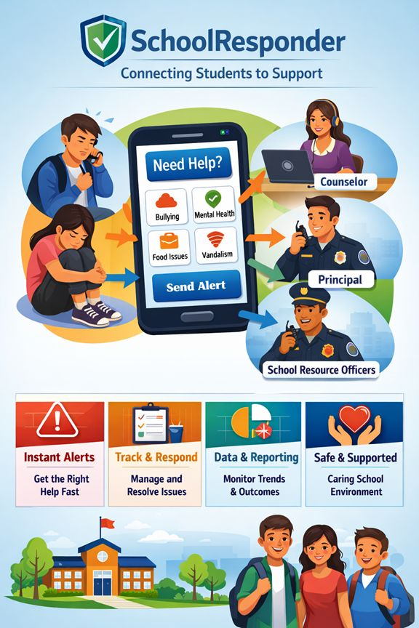

Segment 6 – Direct Communication with On-Site Staff
The greatest advantage of SchoolResponder is immediacy. Reports connect directly to staff who are already on campus, already responsible for student well-being, and already empowered to act. Unlike anonymous call centers, these staff members have access to school policies, crisis plans, and relationships with students. They know which hallway a student is referring to, which peer group dynamics may be relevant, and whether a concern aligns with other observations. This contextual intelligence shortens response times and makes interventions more precise.
For further details see WellnessResponder (a 501c3 non-profit) http://WellnessResponder.com
This white paper explores the disadvantages of centralized anonymous alert systems and contrasts them with the advantages of decentralized, school-driven models such as School Responder.
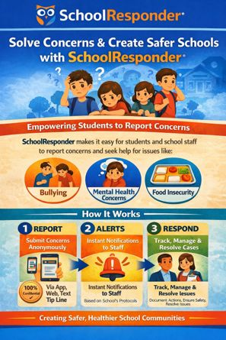

Segment 7 – Local Control and Agency Partnerships
Schools using SchoolResponder can choose when and how to connect alerts to outside agencies. If a concern escalates, administrators can share information with local law enforcement, behavioral health providers, or emergency services instantly. Unlike centralized systems, which automatically push everything through external filters, SchoolResponder gives schools discretion. This aligns with DOE recommendations for “tiered intervention,” where not all concerns require external escalation. Local decision-making means resources are applied proportionally and responsibly.
For further details see WellnessResponder (a 501c3 non-profit) http://WellnessResponder.com
This white paper explores the disadvantages of centralized anonymous alert systems and contrasts them with the advantages of decentralized, school-driven models such as School Responder.
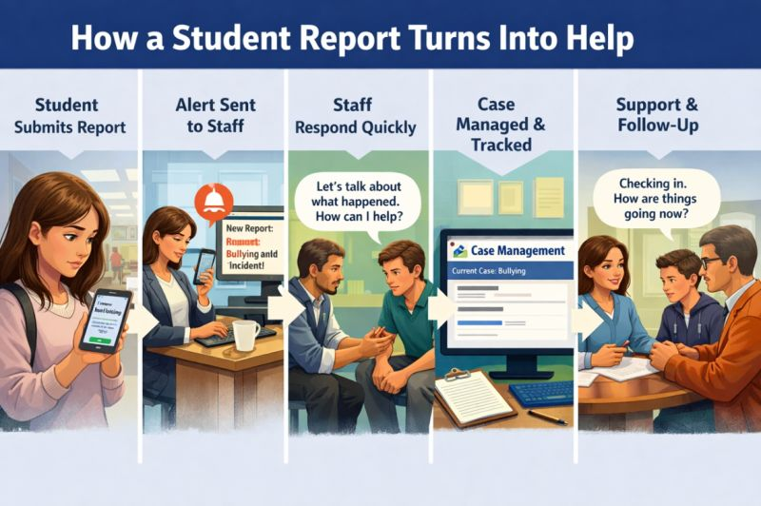

Segment 8 – Accountability and Student Support
Knowing who made the report allows schools to provide targeted support, not punishment. If a student reports self-harm or bullying, staff can intervene with counseling, peer mediation, or wellness resources. The NIMH underscores that early intervention saves lives, and anonymity undermines that by stripping away the chance to offer help. SchoolResponder maintains a record of who reported, enabling follow-up and ensuring no student slips through the cracks.
For further details see WellnessResponder (a 501c3 non-profit) http://WellnessResponder.com
This white paper explores the disadvantages of centralized anonymous alert systems and contrasts them with the advantages of decentralized, school-driven models such as School Responder.

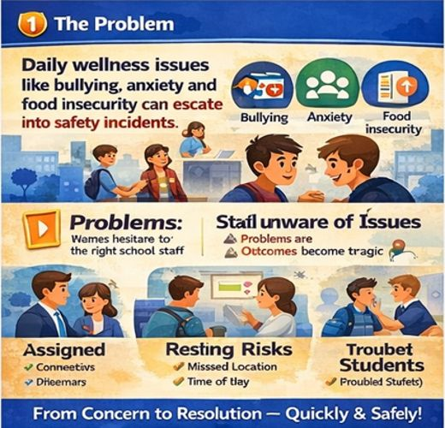

Segment 9 – Reducing False Reports, Strengthening Trust
Because students know their reports are tied to their identity, swatting and hoaxes are significantly reduced. Reports are taken more seriously because accountability is built in. This also builds trust: students understand that their concerns will be heard by people who know them, not strangers. Parents gain confidence that schools are not outsourcing safety but handling it locally. Communities can see a clear chain of accountability.
For further details see WellnessResponder (a 501c3 non-profit) http://WellnessResponder.com
This white paper explores the disadvantages of centralized anonymous alert systems and contrasts them with the advantages of decentralized, school-driven models such as School Responder.
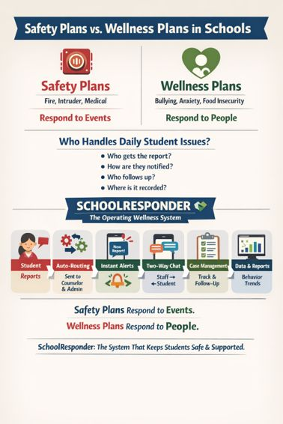

Segment 10 – Faster, Smarter, Safer Schools
At its core, the debate between centralized anonymous alerts and decentralized school-driven systems comes down to effectiveness. Centralized systems promise convenience but deliver confusion and delay. Decentralized models like SchoolResponder empower schools to act quickly, with precision, and with the relational context needed for real safety. They cut through the noise of false alerts, ensure accountability, and integrate seamlessly with local emergency agencies. In an era where every second counts, the choice is clear: decentralized, school-centered safety systems deliver faster, smarter, and safer outcomes for students and communities.
For further details see WellnessResponder (a 501c3 non-profit) http://WellnessResponder.com
