Gas-Safe™: Advanced Burner Protection and Energy Savings in One System
  - How Advanced Sensor Technologies can monitor gas fired systems to improve safety and energy efficiency

In industrial operations where gas-fired systems, hydrogen burners, or confined space processes are in use, safety is not just a compliance requirement it’s a lifeline for equipment, production, and personnel. The Gas-Safe™ Measurement System from Elementale Enterprises (in partnership with CDS Group) is engineered to deliver continuous gas monitoring, fast response, and intelligent alarms, preventing dangerous incidents while optimizing operational uptime and energy use.

Why Gas-Safe?
Combustion-related explosions and shutdowns can stem from:
- Loss of burner flame followed by delayed reignition of accumulated fuel
- Fuel leakage into idle chambers igniting unexpectedly
- Multiple failed ignition attempts without adequate purging
These scenarios can cost companies not only in repairs but also in lost production runs, emergency orders, and, most critically, worker safety.
The Gas-Safe™ System addresses these risks by continuously measuring hazardous or combustible gas levels and triggering alarms before danger escalates. This proactive protection reduces downtime, safeguards product quality, and most importantly, protects people.

Built for Critical Industries
The system excels in high-risk environments such as:
- Natural Gas and Hydrogen Fueled Burner Systems: Where thermal processing is a critical part of the manufacturing process the Gas-Safe™ continuously monitors the process to ensure a safe operating environment (consistent with NFPA and ATEX Standards) while also ensuring that energy efficiency is maximized reducing unnecessary purging and exhaust.

- Mining and Fertilizer Processing: Continuous gas monitoring is used to prevent potentially dangerous accumulation in underground shafts and/or storage areas, protecting personnel and equipment.

- Food Production: Accurate detection ensures safe processing environments and prevents contamination risks.

- Vaporizer Protection: Industrial vaporizers are indispensable, but they carry inherent risks due to the nature of their operation. A Gas-Safe™ system provides the vigilant, intelligent defense necessary to prevent these risks from manifesting into accidents. Through continuous monitoring, rapid response, and seamless integration, Gas-Safe™ transforms the vaporizer from a potential hazard into a reliably safe asset, allowing industries to focus on productivity and quality.

- Confined Space Monitoring (Air Handling Units, Boiler Houses, Steam Generators, etc): In low-occupancy plant rooms or areas with combustible gas or leak risks, Gas-Safe™ issues advanced alarms for any incidents, ensuring safety for personnel and equipment.

Gas-Safe™ comes standard with Class I, Division II certification for hazardous locations, and offers optional Class I, Division I for tougher settings. It fits easily into general or hazardous areas, including both new installs and retrofits.

Technical Excellence
The Gas-Safe™ system is more than a simple gas detector—it’s a fully engineered asset protection solution:
- Single or Dual-sensor configuration for simultaneous monitoring of one or two gases (e.g., methane & CO, hydrogen & CO₂)
- High accuracy: ±0.02% by volume
- Fast T90 response: <25 seconds (T90 = time to reach 90% of final reading)
- Robust build: Dust and moisture filtration for measurement stability
- Mechanical “Loss of Flow” diagnostics for added reliability
- Digital display and Remote HMI Options for centralized monitoring
- Horn and strobe alarms included for immediate onsite alerts

Typical gas detection ranges include:
- Hydrogen: 0–4% Vol
- Methane: 0–100% LEL
- Carbon Monoxide: 0–1000 PPM
- Oxygen: 0–25% Vol
- CO₂: up to 20% Vol
…and more than 30 other hazardous gases

Energy Savings Through Smarter Monitoring
One of the hidden costs in gas-fired systems is excessive purge cycles after flame loss or failed ignitions. These cycles waste heated air, increase fuel consumption, and extend downtime.
Gas-Safe™ reduces purge time by confirming actual gas concentrations in real time—meaning purge cycles can be shorter, safer, and more targeted. The result:
- Lower Fuel Consumption
- Faster System Restarts
- Reduced Emissions from unnecessary exhaust air purging / dumping
This smarter approach to purge management not only saves energy but also boosts operational efficiency, directly improving production margins.

Safety by Design
- Engineered for Compliance: Designed to meet USA NFPA-85 Standard for Boiler & Combustion System Safety Code
- Advanced Sensing: Integrated SIL2 certified flammability sensor, with FAILSAFE functions for O2 and CO2 readings.
- Hazard-Ready: Built for Continuous monitoring in Class I Division II areas as standard, with optional Class I Division I

Automated Safety Response
Upon detection of unsafe gas levels, the Gas-Safe™ triggers preprogrammed responses:
- Alarm Activation: Audible and visual alarms alert operators, prompting immediate investigation and action.
- Process Shutdown: The system can directly interface with vaporizer controls to halt operations, preventing further gas release and ignition risk.
- Ventilation and Purging: Gas-Safe™ can activate ventilation systems to dilute hazardous concentrations or trigger automated purging cycles to clear idle chambers before reignition, thereby preventing accumulation and flashback.
- Failed Ignition Attempts: Repeated ignitions without adequate purging may leave residual fuel in the system. Gas-Safe™ prevents unsafe operation by enforcing purging cycles and alerting operators to abnormal conditions.

Protecting Assets, Product, and People
- Assets: Fewer shutdowns and failures mean lower repair costs and higher equipment longevity.
- Product: Preventing failed batches and missed production schedules maintains throughput and customer satisfaction.
- People: Continuous monitoring and instant alerts minimize risks to personnel in hazardous work environments.

Conclusion
The Gas-Safe™ Measurement System is more than a safety device, it’s a productivity tool, an energy saver, and a safeguard for your workforce. Whether you operate in power generation, manufacturing, or process industries, Gas-Safe™ delivers peace of mind while driving operational efficiency.

Contact Information
Elementale Enterprises, Inc.
📍 15584 Summit Park, Suite 301, Montgomery, TX 77356, USA
📞 (+1) 936-283-4115 | ✉ info@elementale-ent.com
🌐 www.elementale-ent.com

CDS Group Ltd
📍 Weston Coyney Rd, Stoke-on-Trent, ST3 5JU, United Kingdom
📞 (+44) 1782-336666 | ✉ info@cds-group.co.uk
🌐 www.cds-group.co.uk

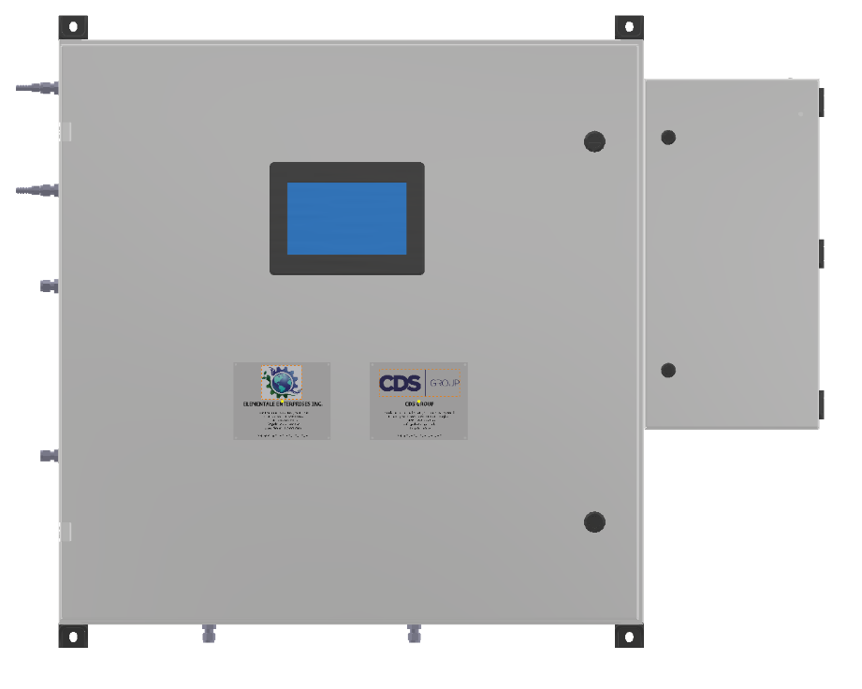
GENERAL ARRANGEMENT OF GAS-SAFETM
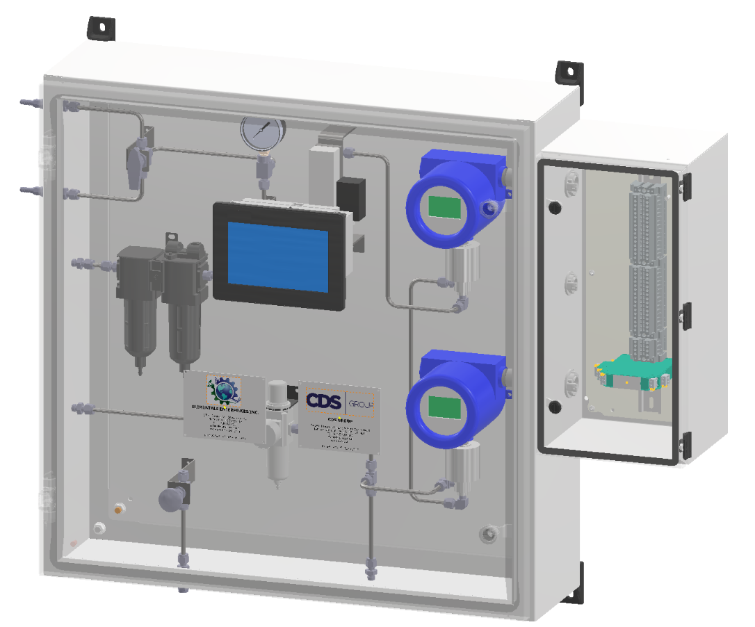

COMPACT SAFE DESIGN OF THE GAS-SAFETM
TYPICAL SIZE 30” x 30” x 9” (760mm x 760mm x 230mm)

