Summer Term Recommended Reads for Elm Class

Our class reader this term is Beowulf by Michael Morpurgo:
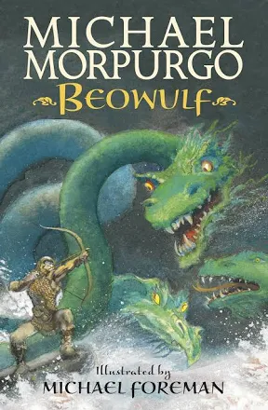 | In fifth-century Denmark, a murderous monster stalks the night, and only the great prince of the Geats has the strength and courage to defeat him. Beowulf's terrifying quest to destroy Grendel, the foul fiend, a hideous sea-hag and a monstrous fire-dragon is the oldest surviving epic in British literature.  Artfully retold and magnificently illustrated, this companion volume to Sir Gawain and the Green Knight is made instantly accessible to children by a formidable children's book partnership.

Other narratives by Michael Morpurgo:
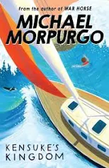 | An utterly magical of one boy’s desert island adventure – full of friendship, trust and humanity. From the nation’s favourite storyteller.  ‘I heard the wind above me in the sails. I remember thinking, this is silly, you haven’t got your safety harness on, you haven’t got your lifejacket on. You shouldn’t be doing this … I was in the cold of the sea before I could even open my mouth to scream.’  Washed up on an island in the Pacific, Michael struggles to survive on his own. With no food and no water, he curls up and closes his eyes ready for the end. When he wakes, there is a plate beside him of fish, of fruit, and a bowl of fresh water. He is not alone …
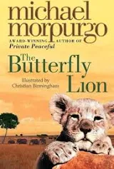 | A lyrical and moving tale of a young boy growing up in Africa, and his lifelong friendship with a white lion, from a master storyteller  When Bertie rescues an orphaned white lion cub from the African veld, the pair are inseparable – until Bertie is sent to boarding school far away in England and the lion is sold to a circus.  Bertie swears that one day they will see one another again, but it is the butterfly lion which ensures that their friendship will never be forgotten.
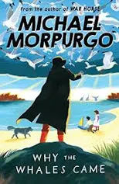 | A stunning story of friendship and our natural world set against the backdrop of the First World War. From the nation’s favourite storyteller, Michael Morpurgo.  Gracie and her friend Daniel have always been warned to stay away from the Birdman and his side of the island. But then they find a message in the sand and discover the Birdman is not who they thought.  But his warnings to stay away from the abandoned and cursed Samson Island stay with them. And when those warnings seem to be coming true, Gracie and Daniel must find out what the Birdman knows – before it’s too late …  Why the Wales Came is a gripping historical tale full of adventure and friendship, from the author of War Horse.

Other Anglo-Saxon narratives:
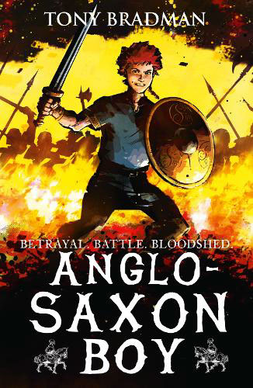 | The story of one Anglo-Saxon boy’s journey to the Battle of Hastings in 1066: Key Stage 2 History brought to life as battle-packed adventure.  1065: Magnus is the son of Harold Godwinson, lord of the Southern Saxons and ruthlessly ambitious claimant to the throne of England. Overnight, Magnus finds himself cast centre-stage in the blood-soaked family feud that led to one of history’s most famous battles.  This is the family tragedy behind 1066: live it with Magnus, as the wolves of history close in on his Anglo-Saxon boyhood.
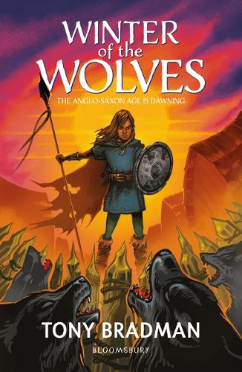 | The history and partnership of the Angles and Saxons are explored in this thrilling adventure about the trials and tribulations of their settlement in Britain.  Oslaf works hard to prove his worth in the village: he labours on the farm, he trains as a warrior, and he is slowly finding his place in the community. But when the Chieftain makes the decision to move the village across the sea to the great new land of Britannia, suddenly the Britons are a greater threat than Oslaf’s rivalry with the Chieftain’s son, Wermund. Can the Angles and the Saxons defeat the Britons? And will Oslaf be as brave as the hero in the tale of Beowulf?  This exciting and dramatic story is packed with great characters and insight into the Angles’ migration, settlement and partnership with the Saxons in 6th century Britain.

We will also be reading The Magic Faraway Tree, which is a fantasy story originally written by Enid Blyton and then adapted and modernised by Jaqueline Wilson.

If you are enjoying this, you may wish to read some other magical stories:
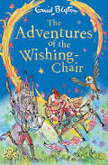 | Set off a magical adventure with the first book in Enid Blyton's classic fantasy series about a chair that can fly and grant wishes!  When Mollie and Peter go to buy their mother a birthday present, they discover the most extraordinary thing: a magical wishing-chair! The Wishing-Chair takes them on some wonderful adventures - to a giant's castle to rescue a new pixie friend, to the Land of Dreams, and even to a disappearing island! Who knows what might happen next?
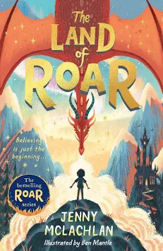 | When Arthur and Rose were little, they were heroes in the Land of Roar, an imaginary world that they found by climbing through the folding bed in their grandad’s attic. Roar was filled with things they loved – dragons, mermaids, ninja wizards and adventure – as well as things that scared them (including a very creepy scarecrow…)  Now the twins are eleven, Roar is just a memory. But when they help Grandad clean out the attic, Arthur is horrified as Grandad is pulled into the folding bed and vanishes. Is he playing a joke? Or is Roar … real?
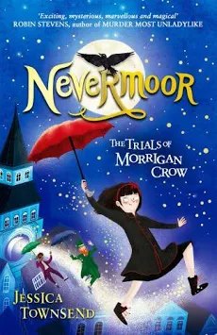 | Morrigan Crow is cursed, destined to die on her eleventh birthday. But, as the clock strikes midnight, she's whisked away by a remarkable man called Jupiter North and taken to the secret city of Nevermoor.  There she's invited to join the Wundrous Society. Mystery, magic and protection are hers - if only she can pass four impossible trials, using an exceptional talent. Which she doesn't have...

You might like to explore some books based on our Science focus, States of Matter:
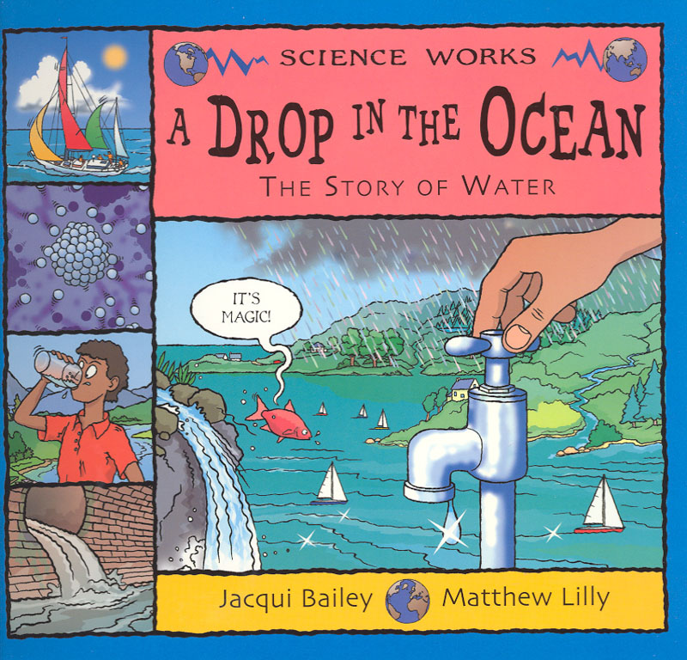 | This series uses cartoon style illustrations and humorous narrative text to make key topics in Science and Geography both accessible and engaging. This approach encourages children to read about and understand complex ideas.  This story follows the passage of a water droplet, from the time when it evaporates from the ocean and becomes the water vapour that makes up clouds to the moment it falls as rain. We learn how water is cleaned and used before being returned once again to this never-ending cycle. This book also contains an experiment, more great facts to know, useful websites and an index.
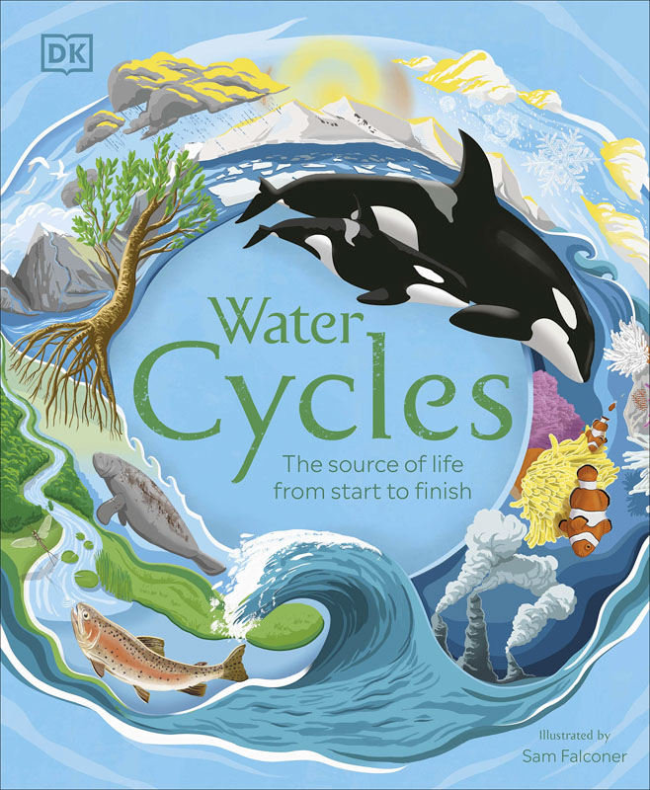 | Dive into the life-cycle of water and discover how it supports all life forms, how humans harness its power, and why we need to conserve it. From snowflakes falling from the clouds and deep ocean currents to hot springs and water in space, this children’s nature book showcases the beauty and power of water in the natural world.
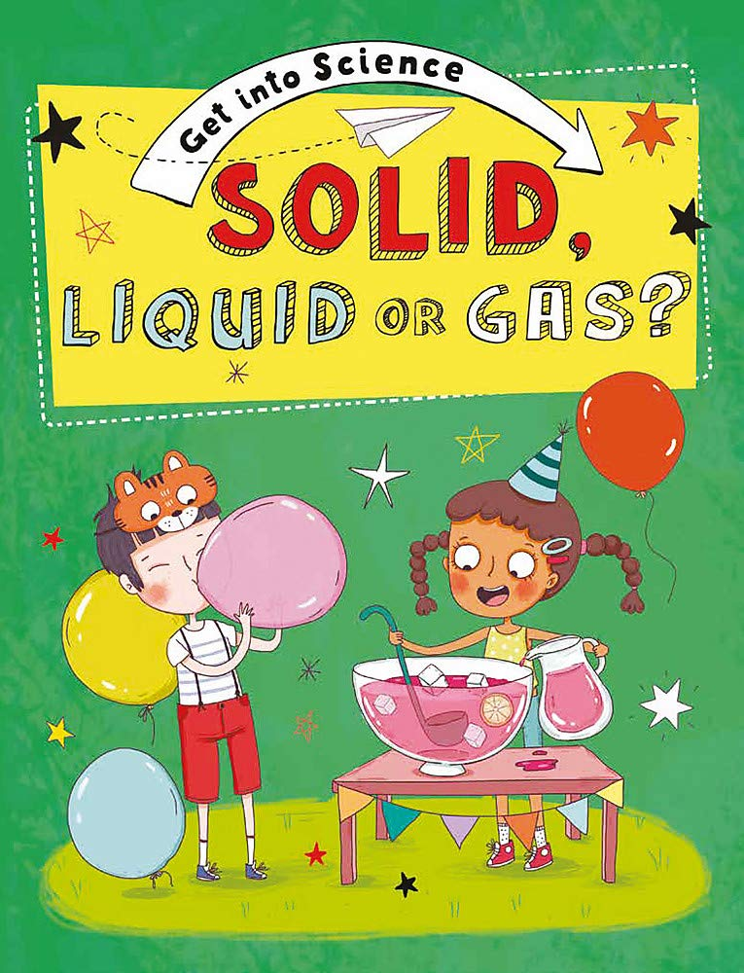 | This first science book exploring the science behind materials and matter provides a great foundation for scientific knowledge. From topics such as melting and dissolving to natural or man-made materials, the book has clear information and fun illustrations. It also has plenty of interactivity such as challenges to think about and activities to try.  Get into Science is a series of eight books for children aged 6+ that explore the science that surrounds them in their everyday world. Each page is full of things for the reader to notice, talk about and try for themselves. The simple text is accompanied by fun illustrations.

In our geography lessons, we will begin to learn about London and the Southeast of the UK:
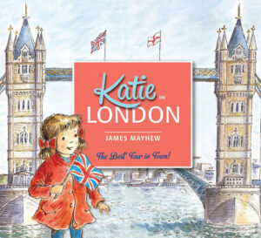 | Come on a magical tour with Katie and discover London's most famous sights! When Katie and her brother Jack visit London with Grandma, something very unexpected happens . . . One of the Trafalgar Square lions comes to life and takes them on a wonderful tour of all the best sights! Including Buckingham Palace, the Tower of London, Big Ben and the London Eye. Featuring many of London's key landmarks, this storybook has become a bestselling introduction to London and is perfect for children visiting the city for the first time.
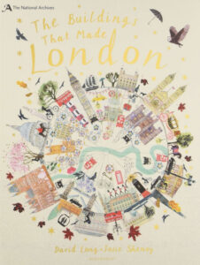 | Take an incredible journey through the streets of London and see beautiful buildings as you've never seen them before! An elegant horizon of historic masterpieces mixed with sleek modern skyscrapers; the familiar London skyline seems to change every year. Using original architectural drawings from The National Archives brought to life by stunning artwork by Josie Shenoy, discover the rich heritage of some of London's most iconic buildings.
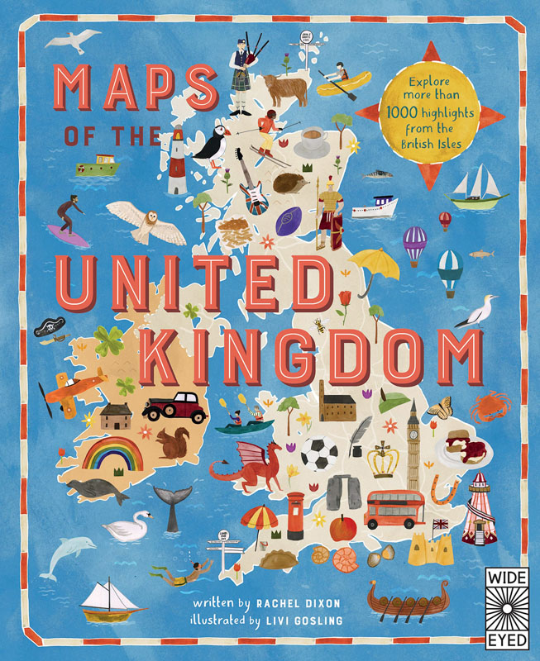 | Take a tour of the United Kingdom as you’ve never seen it before in this fully illustrated set of colourful and fact-filled county maps. Travel through England , Northern Ireland , Scotland and Wales and meet the incredible people born there, learn about the UK’s proud history and discover ancient castles, modern feats of engineering and natural highlights. Maps of the UK is also a beautiful atlas of the UK’s history and culture , showing how Britons from all over the world have shaped the country for thousands of years. A fabulous introduction to the UK’s geography, history and culture, for readers young and old.

Books linked to our history learning, The Stuarts:
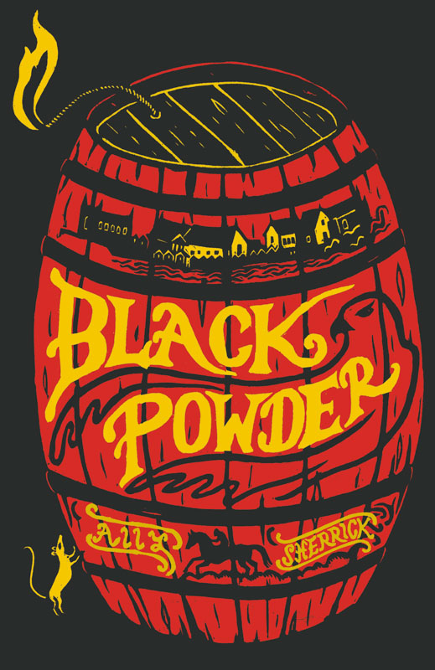 | An action-packed historical adventure that transports the reader back to England at the time of the Gunpowder Plot. Black Powder tells the story of a boy called Tom, who finds himself at the service of an intriguing stranger called ‘The Falcon’. The stranger seems to be the only person who can help Tom to save his father from being hanged, but as Tom journeys towards London he discovers that the Falcon has his own, somewhat explosive, mission in mind. Suddenly Tom is faced with the choice of freeing his father or saving the king from an assassination plot. This gripping adventure will capture imaginations and is likely to resonate with anybody who has ever felt like knowing which people and beliefs to trust can sometimes be extremely difficult.
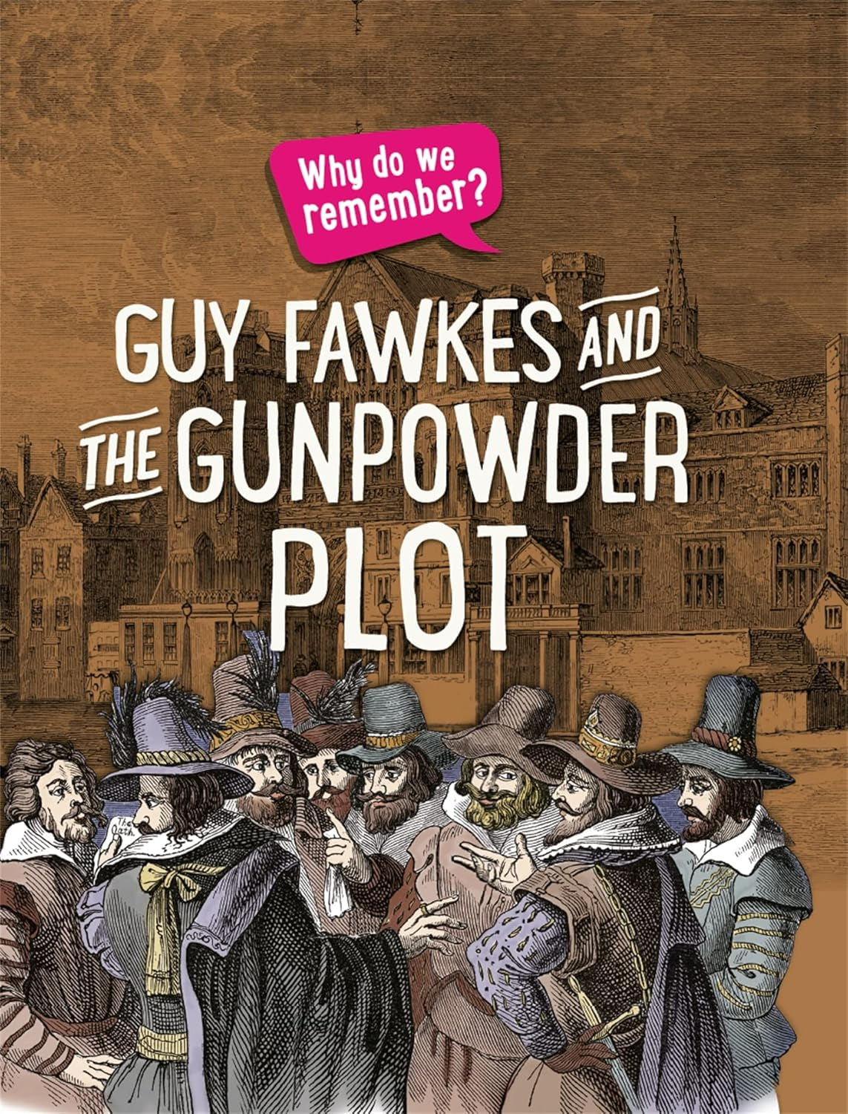 | Find out why we remember the famous Gunpowder Plot of 1605, where Guy Fawkes and his fellow conspirators tried to blow up the Houses of Parliament – with the king inside!  This first history series, aimed at readers aged 5 and up, takes a close look at some key events and personalities through history and reveals how and why they are still important to us today. This book uses a rich variety of historical sources, from diaries to paintings, to bring events to life, while simple historical vocabulary is introduced and explained. Each book also features a simple timeline and explores how we find about the past. All text has been carefully checked by a historian.
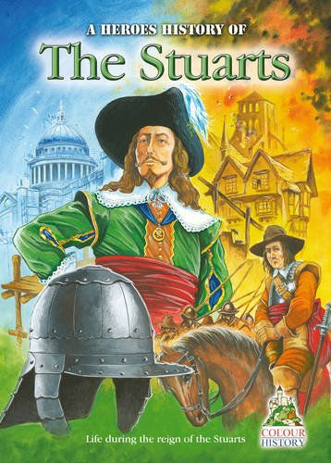 | This book is about a bloodthirsty and often terrifying period of British history, when the nation was divided and at war with itself and several countries in Europe. The Great Plague killed at least one fifth of the people of London and a great fire destroyed much of the city. There was even a plot to blow up the Houses of Parliament! As much as a tenth of the population of Britain may have been killed in the Civil War, which was fought between King Charles I and the army of Parliament. Charles was defeated and for the first time in British history the nation was not ruled by a king or queen. This did not last very long, but never again was a monarch to rule with absolute power. This period also saw fantastic advances in scientific knowledge and the creation of some of the most beautiful art and architecture. Our book begins when the King of Scotland, James VI, became King of England.

Miss Beaumont recommends:
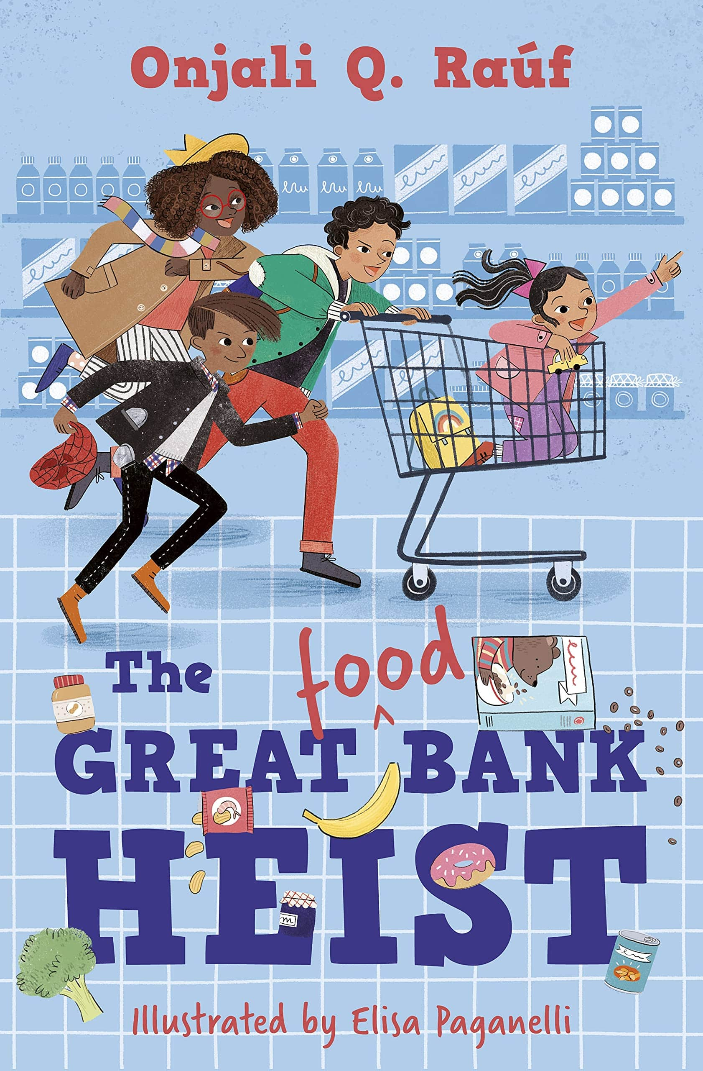 | Written with great empathy and Rauf’s trademark humour, The Great (Food) Bank Heist is a moving story that gives a child’s-eye view of the increasing problem of food poverty.  On Thursdays, Nelson, Ashley and Mum head out to the bank. But not just any old bank – the food bank. With its shining tins and packets of food stacked from floor to ceiling, Nelson thinks it’s the best kind of bank there is. But there’s a thief in town, and the shelves of the food bank are getting emptier each day, leaving people hungrier than ever. For the sake of his family and everyone else’s, Nelson needs to make them stop. But can he and his friends really be the ones to catch the bank robber?
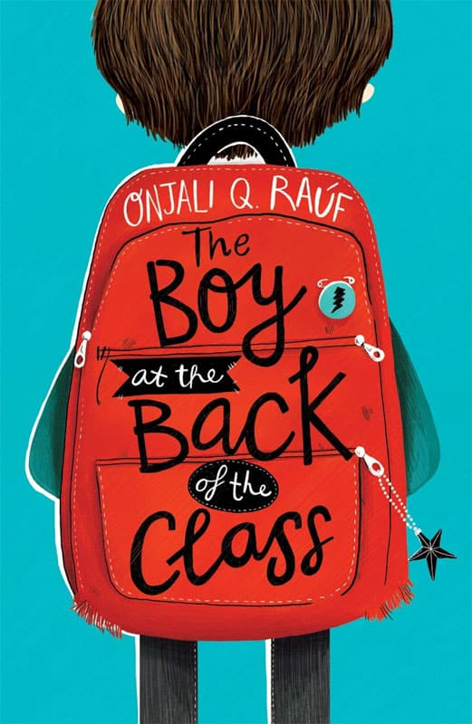 | Ahmet is a refugee and is given a previously empty seat at the back of the class when he starts a new school. He is befriended by the narrator of the story. Through the story, we learn about Ahmet’s background and the ups and downs of integrating into a new school. Kindness and friendship triumph, and the story develops empathy and encourages human connection. A good story for KS2 children to read and discuss.
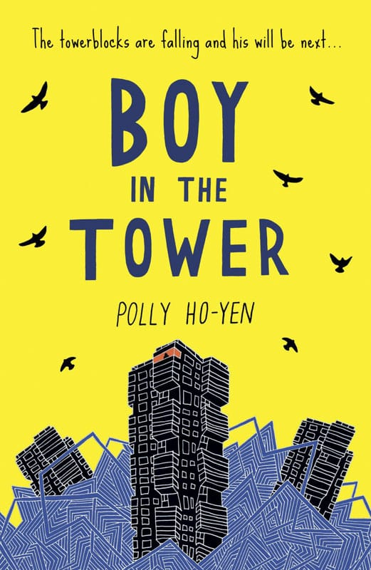 | When they first arrived, they came quietly and stealthily as if they tip-toed into the world when we were all looking the other way.  Ade loves living at the top of a tower block. From his window, he feels like he can see the whole world stretching out beneath him.  His mum doesn’t really like looking outside – but it’s going outside that she hates. She prefers to sleep all day inside their tower, where it’s safe.  Except it isn’t any more. Strange plants have started to take over and tower blocks are falling down around them.  Now Ade and his mum are trapped and there’s no way out…

