Spring Term Recommended Reads for Elm Class

Our class reader this term is The Firework Maker’s Daughter by Phillip Pullman

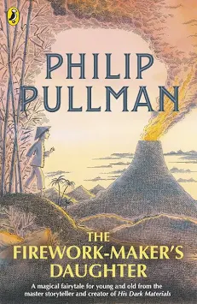

Other narratives by Phillip Pullman:
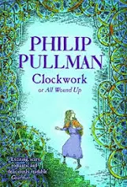 | In Phillip Pullman's Clockwork, an apprentice clockmaker and his acquaintances wind up some characters and fit them into a story on a cold winter's evening. With the snow swirling down, suddenly life and the story begin to merge in a peculiarly macabre - and unstoppable - way.  Almost like clockwork ... Tick, tock, tick, tock! Some stories are like that. Once you've wound them up, nothing will stop them ...
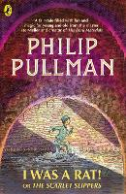 | Who is Roger? He says he was a rat - and some of the time he behaves like a rat. But, he is also a small boy. Or, he could be the Monster of the sewers…Everyone has a view – including The Daily Scourge – who tells their own version in screaming newspaper headlines. There is just one person who really knows who Roger is. And she’s the princess…  Cleverly, Pullman weaves together strands of story from different sources creating a fast-paced and multi-layered adventure.

We will also be reading The Magic Faraway Tree, which is a fantasy story originally written by Enid Blyton and then adapted and modernised by Jaqueline Wilson.

If you are enjoying this, you may wish to read some other Enid Blyton stories:
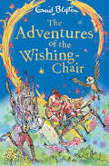 | Set off a magical adventure with the first book in Enid Blyton's classic fantasy series about a chair that can fly and grant wishes!  When Mollie and Peter go to buy their mother a birthday present, they discover the most extraordinary thing: a magical wishing-chair! The Wishing-Chair takes them on some wonderful adventures - to a giant's castle to rescue a new pixie friend, to the Land of Dreams, and even to a disappearing island! Who knows what might happen next?
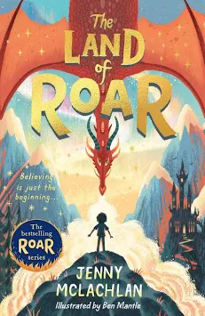 | When Arthur and Rose were little, they were heroes in the Land of Roar, an imaginary world that they found by climbing through the folding bed in their grandad’s attic. Roar was filled with things they loved – dragons, mermaids, ninja wizards and adventure – as well as things that scared them (including a very creepy scarecrow…)  Now the twins are eleven, Roar is just a memory. But when they help Grandad clean out the attic, Arthur is horrified as Grandad is pulled into the folding bed and vanishes. Is he playing a joke? Or is Roar … real?
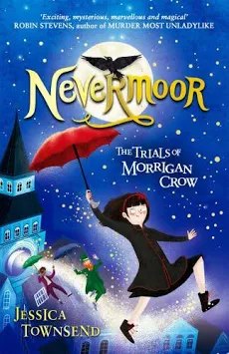 | Morrigan Crow is cursed, destined to die on her eleventh birthday. But, as the clock strikes midnight, she's whisked away by a remarkable man called Jupiter North and taken to the secret city of Nevermoor.  There she's invited to join the Wundrous Society. Mystery, magic and protection are hers - if only she can pass four impossible trials, using an exceptional talent. Which she doesn't have...

You might like to explore some books based on our Science focus, Sound:

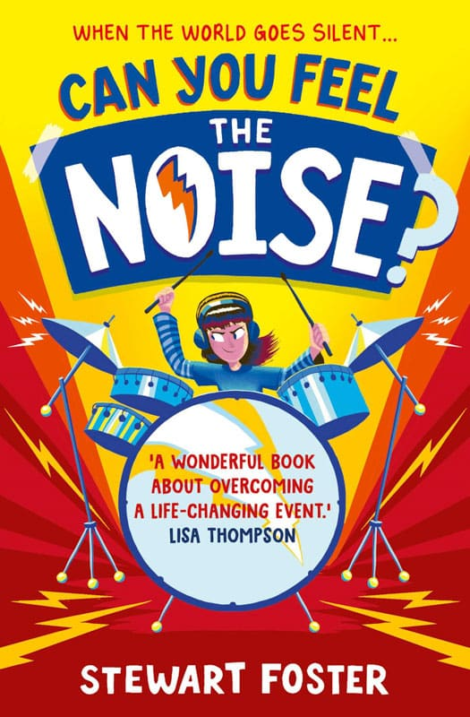 | Life is going well for Sophie. She’s getting by at school, has some pretty awesome friends, and their band have made it through to the semifinals of the Battle of the Bands competition.  But when Sophie wakes up completely deaf one morning, the life she once knew seems like a distant memory. With lessons replaced by endless hospital appointments, and conversations now an exercise in lip-reading, Sophie grows quieter and quieter. Until she discovers the vibrations of sound through an old set of drums and wonders whether life onstage is actually still within reach.  Drawing on the author’s own hearing impairment, Can You Feel the Noise? is a deeply personal and moving story that will stay with you long after reading.
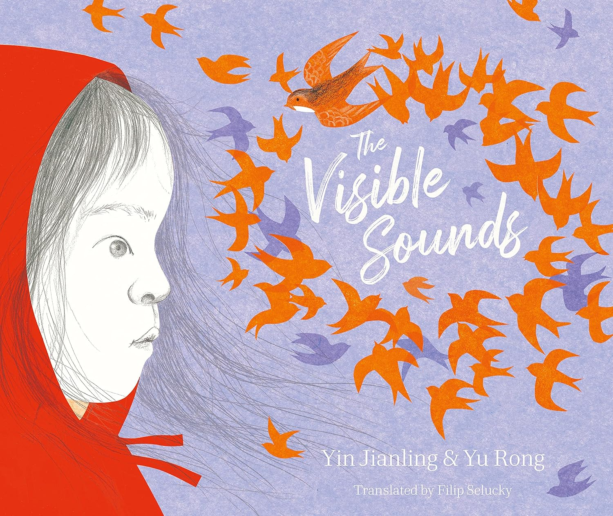 | Based on the true story of Chinese dancer Lihua Tai, The Visible Sounds tells the uplifting tale of a young child dealing with the frustration and solitude of hearing loss. Alone in silence, the child’s life is changed forever when a chance touch unlocks a vibrant new world, now blazing with rainbows of visible sounds.  The Visible Sounds brings a message of hope and joy to children living with a disability and is an inspirational reminder that dreams can become reality.
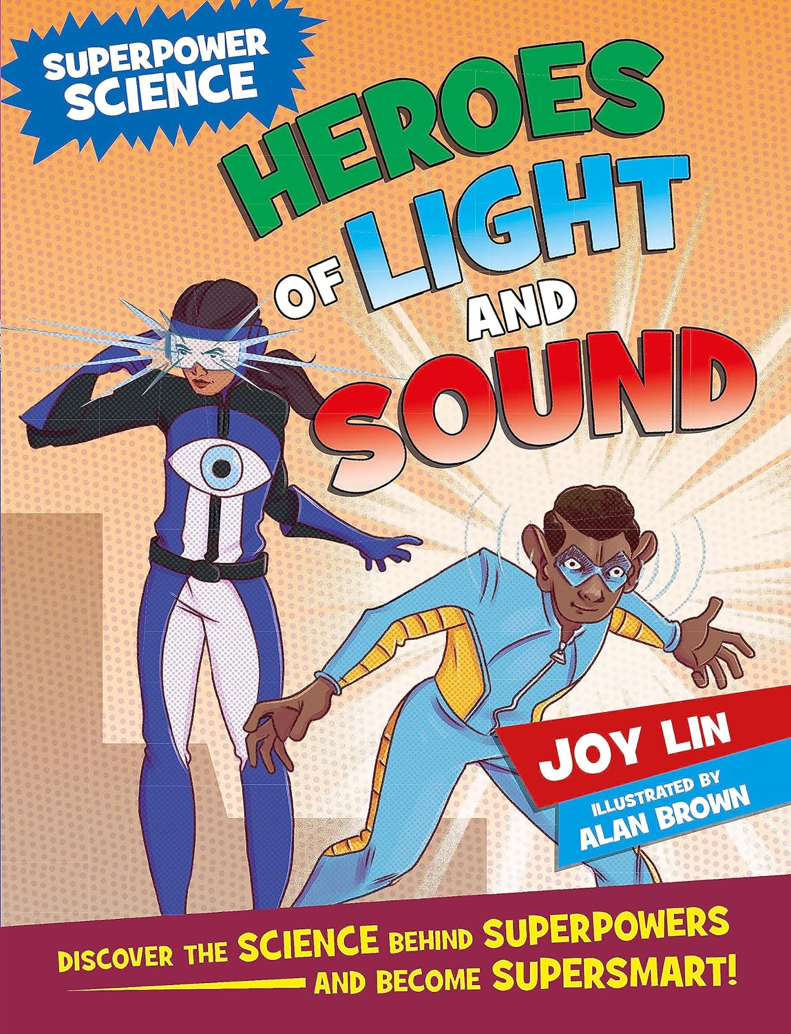 | Science principles come to life through quirky and humorous explanations in comic book format.  What if you could be invisible or have super vision and hearing? You’d be a superhero BUT are these superpowers feasible in the real world? Superpower Science: Heroes of Light and Sound tells you all about the reality of these superpowers when looked at through a scientific lens.  The comic book format and vintage-looking colourful illustrations paired with quirky and humorous explanations turn what would be considered by many as dry physics principles into high interest exciting books.  By pointing out the physical limitations of superpowers, the series aims to fix them, not crush children’s dreams but inspire them to be interested in science.
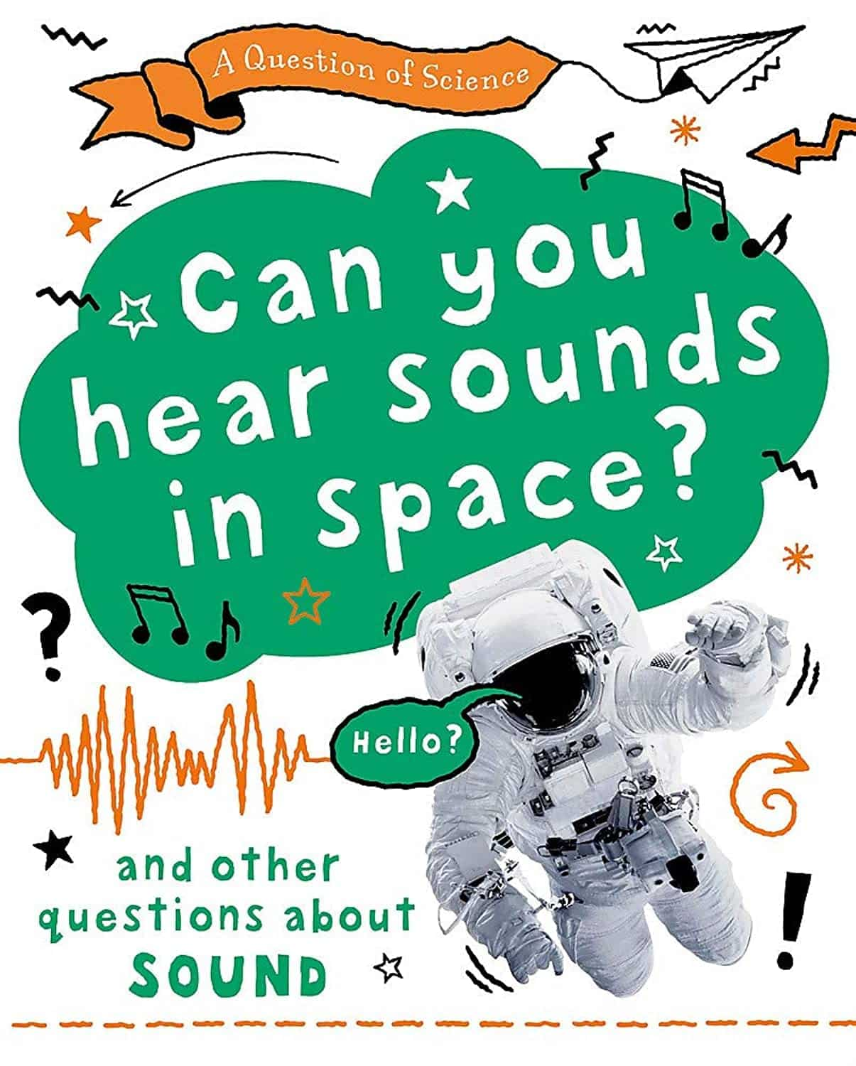 | A fun, quirky science series that tackles the questions other books are afraid to ask!  Can you hear sounds in space? Which animal has the best hearing? And just how fast is a supersonic plane? A Question of Science: Sound answers all these questions and much more.  With an engaging question and answer format, these books draw kids into science in a fun way. Each book features one question per spread with a clear explanation to follow, diagrams and fun and humorous illustrations. The quirky questions are designed to range from those that children will often ask to things they may never have thought of but will still be keen to know the answer to.

In our geography lessons, we will begin to learn about Eastern Europe:
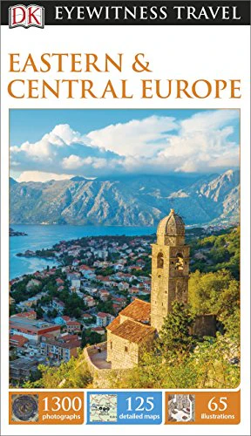 | Explore the imperial palaces of St Petersburg, island-hop around the Dalmatian coast or cruise Slovenia's majestic Lake Bled: everything you need to know is clearly laid out within colour-coded chapters.
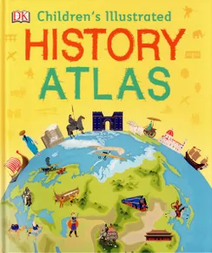 | These maps, arranged chronologically and annotated with information about our past, show different parts of the world at various points in history, from Mesopotamia in 3300 BCE, via the Mughal Empire and France and America during their respective revolutions, to the world as it is today. Includes tips on map-reading and using a scale, key and compass.

Books linked to our art and DT learning:
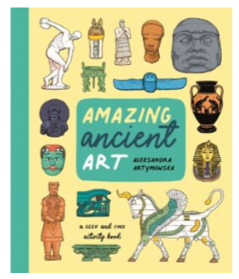 | Dive into this treasure trove of beautifully illustrated artefacts and learn more about the amazing ancient civilisations that created them as you complete puzzles and search for clues.  Can you find all the Egyptian gods hidden in the scene? Or can you match these Roman busts to the description of famous emperors? Explore precious jewels, mosaics, statues and ceramics from across history and throughout the world and find out more about the incredible ancient civilisations who made them. This busy activity book on ancient art is jam-packed with stimulating search-and-finds and perplexing puzzles that can be enjoyed time and time again.
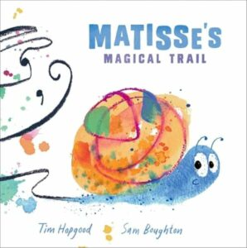 | A beautiful, colourful and bold picture book that encourages children to notice the small things, think big, and express themselves! Matisse is a young snail who loves to create beautiful drawings with his trail. The trouble is most of the time people are far too busy to even notice them. It's only when a child notices Matisse's beautiful trails that his art is finally celebrated - and they inspire a whole class of children to get creative too!

Miss Beaumont’s favourite books:
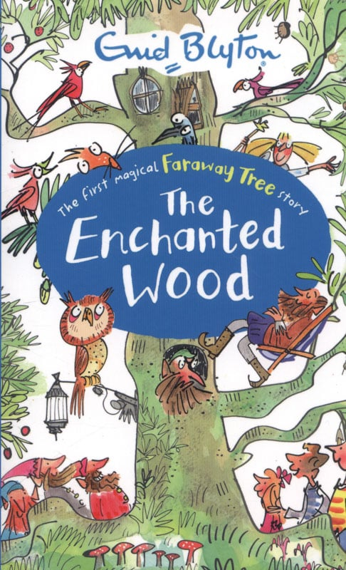 | The first magical story in the Faraway Tree series by one of the world’s most popular children’s authors, Enid Blyton.  Joe, Beth and Frannie find the Enchanted Wood on the doorstep of their new home, and when they discover the Faraway Tree they fall into all sorts of adventures!  Join them and their friends Moonface, Saucepan Man and Silky the fairy as they discover which new land is at the top of the Faraway Tree. Will it be the Land of Spells, the Land of Treats, or the Land of Do-As-You-Please? Discover the magic!
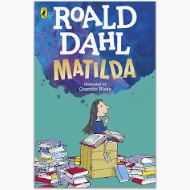 | Matilda is a brilliant child with a magical mind.  But her parents have decided she's just a nuisance who wastes too much time on reading and stories.  And her headmistress Miss Trunchbull is a terrible bully, who thinks children are rotten and awful and should be locked up.  Now it's time for Matilda to find the power to change her story, and show them just how extraordinary children can be . . .
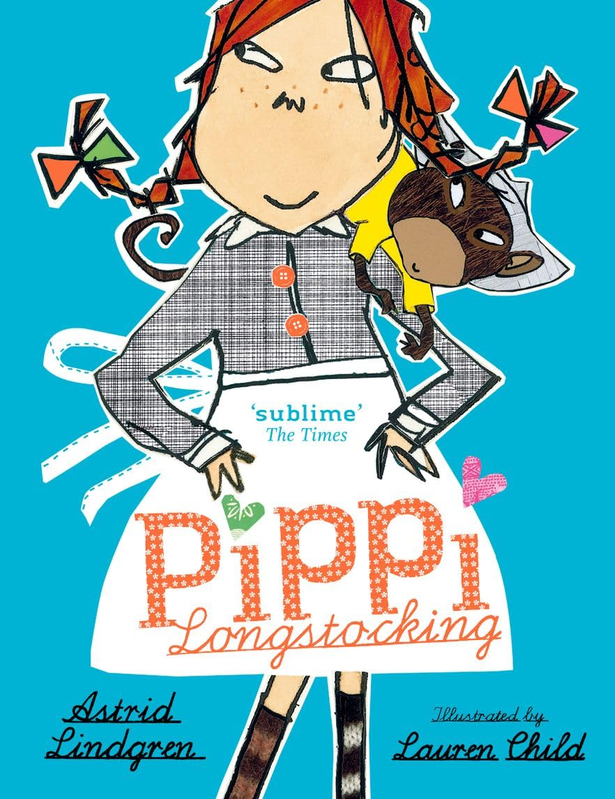 | Pippi Longstocking is nine years old. She has just moved into Villa Villekulla, where she lives all by herself with a horse, a monkey, and a big suitcase full of gold coins. The grown-ups in the village try to make Pippi behave in ways that they think a little girl should, but Pippi has other ideas. She would much rather spend her days arranging wild, exciting adventures to enjoy with her neighbours, Tommy and Annika, or entertaining everyone she meets with her outrageous stories. Pippi thinks nothing of wrestling a circus strongman, dancing a polka with burglars, or tugging a bull’s tail.  Generations of children have fallen in love with Pippi Longstocking. Just like Tommy and Annika, readers are instantly charmed by her warmth, strength and sense of fun.

